Supplemental Material S1

- Materials and Methods
  - Nocturnal Video Units (NVUs)
To be able to observe nocturnal fishes in situ and quantify the space-use and functional role of the most common and abundant nocturnal reef fish, apogonids, we designed and constructed an autonomous nocturnal filming unit for fish identification, which combines remote filming and red illumination. These units are hereafter termed the Nocturnal Video Units or NVUs (Figure 1). Below, we describe in detail each component of the NVUs, as well as the principles behind their usage.

    - Camera system
The camera system for the NVUs was designed around a GoPro™ Hero8. One of the major obstacles with long-term deployment of these cameras, as a remote system, is their relatively short battery life, which only lasts roughly one hour and 50 minutes when recording with the settings required for this project. To extend the battery life for this system, we replaced the standard GoPro™ Hero 8 battery with a 5,200 milliampere external power bank connected via a Type-C USB cable. This allowed the GoPro™ cameras to record footage non-stop for approximately five hours. However, the external power source connected to the camera made it no longer waterproof and, thus, not suitable for submersion. To solve this issue, we housed both the camera and the power bank in a 1.5 litre glass clip top preserve jar (Figure 1). Following empirical tests, this system proved to be fully waterproof under pressure while simultaneously transparent enough to result in footage with sufficient definition to recognise fish individuals to species or genus level, depending on their size. To ensure sufficient memory to store full-HD (1080p) video up to 5h, we used 128gb SD cards. We used the new GoPro™ Hero8 QR control feature (accessible in https://gopro.github.io/labs/control/) to quickly apply a series of standard settings for all GoPro™ cameras in every deployment, including a time overlay on the video footage (see Table S2). A list with the settings used can be found in Table S2.

    - Light system
The light system for each of the NVUs consists of two LED systems. Each system was built from a bank of 36 individual 12V LEDs on a rectangular grid, connected to a 10,000 milliampere power bank via a 12V USB step up cable. These two LED systems were also placed inside a transparent waterproof housing consisting of a 1.5 litre clip top glass preserve jar. For this study red light was used to balance the need to reduced disturbance to fish behaviour (compared to white light) and enhanced underwater penetration (compared to infrared light normally used for nocturnal filming in terrestrial systems). Many camera-based nocturnal studies have shown that the colour of light used to illuminate the field of view can affect which fishes are surveyed (Harvey et al. 2012; Fitzpatrick et al. 2013; Birt et al. 2019). Although rgb red-only emitting LED lights would provide higher energetic efficiency, there were no commercially available red LED lights with the same illuminance and voltage requirement available at the time of the study. We therefore used white light emitting LED lights and opted for a red-light filtering approach using red plastic sheets. To ensure that only light at wavelengths greater than ~600nm (i.e., red-orange to red) were emitted, we performed a series of tests using a Satlantic HyperOCR™ radiometer in a dark room. With the radiometer set up pointing towards the light we were able to manipulate the number of layers (i.e., sheets) of red-light filter plastic while monitoring the wavelength composition of light being emitted. Tests showed that 4 layers of red-light filter plastic allowed for the complete removal of light at wavelength less than 585nm and kept 95% of light above 600nm (see Figure S1). The red wavelength has previously been found to provide adequate illumination for fish detection (Madin et al. 2019) while producing minimal disturbance as it is outside the main area of detection for reef fishes (Job and Shand 2001).
    - Frame/Rope/Buoy
To secure the camera and the lights together, the frame of the NVUs was made of 125 x 500 x 3mm aluminium plates. Holes were drilled into the base plates allowing for the attachment of the camera and light jars with the use of zip ties in two attachment points per jar: one in the ‘neck’ (between the body and the lid), and another one at the base, delimited by a line of white Sikaflex© Pro+ Polyurethane Sealant (Figure 1). A neoprene layer (5mm thick) was used to cushion jars from the aluminium base, allowing for adequate tension and avoiding movement during deployment and retrieval. To stabilize and weight the whole system the aluminium base plates and jars were attached to a half concrete block. This negated the positive floatation of the air-filled glass jars and also raised the system off the sand allowing for a more panoramic field of view. A 14mm by 8m rope and buoy attached to the concrete block allowed for quick and easy boat-based deployment and retrieval.
    - Deployment and retrieval
Immediately before deployment, all O-ring seals on the jars were cleaned with ethanol and lint free tissues and coated with a small amount of silicon grease. All GoPro™ cameras and lights were connected to their respective power banks, turned on, set to the specific operational configurations (via QR code) and put to record before the jars were sealed. NVU’s were then transported to the beach and loaded onto a boat as soon as possible to reduce the chance of overheating. Once the boat was in position (see the next section) each NVU was lowered to the bottom via the rope attached to the buoy, and georeferenced using a handheld surface GPS receiver. After retrieval, NVUs remained sealed until after thorough rinsing with fresh water in the laboratory. This minimised the chance of particles compromising future sealing of the jars.
    - Spatial deployment positioning system
Four deployment sites were established in the Lizard Island lagoon, on the northern Great Barrier Reef (Figure 2). At each site the array started on the edge of the reef, at the interface with the sand. From this starting location, ten NVUs were placed as evenly as possible in a 200m line which extended perpendicular from the reef site out on to the sand (Figure 2). This configuration of ten NVU’s makes up one nocturnal video array. GPS coordinates of each NVU were recorded at deployment. One array was deployed each night before sunset, between 17:45 and 18:15, while retrieval occurred between 07:00 to 07:15 of the following morning. Over the study period, three deployment nights were carried out at each deployment site. Once the NVUs were retrieved and washed down in the wet lab, all SD cards were downloaded and backed up onto two external hard drives for safe keeping.
    - NVU Errors
Over the course of the study 120 NVUs were deployed. From these deployments we only had two instances of flooding. The first was a minor occurance where a little bit of water infiltrated the jar but not enough to submerge the camera. We think this was likely due to the jar being partially open which would cause water to enter upon initial deployment but then the pressure at depth caused the jar to reseal. In the second instance there was a cable caught in the jar opening which caused the jar to remain open over the full course of deployment. In this instance the camera and external battery were fully comprimised. On top of this, 34 other cameras were not included in the analysis due to errors which caused the footage to be substatially different to other deployments. These errors mainly included; camera angle being too high, rope from the NVU covering the camera, power pack issues for the camera, power issues with the lights, and/or errors in initial setup which caused the time display to be absent.
  - Calculating distance from the reef
To obtain a conservative estimate of minimum distance travelled by fishes detected by NVU’s, we calculated the distance from each NVU to the nearest reef. We began by creating a georeferenced set of reef polygons in the Lizard Island reef complex detectable from satellite images, using Google Earth Pro (2010/2011 images) and manually tracing the outline of the reefs at an eye altitude between 150-400m. We exported the polygons as a .kml file to be read into R as a ‘SpatialPolygonsDataFrame’ object using the ‘sf’ package (Pebesma 2018). We also imported the GPS coordinates of each NVU deployment. Then, we used the ‘dist2line’ function from the ‘geosphere’ package (Hijmans 2019) to calculate the distance from each NVU deployment to its nearest mapped reef location, in meters.
  - Potential temporal changes in Apogonidae abundance within cameras
To explore the temporal changes in Apogonidae abundance and, hence, to test for any potential effects of attraction or repellence from the lights, a subsample of two cameras per site, between 25 and 35 meters from the reef were selected. The maximum number (MaxN) of Apogonidae at the beginning of each minute over a 3-minute period was determined every 30 minutes, from 18:30 to 22:30. These MaxN values were plotted for all 8 cameras to assess the temporal abundance patterns (Figure S2). It was assumed that, if there was an attraction effect from the lights, then there would either be A) a quick increase in apogonid abundance relatively soon after last light, or, if the effect strength was low, then there would be B) a steady incline in apogonid abundance as time passed and more fish were attracted without leaving the lights. From this analysis, it was clear that the abundance of apogonids increased slowly after sunset, between last light and 21:30 (Figure S2). However, there was an abrupt increase in abundance at 22:00, which was consistent for most cameras despite the site. Although the reason behind this spike in abundance at 22:00 is unclear, it appears not to be related to light levels, as it occurred almost 3 hours after last light. Furthermore, it follows that our sampling time (21:30) was taken before the peak in abundance of 22:00 and, therefore, that our results are very likely to be conservative.
  - Behavioural Observations
Throughout the video analysis section, we also watched a footage comprising the 3 seconds before and 3 seconds after the “observation instance” (i.e., the ‘still’ images extracted from the complete footages). This small footage immediately preceding and succeeding the still was observed on repeat using the VLC media player software. This allowed us to used not only the still image to identify fish but also their immediate behaviour and movement, which proved to help with counting individuals. This also meant that throughout the video analysis we observed several interesting behavioural events. For example, a frequenly observed behaviour was apogonids lunging and striking at small organisms suspended just above the sand. Unfortunately, due to the small size of the apogonids and the prey they were feeding on it was impossible to determine exactly what was happening and if any “strikes” were successful predation events or not. We also in one instance of the video observed a Lutjanus russellii strike at (and probably consume) a small (<5 cm) apogonid.

  - Visual counts
To assess the nocturnal community on reefs nearest to the NVU deployment transects, two 50m underwater visual surveys were conducted at each site. These counts were carried out during the day by a single observer (W. Collins). On each transect, the individual apogonids were identified to a species level and their size was estimated to the nearest centimetre. Each transect consisted of two separate phases. The first phase was carried out as the tape was being laid, recording fishes in a 5 m wide transect and assessing the larger (>10 cm individuals) which are transient and have lower site attachment. This helped ensure that the more scared fish, which may leave the area because of the diver presence, were counted. The diver then turned around and swam back along the tape, focussing on smaller (<10 cm), more cryptic individuals in a 2 m wide transect. During this transect all holes, overhangs, and caves were checked for hiding individuals.

  - Data analysis
The focus of this study is on the relationships between (A) presence (detection) and (B) abundance of apogonids recorded by the NVUs vs the distance of the NVUs from the reef, as a proxy for space use in apogonids under the assumption that apogonids return to the reef during the day to rest and leave to feed over sandy substrate during the night.
A) For each model, we used the No-U-Turn Markov Chain Monte Carlo (MCMC) sampler in Stan via ‘rstan’ (Stan Development Team 2020) and ‘rstanarm’ (Goodrich et al. 2020) in R. All models used 5,000 iterations per chain and a total of three chains, including a 50% burn-in. We used the default rstanarm model priors, which consisted in normally distributed priors (mean = 0, SD = 2.5) for the intercept and coefficients. The different model structures (i.e., with or without site and the interaction between site and distance from the reef) were then compared using leave-one-out cross-validation (using the ‘loo’ and ‘loo_compare’ functions). The model with the highest expected log predictive density (ELPD) was then selected. In this case, this was the model that only included distance and time period (day or night) as explanatory variables and date as a random effect. This model was then examined with trace plots (function ‘mcmc_trace’), R-hat diagnostics (function ‘mcmc_rhat_hist’), autocorrelation function (function ‘mcmc_acf’) and posterior predictive checks (function ‘pp_check’). This ensured that the models were correctly specified, converged, showed low autocorrelation between MCMC steps and fitted the data adequately.
B) Again, we used the No-U-Turn MCMC sampler in Stan via ‘rstan’ (Stan Development Team 2020) and ‘rstanarm’ (Goodrich et al. 2020) in R, with 5,000 iterations per chain, three chains, a 50% burn-in. Default priors consisted in normally distributed (mean = 0, SD = 2.5) priors for the intercept and coefficients, and an exponentially distributed auxiliary prior (rate = 1). Here, we found no sizeable differences in ELPD between the three models and hence selected the simplest model (same predictors as the detection model). This model was also examined with trace plots (function ‘mcmc_trace’), R-hat diagnostics (function ‘mcmc_rhat_hist’), autocorrelation function (function ‘mcmc_acf’) and posterior predictive checks (function ‘pp_check’).
  - Transforming and modelling home range data
To compare the likely movement distances of apogonids as obtained from our NVU spatial design with the literature, we compiled ‘home range’ estimates (hereafter ‘occupancy areas’) as a function of fish body mass from multiple published studies (following Nash et al. 2015; Streit et al. 2021). As the shape of these occupancy areas estimates were not accessible, we conservatively assumed that estimates stemmed from circular occupancy areas. A conservative estimate of the maximum distance between two points in a circular area is the diameter of the circle, which was obtained according with:
$$D=2\sqrt{\frac{A}{π}}$$
Where ‘D’ is the diameter, and ‘A’ is the occupancy area from each study. Using these derived diameter estimates, we then modelled the relationship between body mass and estimated maximum (fish movement) distance (EMD). Body mass consisted in an estimate of the maximum body mass for each fish species for which occupancy area data was available using compiled length-weight regression coefficients (Froese, R. and Pauly, D. 2021) to obtain weight from maximum reported species lengths. For the apogonids detected in this study, because species-level identification was often not possible, average length-weight parameters at the genus-level were used to estimate the likely body mass of apogonids at the average size detected (i.e., 2.5 cm total length).
To model these data, we again used a Bayesian Generalised linear mixed effect model, with a Gamma error distribution and a log link function. We followed Nash et al. (2013) in including log₁₀ body mass, trophic group, and method used to obtain the data underlying occupancy areas as predictor variables, taxonomic family as a random effect, but, instead of ‘occupancy’ area, used the ‘occupancy diameter’ (as calculated above) as the response variable. This model also used Stan, ‘rstan’ (Stan Development Team 2020) and ‘rstanarm’ (Goodrich et al. 2020) in R, with 6,000 iterations per chain, a total of four chains, a 50% burn-in, normally distributed (mean = 0, SD = 2.5) priors for intercept and coefficients, and an exponentially distributed auxiliary prior (rate = 1). To ensure adequate convergence, low autocorrelation between MCMC steps, and adequate fitting of the data, we examined trace plots (function ‘mcmc_trace’), R-hat diagnostics (function ‘mcmc_rhat_hist’), autocorrelation (function ‘mcmc_acf’) and posterior predictive checks (function ‘pp_check’). Finally, we used this model to estimate the expected maximum movement distance of fishes from the reef-based counts based on their body size.

References
Birt MJ, Stowar M, Currey-Randall LM, McLean DL, Miller KJ (2019) Comparing the effects of different coloured artificial illumination on diurnal fish assemblages in the lower mesophotic zone. Mar Biol 166:154
Fitzpatrick C, McLean D, Harvey ES (2013) Using artificial illumination to survey nocturnal reef fish. Fish Res 146:41–50
Froese, R., Pauly, D. (2021) Search FishBase. https://www.fishbase.se/search.php
Goodrich B, Gabry J, Ali I, Brilleman S (2020) rstanarm: Bayesian applied regression modeling via Stan.
Harvey ES, Dorman SR, Fitzpatrick C, Newman SJ, McLean DL (2012) Response of diurnal and nocturnal coral reef fish to protection from fishing: an assessment using baited remote underwater video. Coral Reefs 31:939–950
Hijmans RJ (2019) Geosphere: Spherical Trigonometry.
Job SD, Shand J (2001) Spectral sensitivity of larval and juvenile coral reef fishes: implications for feeding in a variable light environment. Mar Ecol Prog Ser 214:267–277
Madin EMP, Precoda K, Harborne AR, Atwood TB, Roelfsema CM, Luiz OJ (2019) Multi-Trophic Species Interactions Shape Seascape-Scale Coral Reef Vegetation Patterns. Front Ecol Evol 7:102
Nash KL, Welsh JQ, Graham NAJ, Bellwood DR (2015) Home-range allometry in coral reef fishes: comparison to other vertebrates, methodological issues and management implications. Oecologia 177:73–83
Pebesma E (2018) Simple Features for R: Standardized Support for Spatial Vector Data. R J 10:439–446
Stan Development Team (2020) RStan: the R interface to Stan.
Streit RP, Hemingson CR, Cumming GS, Bellwood DR (2021) How flexible are habitat specialists? Short-term space use in obligate coral-dwelling damselfishes. Rev Fish Biol Fish 31:381–398

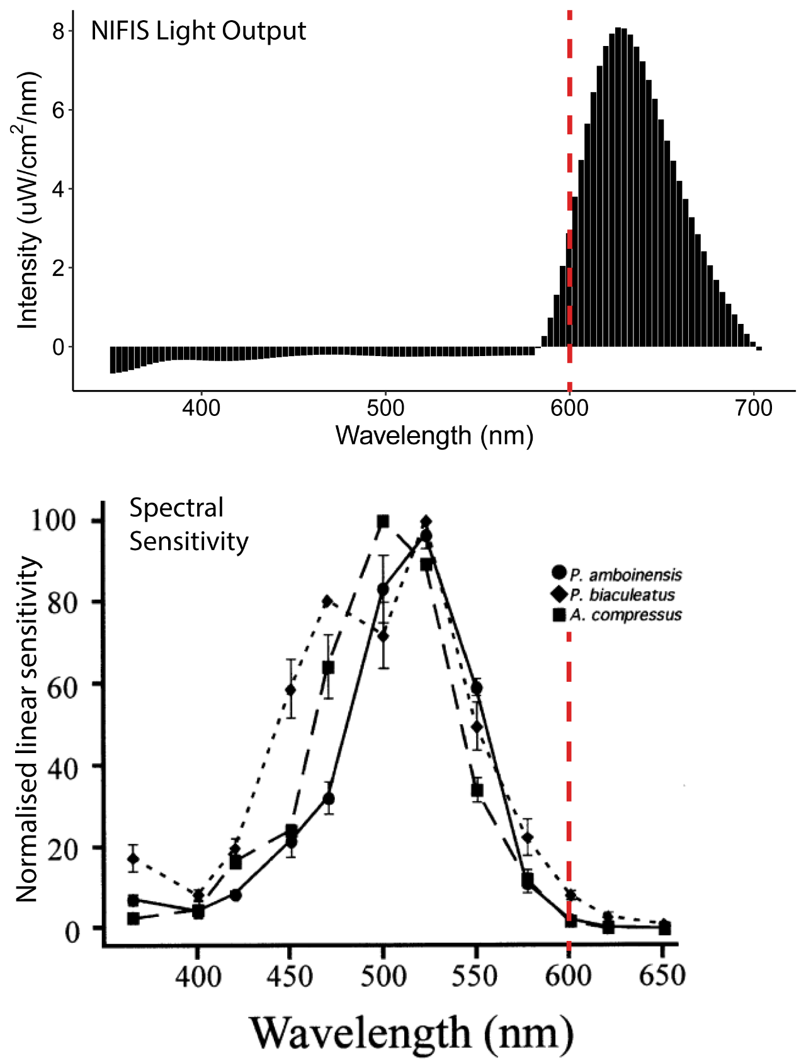

Figure S1: (Top) Output graph from the Satlantic HyperOCR™ radiometer. This graph shows the intensity of light from the NIFIS across the visible light spectrum. This test was run with two LED light banks and 4 layers of red-light filter plastic, as per the final design. (Bottom) Figure from (Job and Shand 2001), normalised spectral sensitivity in post-settlement juveniles of P. amboinensis, P. biaculeatus and A. compressus.
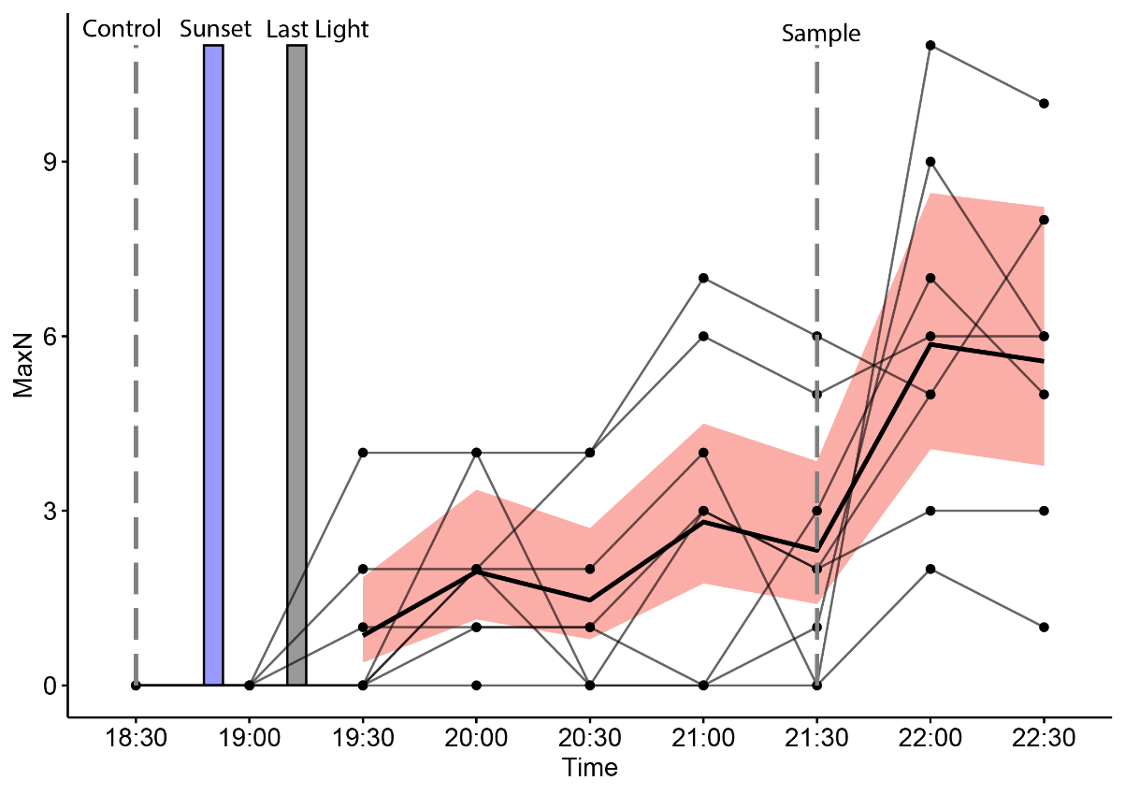
Figure S2: Apogonid MaxN (abundance) at varying times from Cameras between 25 and 35m from the reef. Thicker black line represents the mean MaxN, the pink intervals represent the 95% CI and black dots represent the raw data. Control sample time, sunset, last light, and treatment sample are indicated on the figure.
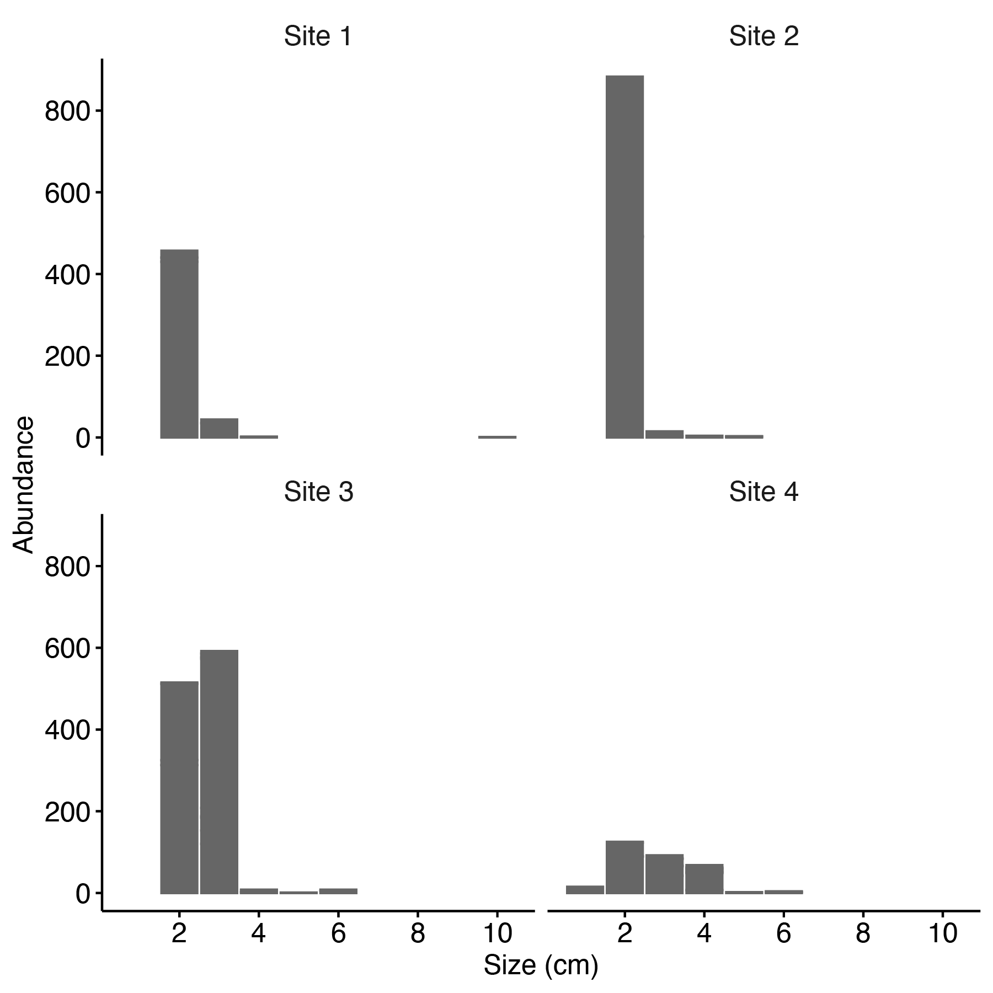
Figure S3: Site level apogonid size frequency distributions from the visual count data (data displayed in Table S2).

Table S1: GoPro Hero 8 settings for use with the QR code feature (accessible in https://gopro.github.io/labs/control/).
Custom code (adding time overlay to recording) | g0oMBRNO=10oMBURN="(0,60)[BRHH:MM:SS ]"
Camera Mode | Video
RES | 1080p
FPS | 30
Lens | Wide
EIS | Off
Hind sight (H9) | Not set
Limit (H9) | Not set
Audio | Not set
White Bal. | Not set
EV Comp. | Not set
Sharpness | Medium
ISO min | Not set
Raw Audio | Not set
ISO max | Not set
Color & Bitrate | Not set
Shutter Lock | Not set
GPS | Off
Boot Mode | Not set
Lang. | English UK
Wifi | Off
LEDs | All off
Beep Vol. | 0%
Voice Cntrl | Off
Auto Off | Not set
Back Light | 10%
Quick Cap. | On
LCD Off | 1 min
Orient Lock | Landscape up
Start Capture Settings | All off
Motion Trigger Settings | All off
Speed Trigger Settings | All off
Sound Trigger Settings | All off
Metadata Features Settings | Original

