Supplementary Information for

Telomere dynamics in the Pacific crown-of-thorns seastar (Acanthaster cf. solaris): effect of age, diet, and tissue type

*Sarah Lok Ting Kwong^{1, 2} (ORCID 0000-0002-0933-9313)
Cecilia Villacorta-Rath³ (ORCID 0000-0002-1060-5447)
Morgan Pratchett² (ORCID 0000-0002-1862-8459)
Sven Uthicke¹ (ORCID 0000-0002-3476-6595)

- Australian Institute of Marine Science, PMB 3 Townsville MC, Townsville, QLD 4810, Australia
- ARC Centre of Excellence of Coral Reef Studies, James Cook University, Townsville, QLD 4811, Australia
- Centre for Tropical Water and Aquatic Ecosystem Research (TropWATER), James Cook University, Townsville, Queensland 4811, Australia

*Corresponding author; sarah.kwong@my.jcu.edu.au

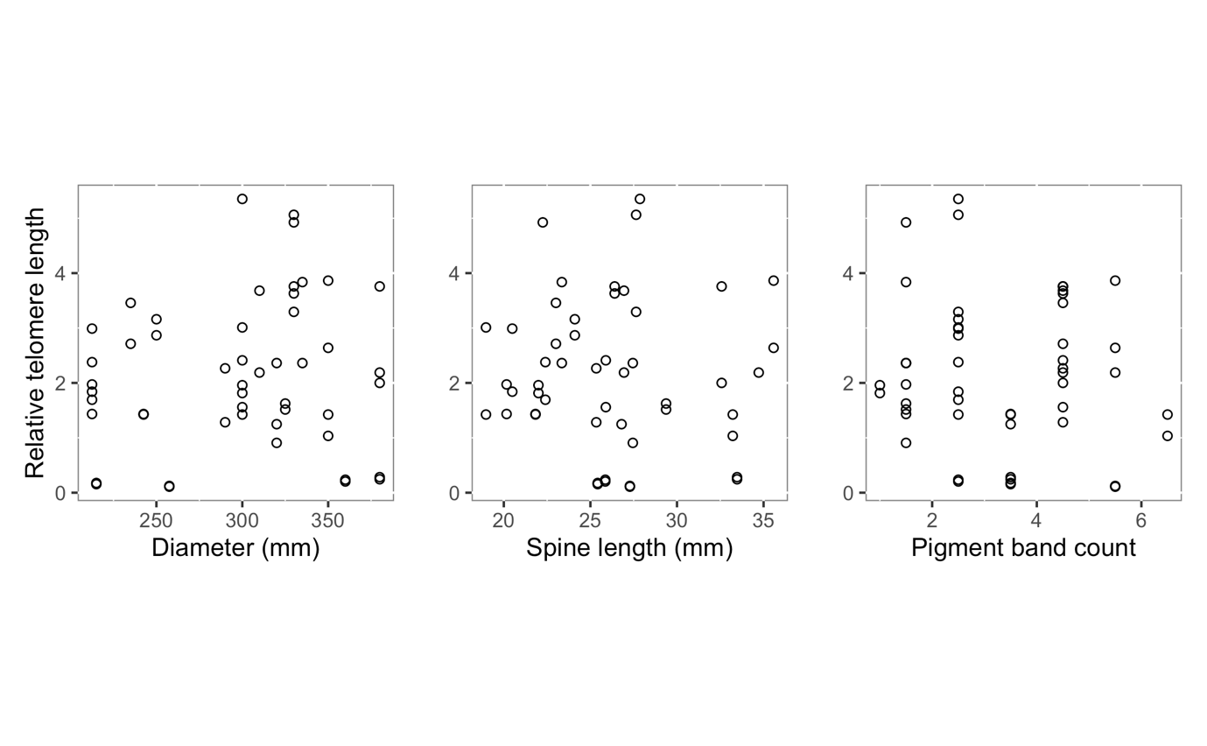
Fig. S1 Relationships between relative telomere length and diameter, spine length, and pigment band count of adult crown-of-thorns seastar (CoTS; Acanthaster cf. solaris).

