Appendix
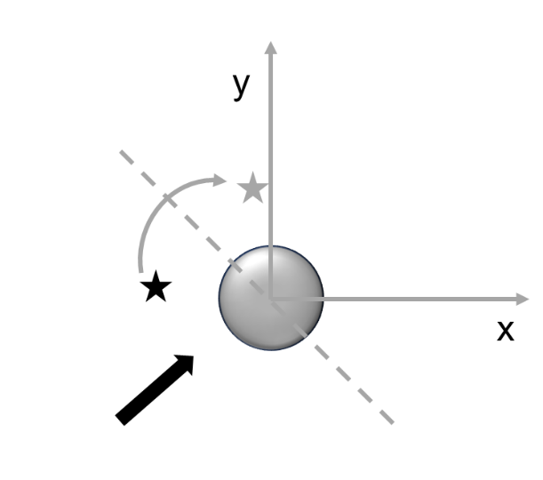
Fig. 5 A schematic representation of mirroring transformation. The coral is marked by the grey circle, the original position of the fish by a black star, and after transformation by a grey star. We mirrored the positions around the axis crossing the center of the coral and perpendicular to the current direction.

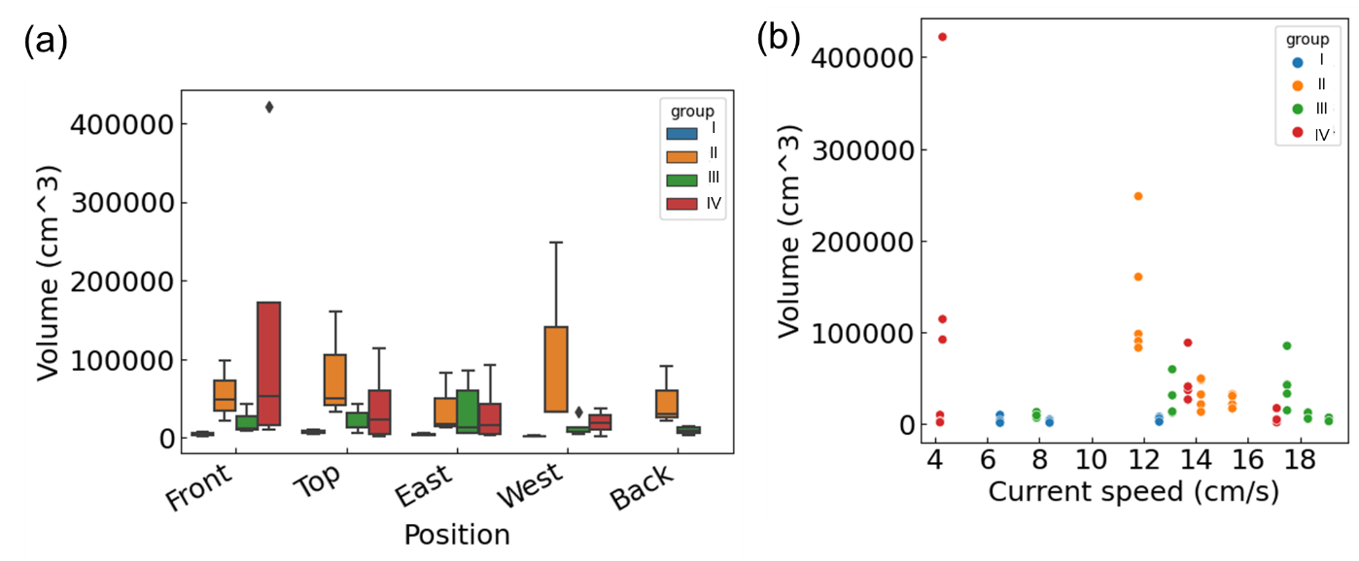
Fig. 6 (a) Volume of foraging spaces vs. position around the coral and (b) vs. current speed in the 4 groups. Liner Mixed-Effect Model did not find a significant effect of these two variables on the volume.

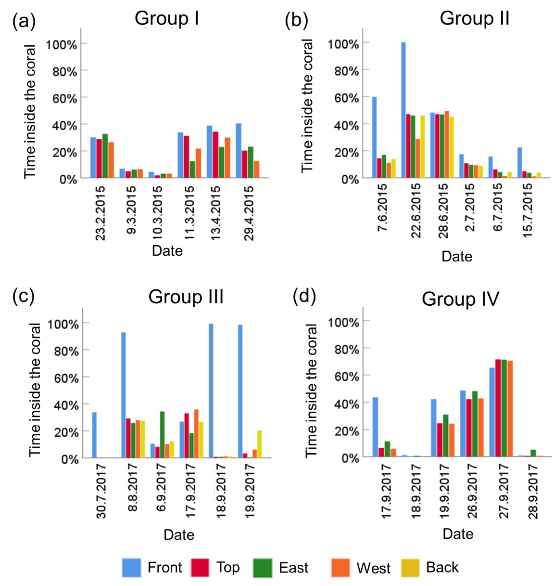
Fig. 7 The percentage of time the different fish were found inside the coral in the 4 groups. The fish assigned names, based on the positions of their foraging spaces around the coral are colored coded (see legends). Measurement of group IV were made prior to the disappearance of the “front” fish in that group. Generalized Linear Mixed-Effects Model found a significant difference in the time spent inside the coral between the fish in the front and the other group members.

Diagnostics for the Generalized Linear Mixed-Effects Models testing for consistency in the position around the coral:
Results of the best fitting model:

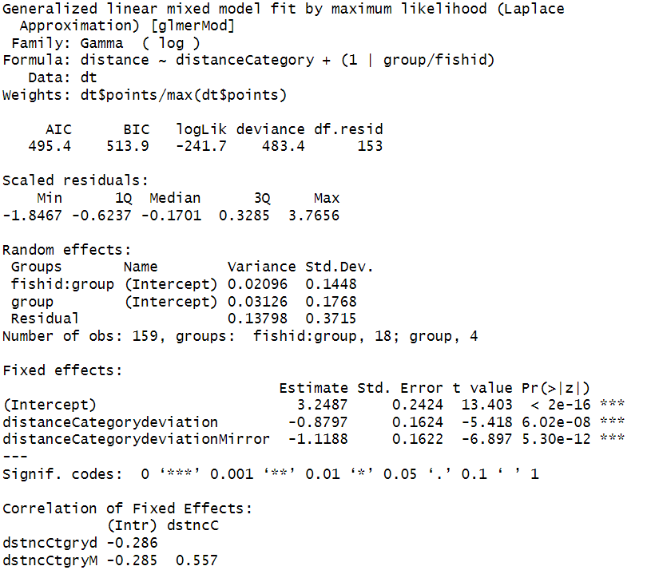

Residual plot:
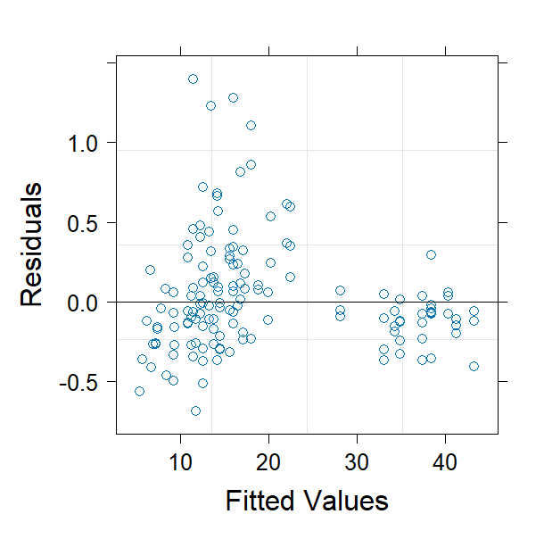
Q-Q plot:
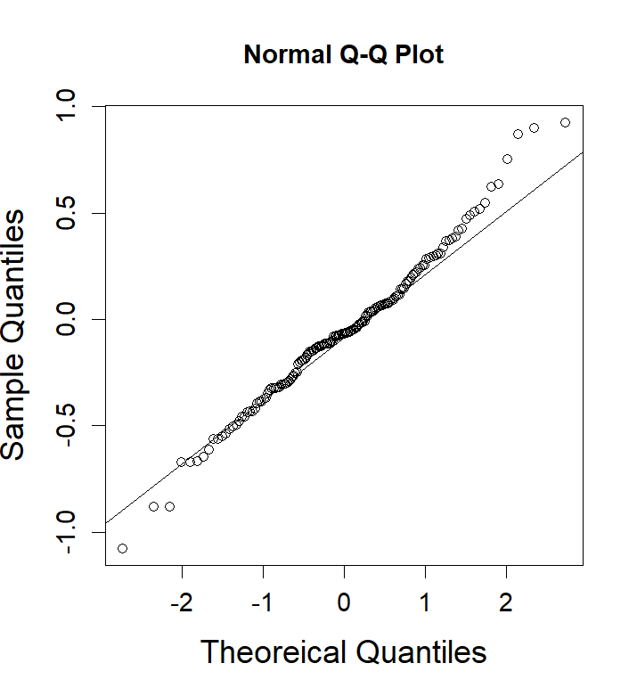
Scale-location plot:

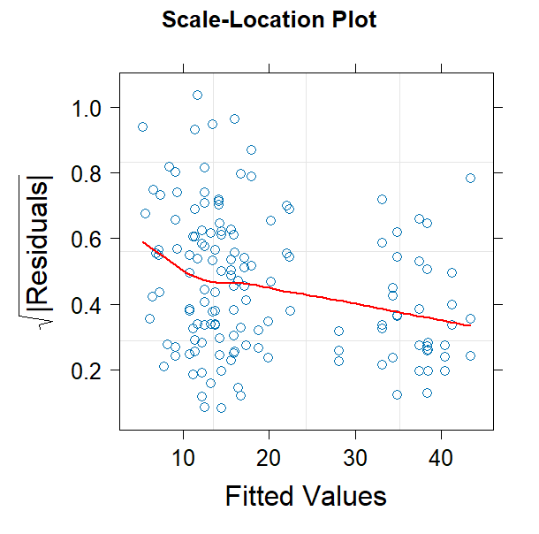

Model selection:
Model | AICc | Akaike weights
Intercept + distance category | -134.0 | 1
Intercept | -101.4 | 0

Diagnostics for the Linear Mixed-Effects Models testing for an effect on the volume of foraging spaces:
Results of full model:
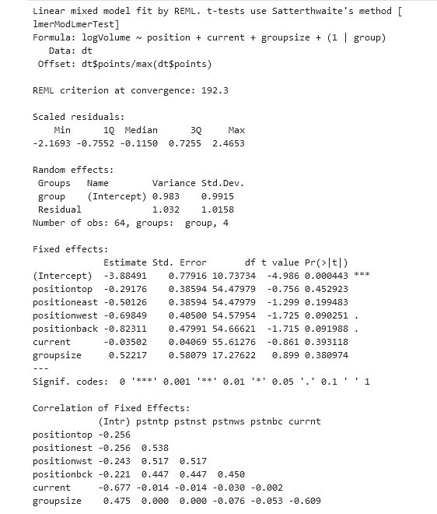

Residual plot:
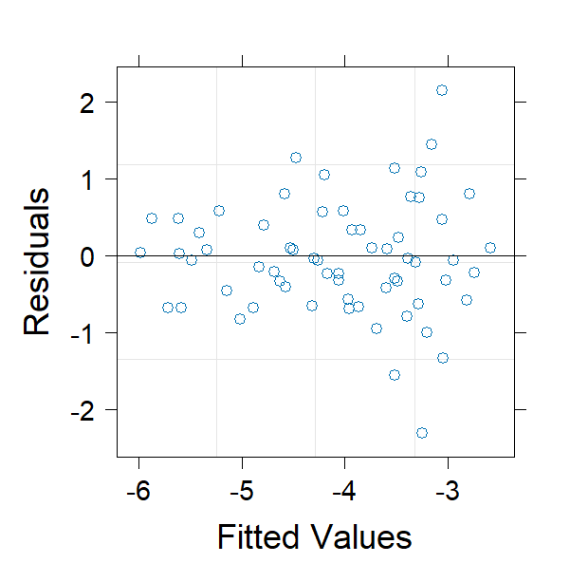
Q-Q plot
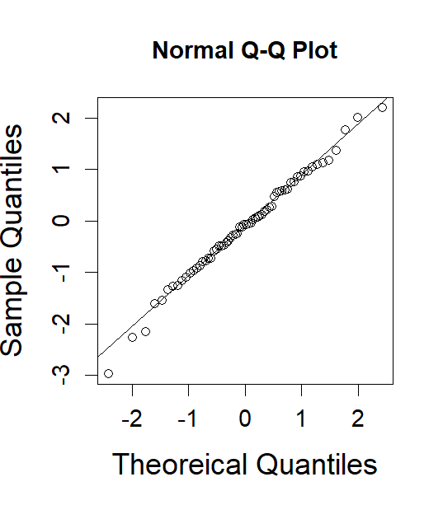

Scale-location plot:
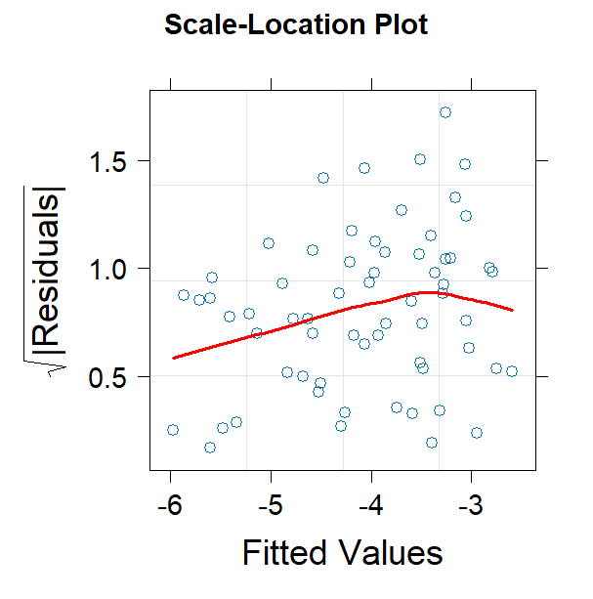
Model selection:
Model | AICc | Akaike weights
Intercept + position + current + group size | 226.0 | 0
Intercept + position + current | 225.3 | 0
Intercept + current + group size | 220.7 | 3
Intercept + position + group size | 221.4 | 2
Intercept + current | 219.9 | 4
Intercept + position | 219.9 | 5
Intercept + group size | 216.3 | 28
Intercept | 214.0 | 58

Diagnostics for the Generalized Linear Mixed-Effects Models testing for effects on the percent of time the fish spent inside the coral:
Results of the best fitting model:
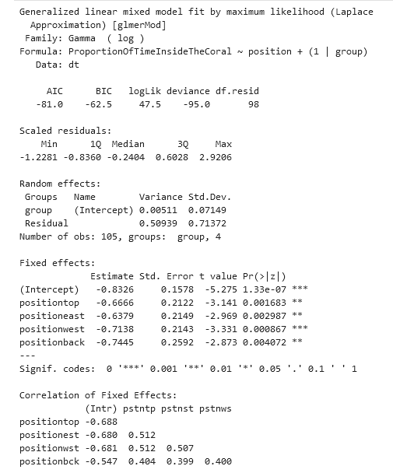

Residual plot:
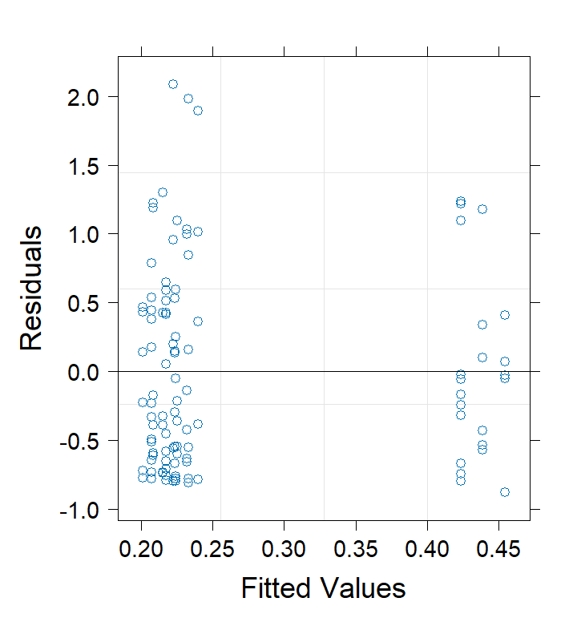
Q-Q plot:
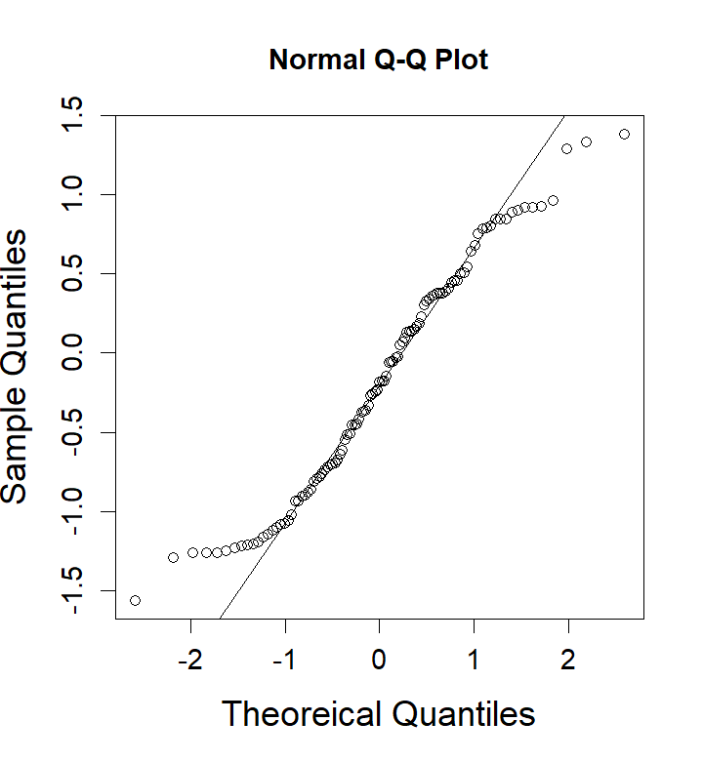

Scale-location plot:
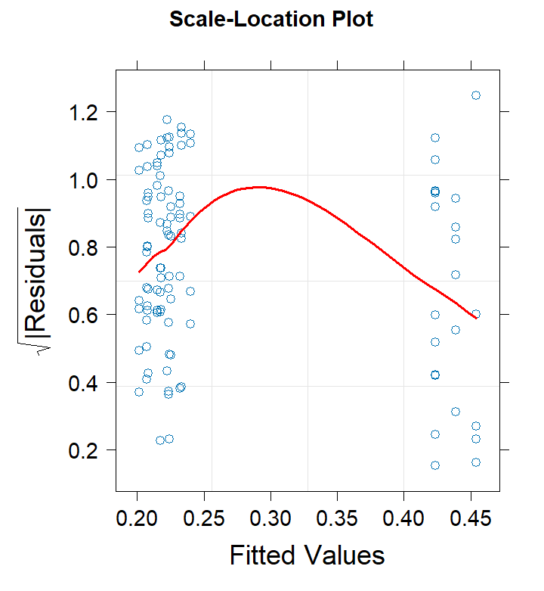

Model selection:
model | AICc | Akaike weights
Intercept + position | -81.0 | 0.99
Intercept | -72.2 | 0.01

