Table S1. Results of mixed-effect GLMs testing the effects of ‘Time’ and ‘Colony size’ on the variation in the abundances of amphipods.
 | Estimate | Std. Error | Z value | P
Total Abundance
Intercept | 1.27 | 0.46 | 2.89 | 0.01
Colony size | 0.02 | 0.003 | 6.25 | 4.02 e-10
Wollastenothoe minuta gen. nov., sp. nov.
Intercept | 0.55 | 0.52 | 1.06 | 0.29
Colony size | 0.02 | 0.004 | 6.37 | 1.63 e-11

Table S2. Epifauna living on colonies of the black coral Antipathella wollastoni. For each taxon, the mean abundances ± standard error at the different times are shown.

Phylum | Class | Order | Family/genus/species | Abundances
 |  |  |  | T1 | T2 | T3
Arthropoda | Malacostraca | Amphipoda | Wollastenothoe minuta gen.nov., sp.nov | 24.5 ± 7.6 | 21.9 ± 5.2 | 150.3 ± 32.8
Arthropoda | Malacostraca | Amphipoda | Phtisica marina | 2.4 ± 0.4 | 12.4 ± 3.4 | 5.9 ± 1.6
Arthropoda | Malacostraca | Amphipoda | Pleustidae sp. | 0.6 ± 0.6 | 0.6 ± 0.6 | 6.7 ± 1.6
Arthropoda | Malacostraca | Amphipoda | Jassa sp. | 0 | 0.1 ± 0.1 | 0.3 ± 0.1
Arthropoda | Malacostraca | Amphipoda | Oedicerotidae sp. | 0.1 ± 0.1 | 0.1 ± 0.1 | 0
Arthropoda | Malacostraca | Amphipoda | Lyssianasidae sp. | 0 | 0 | 0.1 ± 0.1
Arthropoda | Malacostraca | Decapoda | Dardanus arrosor | 0.1 ± 0.1 | 0 | 0
Arthropoda | Malacostraca | Decapoda | Hippolytidae sp. | 1 ± 0.4 | 0.5 ± 0.2 | 0.4 ± 0.2
Arthropoda | Polychaeta | - | - | 0.6 ± 0.5 | 0 | 0
Mollusca | Gastropoda | - | - | 1.1 ± 0.9 | 0 | 0

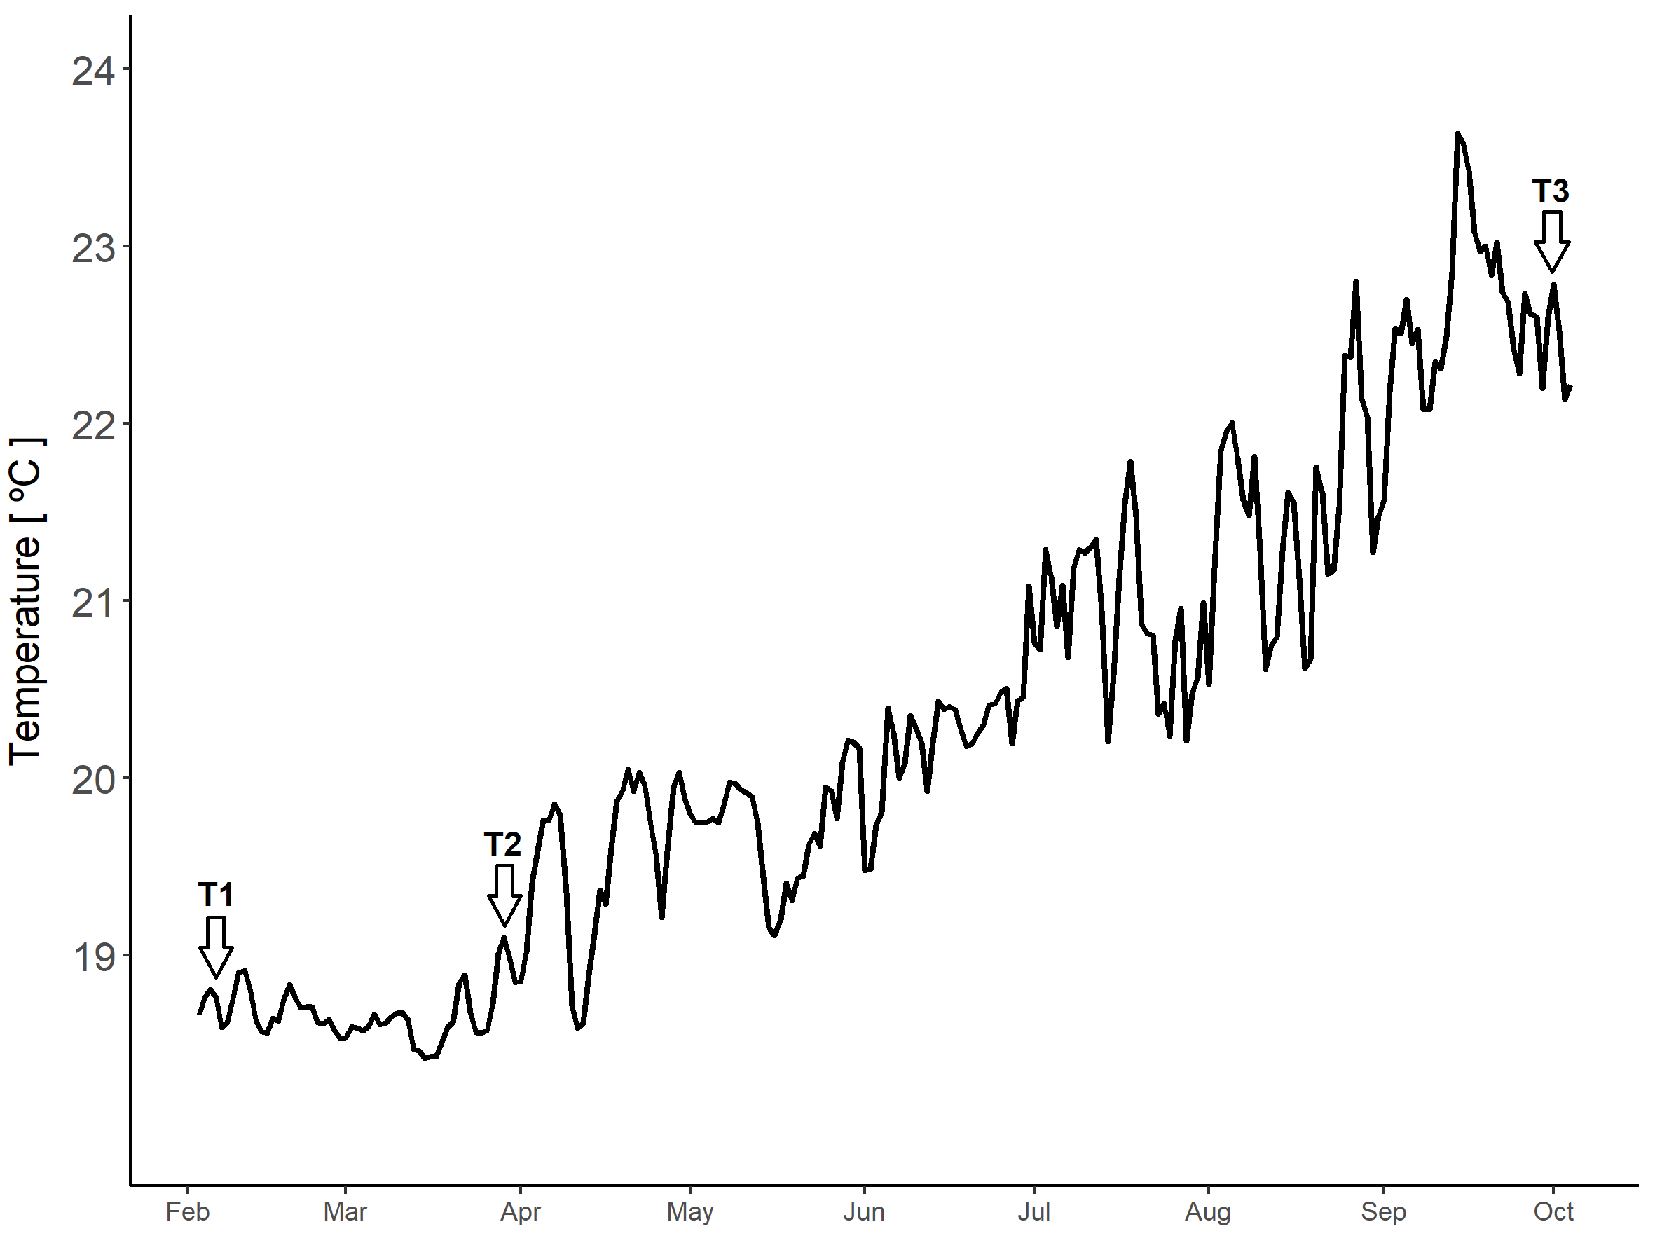
Figure S1. Temporal variation of in situ seawater temperature in the study site. The data correspond to daily average temperatures at 60 m depth. The arrows indicate the times in which the associated epifauna was sampled: T1 (February), T2 (April) and T3 (October).

