Supplements
Table S1. List of all prey species or genera recorded during underwater visual census and included in the structural equation models. Functional groups are B = benthic carnivores, C = corallivores, E = EAM feeders, P_SA = site-attached planktivores, and P_T = transient planktivores.
Family | Species | Functional Group | Reference
Acanthuridae | Acanthurus auranticavus | E | (Robertson 1982)
 | Acanthurus leucocheilus | E | (Green and Bellwood 2009)
 | Acanthurus leucosternon | E | (Green and Bellwood 2009)
 | Acanthurus nigricauda | E | (Choat et al. 2002)
 | Acanthurus nigrofuscus | E | (Green and Bellwood 2009)
 | Acanthurus tristis | E | (Green and Bellwood 2009)
 | Ctenochaetus striatus | E | (Choat et al. 2002)
 | Ctenochaetus truncatus | E | (Eggertsen et al. 2019)
 | Naso brachycentron | E | (Sommer et al. 1996)
 | Naso elegans | E | (Green and Bellwood 2009)
 | Zebrasoma desjardinii | E | (Choat 1991)
 | Zebrasoma scopas | E | (Choat et al. 2002)
 | Acanthurus thompsoni | P_SA | (Hobson 1974; Samoilys et al. 2019)
 | Naso vlamingii | P_SA | (Abesamis and Russ 2005)
 | Acanthurus mata | P_T | (Hobson 1974; Samoilys et al. 2019)
 | Naso brevirostris | P_T | (Choat et al. 2004)
 | Naso hexacanthus | P_T | (Choat et al. 2002)
 | Naso thynnoides | P_T | (Durville et al. 2003)
Apogonidae | Apogonidae | B | (Hobson 1974)
Balistidae | Balistoides conspicillum | B | (Patankar et al. 2018)
 | Pseudobalistes flavimarginatus | B | (Moosleitner 2010)
 | Sufflamen bursa | B | (Samoilys et al. 2019)
 | Melichthys indicus | P_SA | (Samoilys et al. 2019)
 | Odonus niger | P_SA | (Samoilys et al. 2019)
Blenniidae | Sabretooth blennies | B | (Durville et al. 2003)
 | Blennies | E | (Durville et al. 2003)
Caesionidae | Caesio spp | P_T | (Russ et al. 2017)
 | Pterocaesio spp | P_T | (Russ et al. 2017)
Chaetodontidae | Forcipiger longirostris | B | (Hobson 1974)
 | Chaetodon guttatissimus | C | (Allen et al. 1998)
 | Chaetodon melannotus | C | (Sano 1989)
 | Chaetodon meyeri | C | (Sano 1989)
 | Chaetodon triangulum | C | (Chandler et al. 2016)
 | Chaetodon trifasciatus | C | (Narayani et al. 2015)
 | Hemitaurichthys zoster | P_SA | (Samoilys et al. 2019)
 | Heniochus pleurotaenia | P_SA | (Lieske and Myers 2009)
Diodontidae | Diodon liturosus | B | (Patankar et al. 2018)
Holocentridae | Sargocentron spp | B | (Durville et al. 2003)
 | Myripristis spp | P_SA | (Hobson 1974)
Labridae | Anampses meleagrides | B | (Durville et al. 2003)
 | Bodianus spp | B | (Hobson 1974)
 | Cheilinus spp | B | (Hobson 1974)
 | Cheilio inermis | B | (Ormond 1980)
 | Coris spp | B | (Hobson 1974)
 | Epibulus spp | B | (Hiatt and Strasburg 1960)
 | Gomphosus caeruleus | B | (Hobson 1974)
 | Halichoeres spp | B | (Hobson 1974)
 | Hemigymnus spp | B | (Hiatt and Strasburg 1960)
 | Hologymnosus spp | B | (Durville et al. 2003)
 | Labroides spp | B | (Hiatt and Strasburg 1960)
 | Macropharyngodon bipartitus | B | (Hobson 1974)
 | Novaculichthys taeniourus | B | (Hiatt and Strasburg 1960)
 | Oxycheilinus digramma | B | (Durville et al. 2003)
 | Pseudocheilinus spp | B | (Hobson 1974)
 | Stethojulis albovittata | B | (Hiatt and Strasburg 1960)
 | Thalassoma spp | B | (Hobson 1974)
 | Wetmorella spp | B | (Westneat 2001)
 | Labrichthys unilineatus | C | (Westneat 2001)
 | Cirrhilabrus exquisitus | P_SA | (Huertas and Bellwood 2020)
 | Thalassoma amblycephalum | P_SA | (Sano et al. 1984)
Lethrinidae | Gnathodentex aureolineatus | B | (Sano et al. 1984)
 | Monotaxis grandoculis | B | (Hobson 1974)
Microdesmidae | Ptereleotris evides | P_SA | (Durville et al. 2003)
Monacanthidae | Amanses scopas | C | (Durville et al. 2003)
 | Oxymonacanthus longirostris | C | (Patankar et al. 2018)
Mullidae |  | B | (Hobson 1974)
Nemipteridae | Scolopsis spp | B | (Hiatt and Strasburg 1960)
Pempheridae | Parapriacanthus ransonneti | P_SA | (Durville et al. 2003)
 | Pempheris vanicolensis | P_SA | (Durville et al. 2003)
Pinguipedidae | Parapercis spp | B | (Hiatt and Strasburg 1960)
Pomacanthidae | Pomacanthus imperator | B | (Alwany 2009; Samoilys et al. 2019)
 | Pygoplites diacanthus | B | (Alwany 2009; Samoilys et al. 2019)
Pomacentridae | Plectroglyphidodon spp | E | (Frédérich et al. 2009; Samoilys et al. 2019)
 | Pomacentrus chrysurus | E | (Allen 1991; Frédérich et al. 2009)
 | Pomacentrus indicus | E | (Allen 1991)
 | Pomacentrus pavo | E | (Allen 1991)
 | Abudefduf vaigiensis | P_SA | (Allen 1991; Frédérich et al. 2009)
 | Amblyglyphidodon spp | P_SA | (Frédérich et al. 2009; McMahon et al. 2016)
 | Chromis spp | P_SA | (Hobson 1974; McMahon et al. 2016)
 | Dascyllus spp | P_SA | (Hobson 1974; Frédérich et al. 2009)
 | Pomacentrus caeruleus | P_SA | (Frédérich et al. 2009)
 | Pomacentrus philippinus | P_SA | (Frédérich et al. 2009; Pinheiro et al. 2023)
Scaridae | Calotomus spp | E | (Hobson 1974; Plass-Johnson et al. 2013)
Scaridae | Cetoscarus spp | E | (Plass-Johnson et al. 2013)
 | Chlorurus spp | E | (Green and Bellwood 2009; Plass-Johnson et al. 2013)
 | Hipposcarus spp | E | (Green and Bellwood 2009)
 | Scarus spp | E | (Hobson 1974; Green and Bellwood 2009)
Serranidae | Pseudanthias spp | P_SA | (Hobson 1974; Durville et al. 2003)
Siganidae | Siganus spp | E | (Hiatt and Strasburg 1960; Durville et al. 2003)
Zanclidae | Zanclus cornutus | B | (Hiatt and Strasburg 1960; Hobson 1974)

Table S2. List of all fishery target and reef-associated, teleost predators recorded on underwater visual census and included in the structural equation models.
Genus | Species
Lutjanidae | Lutjanus bohar
 | Lutjanus gibbus
 | Lutjanus kasmira
 | Macolor macularis
Serranidae | Aethaloperca rogaa
 | Anyperodon leucogrammicus
 | Cephalopholis argus
 | Cephalopholis leopardus
 | Cephalopholis miniata
 | Cephalopholis nigripinnis
 | Cephalopholis sexmaculata
 | Cephalopholis spiloparaea
 | Epinephelus fasciatus
 | Epinephelus longispinis
 | Epinephelus macrospilos
 | Epinephelus merra
 | Epinephelus polyphekadion
 | Epinephelus spilotoceps
 | Plectropomus areolatus
 | Plectropomus laevis
 | Variola louti
Table S3. Results from statistical tests (parametric t-test, t; and non-parametric Wilcoxon test, W) comparing mean depth (m), complexity, and fish biomass (g/m²) between inner and outer atoll sites. BenCarn = benthic carnivore; EAM = epilithic algal matrix; SA = site-attached; T = transient. Bold indicates significant (p < 0.05).
Group | Test | Statistic | Degrees of Freedom | P-value
Depth | W | 0 |  | 0.00
Complexity | t | 1.83 | 30.73 | 0.08
Grouper | W | 137 |  | 0.09
Snapper | W | 266 |  | 0.06
BenCarn | W | 273 |  | 0.05
Corallivore | W | 145 |  | 0.14
EAM feeder | W | 287 |  | 0.02
Planktivore_SA | W | 69 |  | 0.00
Planktivore_T | W | 284 |  | 0.02

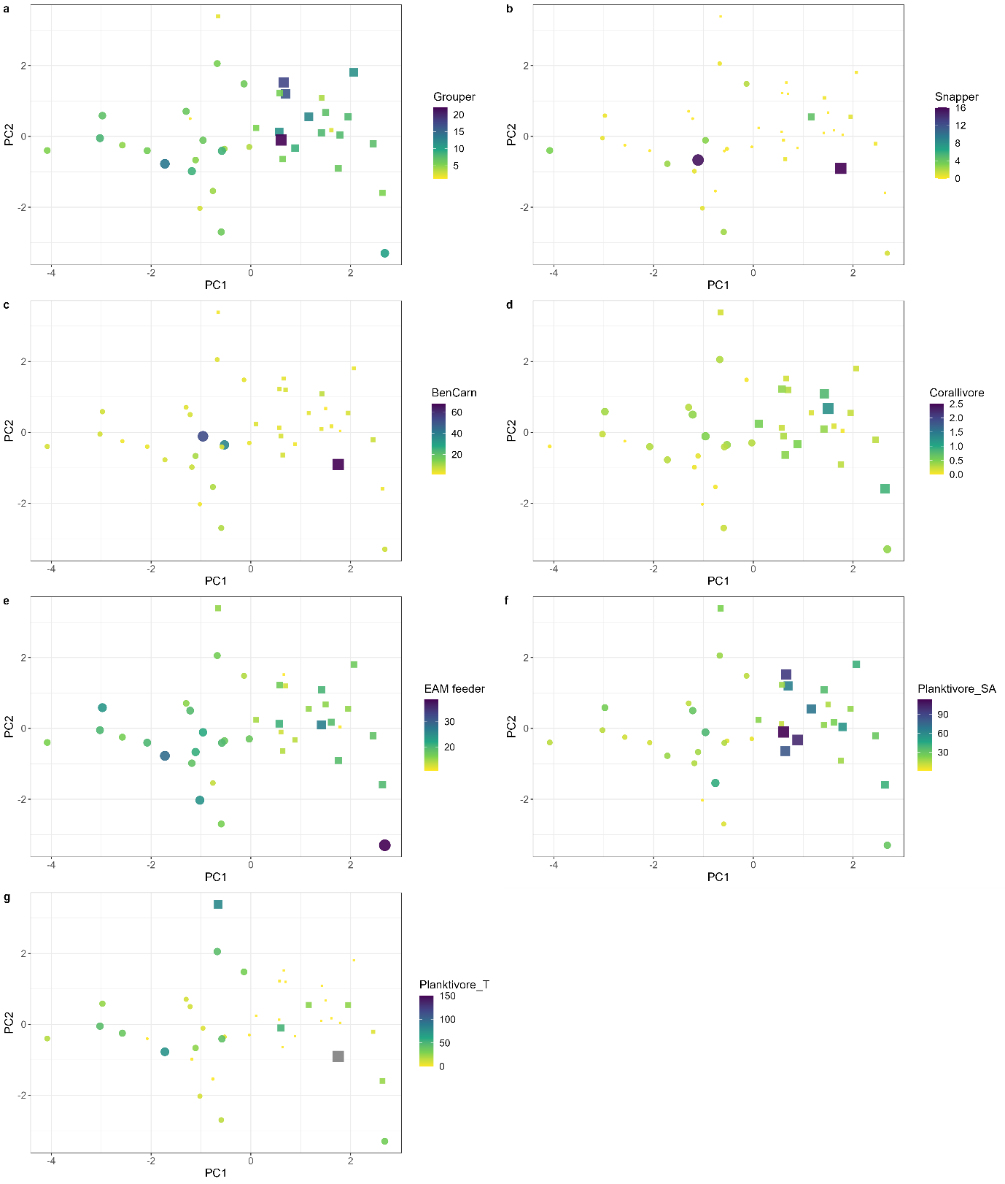
Figure S1. Mean site-level biomass (g/m²) of predators (a: grouper; and b: snapper) and prey (c: benthic carnivores (BenCarn); d: corallivores; e: EAM feeders; f: site-attached (SA) planktivores; g: transient (T) planktivores) plotted on the PC1 and PC2 coordinates for each site. Note that colour scales are different in each panel and that points are scaled to biomass values. Circles = inner atoll, squares = outer atoll.
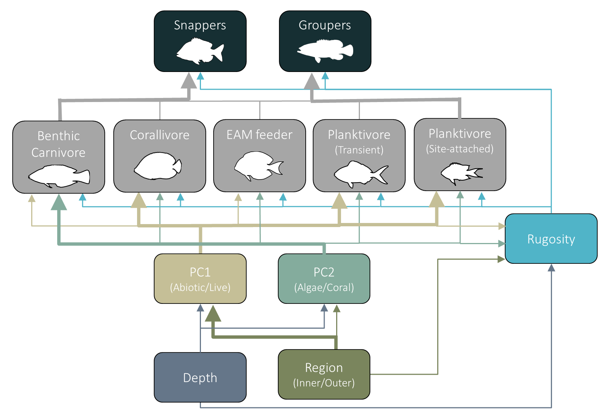
Figure S2. The full (null) model of path analysis exploring the abiotic and biotic drivers of reef predator biomass. Arrows indicate causal paths. Thick arrows indicate significant relationships, thin arrows denote non-significant, and dotted double arrows signify significant covariance.
References
Abesamis RA, Russ GR (2005) Density-dependent spillover from a marine reserve: Long-term evidence. Ecological Applications 15:1798-1812
Allen GR (1991) Damselfishes of the world. Mergus Publishers, Melle, Germany
Allen GR, Steene RC, Allen M (1998) A guide to angelfishes & butterflyfishes. Odyssey, Perth
Alwany MA (2009) Distribution and feeding ecology of the angelfishes (Pomacanthidae) in Shalateen region, Red Sea, Egypt. Egyptian Journal of Aquatic Biology & Fisheries 13:79 - 91
Chandler JF, Burn D, Berggren P, Sweet MJ (2016) Influence of Resource Availability on the Foraging Strategies of the Triangle Butterflyfish Chaetodon triangulum in the Maldives. PLOS ONE 11:e0151923
Choat JH (1991) The biology of herbivorous fishes on coral reefs. In: Sale PF (ed) The ecology of fishes on coral reefs. Academic Press, San Diego, CA, pp120-155
Choat JH, Clements KD, Robbins WD (2002) The trophic status of herbivorous fishes on coral reefs. Marine Biology 140:613-623
Choat JH, Robbins WD, Clements KD (2004) The trophic status of herbivorous fishes on coral reefs. Marine Biology 145:445-454
Durville P, Chabanet P, Quod JP (2003) Visual Census of the Reef Fishes in the Natural Reserve of the Glorieuses Islands (Western Indian Ocean). Western Indian Ocean J Mar Sci 2:95–104
Eggertsen M, Chacin DH, Åkerlund C, Halling C, Berkström C (2019) Contrasting distribution and foraging patterns of herbivorous and detritivorous fishes across multiple habitats in a tropical seascape. Marine Biology 166:51
Frédérich B, Fabri G, Lepoint G, Vandewalle P, Parmentier E (2009) Trophic niches of thirteen damselfishes (Pomacentridae) at the Grand Récif of Toliara, Madagascar. Ichthyological Research 56:10-17
Green AL, Bellwood DR (2009) Monitoring Functional Groups of Herbivorous Reef Fishes as Indicators of Coral Reef Resilience: A Practical Guide for Coral Reef Managers in the Asia Pacific Region. In: Green AL, Bellwood DR (eds). IUCN working group on Climate Change and Coral Reefs., Gland, Switzerland 70
Hiatt RW, Strasburg DW (1960) Ecological Relationships of the Fish Fauna on Coral Reefs of the Marshall Islands. Ecological Monographs 30:65-127
Hobson ES (1974) Feeding relationships of Teleostean fishes on coral reefs in Kona, Hawaii. Fishery Bulletin 72:915–931
Huertas V, Bellwood DR (2020) Trophic separation in planktivorous reef fishes: a new role for mucus? Oecologia 192:813-822
Lieske E, Myers R (2009) Coral reef fishes. Princeton University Press
McMahon KW, Thorrold SR, Houghton LA, Berumen ML (2016) Tracing carbon flow through coral reef food webs using a compound-specific stable isotope approach. Oecologia 180:809-821
Moosleitner H (2010) Feeding associations with triggerfishes (Balistidae) in the Red Sea and in the Indian Ocean. Bulletin of Fish Biology Volume 12:71-77
Narayani S, Venu S, Arun Kumar M, Ram BS (2015) Ecomorphology of the Feeding Characteristics in Selected Reef Fishes from South Andaman Islands: A Preliminary Study. Journal of Marine Biology and Oceanography 4
Ormond RFG (1980) Aggressive mimicry and other interspecific feeding associations among Red Sea coral reef predators. Journal of Zoology 191:247-262
Patankar V, Paranjape A, Tyabji Z, Wagh T, Marathe A (2018) Occurrence and distribution of tetraodontiform fishes of the Andaman and Nicobar Islands, India. Check List 14:529–537
Pinheiro HT, MacDonald C, Quimbayo JP, Shepherd B, Phelps TA, Loss AC, Teixeira JB, Rocha LA (2023) Assembly rules of coral reef fish communities along the depth gradient. Current Biology 33:1421-1430.e1424
Plass-Johnson JG, McQuaid CD, Hill JM (2013) Stable isotope analysis indicates a lack of inter- and intra-specific dietary redundancy among ecologically important coral reef fishes. Coral Reefs 32:429-440
Robertson DR (1982) Fish Feces as Fish Food on a Pacific Coral Reef. Marine Ecology Progress Series 7:253-265
Russ GR, Aller-Rojas OD, Rizzari JR, Alcala AC (2017) Off-reef planktivorous reef fishes respond positively to decadal-scale no-take marine reserve protection and negatively to benthic habitat change. Marine Ecology 38:e12442
Samoilys MA, Halford A, Osuka K (2019) Disentangling drivers of the abundance of coral reef fishes in the Western Indian Ocean. Ecology and Evolution 9:4149-4167
Sano M (1989) Feeding habits of Japanese butterflyfishes (Chaetodontidae). Env Biol Fish 25:195-203
Sano M, Shimizu M, Nose Y (1984) Food habits of teleostean reef fishes in Okinawa Island, southern Japan. University of Tokyo Press, Tokyo, Japan
Sommer C, Schneider W, Poutiers J (1996) FAO species identification field guide for fishery purposes: The living marine resources of Somalia
Westneat MW (2001) Labridae. Wrasses, hogfishes, razorfishes, corises, tuskfishes. In: Carpenter KE, Niem V (eds) FAO species identification guide for fishery purposes The living marine resources of the Western Central Pacific. FAO, Rome, pp3381-3467

