Supporting information

Table S1. The 26 sampling site names, their geographic regions, their GPS co-ordinates in decimal degrees, the sampling date (yyyy/mm/dd) and the number of coral individuals sampled per site. Asterisks (*) indicate the sites that were sampled opportunistically.
Site name | Region | Latitude | Longitude | Sampling date (yyyy/mm/dd) | Coral individuals sampled
Nakano Beach | Iriomote | 24.43152 | 123.7924 | 2023/06/09 | 15
Amitori | Iriomote | 24.34577 | 123.69 | 2023/06/10 | 15
Sotopanari | Iriomote | 24.38228 | 123.7196 | 2023/06/10 | 15
Nakano-Oki | Iriomote | 24.43522 | 123.7993 | 2023/06/11 | 16
Ukibaru | Okinawa | 26.34987 | 127.9936 | 2023/06/08 | 10
Sakiyama | Okinawa | 26.70673 | 127.9662 | 2023/06/13 | 15
Kourijima | Okinawa | 26.71213 | 128.0281 | 2023/06/13 | 16
Onna1 | Okinawa | 26.51351 | 127.8627 | 2023/06/15 | 16
Onna2 | Okinawa | 26.50093 | 127.8409 | 2023/06/15 | 15
Hentona plots* | Okinawa | 26.75058 | 128.1848 | 2023/08/12 | 2
Tomori | Amami | 28.46129 | 129.7186 | 2023/07/08 | 15
Saneku | Amami | 28.19227 | 129.1905 | 2023/07/09 | 15
Ankyaba | Amami | 28.11133 | 129.3473 | 2023/07/09 | 16
Sani | Amami | 28.51297 | 129.667 | 2023/07/10 | 15
Shitoko | Yakushima | 30.44893 | 130.5214 | 2023/07/11 | 16
Yudomari | Yakushima | 30.23356 | 130.4736 | 2023/07/12 | 15
Owase | Sata | 31.03699 | 130.6757 | 2023/07/14 | 2
Tajiri | Sata | 31.00671 | 130.6765 | 2023/07/14 | 14
Amaji2 | Kochi | 32.80153 | 132.63 | 2023/07/18 | 15
Amaji1 | Kochi | 32.81577 | 132.6438 | 2023/07/18 | 15
Himeshima | Kochi | 32.74289 | 132.4923 | 2023/07/19 | 12
Torinokubi | Kochi | 32.75311 | 132.5493 | 2023/07/19 | 12
Kashiwajima plots* | Kochi | 32.77418 | 132.6244 | 2023/08/24 | 1
Nishidomari plots* | Kochi | 32.77917 | 132.7327 | 2023/08/22 | 11
Nahari | Kochi | 33.41154 | 134.0309 | 2023/07/21 | 1
Kushimoto | Wakayama | 33.47938 | 135.7461 | 2023/07/24 | 21

Table S2. Pocillopora PCR reagents and volumes used per sample, and PCR conditions following (Flot et al., 2008).
Reagent | Volume (µl) | Stages | Temperature (°C) | Time (minute: second)
HotStarTaq master mix | 10 | 1 | 94 | 1:00
FATP6.1 | 1 | 2 (40 cycles) | 94 | 0:30
RORF | 1 | 2 (40 cycles) | 53 | 0:30
CoralLoad | 2 | 2 (40 cycles) | 72 | 1:15
H₂O | 5 | 3 | 72 | 5:00
Genomic DNA | 1
Total volume | 20

Table S3. Symbiodiniaceae PCR reagents (* indicates items that are part of the TaKaRa Ex Taq® Hot Start kit) and volumes used per sample and PCR conditions used, adapted from Hume et al. (2018).
Reagent | Volume (µl) | Stages | Temperature (°C) | Time (minute: second)
10x ExTaq buffer* | 2 | 1 | 98 | 2:00
dNTP mixture* | 1.6 | 2 (35 cycles) | 98 | 0:10
SYM_VAR_5.8S2 | 1.2 | 2 (35 cycles) | 56 | 0:30
SYM_VAR_REV | 1.2 | 2 (35 cycles) | 72 | 0:30
ExTaq HS* | 0.2 | 3 | 72 | 7:00
H₂O | 12.8
Genomic DNA | 1
Total volume | 20

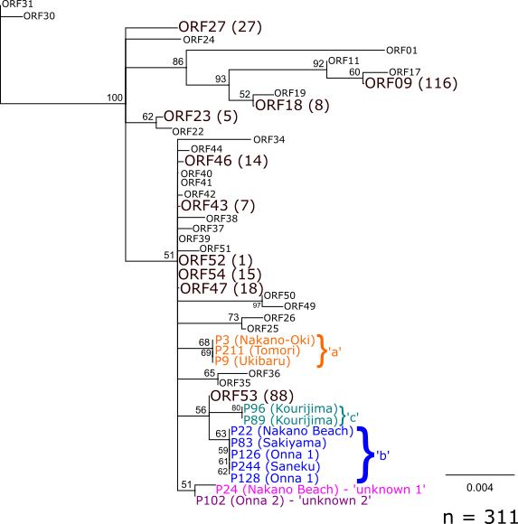
Figure S1. Phylogenetic tree showing the relationship between selected known haplotypes (Gélin et al., 2017). Large, dark brown fonts indicate haplotypes that were found in this work, followed by the number of corals in brackets found to be in that haplotype. Coloured fonts mark previously unrecorded sequences/haplotypes found in this study, showing the sample number and the location. ‘a’ was found in three samples, ‘b’ in five, ‘c’ in two; while ‘unknown 1’ and ‘unknown 2’ are singletons.
Table S4. ORF haplotypes found in this study and the associated PSH, SSH and possible morphotypes according to Table 3 of Gélin et al. (2017).
ORF | PSH | SSH | Possible morphotypes according to SSH
09 | 4 | 4 | damicornis
18 | 5 | 5a-d | acuta, brevicornis, eydouxi, verrucosa
23 | 6 | 6 | damicornis, verrucosa, elegans, meandrina
27 | 9 | 9a-c | eydouxi, meandrina, woodjonesi, verrucosa, molokensis, damicornis, zelli
43 | 13 | 13a | verrucosa, damicornis, meandrina, eydouxi, molokensis, kelleheri, zelli
46 | 13 | 13b | verrucosa, damicornis, eydouxi, meandrina, molokensis, kelleheri
47 | 13 | 13c | verrucosa, kelleheri, damicornis, meandrina
52 | 15 | 15 | damicornis
53 | 16 | 16 | verrucosa, damicornis, kelleheri, lingulata, meandrina
54 | 16 | 16 | verrucosa, damicornis, kelleheri, lingulata, meandrina

Table S5. Parameter estimates, p value and confidence interval of the ordinal logistical regression (model <- polr(rank ~ PC1+PC2)), where PC1 and PC2 scores are predictor variables, and ‘rank’ (the different number of haplotypes) is the response variable. All values are rounded to three significant figures.
 | Value | Std. Error | t value | p value | CI (2.5%, 97.5%)
PC1 | 1.61 | 0.440 | 3.66 | < 0.001 | 0.890, 2.65
PC2 | 0.409 | 0.288 | 1.42 | 0.156 | -0.150, 0.997
1|2 | -1.06 | 0.804 | -1.32 | 0.188
2|4 | 0.213 | 0.711 | 0.300 | 0.764
4|5 | 0.692 | 0.706 | 0.980 | 0.327
5|6 | 2.162 | 0.753 | 2.872 | 0.004
6|7 | 3.362 | 0.862 | 3.899 | < 0.001
7|8 | 5.826 | 1.438 | 4.052 | < 0.001

Table S6. Defining Intragenomic Variants (DIVs) that make up symbiont ITS2 type profiles, ordered from high to low abundance. The total number of samples included are 325. Note that sample P26 fed into both type 88 and 92.
ITS2 type profile UID | 85 | 89 | 94 | 86 | 96 | 88 | 90 | 95 | 91 | 84 | 87 | 92 | 93
Clade | C | C | C | C | C | C | C | C | C | C | C | C | D
ITS2 type profile | C1bi/C1d-C1-C42.2-C3cg-C3cw-C1b | 6597-6601-8157-8156-C42.2 | 6597-6601-C42.2-8157-C1-8181 | C42a-C42.2-C1-C1b-C1au | C1bi-C1-10319-C42.2-10334 | C1d/C1-C42.2-C3cg-C1b | C42u/C42a-C1-C42.2 | C42a-C1-C42.2-C42b-C1b-8149 | C1ag/C42.2-C1-C3cg | 25378_C/C1c-C42.2-C1-4390_C-6682_C | C42a-C1-C42.2-C1b-8236 | C1bb | D1
Majority ITS2 sequence | C1bi/C1d | noName | noName | C42a | C1bi | C1d/C1 | C42u/C42a | C42a | C1ag/C42.2 | noName/C1c | C42a | C1bb | D1
Associated species | None | None | None | None | None | S. goreaui | None | None | None | None | None | None | S. glynnii
ITS2 profile abundance local | 115 | 64 | 48 | 23 | 19 | 15 | 11 | 11 | 9 | 5 | 4 | 1 | 1

References
Flot, J.-F., Magalon, H., Cruaud, C., Couloux, A., & Tillier, S. (2008). Patterns of genetic structure among Hawaiian corals of the genus Pocillopora yield clusters of individuals that are compatible with morphology. Comptes Rendus. Biologies, 331(3), 239-247. https://doi.org/10.1016/j.crvi.2007.12.003
Gélin, P., Postaire, B., Fauvelot, C., & Magalon, H. (2017). Reevaluating species number, distribution and endemism of the coral genus Pocillopora Lamarck, 1816 using species delimitation methods and microsatellites. Mol Phylogenet Evol, 109, 430-446. https://doi.org/10.1016/j.ympev.2017.01.018
Hume, B., Ziegler, M., Poulain, J., Pochon, X., Romac, S., Boissin, E., de Vargas, C., Planes, S., Wincker, P., & Voolstra, C. (2018). An improved primer set and amplification protocol with increased specificity and sensitivity targeting the Symbiodinium ITS2 region. PeerJ 6, e4816. https://doi.org/https://doi.org/10.7717/peerj.4816

