Heat-tolerant algal symbionts may prevent extirpation of the threatened elkhorn coral, Acropora palmata, in Florida during intensifying marine heatwaves

Richard F. Karp¹, Fabrizio Lepiz-Conejo¹, Shayle Matsuda², Bryce Corbett², Alexandra Wen¹, Joseph D. Unsworth¹, Martine D’Alessandro¹, Ken Nedimeyer³, Amelia Moura⁴, Erinn Muller⁵, Zachary Craig^{5,6}, Diego Lirman¹, Ross Cunning^{2,1}, Andrew C. Baker^{1*}

¹Department of Marine Biology and Ecology, Rosenstiel School of Marine, Atmospheric, and Earth Science, University of Miami, 4600 Rickenbacker Causeway, Miami, FL 33149 USA
²Conservation Research Department, John G. Shedd Aquarium, 1200 South DuSable Lake Shore Drive, Chicago, IL, 60605 USA
³Reef Renewal USA, Tavernier, FL, USA
⁴Coral Restoration Foundation, Key Largo, FL, USA
⁵Mote Marine Laboratory, Sarasota, FL 34241 USA
⁶Division of Aquatic Resources - Department of Land and Natural Resources, Kailua Kona, HI, USA
*Corresponding authors:
Richard Karp, (412)-999-7394, rfk30@miami.edu, ORCID: 0000-0001-7561-2018
Andrew Baker, (305) 421-4642‬, abaker@earth.miami.edu, ORCID: 0000-0002-7866-2587

Supplemental Information

SI Table 1: Independent colonies collected at each nursery, unique genets tested for thermal tolerance at each nursery, and the number of genets from that nursery also present at other nurseries evaluated.

Nursery | Nursery type | Colonies collected | Unique genets | Genets present at other nurseries
Coral Restoration Foundation (CRF) | In situ | 78 | 77 | 21
Mote Marine Lab (MML) | Ex situ | 10 | 10 | 0
Reef Renewal (RR) | In situ | 49 | 49 | 37
University of Miami (UM) | In situ | 35 | 35 | 27

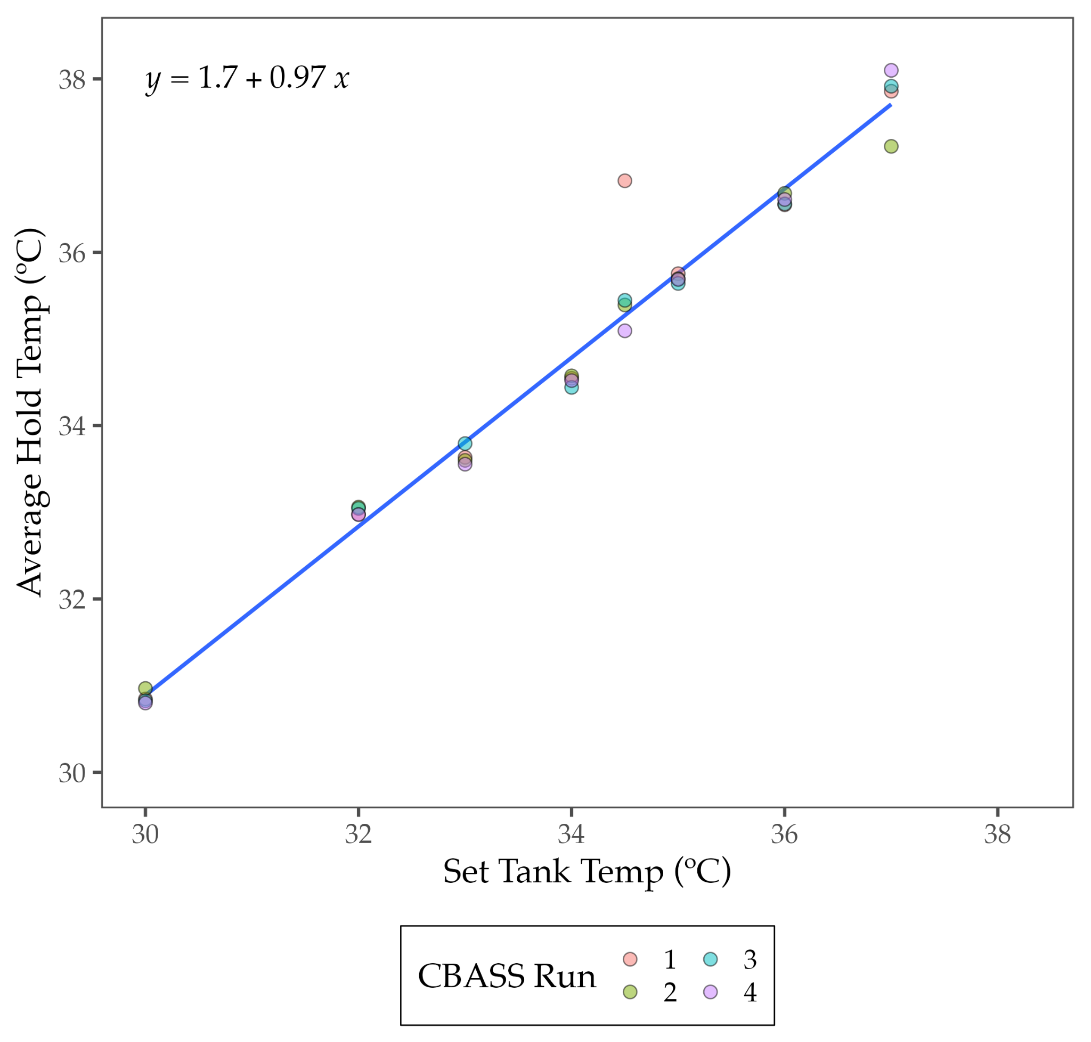
b
a
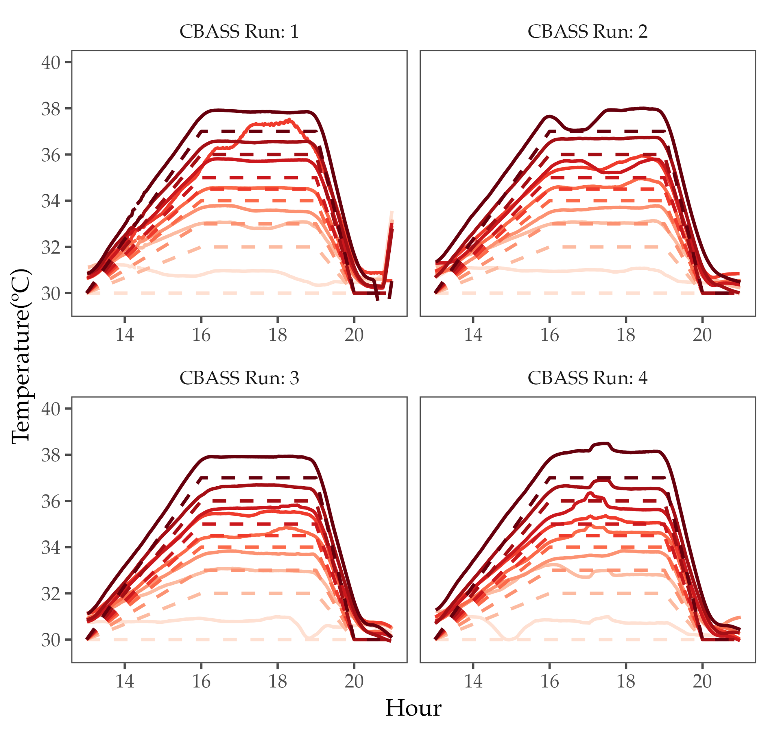
Figure S1: CBASS-run temperatures- a) HOBO temperatures for each of the four CBASS runs in solid lines, and set point tank temperatures in dotted line. b) Mean 3-hour hold temperature for each tank showing theoretical set-point along X-axis and HOBO mean hold temperature used for the model on the Y-axis.
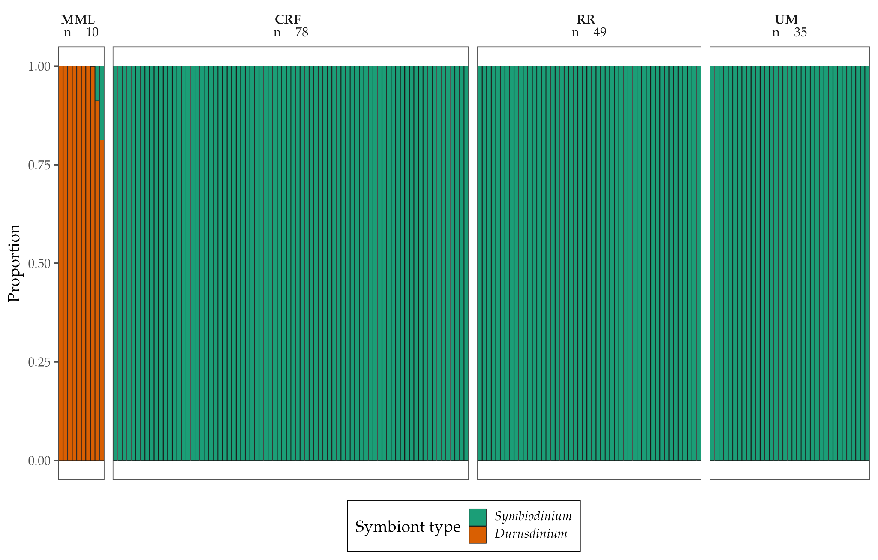

Figure S2: Symbiont community distribution based on nursery for each colony (line separation) using quantitative PCR.
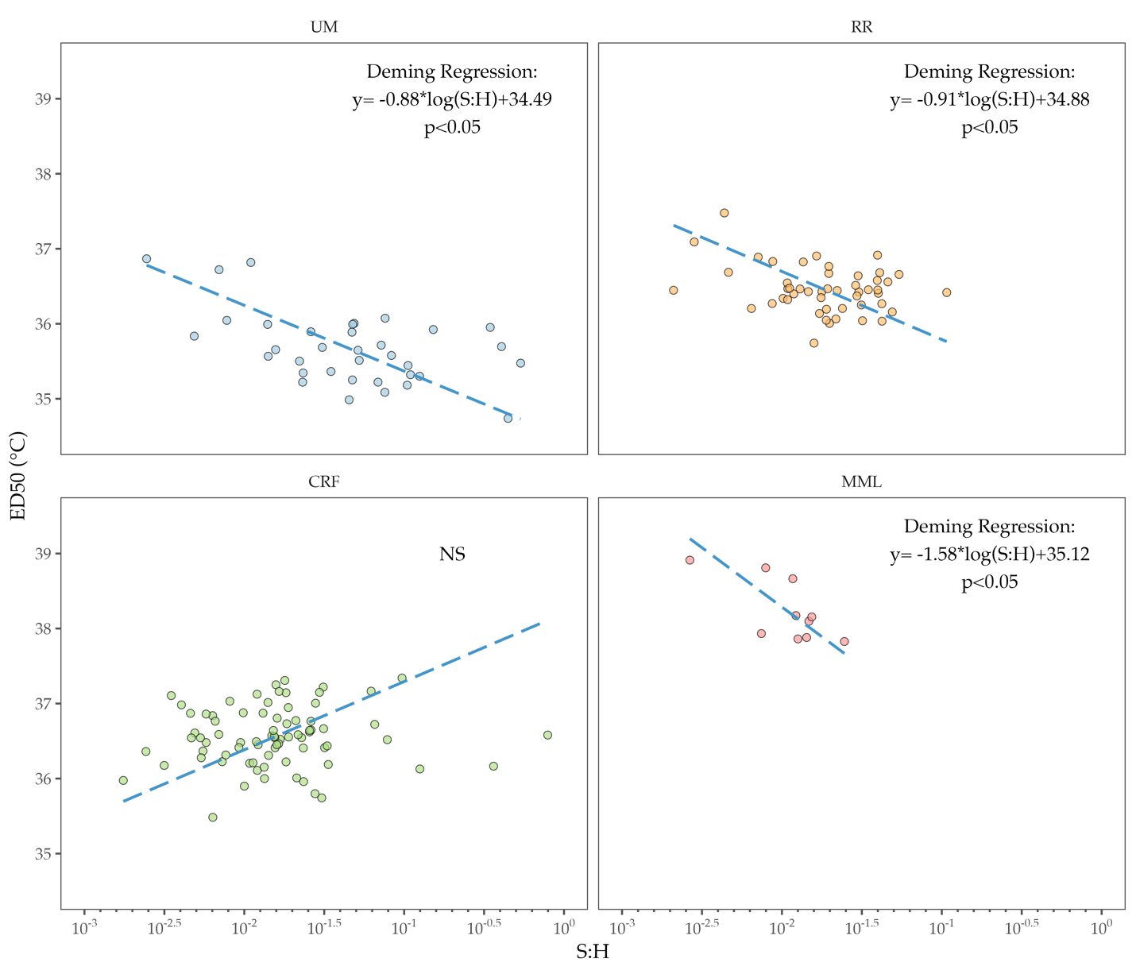
Figure S3: Deming regression showing the significance of symbiont to host cell ratio (S:H) on raw ED50 for all nurseries. Dotted lines show the line of best fit with the best fit equation and significance in the upper right corner for each nursery.

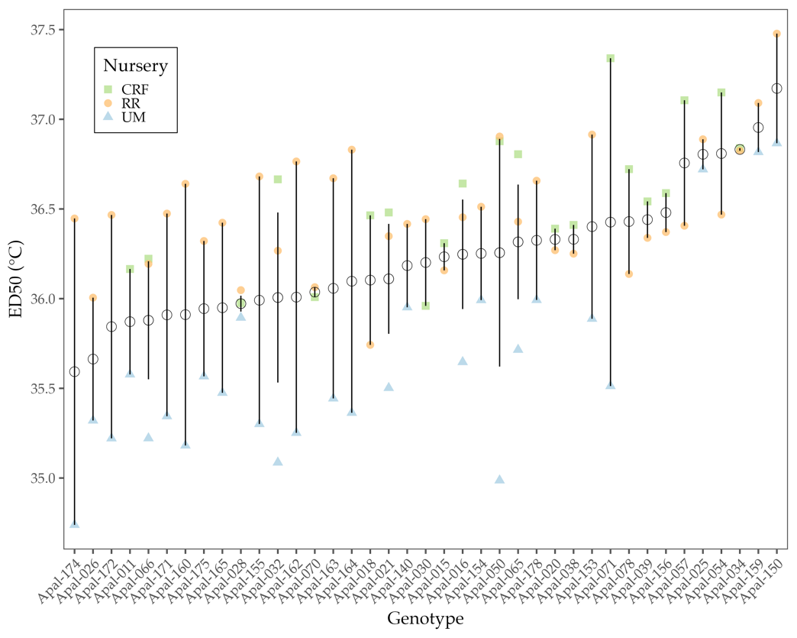
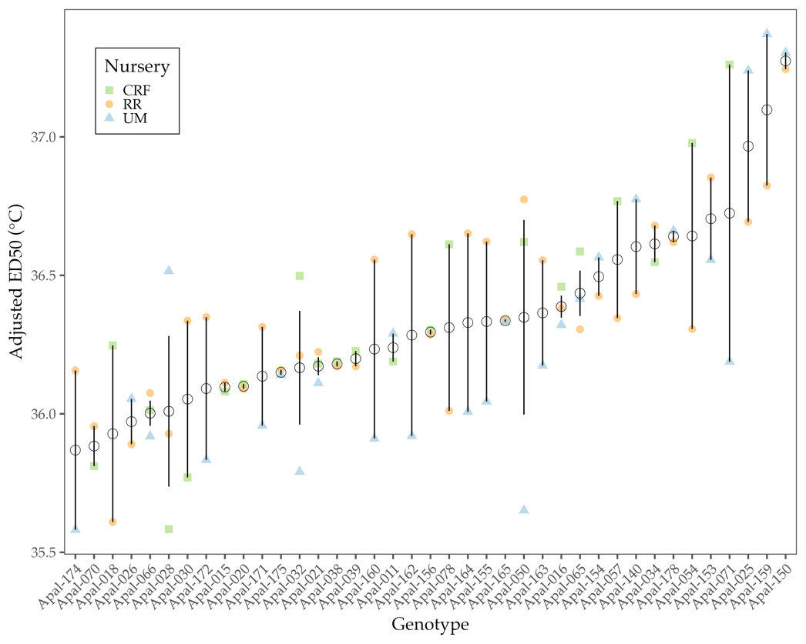
b
a
Figure S4: ED50 (a) and Adjusted ED50 (b) for genets measured at multiple nurseries, showing mean for each genet (open circle) and standard deviation (whiskers).
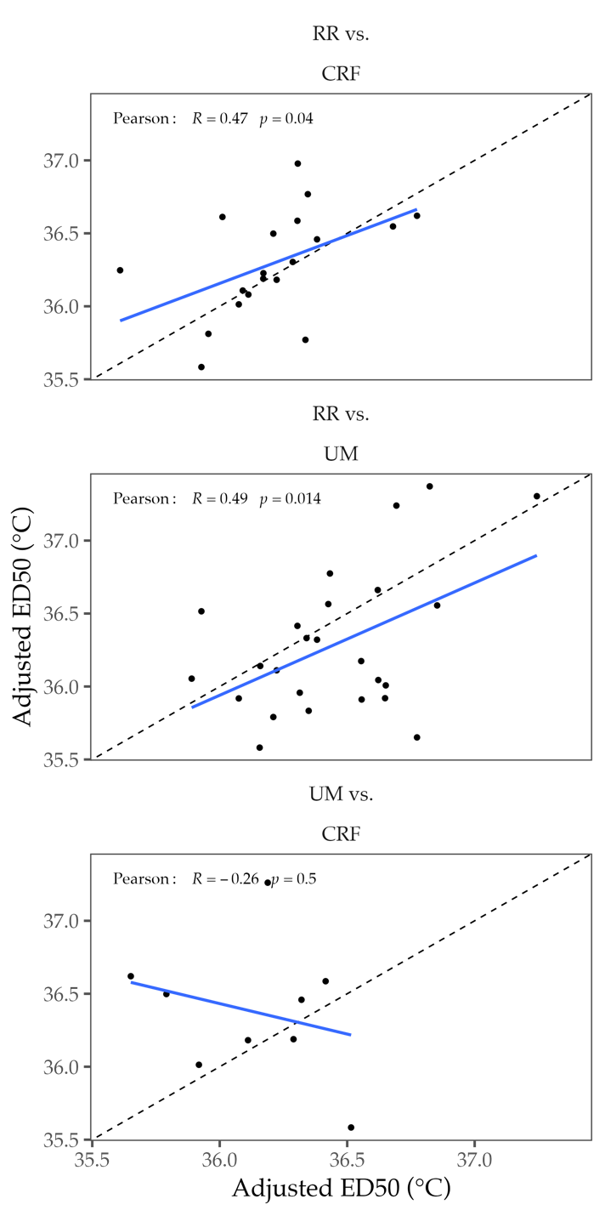
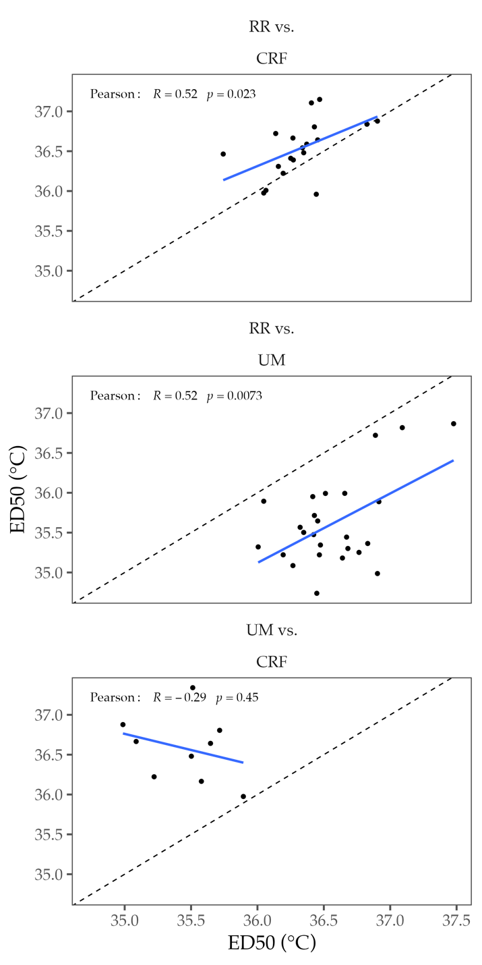
b
a

Figure S5: Pearson correlation between nurseries with shared genets for ED50 (a) and adjusted ED50s (b). The blue line is the line of best fit with Pearson correlation coefficients. The dotted line is the line of identity, showing one-to-one correlation.

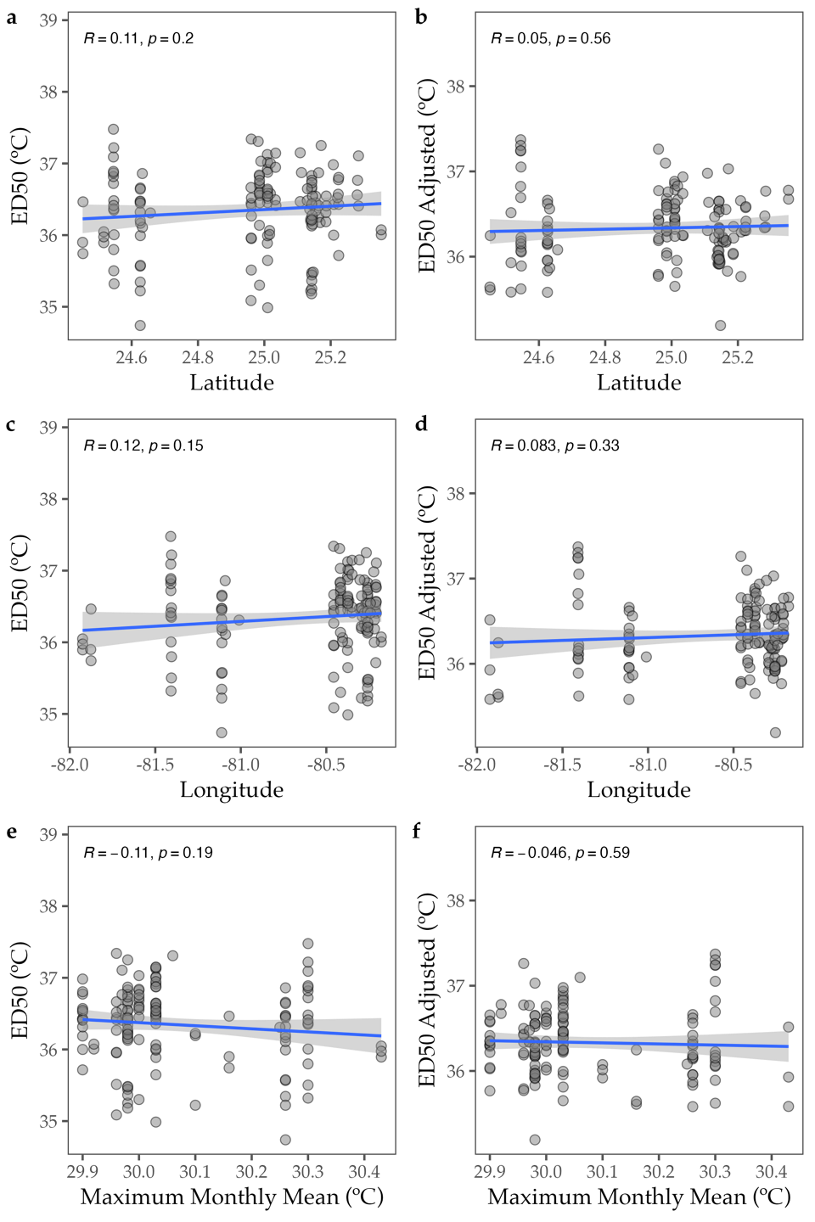
Figure S6: Correlation between environmental origins of colonies based on latitude and ED50 (a), latitude and adjusted ED50 (b), longitude and ED50 (c), longitude and adjusted ED50 (d), maximum monthly mean and ED50 (e), and maximum monthly mean. Ean and adjusted ED50 (f).

SI Table 2: Comparison between thermal tolerance parameters for A. palmata (this study) and A. cervicornis from Cunning et al. 2021 hosting only Symbiodinium.

Metric | A. palmata | A. cervicornis
Total range in ED50 (ºC) | 4.2 | 2.57
Total variance explained by nursery in ED50 (%) | 17 | 37
Range in ED50 of just Symbiodinium (ºC) | 2.73 | 2.57
Variance explained by nursery in ED50 for only Symbiodinium colonies (%) | 31 | 37
Mean ED50s at UM (ºC) (n=35 vs n=41) | 35.67±0.48 | 35.78±0.33
Mean ED50s at CRF (ºC) (n=78 vs n=44) | 36.56±0.39 | 36.07±0.46
Mean ED50s at RR (ºC) (n= 49 vs n=42) | 36.46±0.31 | 36.39±0.46
Adjusted mean ED50 (ºC) for Symbiodinium colonies (°C) | 36.34±0.38 | 35.98±0.39

