Supplementary Information
Pocillopora host-symbiont interactions along an extreme environmental gradient

Chiara M. Duijser^{1,2*}, Matthew R. Nitschke^{1,3,4}, Sage H. Rassmussen¹, Emma F. Camp¹

Coral Reefs

¹Climate Change Cluster, University of Technology Sydney, Broadway 2007, NSW, Australia
²Department of Freshwater and Marine Ecology, Institute for Biodiversity and Ecosystem Dynamics, University of Amsterdam, Amsterdam, the Netherlands
³Australian Institute of Marine Science, Townsville, QLD, Australia
⁴School of Biological Sciences, Victoria University of Wellington, Wellington, New Zealand

*Corresponding Author: Chiara M. Duijser, e-mail: cmduijser@gmail.com

Supplementary Methods
Methods S1. We tested the accuracy of the HOBO MX2501 logger in a laboratory setting where temperature was gradually increased while measuring the pH of artificial seawater. Around 34°C, pH values started to decline (Figure S4), thus caution should be applied for pH measurements corresponding to this temperature; we note where this is applicable in the results section.

Methods S2. Diversity Arrays Technology (DArT) SNP processing. For each host sample, hard coral tissue (10-15 mg) was transferred into a 1.1 mL microtube and kept submerged in 600 μL 100% ethanol. Samples were sent to Diversity Arrays Technology (DArT) Pty Ltd, Australia for sequencing. PstI and HpaII were used as restriction enzymes during DArTseq genotyping to reduce genome complexity (Sansaloni et al. 2011). After 30 PCR cycles, restriction fragments were subjected to 100 cycles of sequencing (single reads) on the Illumina NovaSeq platform. Barcode regions with a Phred quality score < 30 and whole reads with Phred quality score < 10 were filtered out. The reads were mapped to the Pocillopora verrucosa genome (v.1.0, Reefgenomics.org) to ensure removal of non-coral sequences.

Methods S3. The four tested population models were:
- Model 1 = populations are reef locations
- Model 2 = populations are DAPC lineages
- Model 3 = populations are STRUCTURE lineages including “hybrid” population
- Model 4 = populations are STRUCTURE lineages with hybrids removed

Methods S4. Coral tissue was removed from the sample with a clean brush. This tissue was suspended in 100% ethanol in a 2 ml sample tube. After this step, ethanol (400 µL) was pipetted with the suspended tissue into a clean 2 ml sample tube. Samples were centrifuged for 5 minutes at 13,000 relative centrifugal force (rcf) at room temperature (23°C). After centrifuging the coral tissue, a pellet was formed at the base of the tube. All ethanol was pipetted out and the remaining pellet was stored in the freezer (-40°C) until DNA extraction.

Methods S5. DNA Extraction and amplification additional methods. The ITSintfor 2 primer (5'-TCG TCG GCA GCG TCA GAT GTG TAT AAG AGA CAG GAA TTG CAG AAC TCC GTG-3'; LaJeunesse et al. 2000) and ITS2-reverse primers (5'-GTC TCG TGG GCT CGG AGA TGT GTA TAA GAG ACA GGG GAT CCA TAT GCT TAA GTT CAG-‘3; Coleman et al. 1994) (Illumina adapters underlined) were used. For individual PCR amplifications, a mix of DNA product (3 mL), master mix (2x ImmoMixTM Red, Bioline) (12.5 mL), ITSintfor2 primer (1 mL), ITS2-reverse primer (1 mL) and DNase-free water (10.5 mL) up to a total volume of 27.5 mL was used. PCR consisted of a 2 min denaturation step at 95°C, followed by 33 cycles of annealing steps at 95°C for 30 s, 52°C for 14 s and 72°C for 30 s, followed by the final extension step at 72°C for 5 min. PCR products were sent off for sequencing by the Australian Genome Research Facility on a Next Generation Sequencing platform (Illumina MiSeq platform).

Supplementary Tables
Table S1. Explanation of LIFT-FRRF parameters that yield the photobiological phenotype.
Parameter | Definition | Physiological explanation
F_{v}/F_{m} | Maximum photochemical quantum yield of PSII under dark conditions | Reflects the photosynthetic efficiency or photosynthetic capacity of the algal symbionts (Yang et al. 2017)
E_{K} | Minimum saturating irradiance | An individual E_{K} value represents the irradiance at which a sample transitions from light limited to light saturated. E_{K} variance indicates the range of light intensities that can be used for photosynthesis through photo-acclimation (i.e., ecological niche width) (Suggett et al. 2022)
σ_{PSII} | Functional absorption cross section of PSII | Provides simultaneous assessment of the kinetics of the electron transport between PSII and PSI, and quantifies the extent of energy transfer between PSII units (Kolber 1998; Soliense 2024)
σ_{LHCII} | Effective cross-section of PSII light harvesting | Combination of cross section and recent light history; σ_{PSII}/(F_{v}/F_{m}) (Suggett et al. 2015, 2022; Oxborough 2012)
τ₁, τ₂, τ₃ | Minimum electron turnover time from QA to QB, QB to PQ, PQ to PSI, respectively | Minimum electron turnover time constants from plastoquinone A to plastoquinone B, plastoquinone B to the plastoquinone pool, plastoquinone pool to photosystem I.  Slower electron turnover times coupled with reliance on non-photochemical quenching (NPQ) could point towards low-light adaptation (Hennige et al. 2008; Soliense 2024; Suggett et al. 2015)
TPQ_PSI | Transfer time for electrons from PQ pool to PSI | Time constants reflecting the dynamics and the time-scales of photosynthetic electron transport (Soliense 2024)
CarQ | Carotenoid quenching | Amplitude and time constant of carotenoid quenching is possibly involved in photoprotection (at high excitation power) and is thought to play a role in photosynthetic performance of the symbiont (Soliense 2024)
QBP | QB pool size | Refers to the abundance of plastoquinone B which is an electron acceptor molecule, playing a role in photosynthetic activity (Soliense 2024)
PQP | Plastoquinone pool size | Refers to the abundance of plastoquinone molecules that act as an electron carrier, thereby playing a role in photosynthetic efficiency (Soliense 2024)

Table S2. a Analysis of molecular variance (AMOVA) results using 2,075 SNPs of genetic variation within and between the three populations of interest. df = degrees of freedom, SS = sum of squares, MS = mean squares, Φ = fixation index, p-value based on 1000 permutations. * denotes significant p-values < 0.05. b Pairwise F_{ST} values (below diagonal) and associated p-values (above diagonal) of Pocillopora acuta populations across an environmental gradient based on 2,075 SNPs. * moderate differentiation (0.05-0.15), ** strong differentiation (0.15-0.25), *** very strong (> 0.25) differentiation (Wright 1978).
a
Source of variation | df | SS | MS |  | Variation (%) | Φ | p-value
Analysis of all individuals
Between populations | 2 | 17023.02 | 8511.51 |  | 61.8 | 0.58 | 0.01*
Between individuals within populations | 19 | 6059.30 | 318.91 |  | -4.0 | -0.11 | 0.73
Within individuals | 22 | 8675.00 | 394.32 |  | 42.2 | 0.62 | 0.01*
b
 | Population 1 |  |  | Population 2 |  | Hybrid
Population 1 | - |  |  | < 0.01 |  | < 0.01
Population 2 | 0.810*** |  |  | - |  | < 0.01
Hybrid | 0.405*** |  |  | 0.499*** |  | -

Table S3. Pairwise F_{ST} values (below diagonal) and associated p-values (above diagonal) of Pocillopora acuta populations across an environmental gradient based on 2,075 SNPs. * moderate differentiation (0.05-0.15), ** strong differentiation (0.15-0.25), *** very strong (> 0.25) differentiation [9]. a Genetic structure from population model with hybrid individuals included in the two populations (model 2). b Genetic structure with hybrid individuals removed (model 4).
a | Population 1 | Population 2
Population 1 | - | < 0.01
Population 2 | 0.529*** | -
b | Population 1 | Population 2
Population 1 | - | < 0.01
Population 2 | 0.810*** | -

Table S4. Relative abundance (%) of Symbiodiniaceae genera for each of the three lineages.
Symbiont genus | Lineage 1 | Lineage 2 | Hybrid
Durusdinium | 0.014 % | 99.96 % | 28.51 %
Cladocopium | 99.91 % | 0.04 % | 71.45 %
Breviolum | 0.07 % | 0 % | 0.04 %
Fugacium | 0.005 % | 0 % | 0 %

Supplementary Figures
Figure S1. Aerial image of Low Isles at low tide. The sandy reef flat (SRF) is exposed at low tide leading to lower coral cover (per obs. Camp), hence sampling took place slightly out of line of the environmental gradient (inner reef). ©davidwallphoto.com.

Figure S2. Five samples were taken from each individual coral colony (4-5 cm in length). Two fragments from shaded (sh) parts of the branches and two exposed (ex) areas were collected to assess Symbiodiniaceae diversity. One fragment was collected for the population genetic analysis of the coral host (pg), Pocillopora acuta.
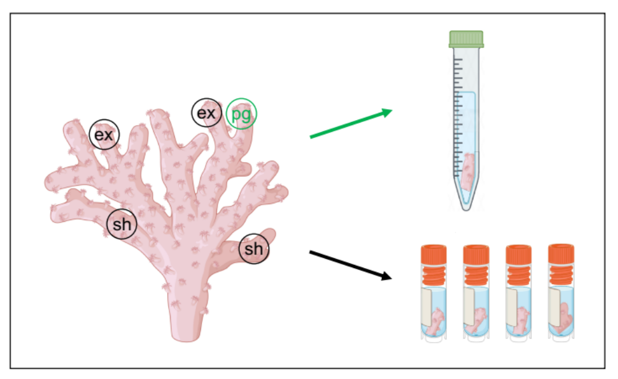

Figure S3. Full dataset for temperature and pH on the outer reef (a/c) and inner mangrove (b/d) from February 2022-February 2023. Temperatures outside logger calibration range (25 ± 10°C) are included in this figure.
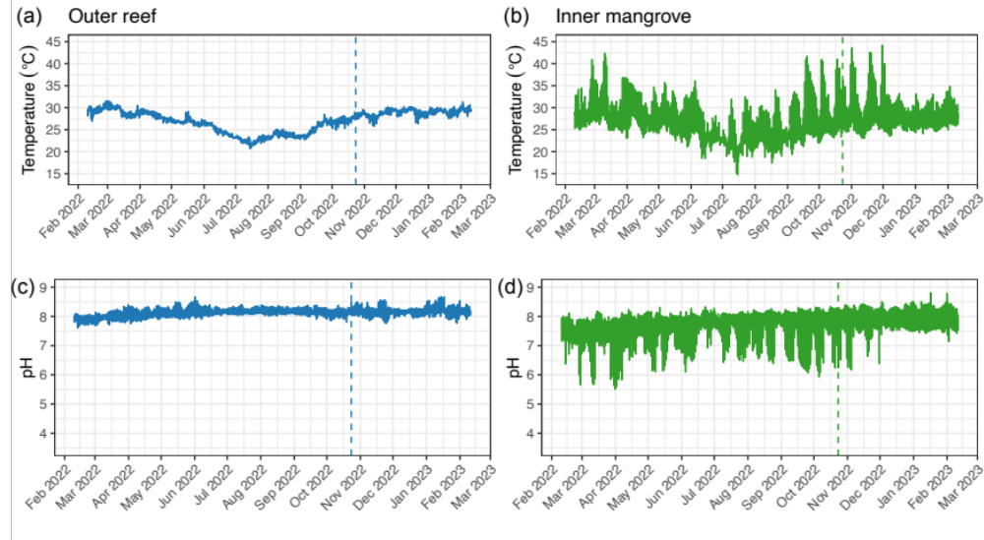
Figure S4. Comparison of the HOBO MX2501 Onset loggers used in the field. The green line shows the logger used in the inner mangrove, while the blue line represents the logger used in the outer reef site.
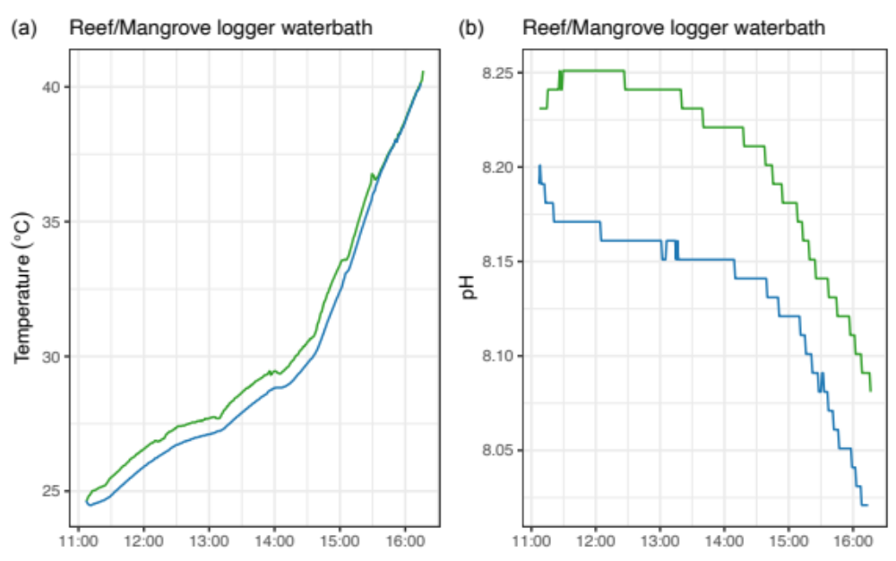

Figure S5. Comparison temperature loggers. Temperature for both sites was measured with a second logger (HOBO Pendant) as back-up (grey dotted line).
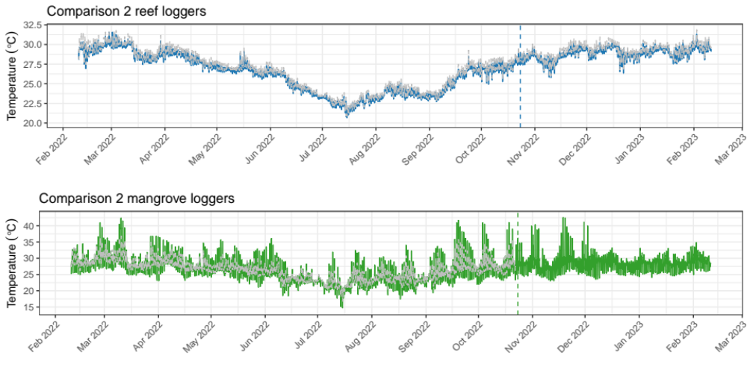

Figure S6. Sampling conditions (temperature, pH and tidal height) during the week of sampling. Data was collected every hour. Tidal data is obtained from WillyWeather.com.au. Data points outside calibration range (25 ± 10°C) are removed. Blue and green dotted lines represent sampling time for reef and mangrove at 23 October 2022, respectively. Grey shades represent night and light grey shades represent day.
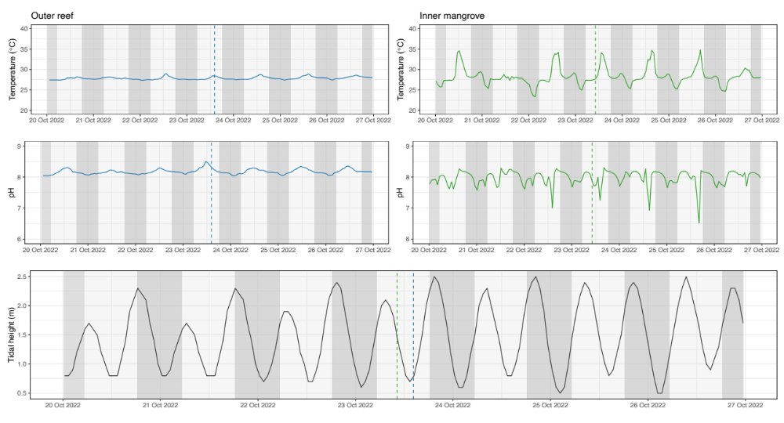
Figure S7. Genomic relationship matrix of our sampled coral individuals based on multidimensional scaling (a) and Fruchter-Reingold (b). Some reef samples, mostly from the inner reef, seem closely related. Two inner mangrove specimens are found to be clones (red line). The nodes are the sampled individuals and the lines between nodes represent the relatedness between individuals.
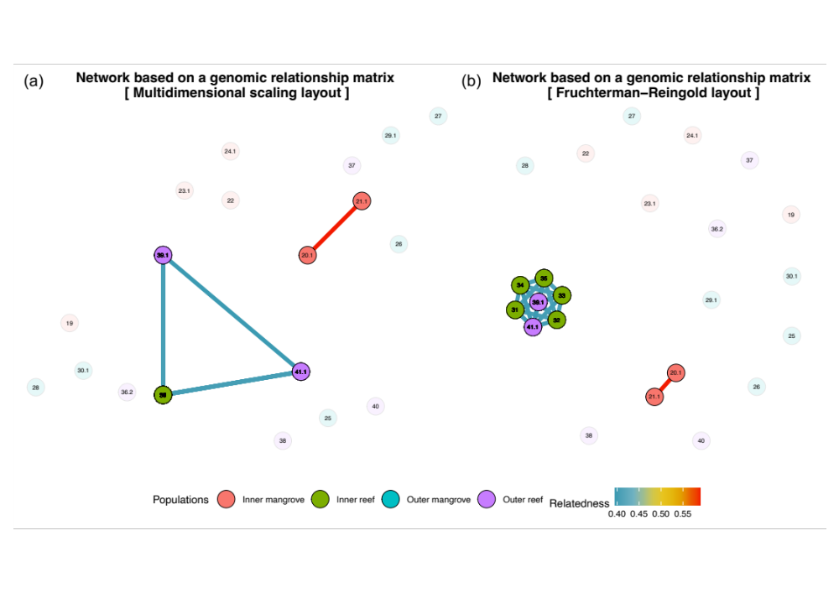

Figure S8. Overview of the sampled corals per site. Due to technical limitations, one photo is missing for the outer reef and three photos are missing for the inner reef site. Distinct morphotypes seem present across the sampling sites. Colonies sampled from the reef sites have more fine and spindly branches, while chunky branches are observed in the mangrove areas. Photos taken by Jake Crosby, Dr Shawna Foo and Chiara M. Duijser.

Figure S9. PCA of 9 photo-physiological parameters obtained with Light-Induced Fluorescence Transient-Fast Repetition Rate fluorometry (LIFT-FRRf). a PCA shown for the populations with clones included. b PCA shown for the lineages with clones excluded.
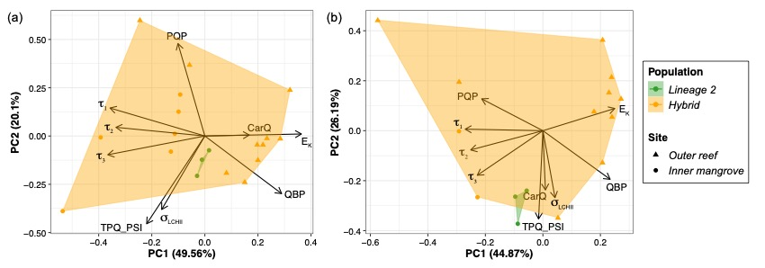

Figure S10. Background Symbiodiniaceae sequences (< 1%) across all three lineages: lineage 1, lineage 2 and hybrid (a-c) for shaded vs. exposed areas of the coral colony sampled. Each bar represents one individual.
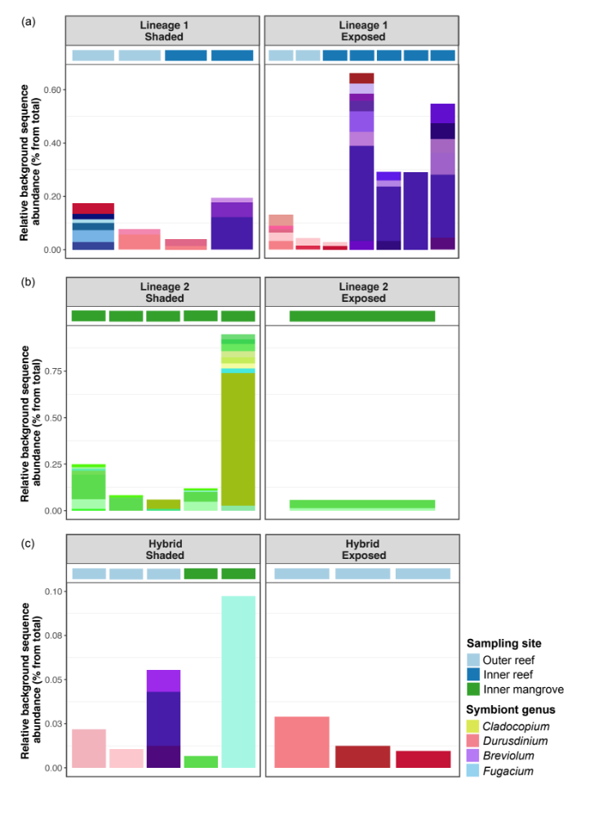

Figure S11. Principal Coordinate Analysis (PCoA) of Symbiodiniaceae communities across the three different lineages and between shaded and exposed regions of individual coral colonies.
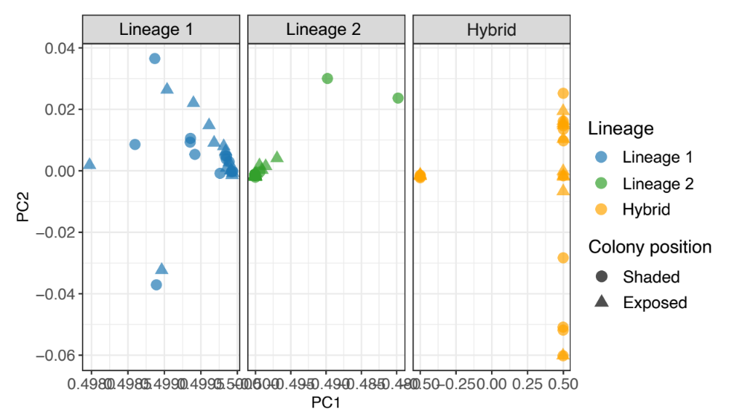
Figure S12. Phenogram visualising genetic similarity based on Euclidean distances between lineages and their respective major ITS2 type profiles (pie charts).
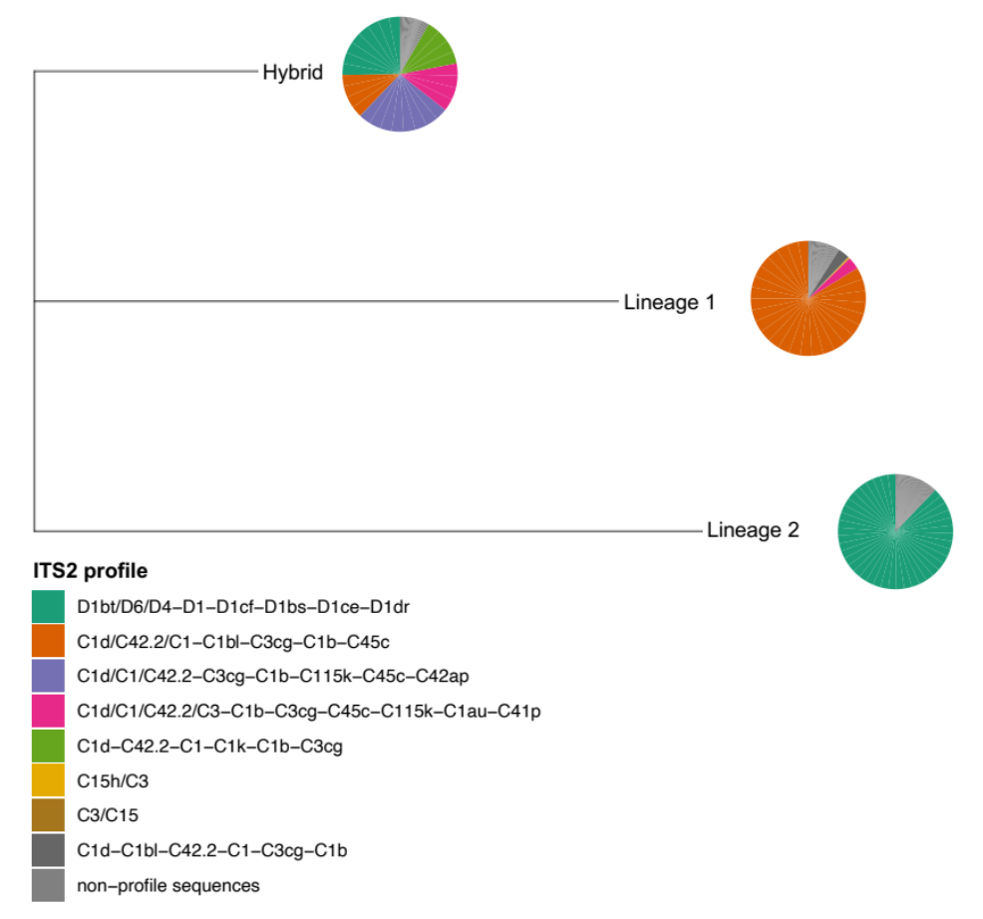
Method S6. Additional filtering method and associated results. We tested an alternate filtering process to ensure the data was not impacted by any filtering step (or overfiltering). SNPs were filtered using removal of secondaries, reproducibility >0.995, locus call rate >0.95, individual call rate >0.80, read depth ≤20 and ≥200 and removal of monomorphic loci. After sequencing processing, filtering and clone removal, 1,924 high-quality SNPs and 22 genotypes were retained for the analysis. We found results to be similar across all analyses, which are displayed below.

Table S5. Pairwise F_{ST} values (below diagonal) and associated p-values (above diagonal) of Pocillopora acuta populations across an environmental gradient based on 1,924 SNPs. F_{ST} values are shown for all four population models (a-d). * moderate differentiation (0.05-0.15), ** strong differentiation (0.15-0.25), *** very strong (> 0.25) differentiation [9].
a Model 1 | Outer reef | Inner reef | Outer mangrove | Inner mangrove
Outer reef | - | < 0.01 | < 0.01 | < 0.01
Inner reef | 0.178** | - | < 0.01 | < 0.01
Outer mangrove | 0.416*** | 0.779*** | - | < 0.01
Inner mangrove | 0.278*** | 0.661*** | 0.010 | -
b Model 2 | Population 1 | Population 2
Population 1 | - | < 0.01
Population 2 | 0.505*** | -
c Model 3 | Population 1 | Population 2 | Hybrid
Population 1 | - | < 0.01 | < 0.01
Population 2 | 0.776*** | - | < 0.01
Hybrid | 0.444*** | 0.433*** | -
d Model 4 | Population 1 | Population 2
Population 1 | - | < 0.01
Population 2 | 0.776*** | -
Analysis of molecular variance (AMOVA) was run with the same parameters as before, again on all four population models.

Table S6. AMOVA results using 1,924 SNPs of genetic variation within and between the three populations of interest for all four population models (a-d). df = degrees of freedom, SS = sum of squares, MS = mean squares, Φ = fixation index, p-value based on 1000 permutations. * denotes significant p-values < 0.05.
a Model 1
Source of variation | df | SS | MS | Variation (%) | F | p-value
Analysis of all individuals
Between sites | 3 | 9148.66 | 3049.55 | 44.06 | 0.43 | 0.01
Between samples within sites | 18 | 5651.29 | 313.96 | 0.46 | -0.01 | 0.47
Within individuals | 22 | 7022.38 | 319.29 | 56.40 | 0.44 | 0.01
b Model 2
Source of variation | df | SS | MS | Variation (%) | F | p-value
Analysis of all individuals
Between pop | 1 | 7677.28 | 7677.28 | 49.84 | 0.53 | 0.01
Between samples within pop | 20 | 7122.67 | 356.13 | 2.74 | 0.06 | 0.27
Within individuals | 22 | 7022.38 | 319.20 | 47.41 | 0.50 | 0.01
c Model 3
Source of variation | df | SS | MS | Variation (%) | F | p-value
Analysis of all individuals
Between pop | 2 | 11044.95 | 5522.47 | 59.39 | 0.49 | 0.01
Between samples within pop | 19 | 3755.01 | 197.63 | -9.55 | -0.24 | 0.96
Within individuals | 22 | 7022.38 | 319.20 | 50.16 | 0.59 | 0.01
d Model 4
Source of variation | df | SS | MS | Variation (%) | F | p-value
Analysis of all individuals
Between pop | 1 | 8868.99 | 8868.99 | 77.58 | 0.57 | 0.07
Between samples within pop | 15 | 177.24 | 11.82 | -20.72 | -0.92 | 1.00
Within individuals | 17 | 5084.00 | 299.06 | 43.14 | 0.78 | 0.01

STRUCTURE analysis detected two genetic clusters (K = 2), indicating the presence of two populations in the dataset with some evidence of hybrids.

Figure S13. Individual cluster classifications of the coral host admixture proportions based on STRUCTURE analysis after using additional filtering method.
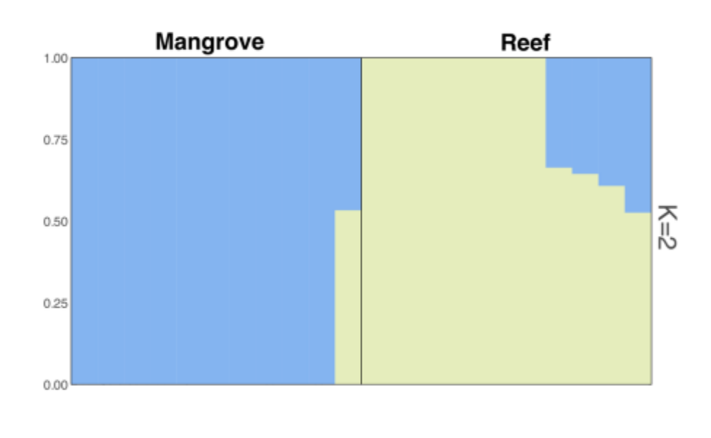

References
Coleman AW, Suarez A, Goff LJ (1994) Molecular delineation of species and syngens in volvocacean green algae (Chlorophyta). Journal of Phycology 30:80–90
Hennige S, Smith D, Perkins R, Consalvey M, Paterson D, Suggett D. 2008 Photoacclimation, growth and distribution of massive coral species in clear and turbid waters. Mar. Ecol. Prog. Ser. 369, 77–88. (doi:10.3354/meps07612)
Kolber ZS. 1998 Measurements of variable chlorophyll fluorescence using fast repetition rate techniques: defining methodology and experimental protocols. Biochimica et Biophysica Acta 1376, 88–106.
Lajeunesse T, Trench R (2000) Biogeography of two species of Symbiodinium (Freudenthal) inhabiting the intertidal sea anemone Anthopleura elegantissima (Brandt). The Biological Bulletin 199:126–134
Oxborough K, Moore CM, Suggett DJ, Lawson T, Chan HG, Geider RJ. 2012 Direct estimation of functional PSII reaction center concentration and PSII electron flux on a volume basis: a new approach to the analysis of Fast Repetition Rate fluorometry (FRRf) data. Limnology & Ocean Methods 10, 142–154. (doi:10.4319/lom.2012.10.142)
Sansaloni C, Petroli C, Jaccoud D, Carling J, Detering F, Grattapaglia D, Kilian A. 2011 Diversity Arrays Technology (DArT) and next-generation sequencing combined: genome-wide, high throughput, highly informative genotyping for molecular breeding of Eucalyptus. BMC Proc. 5, P54, 1753-6561-5-S7-P54. (doi:10.1186/1753-6561-5-S7-P54)
Soliense. Fluoresence/photosynthetic properties: LIFT-FRR Method. [Internet]. Available from: https://soliense.com/LIFT_Method.php. [Accessed 1 April 2024].
Suggett DJ et al. 2022 Toward bio‐optical phenotyping of reef‐forming corals using Light‐Induced Fluorescence Transient‐Fast Repetition Rate fluorometry. Limnology & Ocean Methods 20, 172–191. (doi:10.1002/lom3.10479)
Suggett DJ, Goyen S, Evenhuis C, Szabó M, Pettay DT, Warner ME, Ralph PJ. 2015 Functional diversity of photobiological traits within the genus Symbiodinium appears to be governed by the interaction of cell size with cladal designation. New Phytol 208, 370–381. (doi:10.1111/nph.13483)
Wright S. 1978 Variability within and among natural populations. Chicago: University of Chicago Press.
Yang H, Yang X, Zhang Y, Heskel MA, Lu X, Munger JW, Sun S, Tang J. 2017 Chlorophyll fluorescence tracks seasonal variations of photosynthesis from leaf to canopy in a temperate forest. Global Change Biology 23, 2874–2886. (doi:10.1111/gcb.13590)

