Supplementary Information for

Predicting demography from species traits: larval development time and its sensitivity to warming depend on egg size in corals
Joana Figueiredo^{1*}, Andrew H. Baird², Saki Harii³, Sean R. Connolly⁴

¹National Coral Reef Institute, Nova Southeastern University, Dania Beach, FL, USA, ²James Cook University, Townsville, QLD, Australia, ³Sesoko Marine Research Station, Tropical Biosphere Research Center, University of the Ryukyus, Sesoko, Okinawa, Japan, ⁴Smithsonian Tropical Research Institute, Panama City, Panama

*Corresponding author: jfigueiredo@nova.edu

This PDF file includes:
Supplementary Methods and Results

Species | FUNCTIONAL FORM OF THE SURVIVAL MODEL |  |  |  | TEMPERATURE DEPENDENCE
Species | Model | Nr. par. | MLL | AIC_{c} | Model and parameters | Nr. par. | MLL | AIC_{c}
Ctenactis echinata | Generalised Weibull | 9 | -234.6 | 488.632
Ctenactis echinata | Weibull | 6 | -234.6 | 481.8 | 1. λ_{T}, ν_{T} | 6 | -234.6 | 481.8
 |  |  |  |  | 2. λ, ν_{T} | 4 | -253.5 | 515.3
 |  |  |  |  | 3. λ_{T}, ν | 4 | -234.7 | 477.4
 |  |  |  |  | 4. λ, ν | 2 | -253.6 | 511.2
Ctenactis echinata | Exponential | 3 | -529.6 | 1065.5
Acropora tenuis | Generalised Weibull | 9 | -805.8 | 1630.1
Acropora tenuis | Weibull | 6 | -805.8 | 1623.9 | 1. λ_{T}, ν_{T} | 6 | -805.8 | 1623.9
 |  |  |  |  | 2. λ, ν_{T} | 4 | -812.2 | 1632.5
 |  |  |  |  | 3. λ_{T}, ν | 4 | -806.9 | 1621.9
 |  |  |  |  | 4. λ, ν | 2 | -816.8 | 1637.6
Acropora tenuis | Exponential | 3 | -827.8 | 1661.6
Acropora digitifera | Generalised Weibull | 6 | -579.8 | 1179.0
Acropora digitifera | Weibull | 4 | -579.8 | 1172.3 | 1. λ_{T}, ν_{T} | 4 | -579.8 | 1172.3
 |  |  |  |  | 2. λ, ν_{T} | 3 | -583.7 | 1175.7
 |  |  |  |  | 3. λ_{T}, ν | 3 | -582.3 | 1172.8
 |  |  |  |  | 4. λ, ν | 2 | -597.9 | 1199.9
Acropora digitifera | Exponential | 2 | -682.7 | 1371.7
Lobophyllia corymbosa | Generalised Weibull | 9 | -727.0 | 1473.7
Lobophyllia corymbosa | Weibull | 6 | -727.0 | 1466.8 | 1. λ_{T}, ν_{T} | 6 | -727.0 | 1466.8
 |  |  |  |  | 2. λ, ν_{T} | 4 | -727.0 | 1462.4
 |  |  |  |  | 3. λ_{T}, ν | 4 | -728.0 | 1464.3
 |  |  |  |  | 4. λ, ν | 2 | -728.9 | 1462.0
Lobophyllia corymbosa | Exponential | 3 | -813.6 | 1633.3
Table S1. Selection of the functional form of the survival model and temperature dependence (_{T}) of its parameters. Maximum log-likelihoods (MLL) and Akaike Information Criteria corrected for small samples (AIC_{c}) were used to select the models (note: likelihood ratio tests selected the same best-fitting model)
Table S2. Selection of the temperature dependence of the competency parameters for Ctenactis echinata, Acropora digitifera, and Lobophyllia corymbosa as described in Figueiredo et al. (2014, 2022). The parameters (c - proportion of larvae able to acquire competency; λ, ν and σ - mortality parameters; - minimum time to competency; a - per-capita rate of acquisition of competency for t > t_{c}). were estimated using the method of maximum log-likelihood (MLL). The Akaike Information Criteria corrected for small samples (AICc) and likelihood ratio tests were used to assess which parameters were temperature-dependent and select the best-fitting models. The subscript T signifies that the parameter varies with temperature; when absent, the parameter is constrained to be equal for all temperatures, e.g. λ, ν, c, a_{T}, t_{c T} signifies that λ, ν and c are independent of temperature, while a and t_{c} are dependent on temperature.
Species | Model and parameters | Nr. of parameters | MLL | AIC_{c}
Ctenactis echinata | 1. c_{T}, a_{T}, t_{cT} | 9 | -62.1 | 146.2
Ctenactis echinata | 2. c, a_{T}, t_{cT} | 7 | -62.1 | 140.6
Ctenactis echinata | 3. c_{T}, a, t_{cT} | 7 | -62.1 | 140.7
Ctenactis echinata | 4. c_{T}, a_{T}, t_{c} | 7 | -62.3 | 141.0
Ctenactis echinata | 5. c, a, t_{cT} | 5 | -62.2 | 139.6
Ctenactis echinata | 6. c, a_{T}, t_{c} | 5 | -63.2 | 137.7
Ctenactis echinata | 7. c_{T}, a, t_{c} | 5 | -63.2 | 137.7
Ctenactis echinata | 8. c, a, t_{c} | 3 | -63.8 | 134.1
Acropora digitifera | 1. λ_{T}, ν_{T}, c_{T}, a_{T}, t_{cT} | 10 | -722.5 | 1468.7
Acropora digitifera | 2. λ_{T}, ν_{T}, c, a_{T}, t_{cT} | 9 | -723.6 | 1468.1
Acropora digitifera | 3. λ_{T}, ν_{T}, c_{T}, a, t_{cT} | 9 | -732.6 | 1486.1
Acropora digitifera | 4. λ_{T}, ν_{T}, c_{T}, a_{T}, t_{c} | 9 | -744.0 | 1508.9
Acropora digitifera | 5. λ_{T}, ν_{T}, c, a, t_{c T} | 8 | -732.9 | 1484.2
Acropora digitifera | 6. λ_{T}, ν_{T}, c, a_{T}, t_{c} | 8 | -745.0 | 1508.3
Acropora digitifera | 7. λ_{T}, ν_{T}, c_{T}, a, t_{c} | 8 | -744.0 | 1506.3
Acropora digitifera | 8. λ_{T}, ν_{T}, c, a, t_{c} | 7 | -745.2 | 1506.1
Lobophyllia corymbosa | 1. λ, ν, c_{T}, a_{T}, t_{cT} | 11 | -2719.8 | 5464.7
Lobophyllia corymbosa | 2. λ, ν, c, a_{T}, t_{cT} | 9 | -2720.0 | 5460.0
Lobophyllia corymbosa | 3. λ, ν, c_{T}, a, t_{cT} | 9 | -2720.2 | 5460.5
Lobophyllia corymbosa | 4. λ, ν, c_{T}, a_{T}, t_{c} | 9 | -2763.5 | 5547.0
Lobophyllia corymbosa | 5. λ, ν, c, a, t_{c T} | 7 | -2720.5 | 5456.2
Lobophyllia corymbosa | 6. λ, ν, c, a_{T}, t_{c} | 7 | -2768.5 | 5552.3
Lobophyllia corymbosa | 7. λ, ν, c_{T}, a, t_{c} | 7 | -2774.5 | 5564.2
Lobophyllia corymbosa | 8. λ, ν, c, a, t_{c} | 5 | -2775.6 | 5561.9

Table S3. Selection of the functional form of the loss of competency and temperature dependence of the competency parameters for A. tenuis as described in Figueiredo et al. (2022). The parameters ( - minimum time to competency; a - per-capita rate of acquisition of competency for t > t_{c}; b and η - two parameters of the Weibull distribution for per-capita rate of loss of competency). were estimated using the maximum log-likelihood method (MLL). The Akaike Information Criteria corrected for small samples (AIC_{c}) and likelihood ratio tests were used to select the best fitting model. _{T} signifies that the parameter varies with temperature (i.e. temperature dependence); when absent, the parameter is constrained to be equal for all temperatures (i.e. independent of temperature), e.g. t_{cT,} a, b_{T}, η_{T} signify that a is independent of temperature, while t_{cT,} b_{T} and η_{T} are dependent of temperature.

FUNCTIONAL FORM OF  THE LOSS OF COMPETENCY |  |  |  | TEMPERATURE DEPENDENCE OF ALL COMPETENCY PARAMETERS
Model | Nr. par. | MLL | AIC_{c} | Model parameters | Nr. par. | MLL | AIC_{c}
Generalised Weibull | 15 | -228.7 | 492.1
Weibull | 12 | -228.7 | 484.4 | t_{cT,} a_{T}, b_{T}, η_{T} | 12 | -228.7 | 484.4
 |  |  |  | t_{c,} a_{T}, b_{T}, η_{T} | 10 | -265.3 | 552.6
 |  |  |  | t_{cT,} a, b_{T}, η_{T} | 10 | -249.4 | 520.8
 |  |  |  | t_{cT,} a_{T}, b, η_{T} | 10 | -237.3 | 496.6
 |  |  |  | t_{cT,} a_{T}, b_{T}, η | 10 | -235.8 | 493.6
 |  |  |  | t_{c,} a, b_{T}, η_{T} | 8 | -265.8 | 548.8
 |  |  |  | t_{c,} a_{T}, b, η_{T} | 8 | -272.8 | 563.0
 |  |  |  | t_{c,} a_{T}, b_{T}, η | 8 | -269.4 | 556.1
 |  |  |  | t_{cT,} a, b, η_{T} | 8 | -254.3 | 525.9
 |  |  |  | t_{cT,} a, b_{T}, η | 8 | -252.3 | 521.8
 |  |  |  | t_{cT,} a_{T}, b, η | 8 | -237.6 | 492.4
 |  |  |  | t_{c,} a, b, η_{T} | 6 | -273.9 | 560.5
 |  |  |  | t_{c,} a, b_{T}, η | 6 | -270.5 | 553.7
 |  |  |  | t_{c,} a_{T}, b, η | 6 | -273.6 | 560.0
 |  |  |  | t_{cT,} a, b, η | 6 | -255.8 | 524.3
 |  |  |  | t_{c,} a, b, η | 4 | -274.3 | 557.0
Exponential | 9 | -249.9 | 519.4

Table S4. Estimated survival and competency model parameters and mean time to competency (mtc) of the three species for all temperatures, with 95% confidence intervals. λ, ν and σ are mortality parameters (h⁻¹), is the minimum time to competency (h), a is the per-capita rate of acquisition of competency for t > t_{c} (h⁻¹) and c is the proportion of larvae able to acquire competency. The mean time to competency (mtc) was calculated as 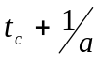 . * denotes that this parameter was independent of temperature in the best-fitting model selected by AIC_{c} and likelihood ratio tests (see Tables S1-3).

Species | Parameter | Temperature
Species | Parameter | 27°C | 29°C | 31°C
Ctenactis echinata | λ | 8.08×10⁻³ | 1.87×10⁻² | 5.64×10⁻²
Ctenactis echinata | λ | (4.96×10⁻³ – 1.26×10⁻²) | (1.19×10⁻² – 2.86×10⁻²) | (3.62×10⁻² – 8.61×10⁻²)
Ctenactis echinata | ν* | 0.363 | 0.363 | 0.363
Ctenactis echinata | ν* | (0.322 – 0.403) | (0.322 – 0.403) | (0.322 – 0.403)
Ctenactis echinata | 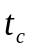* | 28.35 | 28.35 | 28.35
Ctenactis echinata |  | (21.76 – 36.06) | (21.76 – 36.06) | (21.76 – 36.06)
Ctenactis echinata | a* | 3.92×10⁻² | 3.92×10⁻² | 3.92×10⁻²
Ctenactis echinata | a* | (1.32×10⁻² – 0.109) | (1.32×10⁻² – 0.109) | (1.32×10⁻² – 0.109)
Ctenactis echinata | c* | 0.398 | 0.398 | 0.398
Ctenactis echinata | c* | (0.291 – 0.512) | (0.291 – 0.512) | (0.291 – 0.512)
Ctenactis echinata | mtc | 53.85 | 53.85 | 53.85
Acropora tenuis | λ | 7.49×10⁻⁵ | 1.92×10⁻⁴ | 3.46×10⁻⁴
Acropora tenuis | λ | (3.39×10⁻⁵ – 1.65×10⁻⁴) | (1.08×10⁻⁴ – 3.35×10⁻⁴) | (2.16×10⁻⁴ – 5.36×10⁻⁴)
Acropora tenuis | ν* | 0.609 | 0.609 | 0.609
Acropora tenuis | ν* | (0.521 – 0.716) | (0.521 – 0.716) | (0.521 – 0.716)
Acropora tenuis |  | 85.32 | 60.28 | 41.66
Acropora tenuis |  | (81.16 – 89.43) | (58.31 – 62.29) | (40.97– 42.26)
Acropora tenuis | a | 0.295 | 4.94×10⁻² | 2.61×10⁻²
Acropora tenuis | a | (0.028 – 2.816) | (3.60×10⁻² – 6.82×10⁻²) | (2.22×10⁻² – 3.10×10⁻²)
Acropora tenuis | b | 3.12×10⁻⁴ | 1.29×10⁻³ | 1.63×10⁻³
Acropora tenuis | b | (8.73×10⁻⁵ – 1.06×10⁻³) | (9.05×10⁻⁴ – 1.83×10⁻³) | (1.25×10⁻³ – 2.12×10⁻³)
Acropora tenuis | η | 0.376 | 0.748 | 0.880
Acropora tenuis | η | (0.240 – 0.565) | (0.541 – 1.037) | (0.653 – 1.164)
Acropora tenuis | mtc | 88.56 | 80.53 | 79.90
Acropora digitifera | λ | 2.49×10⁻⁴ |  | 8.90×10⁻⁴
Acropora digitifera | λ | (1.10×10⁻⁴ – 5.71×10⁻⁴) |  | (4.79×10⁻⁴ – 1.63×10⁻³)
Acropora digitifera | ν | 0.492 |  | 0.349
Acropora digitifera | ν | (0.382 – 0.641) |  | (0.284– 0.424)
Acropora digitifera |  | 97.00 |  | 81.88
Acropora digitifera |  | (94.38 – 99.50) |  | (81.31 – 82.50)
Acropora digitifera | a | 0.059 |  | 0.032
Acropora digitifera | a | (0.049 – 0.072) |  | (0.028 – 0.038)
Acropora digitifera | c* | 0.698 |  | 0.698
Acropora digitifera | c* | (0.617 – 0.765) |  | (0.617 – 0.765)
Acropora digitifera | mtc | 113.95 |  | 112.87
Lobophyllia corymbosa | λ* | 9.31×10⁻⁴ | 9.31×10⁻⁴ | 9.31×10⁻⁴
Lobophyllia corymbosa | λ* | (6.77×10⁻⁴ – 1.30×10⁻³) | (6.77×10⁻⁴ – 1.30×10⁻³) | (6.77×10⁻⁴ – 1.30×10⁻³)
Lobophyllia corymbosa | ν* | 0.431 | 0.431 | 0.431
Lobophyllia corymbosa | ν* | (0.372 – 0.501) | (0.372 – 0.501) | (0.372 – 0.501)
Lobophyllia corymbosa |  | 83.26 | 79.02 | 55.14
Lobophyllia corymbosa |  | (81.12 – 85.64) | (75.96 – 82.58) | (51.74 – 58.30)
Lobophyllia corymbosa | a* | 0.016 | 0.016 | 0.016
Lobophyllia corymbosa | a* | (0.013 – 0.019) | (0.013 – 0.019) | (0.013 – 0.019)
Lobophyllia corymbosa | c* | 0.583 | 0.583 | 0.583
Lobophyllia corymbosa | c* | (0.530 – 0.630) | (0.530 – 0.630) | (0.530 – 0.630)
Lobophyllia corymbosa | mtc | 145.5129 | 141.2686 | 117.3953

Fig. S1. Proportion of surviving larvae in the experiment without settlement cues (left), and proportion of competent larvae (right) of Ctenactis echinata over time at current (27 ºC, purple) and warmer temperature [29 (green) and 31ºC (orange)]. Open circles show average (±SE) survival and settlement observations across the four replicates, respectively. Solid lines show best-fit models. To make all points visible, the points and corresponding model fits for 27 and 29°C were shifted -0.2 and -0.1 d⁻¹, respectively, along the x-axis.

Fig. S2. Proportion of surviving larvae in the experiment without settlement cues (left), and proportion of competent larvae (right) of Acropora tenuis over time at current (27 ºC, purple) and warmer temperatures [29 (green) and 31ºC (orange)]. Open circles show average (±SE) survival and settlement observations, respectively. Solid lines show best-fit models. To make all points visible, the points and corresponding model fits for 27 and 29°C were shifted -0.2 and -0.1 d⁻¹, respectively, along the x-axis.

Fig. S3. Proportion of surviving larvae in the experiment without settlement cues (left), and proportion of larvae settled (D-F, right) over time in the experiment with settlement cues for the species Acropora digitifera at current (27 ºC, purple) and +4°C warmer temperature [31ºC (orange)]. Open circles show average (±SE) survival and settlement observations, respectively. Solid lines show best-fit models. To make all points visible, the points and corresponding model fits for 27 °C were shifted -0.1 d⁻¹ along the x-axis.

Fig. S4. Proportion of surviving larvae in the experiment without settlement cues (left graph), and proportion of larvae settled (right graph, left y-axis) and swimming at the end of the experiment (right, right axis) in the experiment with settlement cues over time for the species Lobophyllia corymbosa at current (27 ºC, purple) and warmer temperatures [29 (green) and 31ºC (orange)]. Open circles show average (±SE) survival and settlement observations, respectively. Solid lines show best-fit models. Filled circles show the average (±SE) proportion of larvae alive and swimming at the end of the experiment and represents corresponding model predictions. To make all points visible, the points and corresponding model fits for 27 and 29°C were shifted -0.2 and -0.1 d⁻¹, respectively, along the x-axis.

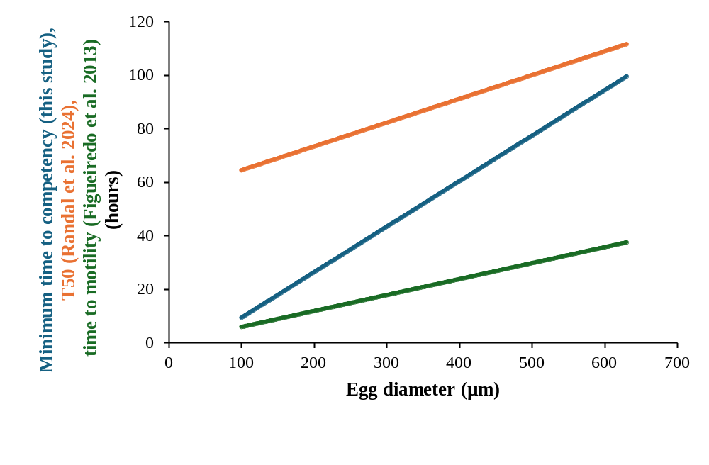
Fig. S5. Comparison between relationship between egg diameter (µm) and minimum time to competency (this study, blue), time to 50% competency (T50, Randall et al. 2024, orange), and time to motility (Figueiredo et al. 2013, green), in hours.

