Supplementary Materials
One-time broadscale SCTLD intervention effectiveness on Montastraea cavernosa in an endemic zone
Amanda Zummo¹, Reagan Sharkey¹, Samantha Buckley¹, Karen Neely², Greta Aeby³, and Brian Walker¹
¹ Geographic Information Systems (GIS) and Spatial Ecology Laboratory, National Coral Reef Institute, Nova Southeastern University, Dania Beach, FL, United States
² National Coral Reef Institute, Nova Southeastern University, Dania Beach, FL, United States
³ Department of Biological and Environmental Sciences, Qatar University, Doha, Qatar
*Correspondence: Amanda Zummo, zummoamanda@aol.com
S1 Distribution of days elapsed between initial treatment and revisit per colony color coded by their K-means cluster month groups. Revisited corals were categorized with three clusters into 13-21 months (n=55), 24-34 months (n=61), and 35-41 months (n=62) post-treatment and are referred to as month groups
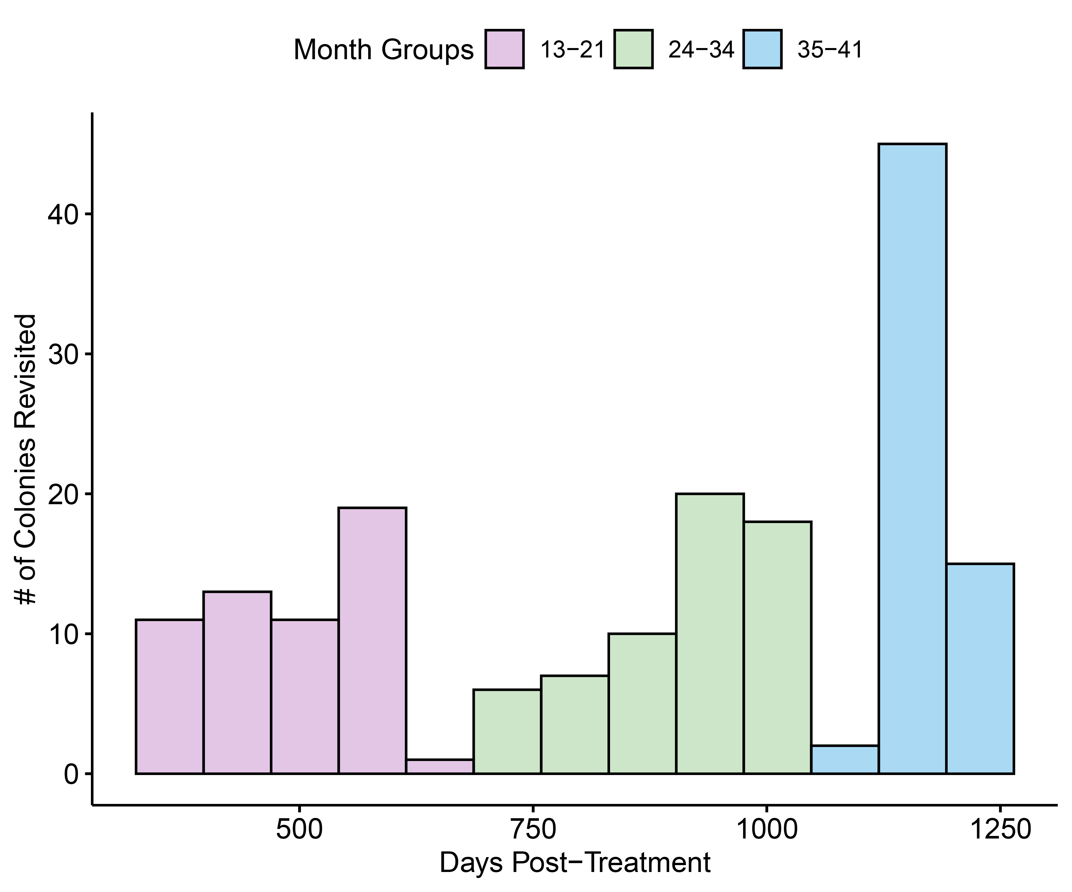

S2 Percent change of live tissue for each colony was calculated to standardize for variations in surface area (m²) and starting live tissue area (m²)
S3 The coral surface area equation includes l = maximum colony length * ½, w = maximum colony width * ½, and h = maximum colony height. The surface area of an ellipsoid is multiplied by ½ to account for the hemispherical shape of the M. cavernosa colony
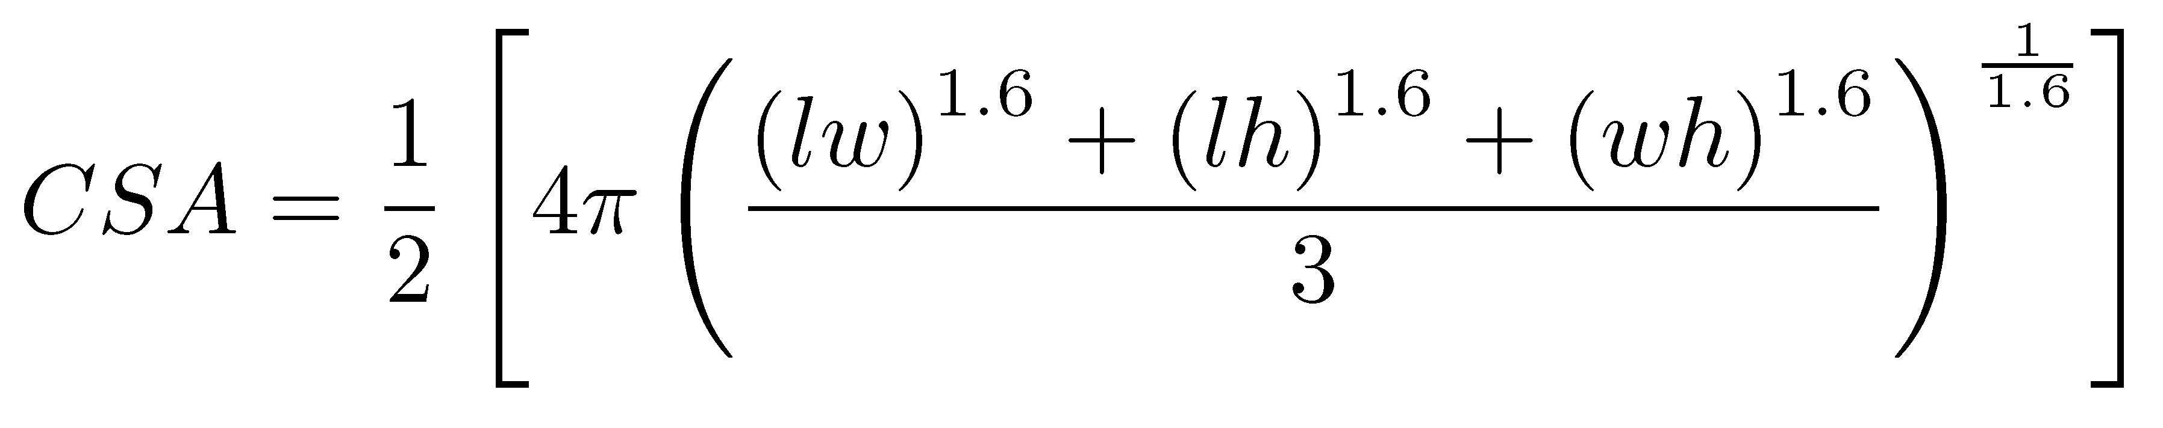
S4 The live tissue area equation uses the percentage of live tissue coverage that was recorded during broadscale disease intervention and revisit dives. This percentage was divided by 100 to change the percentage to a decimal. The decimal was multiplied by the surface area of that colony (CSA) to find the live tissue area (m²) (LTA)
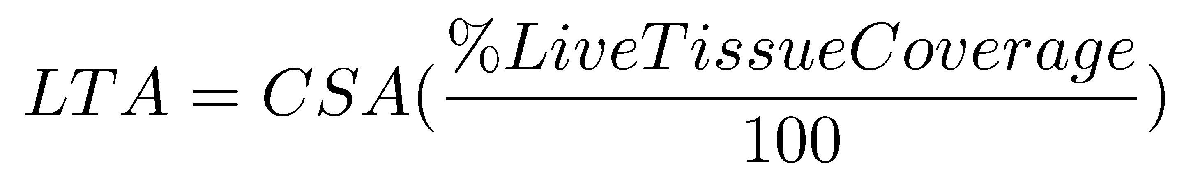
S5 The total live tissue area (cm²) was calculated as the sum of the ending live tissue area for all revisited colonies. The hypothetical live tissue area (cm²) (Hyp. LTA) was calculated as the sum of the starting live tissue area and the observed 34% decline in live tissue on untreated M. cavernosa colonies (Aeby et al. 2019) for all revisited colonies. The amount of live tissue saved from broadscale disease intervention activities was calculated from the total live tissue area (cm²) and the hypothetical live tissue area (cm²). Using the average size microfragment (cm²) and number of microfragments produced per year by Mote Marine Laboratory and Aquarium (Page et al. 2018), the total amount of live tissue area saved from broadscale disease intervention activities can be converted to the equivalent number of microfragments and years it would take to produce.
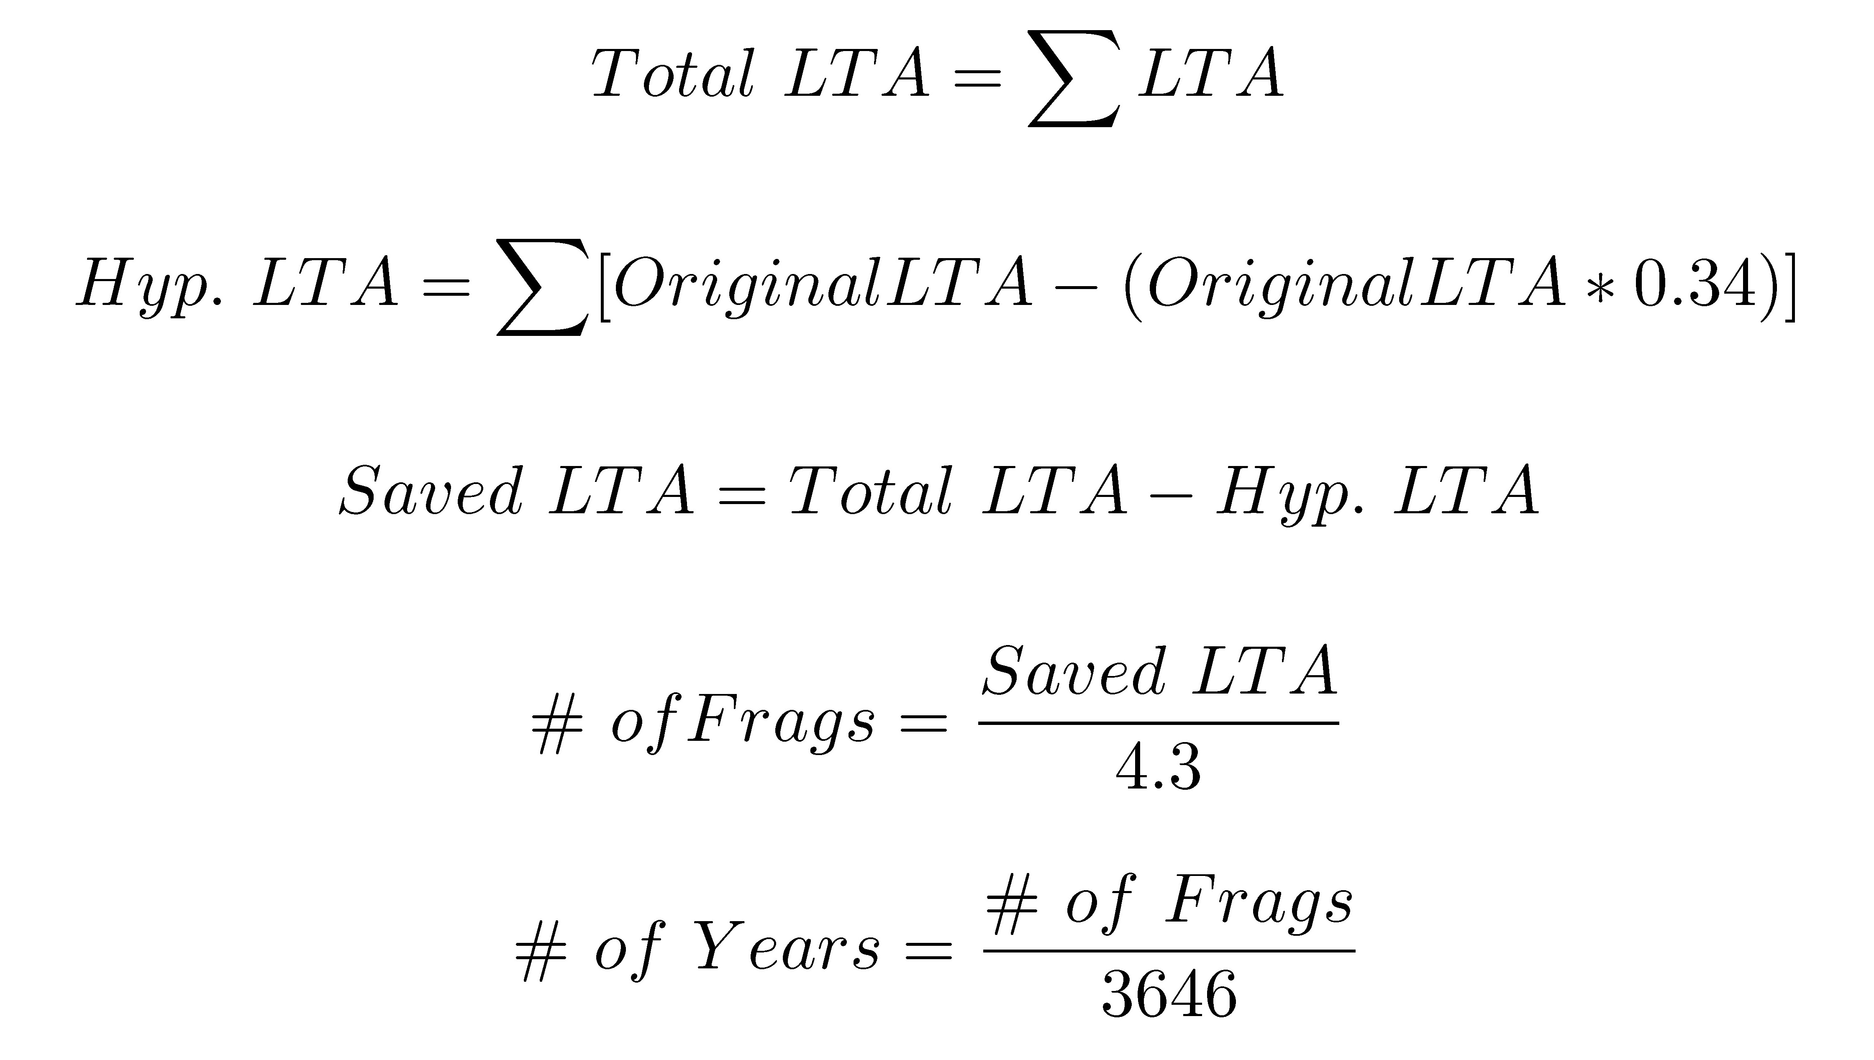
S6 The best fitted binomial generalized linear model to explain the influence month groups and treatment type have on colony condition
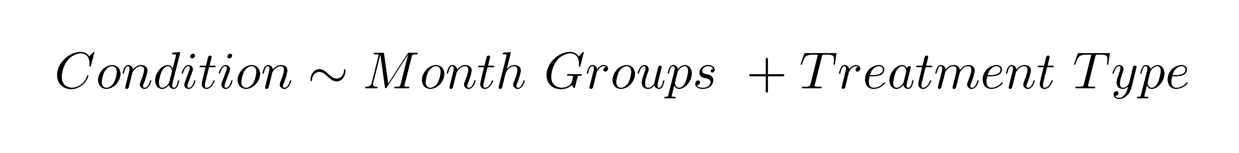
S7 Mean colony surface area (m²) was significantly higher for corals in the 13-21 month group compared to the other two groups. Dashed line in the boxplots represent the mean surface area (m²) for each month group. Solid lines in the boxplots represent the median surface area (m²) for each month group. Asterisks indicate significance
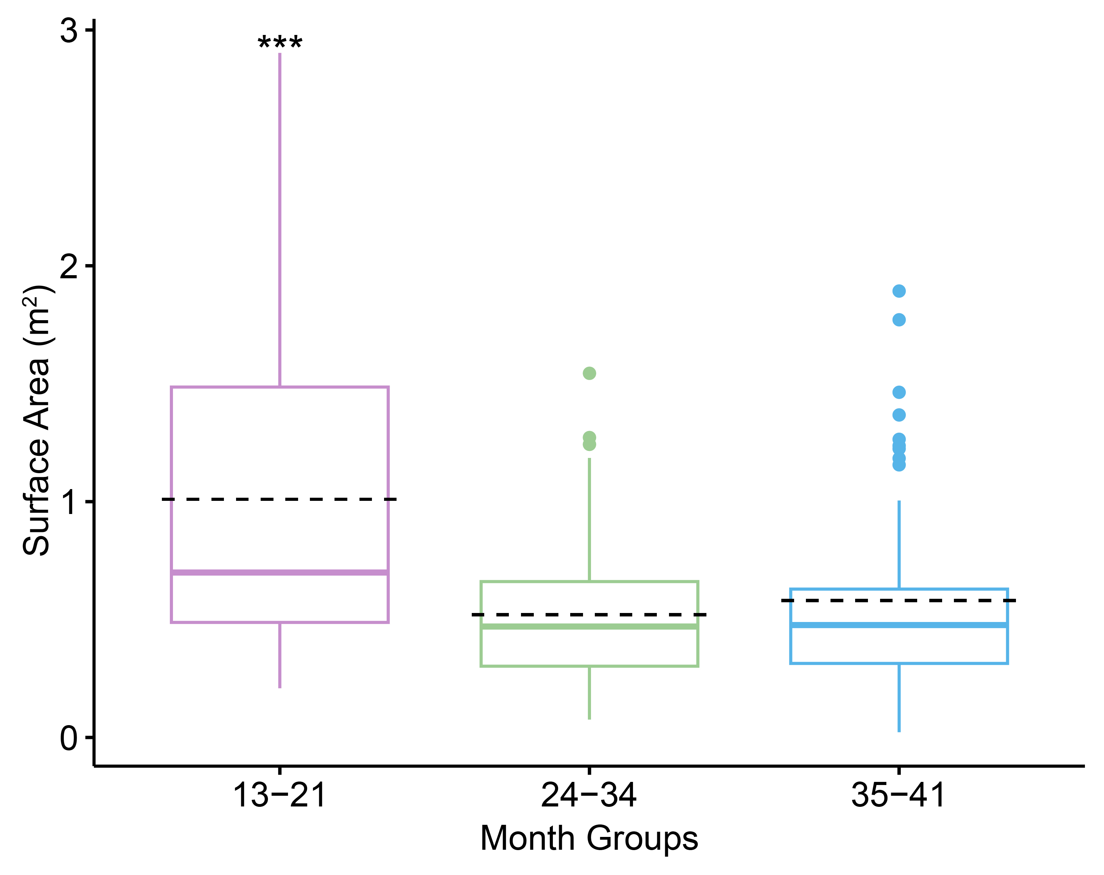
S8 The percentage change of live tissue coverage for each month groups did not differ significantly. Dashed lines are the mean percent change in live tissue coverage. Solid lines are the median percent change in live tissue coverage
