Supplemental material.
Appendix A1. Exploring depth-related effects on fish biomass.
Fish and benthic surveys were conducted exclusively on coral dominated fore-reef habitats at depths of 10 - 15 m, except for Belize and Honduras where surveys were conducted at depths of 5 – 20 m. Although previous studies found that depth had no effect on coral cover across the surveyed sites (Williams et al. 2015), fish assemblages can vary substantially across depth ranges (Schultz et al. 2014). To assess whether there was an effect of depth on total fish biomass, herbivore biomass, or piscivore biomass (g/m²), Linear Mixed Effects Models (LMM) were implemented using the R package lme4 (Bates et al. 2015). Data were analysed at the transect level, with depth as a fixed effect, and Country and Site nested within Country included as a random effect to account for local-scale variability. Biomass data were log+1 transformed. Significance of the fixed effect Depth was assessed using Type III ANOVA F-tests with Satterthwaite's approximation for degrees of freedom. The LMMs revealed no significant effect of depth on either total, herbivore, or piscivore biomass (Table A1), so survey data from all depths and countries were included in subsequent analyses.
Table A1. Effect of transect depth (m) on total, herbivore, and piscivore biomass (g/m², log + 1-transformed) across all the surveyed sites. Effects were estimated using linear mixed-effects models, with Country and Site (nested within Country) included as random effects.
 | log(Total Biomass + 1) |  |  | log(Herbivore Biomass + 1) |  |  | log(Piscivore Biomass + 1)
Predictors | Estimates | CI | p | Estimates | CI | p | Estimates | CI | p
(Intercept) | 3.17 | 2.61 – 3.73 | <0.001 | 1.83 | 1.37 – 2.28 | <0.001 | 1.35 | 0.83 – 1.86 | <0.001
Depth | 0.01 | -0.02 – 0.04 | 0.596 | -0.01 | -0.04 – 0.02 | 0.429 | 0.02 | -0.01 – 0.05 | 0.301
Random Effects
Observations | 917 |  |  | 917 |  |  | 917
Marginal R² / Conditional R² | 0.000 / 0.399 |  |  | 0.001 / 0.265 |  |  | 0.001 / 0.295

Table S1. Fish species classified into herbivore (excavator/scraper) and piscivore/piscivore-invertivore functional groups.
Family | Species | Functional Group
Aulostomidae | Aulostomus maculataus | Piscivore
Bothidae | Bothus lunatus | Piscivore-invertivore
Bothidae | Bothus ocellatus | Piscivore-invertivore
Carangidae | Caranx bartholomaei | Piscivore
Carangidae | Caranx crysos | Piscivore
Carangidae | Caranx latus | Piscivore
Carangidae | Caranx ruber | Piscivore
Carangidae | Elagatis bipinnulata | Piscivore
Carangidae | Trachinotus falcatus | Piscivore-invertivore
Haemulidae | Anisotremus surinamensis | Piscivore-invertivore
Haemulidae | Haemulon parra | Piscivore-invertivore
Haemulidae | Haemulon plumieri | Piscivore-invertivore
Haemulidae | Haemulon sciurus | Piscivore-invertivore
Lutjanidae | Lutjanus analis | Piscivore-invertivore
Lutjanidae | Lutjanus apodus | Piscivore-invertivore
Lutjanidae | Lutjanus cyanopterus | Piscivore-invertivore
Lutjanidae | Lutjanus griseus | Piscivore-invertivore
Lutjanidae | Lutjanus jocu | Piscivore-invertivore
Lutjanidae | Lutjanus mahogoni | Piscivore-invertivore
Lutjanidae | Lutjanus synagris | Piscivore-invertivore
Lutjanidae | Ocyurus chrysurus | Piscivore-invertivore
Muraenidae | Channomuraena vittata | Piscivore-invertivore
Muraenidae | Echidna catenata | Piscivore
Muraenidae | Enchelycore nigricans | Piscivore
Muraenidae | Gymnothorax funebris | Piscivore
Muraenidae | Gymnothorax miliaris | Piscivore
Muraenidae | Gymnothorax moringa | Piscivore
Scaridae | Scarus coelestinus | Herbivore
Scaridae | Scarus coeruleus | Herbivore
Scaridae | Scarus iserti | Herbivore
Scaridae | Scarus taeniopterus | Herbivore
Scaridae | Scarus vetula | Herbivore
Scaridae | Sparisoma atomarium | Herbivore
Scaridae | Sparisoma aurofrenatum | Herbivore
Scaridae | Sparisoma chrysopterum | Herbivore
Scaridae | Sparisoma rubripinne | Herbivore
Scaridae | Sparisoma viride | Herbivore
Scombridae | Acanthocybium solandri | Piscivore
Scombridae | Scomberomorus regalis | Piscivore-invertivore
Scorpaenidae | Pterois volitans | Piscivore-invertivore
Scorpaenidae | Scorpaena grandicornis | Piscivore-invertivore
Scorpaenidae | Scorpaena plumieri | Piscivore-invertivore
Serranidae | Cephalopholis cruentatus | Piscivore
Serranidae | Cephalopholis fulvus | Piscivore
Serranidae | Epinephelus guttatus | Piscivore
Serranidae | Epinephelus striatus | Piscivore
Serranidae | Hypoplectrus chlorurus | Piscivore-invertivore
Serranidae | Hypoplectrus guttavarius | Piscivore-invertivore
Serranidae | Hypoplectrus indigo | Piscivore-invertivore
Serranidae | Hypoplectrus nigricans | Piscivore-invertivore
Serranidae | Hypoplectrus puella | Piscivore-invertivore
Serranidae | Hypoplectrus sp. | Piscivore-invertivore
Serranidae | Hypoplectrus unicolor | Piscivore-invertivore
Serranidae | Liopropoma rubre | Piscivore-invertivore
Serranidae | Mycteroperca bonaci | Piscivore
Serranidae | Mycteroperca interstitialis | Piscivore
Serranidae | Mycteroperca tigris | Piscivore
Serranidae | Mycteroperca venenosa | Piscivore
Serranidae | Rypticus saponaceus | Piscivore-invertivore
Serranidae | Serranus baldwini | Piscivore-invertivore
Serranidae | Serranus tigris | Piscivore
Sphyraenidae | Sphyraena barracuda | Piscivore
Synodontidae | Synodus intermedius | Piscivore
Synodontidae | Synodus saurus | Piscivore

Table S2. Variance Inflation Factors (VIFs) for all continuous predictor variables included in the full linear mixed-effects model used to identify the most important drivers of fish biomass.
Variables | VIF
Age | 2.51
Area | 5.26
Enforcement | 4.67
Compliance | 4.65
Macroalgae | 3.11
Turf | 1.73
HumanPopulationDensity | 4.54
HabitatQuality | 2.17

Table S3. Pairwise comparisons of the effect of MPA compliance and enforcement (levels: None, Low, Medium, High) on total, herbivore, and piscivore biomass (g/m²; log- or log+1-transformed, as specified) of small fish (< 20 cm) across the surveyed sites. Results are from linear mixed-effects models (LMMs) with site nested within country as random effects. P-values were adjusted for multiple comparisons using the Tukey method. Degrees of freedom were estimated using the Kenward-Roger method (Total) or Satterthwaite method (Herbivore, Piscivore), selected based on model stability. Values are reported on the log scale. Significant comparisons (p < 0.05) are shown in bold.
 | Log(Total Biomass) |  |  |  |  | Log(Herbivore Biomass+1) |  |  |  |  |  | Log(Piscivore Biomass+1)
Compliance | Estimate | SE | df | t | p_{adj} |  | Estimate | SE | df | t | p_{adj} |  | Estimate | SE | df | t | p_{adj}
None, Low | 1.15 | 1.45 | 2.99 | 0.79 | 0.85 |  | 1.15 | 0.52 | 25.00 | 2.22 | 0.15 |  | -0.70 | 0.46 | 25.00 | -1.50 | 0.45
None, Medium | 0.21 | 1.00 | 2.59 | 0.21 | 1.00 |  | -0.31 | 0.31 | 25.00 | -1.00 | 0.75 |  | 0.85 | 0.28 | 25.00 | 3.01 | 0.03
None, High | -0.83 | 1.37 | 2.34 | -0.61 | 0.92 |  | 0.43 | 0.40 | 25.00 | 1.08 | 0.71 |  | -0.11 | 0.35 | 25.00 | -0.31 | 0.99
Low, Medium | -0.95 | 1.45 | 2.25 | -0.65 | 0.91 |  | -1.46 | 0.41 | 25.00 | -3.55 | 0.01 |  | 1.54 | 0.37 | 25.00 | 4.17 | 0.00
Low, High | -1.98 | 1.11 | 2.37 | -1.78 | 0.45 |  | -0.72 | 0.34 | 25.00 | -2.16 | 0.16 |  | 0.59 | 0.30 | 25.00 | 1.96 | 0.23
Medium, High | -1.03 | 0.94 | 2.10 | -1.11 | 0.72 |  | 0.74 | 0.24 | 25.00 | 3.08 | 0.02 |  | -0.95 | 0.22 | 25.00 | -4.43 | 0.00
Enforcement
None, Low | -0.42 | 1.37 | 2.34 | -0.31 | 0.99 |  | -1.81 | 0.40 | 25.00 | -4.58 | 0.00 |  | 0.81 | 0.35 | 25.00 | 2.30 | 0.12
None, Medium | 0.58 | 0.83 | 2.81 | 0.69 | 0.89 |  | -0.02 | 0.28 | 25.00 | -0.08 | 1.00 |  | 0.04 | 0.25 | 25.00 | 0.17 | 1.00
None, High | -0.80 | 0.86 | 2.82 | -0.93 | 0.80 |  | 0.32 | 0.26 | 25.00 | 1.23 | 0.61 |  | -0.97 | 0.23 | 25.00 | -4.20 | 0.00
Low, Medium | 1.00 | 1.08 | 2.11 | 0.92 | 0.80 |  | 1.79 | 0.28 | 25.00 | 6.31 | 0.00 |  | -0.77 | 0.25 | 25.00 | -3.05 | 0.03
Low, High | -0.38 | 1.36 | 2.27 | -0.28 | 0.99 |  | 2.12 | 0.37 | 25.00 | 5.73 | 0.00 |  | -1.78 | 0.33 | 25.00 | -5.36 | 0.00
Medium, High | -1.37 | 0.83 | 2.60 | -1.66 | 0.48 |  | 0.34 | 0.24 | 25.00 | 1.41 | 0.51 |  | -1.01 | 0.22 | 25.00 | -4.69 | 0.00

Table S4. Pairwise comparisons of the effect of MPA compliance and enforcement (levels: None, Low, Medium, High) on total, herbivore, and piscivore biomass (g/m²; log+1-transformed) of large fish (≥ 20 cm) across the surveyed sites. Results are from linear mixed-effects models (LMMs) with site nested within country as random effects. P-values were adjusted for multiple comparisons using the Tukey method. Degrees of freedom were estimated using the asymptotic method (Total) or Satterthwaite method (Herbivore, Piscivore), selected based on model stability. Values are reported on the log scale. Significant comparisons (p < 0.05) are shown in bold.
 | Total Biomass |  |  |  |  | Herbivore Biomass |  |  |  |  |  | Piscivore Biomass
Compliance | Estimate | SE | df | t | p_{adj} |  | Estimate | SE | df | t | p_{adj} |  | Estimate | SE | df | t | p_{adj}
None, Low | 1.00 | 1.059 | Inf | 0.944 | 0.78 |  | -2.00 | 0.72 | 23.60 | -2.76 | 0.05 |  | 0.84 | 1.61 | 2.95 | 0.52 | 0.95
None, Medium | -0.78 | 0.714 | Inf | -1.086 | 0.70 |  | -0.94 | 0.43 | 22.10 | -2.18 | 0.16 |  | -0.33 | 1.12 | 2.75 | -0.30 | 0.99
None, High | -1.11 | 0.987 | Inf | -1.12 | 0.68 |  | -2.43 | 0.56 | 24.70 | -4.35 | 0.00 |  | -0.30 | 1.58 | 2.69 | -0.19 | 1.00
Low, Medium | -1.78 | 1.051 | Inf | -1.689 | 0.33 |  | 1.06 | 0.58 | 24.50 | 1.82 | 0.29 |  | -1.17 | 1.69 | 2.63 | -0.69 | 0.89
Low, High | -2.11 | 0.8 | Inf | -2.631 | 0.04 |  | -0.44 | 0.46 | 22.10 | -0.94 | 0.78 |  | -1.14 | 1.28 | 2.64 | -0.89 | 0.81
Medium, High | -0.33 | 0.682 | Inf | -0.484 | 0.96 |  | -1.49 | 0.36 | 29.40 | -4.20 | 0.00 |  | 0.03 | 1.11 | 2.63 | 0.03 | 1.00
Enforcement
None, Low | -1.08 | 0.987 | Inf | -1.094 | 0.69 |  | 1.36 | 0.56 | 24.70 | 2.44 | 0.10 |  | -0.75 | 1.58 | 2.69 | -0.48 | 0.96
None, Medium | -1.32 | 0.614 | Inf | -2.154 | 0.14 |  | -0.31 | 0.40 | 27.60 | -0.76 | 0.87 |  | -1.77 | 0.94 | 3.01 | -1.88 | 0.39
None, High | -0.89 | 0.605 | Inf | -1.466 | 0.46 |  | -0.69 | 0.35 | 22.10 | -1.96 | 0.23 |  | -0.70 | 0.93 | 2.91 | -0.75 | 0.87
Low, Medium | -0.24 | 0.773 | Inf | -0.313 | 0.99 |  | -1.67 | 0.39 | 22.10 | -4.28 | 0.00 |  | -1.02 | 1.27 | 2.53 | -0.80 | 0.85
Low, High | 0.19 | 0.98 | Inf | 0.197 | 1.00 |  | -2.06 | 0.53 | 25.10 | -3.90 | 0.00 |  | 0.05 | 1.57 | 2.67 | 0.03 | 1.00
Medium, High | 0.44 | 0.603 | Inf | 0.722 | 0.89 |  | -0.39 | 0.36 | 29.40 | -1.09 | 0.70 |  | 1.07 | 0.93 | 2.95 | 1.14 | 0.69

Table S5. Effect of MPA characteristics (age, size, compliance, enforcement, protection status), environmental factors (macroalgal and turf algal cover, habitat quality (coral cover and rugosity), and human population density (individuals/km²) on total, herbivore, and piscivore biomass (g/m², log-transformed for total; log + 1-transformed for herbivores and piscivores) of small fish (< 20 cm) across surveyed MPA sites. Effects were estimated using linear mixed-effects models, with Country and Site (nested within Country) included as random effects. This table presents the full model with all predictors included. All continuous predictors were standardised (mean = 0, SD = 1) to facilitate comparison; thus, coefficients represent the effect of a one standard deviation change in each predictor. CI = confidence interval.
 | Total Biomass |  |  | Herbivore Biomass |  |  | Piscivore Biomass
Predictors | Estimates | CI | p | Estimates | CI | p | Estimates | CI | p
(Intercept) | 3.45 | 2.15 – 4.75 | <0.001 | 1.64 | 0.34 – 2.94 | 0.014 | 1.19 | 0.38 – 1.99 | 0.004
Age | 0 | -0.75 – 0.75 | 0.996 | -0.22 | -0.88 – 0.43 | 0.475 | 0.22 | -0.26 – 0.69 | 0.345
Compliance | 0.89 | -0.28 – 2.07 | 0.126 | -0.15 | -1.33 – 1.04 | 0.796 | -0.06 | -0.78 – 0.66 | 0.858
Coral | -0.16 | -0.62 – 0.30 | 0.458 | -0.05 | -0.39 – 0.28 | 0.738 | -0.08 | -0.39 – 0.22 | 0.573
Enforcement | 0.53 | -0.23 – 1.29 | 0.157 | -0.32 | -1.05 – 0.41 | 0.369 | 0.41 | -0.07 – 0.88 | 0.087
HumanPopulationDensity | 0.28 | -0.43 – 0.98 | 0.416 | 0.01 | -0.60 – 0.62 | 0.977 | 0.17 | -0.27 – 0.61 | 0.428
Macroalgae | 0.03 | -0.43 – 0.48 | 0.903 | -0.3 | -0.64 – 0.03 | 0.075 | -0.06 | -0.36 – 0.24 | 0.684
ProtectionStatus [Restricted] | 0.59 | -1.72 – 2.90 | 0.564 | -0.5 | -2.81 – 1.80 | 0.622 | 0.02 | -1.40 – 1.45 | 0.971
Rugosity | 0.1 | -0.05 – 0.25 | 0.195 | 0.04 | -0.09 – 0.17 | 0.549 | 0.02 | -0.11 – 0.16 | 0.752
Size | 0.81 | -0.01 – 1.62 | 0.052 | -0.42 | -1.14 – 0.30 | 0.237 | 0.21 | -0.31 – 0.73 | 0.404
Turf | -0.48 | -0.88 – -0.07 | 0.025 | -0.12 | -0.45 – 0.20 | 0.431 | -0.26 | -0.52 – 0.00 | 0.052
Random Effects
σ² | 0.43 |  |  | 0.35 |  |  | 0.39
τ₀₀ | 0.57 _{ReefName} |  |  | 0.68 _{ReefName} |  |  | 0.33 _{ReefName}
 | 0.49 _{Country} |  |  | 0.30 _{Country} |  |  | 0.23 _{Country}
Observations | 128 |  |  | 128 |  |  | 128
Marginal R² / Conditional R² | 0.343 / 0.715 |  |  | 0.135 / 0.666 |  |  | 0.175 / 0.412

Table S6. Effect of MPA characteristics (age, size, compliance, enforcement, protection status), environmental factors (macroalgal and turf algal cover, habitat quality (coral cover and rugosity), and human population density (individuals/km²) on total, herbivore, and piscivore biomass (g/m², log + 1-transformed) of large fish (≥ 20 cm) across surveyed MPA sites. Effects were estimated using linear mixed-effects models, with Country and Site (nested within Country) included as random effects. This table presents the full model with all predictors included. All continuous predictors were standardised (mean = 0, SD = 1) to facilitate comparison; thus, coefficients represent the effect of a one standard deviation change in each predictor. CI = confidence interval.
 | Total Biomass |  |  | Herbivore Biomass |  |  | Piscivore Biomass
Predictors | Estimates | CI | p | Estimates | CI | p | Estimates | CI | p
(Intercept) | 2.54 | 1.90 – 3.18 | <0.001 | 1.23 | 0.49 – 1.97 | 0.001 | 1.06 | -0.32 – 2.44 | 0.13
Age | -0.24 | -0.67 – 0.19 | 0.258 | 0.32 | -0.17 – 0.81 | 0.185 | -0.14 | -0.91 – 0.63 | 0.697
Compliance | 1.32 | 0.72 – 1.92 | <0.001 | 1.33 | 0.62 – 2.03 | 0.001 | 0.97 | -0.35 – 2.29 | 0.137
Coral | 0.32 | -0.02 – 0.67 | 0.066 | 0.28 | -0.14 – 0.70 | 0.175 | 0.07 | -0.31 – 0.46 | 0.689
Enforcement | 0.43 | 0.01 – 0.85 | 0.045 | 0.53 | 0.05 – 1.01 | 0.033 | 0.5 | -0.32 – 1.32 | 0.215
HumanPopulationDensity | -0.27 | -0.68 – 0.14 | 0.181 | -0.03 | -0.51 – 0.44 | 0.879 | -0.28 | -0.97 – 0.41 | 0.396
Macroalgae | 0.33 | -0.00 – 0.65 | 0.052 | 0.54 | 0.14 – 0.93 | 0.012 | 0.06 | -0.32 – 0.45 | 0.724
ProtectionStatus [Restricted] | 0.97 | -0.21 – 2.15 | 0.094 | 1.26 | -0.10 – 2.62 | 0.065 | 1.31 | -1.23 – 3.86 | 0.262
Rugosity | -0.06 | -0.24 – 0.12 | 0.501 | -0.09 | -0.28 – 0.11 | 0.373 | 0.06 | -0.14 – 0.26 | 0.568
Size | 0.51 | 0.02 – 1.00 | 0.043 | 0.55 | -0.04 – 1.13 | 0.064 | 0.44 | -0.36 – 1.24 | 0.258
Turf | 0.11 | -0.12 – 0.34 | 0.337 | 0.1 | -0.16 – 0.37 | 0.43 | -0.07 | -0.40 – 0.26 | 0.658
Random Effects
σ² | 0.71 |  |  | 0.67 |  |  | 0.92
τ₀₀ | 0.11 _{ReefName} |  |  | 0.00 _{ReefName} |  |  | 0.73 _{ReefName}
 | 0.31 _{Country} |  |  | 0.45 _{Country} |  |  | 0.29 _{Country}
Observations | 236 |  |  | 236 |  |  | 236
Marginal R² / Conditional R² | 0.534 / 0.595 |  |  | 0.477 / 0.597 |  |  | 0.333 / 0.599

Fig. S1. MPA establishment from 1970 to 2008 within the Lesser Antilles and Central Caribbean (CaMPAM 2014, UNEP-WCMC 2021).
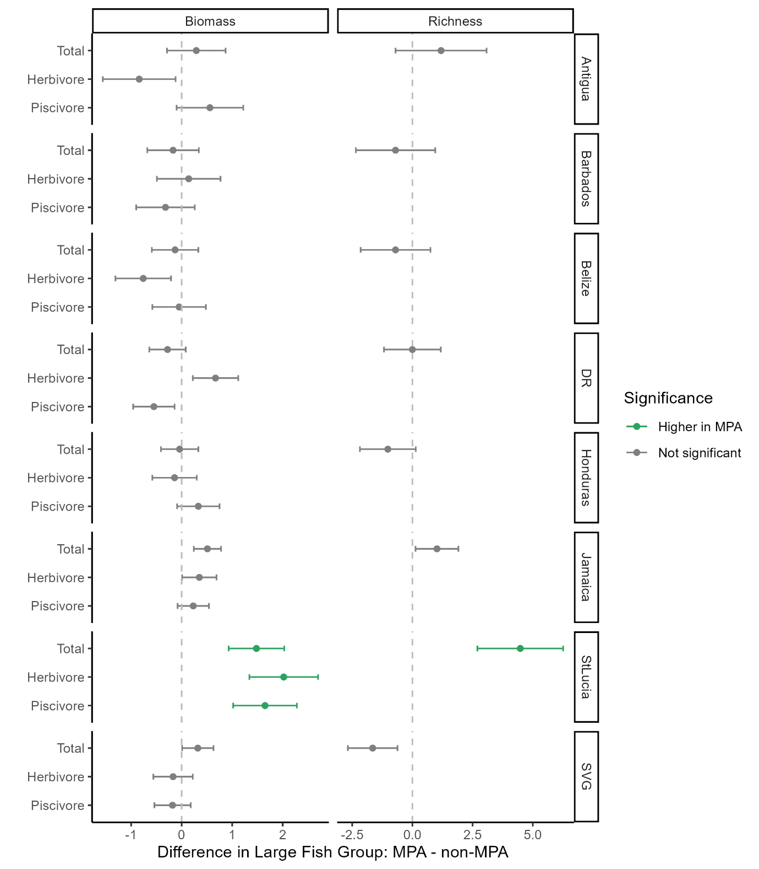
Fig. S2. Effect of MPA presence on large fish total biomass, herbivore biomass, piscivore biomass (g/m²; log +1 transformed), and species richness (species per m²) across all surveyed sites. Each panel represents a different country (DR = Dominican Republic; SVG = Saint Vincent and the Grenadines). Points show the estimated difference in marginal means between MPA and non-MPA sites (MPA – non-MPA), derived from linear mixed-effects models with MPA × Country as fixed effects and a random intercept for site. Error bars indicate standard error.

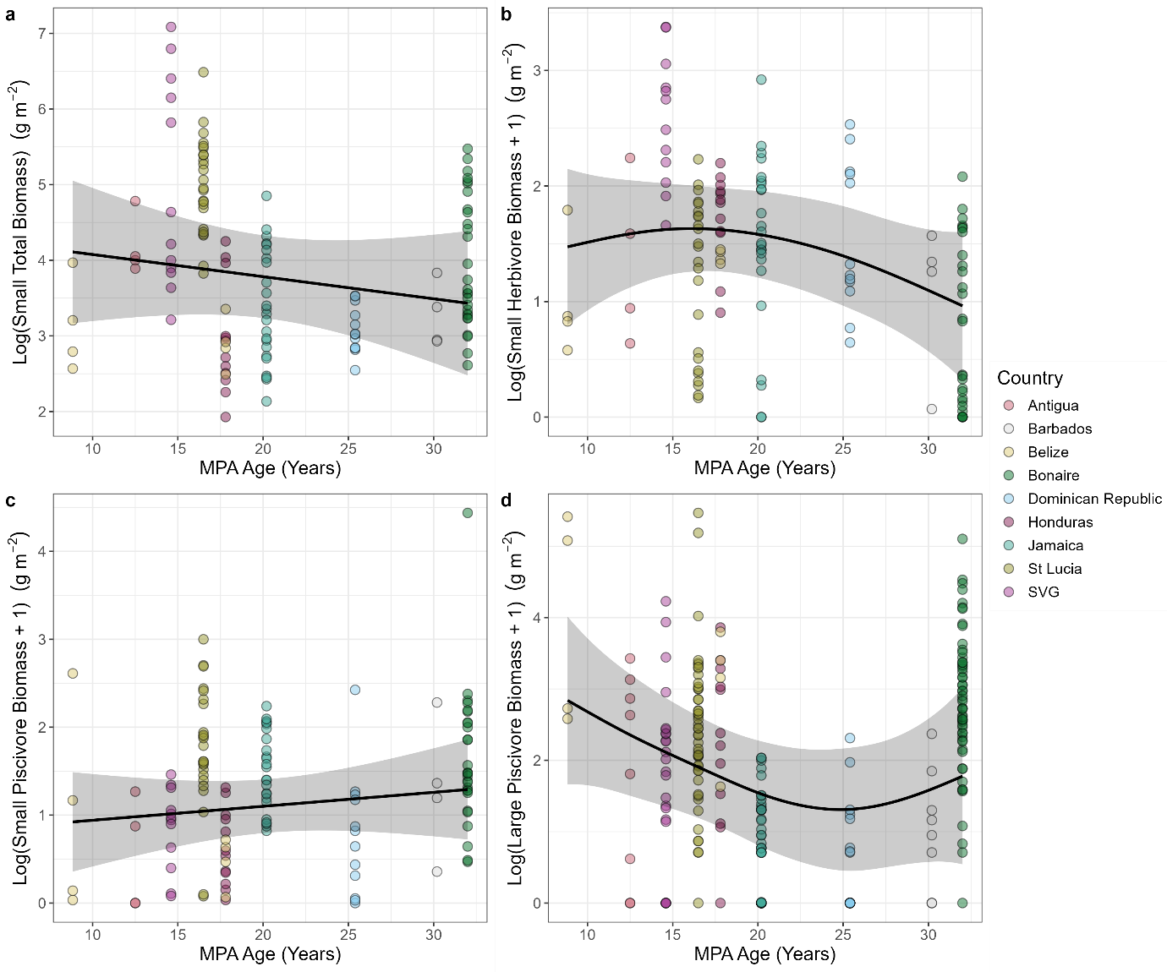
Fig. S3. Relationships between fish biomass and MPA age (years) for variables with non-significant effects (p > 0.05) across surveyed MPAs. Panels show: a) small total biomass, b) small herbivore biomass, c) small piscivore biomass, and d) large piscivore biomass. Models are either generalized additive mixed models (GAMMs; b, d) or linear mixed-effects models (LMMs; a, c), each including MPA age as a fixed effect and country as a random intercept. Biomass data (g/m²) were log+1 transformed, except for small total biomass (log only). Black lines and shaded ribbons show model predictions and 95% confidence intervals; coloured points represent raw, untransformed transect-level observations. SVG = Saint Vincent and the Grenadines.
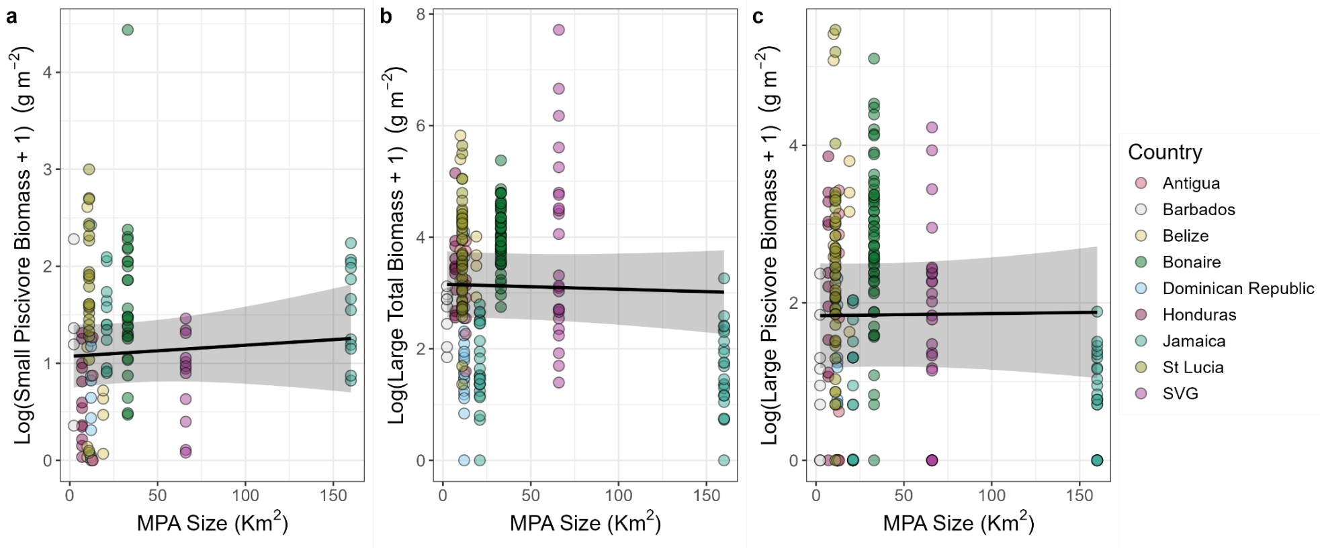
Fig. S4. Relationships between fish biomass and MPA size (km²) for variables with non-significant effects (p > 0.05) across surveyed MPAs. Panels show: a) small piscivore biomass, b) large total biomass, and c) large piscivore biomass. All models are linear mixed-effects models including MPA size as a fixed effect and country as a random intercept. Biomass data (g/m²) were log+1 transformed prior to analysis. Black lines and shaded ribbons show model predictions and 95% confidence intervals; coloured points represent raw, untransformed transect-level observations. SVG = Saint Vincent and the Grenadines.
References
CaMPAM. 2014. Caribbean Marine Protected Area Management Network and Forum. CaMPAM.
Schultz, A. L., H. A. Malcolm, D. J. Bucher, M. Linklater, and S. D. Smith. 2014. Depth and medium-scale spatial processes influence fish assemblage structure of unconsolidated habitats in a subtropical marine park. PLoS ONE 9:e96798.
UNEP-WCMC, I. 2021. Protected Planet: The World Database on Protected Areas (WDPA).

