Supplementary Information

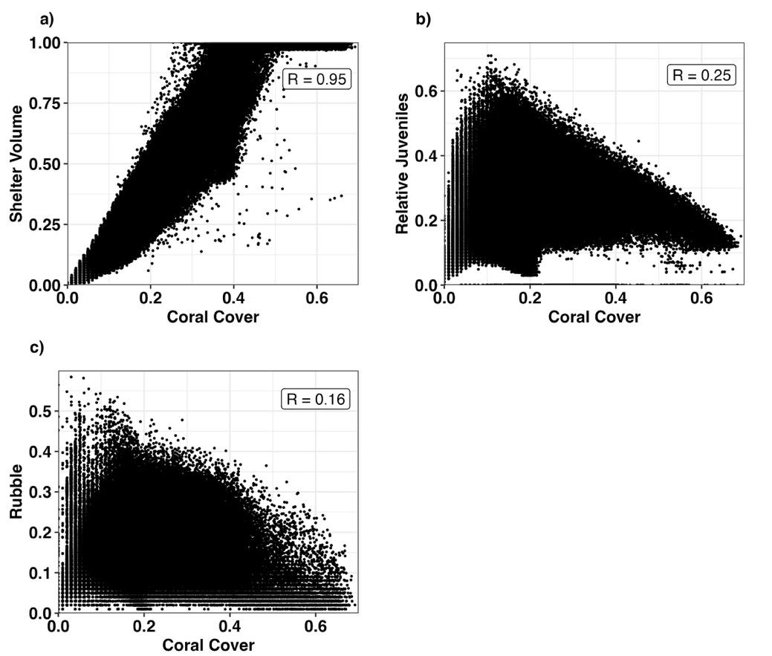
Supplementary Figure 1: Scatter plots of a) Shelter Volume, b) Relative Recruits and c) Rubble against Coral Cover. Each point is an annual observation from one the 3,806 reefs on the GBR, from 2007-2100. See Table 1 for information on how these values were obtained form ReefMod-GBR. In each subplot, Pearson correlation coefficient’s (R) are shown for each variable combination.
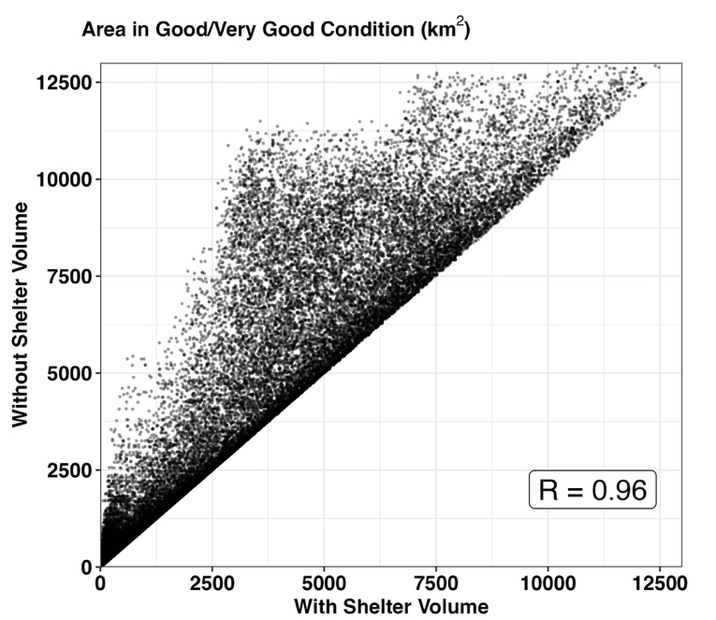
Supplementary Figure 2: Scatter plots of total area across the GBR ranked in Good/Very Good condition with and without relative shelter volume included in the RCI. Each point is an annual observation, from 2007-2100 from an individual Monte Carlo simulation, varying RCI thresholds by $±$25%.

