Supplemental Materials
Host identity shapes Endozoicomonas composition in coral microbiomes across depths and marine protected areas at Little Cayman Island
Authors: Madelaine L. Brown¹, Andrew J. Maritan^{1,2}, Gretchen Goodbody-Gringley^{3,4}, Matthew L. Doherty^{3,5}, Alex D. Chequer^{3,4}, Frank J. Stewart^{1,6}, Zoe A. Pratte¹

Author Affiliations:
- Department of Microbiology & Cell Biology, Montana State University, Bozeman, MT, USA
- Max Planck Institute for Marine Microbiology, Bremen, Germany
- Reef Ecology and Evolutionary Laboratory, Central Caribbean Marine Institute, Little Cayman, Cayman Islands
- Department of Biology, San Diego State University, San Diego, CA, USA
- School of Biological and Marine Sciences, University of Plymouth, Plymouth, U.K.
- School of Biological Sciences, Georgia Institute of Technology, Atlanta, GA, USA
Corresponding Author: Zoe A. Pratte, (zoe.pratte@montana.edu)

Table S1: Number of hard coral samples. Hard corals collected from each sampling site and depth (m and category). Agaricia spp. and M. cavernosa samples were collected from all sampling sites at all sampling depths. Porites astreoides were collected from all sampling sites, but not all sampling depths (m) for The Edge.
Hard Coral Species | Site | Depth (Category) | Depth (m) | Number of Samples
Agaricia spp. | Crystal Palace Wall | shallow photic | 4.5 | 1
Agaricia spp. | Crystal Palace Wall | shallow photic | 9.1 | 1
Agaricia spp. | Crystal Palace Wall | mid photic | 13.7 | 1
Agaricia spp. | Crystal Palace Wall | mid photic | 18.3 | 2
Agaricia spp. | Crystal Palace Wall | deep photic | 22.8 | 2
Agaricia spp. | Crystal Palace Wall | deep photic | 27.5 | 2
Agaricia spp. | Crystal Palace Wall | upper mesophotic | 32 | 2
Agaricia spp. | Crystal Palace Wall | upper mesophotic | 36.6 | 1
Agaricia spp. | McCoy's Wall | shallow photic | 4.5 | 1
Agaricia spp. | McCoy's Wall | shallow photic | 9.1 | 2
Agaricia spp. | McCoy's Wall | mid photic | 13.7 | 1
Agaricia spp. | McCoy's Wall | mid photic | 18.3 | 2
Agaricia spp. | McCoy's Wall | deep photic | 22.8 | 2
Agaricia spp. | McCoy's Wall | deep photic | 27.5 | 2
Agaricia spp. | McCoy's Wall | upper mesophotic | 32 | 3
Agaricia spp. | McCoy's Wall | upper mesophotic | 36.6 | 2
Agaricia spp. | Ron's Rock | shallow photic | 4.5 | 2
Agaricia spp. | Ron's Rock | shallow photic | 9.1 | 1
Agaricia spp. | Ron's Rock | mid photic | 13.7 | 1
Agaricia spp. | Ron's Rock | mid photic | 18.3 | 3
Agaricia spp. | Ron's Rock | deep photic | 22.8 | 2
Agaricia spp. | Ron's Rock | deep photic | 27.5 | 2
Agaricia spp. | Ron's Rock | upper mesophotic | 32 | 2
Agaricia spp. | Ron's Rock | upper mesophotic | 36.6 | 2
Agaricia spp. | The Edge | shallow photic | 4.5 | 2
Agaricia spp. | The Edge | shallow photic | 9.1 | 2
Agaricia spp. | The Edge | mid photic | 13.7 | 2
Agaricia spp. | The Edge | mid photic | 18.3 | 2
Agaricia spp. | The Edge | deep photic | 22.8 | 2
Agaricia spp. | The Edge | deep photic | 27.5 | 2
Agaricia spp. | The Edge | upper mesophotic | 32 | 3
Agaricia spp. | The Edge | upper mesophotic | 36.6 | 3
Montastraea covernosa | Crystal Palace Wall | shallow photic | 4.5 | 1
Montastraea covernosa | Crystal Palace Wall | shallow photic | 9.1 | 1
Montastraea covernosa | Crystal Palace Wall | mid photic | 13.7 | 1
Montastraea covernosa | Crystal Palace Wall | mid photic | 18.3 | 2
Montastraea covernosa | Crystal Palace Wall | deep photic | 22.8 | 2
Montastraea covernosa | Crystal Palace Wall | deep photic | 27.5 | 1
Montastraea covernosa | Crystal Palace Wall | upper mesophotic | 32 | 3
Montastraea covernosa | Crystal Palace Wall | upper mesophotic | 36.6 | 3
Montastraea covernosa | McCoy's Wall | shallow photic | 4.5 | 1
Montastraea covernosa | McCoy's Wall | shallow photic | 9.1 | 1
Montastraea covernosa | McCoy's Wall | mid photic | 13.7 | 1
Montastraea covernosa | McCoy's Wall | mid photic | 18.3 | 3
Montastraea covernosa | McCoy's Wall | deep photic | 22.8 | 2
Montastraea covernosa | McCoy's Wall | deep photic | 27.5 | 3
Montastraea covernosa | McCoy's Wall | upper mesophotic | 32 | 4
Montastraea covernosa | McCoy's Wall | upper mesophotic | 36.6 | 2
Montastraea covernosa | Ron's Rock | shallow photic | 4.5 | 1
Montastraea covernosa | Ron's Rock | shallow photic | 9.1 | 0
Montastraea covernosa | Ron's Rock | mid photic | 13.7 | 3
Montastraea covernosa | Ron's Rock | mid photic | 18.3 | 2
Montastraea covernosa | Ron's Rock | deep photic | 22.8 | 2
Montastraea covernosa | Ron's Rock | deep photic | 27.5 | 1
Montastraea covernosa | Ron's Rock | upper mesophotic | 32 | 2
Montastraea covernosa | Ron's Rock | upper mesophotic | 36.6 | 2
Montastraea covernosa | The Edge | shallow photic | 4.5 | 1
Montastraea covernosa | The Edge | shallow photic | 9.1 | 2
Montastraea covernosa | The Edge | mid photic | 13.7 | 2
Montastraea covernosa | The Edge | mid photic | 18.3 | 2
Montastraea covernosa | The Edge | deep photic | 22.8 | 2
Montastraea covernosa | The Edge | deep photic | 27.5 | 3
Montastraea covernosa | The Edge | upper mesophotic | 32 | 2
Montastraea covernosa | The Edge | upper mesophotic | 36.6 | 2
Porites astreoides | Crystal Palace Wall | shallow photic | 4.5 | 1
Porites astreoides | Crystal Palace Wall | shallow photic | 9.1 | 1
Porites astreoides | Crystal Palace Wall | mid photic | 13.7 | 1
Porites astreoides | Crystal Palace Wall | mid photic | 18.3 | 3
Porites astreoides | Crystal Palace Wall | deep photic | 22.8 | 2
Porites astreoides | Crystal Palace Wall | deep photic | 27.5 | 2
Porites astreoides | Crystal Palace Wall | upper mesophotic | 32 | 2
Porites astreoides | Crystal Palace Wall | upper mesophotic | 36.6 | 1
Porites astreoides | McCoy's Wall | shallow photic | 4.5 | 2
Porites astreoides | McCoy's Wall | shallow photic | 9.1 | 3
Porites astreoides | McCoy's Wall | mid photic | 13.7 | 2
Porites astreoides | McCoy's Wall | mid photic | 18.3 | 3
Porites astreoides | McCoy's Wall | deep photic | 22.8 | 3
Porites astreoides | McCoy's Wall | deep photic | 27.5 | 0
Porites astreoides | McCoy's Wall | upper mesophotic | 32 | 2
Porites astreoides | McCoy's Wall | upper mesophotic | 36.6 | 1
Porites astreoides | Ron's Rock | shallow photic | 4.5 | 2
Porites astreoides | Ron's Rock | shallow photic | 9.1 | 1
Porites astreoides | Ron's Rock | mid photic | 13.7 | 2
Porites astreoides | Ron's Rock | mid photic | 18.3 | 0
Porites astreoides | Ron's Rock | deep photic | 22.8 | 2
Porites astreoides | Ron's Rock | deep photic | 27.5 | 0
Porites astreoides | Ron's Rock | upper mesophotic | 32 | 2
Porites astreoides | Ron's Rock | upper mesophotic | 36.6 | 0
Porites astreoides | The Edge | shallow photic | 4.5 | 0
Porites astreoides | The Edge | shallow photic | 9.1 | 0
Porites astreoides | The Edge | mid photic | 13.7 | 0
Porites astreoides | The Edge | mid photic | 18.3 | 1
Porites astreoides | The Edge | deep photic | 22.8 | 0
Porites astreoides | The Edge | deep photic | 27.5 | 0
Porites astreoides | The Edge | upper mesophotic | 32 | 0
Porites astreoides | The Edge | upper mesophotic | 36.6 | 0

Table S2: Number of soft coral samples. Soft corals collected from each sampling site and depth (m and category). All soft coral groups were collected at all sites; however not all groups were collected at all depths.
Soft Coral Group | Site | Depth (Category) | Depth (m) | Number of Samples
Cladiellidae | Crystal Palace Wall | shallow photic | 4.5 | 0
Cladiellidae | Crystal Palace Wall | shallow photic | 9.1 | 0
Cladiellidae | Crystal Palace Wall | mid photic | 13.7 | 0
Cladiellidae | Crystal Palace Wall | mid photic | 18.3 | 1
Cladiellidae | Crystal Palace Wall | deep photic | 22.8 | 2
Cladiellidae | Crystal Palace Wall | deep photic | 27.5 | 0
Cladiellidae | Crystal Palace Wall | upper mesophotic | 32 | 0
Cladiellidae | Crystal Palace Wall | upper mesophotic | 36.6 | 0
Cladiellidae | McCoy's Wall | shallow photic | 4.5 | 0
Cladiellidae | McCoy's Wall | shallow photic | 9.1 | 2
Cladiellidae | McCoy's Wall | mid photic | 13.7 | 0
Cladiellidae | McCoy's Wall | mid photic | 18.3 | 1
Cladiellidae | McCoy's Wall | deep photic | 22.8 | 0
Cladiellidae | McCoy's Wall | deep photic | 27.5 | 0
Cladiellidae | McCoy's Wall | upper mesophotic | 32 | 0
Cladiellidae | McCoy's Wall | upper mesophotic | 36.6 | 0
Cladiellidae | Ron's Rock | shallow photic | 4.5 | 2
Cladiellidae | Ron's Rock | shallow photic | 9.1 | 5
Cladiellidae | Ron's Rock | mid photic | 13.7 | 0
Cladiellidae | Ron's Rock | mid photic | 18.3 | 3
Cladiellidae | Ron's Rock | deep photic | 22.8 | 2
Cladiellidae | Ron's Rock | deep photic | 27.5 | 0
Cladiellidae | Ron's Rock | upper mesophotic | 32 | 0
Cladiellidae | Ron's Rock | upper mesophotic | 36.6 | 0
Cladiellidae | The Edge | shallow photic | 4.5 | 0
Cladiellidae | The Edge | shallow photic | 9.1 | 1
Cladiellidae | The Edge | mid photic | 13.7 | 1
Cladiellidae | The Edge | mid photic | 18.3 | 1
Cladiellidae | The Edge | deep photic | 22.8 | 0
Cladiellidae | The Edge | deep photic | 27.5 | 0
Cladiellidae | The Edge | upper mesophotic | 32 | 1
Cladiellidae | The Edge | upper mesophotic | 36.6 | 2
Gorgoniidae | Crystal Palace Wall | shallow photic | 4.5 | 0
Gorgoniidae | Crystal Palace Wall | shallow photic | 9.1 | 1
Gorgoniidae | Crystal Palace Wall | mid photic | 13.7 | 0
Gorgoniidae | Crystal Palace Wall | mid photic | 18.3 | 2
Gorgoniidae | Crystal Palace Wall | deep photic | 22.8 | 0
Gorgoniidae | Crystal Palace Wall | deep photic | 27.5 | 1
Gorgoniidae | Crystal Palace Wall | upper mesophotic | 32 | 1
Gorgoniidae | Crystal Palace Wall | upper mesophotic | 36.6 | 0
Gorgoniidae | McCoy's Wall | shallow photic | 4.5 | 1
Gorgoniidae | McCoy's Wall | shallow photic | 9.1 | 2
Gorgoniidae | McCoy's Wall | mid photic | 13.7 | 1
Gorgoniidae | McCoy's Wall | mid photic | 18.3 | 2
Gorgoniidae | McCoy's Wall | deep photic | 22.8 | 2
Gorgoniidae | McCoy's Wall | deep photic | 27.5 | 1
Gorgoniidae | McCoy's Wall | upper mesophotic | 32 | 1
Gorgoniidae | McCoy's Wall | upper mesophotic | 36.6 | 0
Gorgoniidae | Ron's Rock | shallow photic | 4.5 | 0
Gorgoniidae | Ron's Rock | shallow photic | 9.1 | 0
Gorgoniidae | Ron's Rock | mid photic | 13.7 | 2
Gorgoniidae | Ron's Rock | mid photic | 18.3 | 1
Gorgoniidae | Ron's Rock | deep photic | 22.8 | 1
Gorgoniidae | Ron's Rock | deep photic | 27.5 | 0
Gorgoniidae | Ron's Rock | upper mesophotic | 32 | 2
Gorgoniidae | Ron's Rock | upper mesophotic | 36.6 | 1
Gorgoniidae | The Edge | shallow photic | 4.5 | 0
Gorgoniidae | The Edge | shallow photic | 9.1 | 1
Gorgoniidae | The Edge | mid photic | 13.7 | 0
Gorgoniidae | The Edge | mid photic | 18.3 | 0
Gorgoniidae | The Edge | deep photic | 22.8 | 0
Gorgoniidae | The Edge | deep photic | 27.5 | 0
Gorgoniidae | The Edge | upper mesophotic | 32 | 0
Gorgoniidae | The Edge | upper mesophotic | 36.6 | 0
Malacalcyonacea | Crystal Palace Wall | shallow photic | 4.5 | 2
Malacalcyonacea | Crystal Palace Wall | shallow photic | 9.1 | 1
Malacalcyonacea | Crystal Palace Wall | mid photic | 13.7 | 1
Malacalcyonacea | Crystal Palace Wall | mid photic | 18.3 | 1
Malacalcyonacea | Crystal Palace Wall | deep photic | 22.8 | 1
Malacalcyonacea | Crystal Palace Wall | deep photic | 27.5 | 0
Malacalcyonacea | Crystal Palace Wall | upper mesophotic | 32 | 0
Malacalcyonacea | Crystal Palace Wall | upper mesophotic | 36.6 | 1
Malacalcyonacea | McCoy's Wall | shallow photic | 4.5 | 3
Malacalcyonacea | McCoy's Wall | shallow photic | 9.1 | 1
Malacalcyonacea | McCoy's Wall | mid photic | 13.7 | 2
Malacalcyonacea | McCoy's Wall | mid photic | 18.3 | 0
Malacalcyonacea | McCoy's Wall | deep photic | 22.8 | 0
Malacalcyonacea | McCoy's Wall | deep photic | 27.5 | 0
Malacalcyonacea | McCoy's Wall | upper mesophotic | 32 | 1
Malacalcyonacea | McCoy's Wall | upper mesophotic | 36.6 | 0
Malacalcyonacea | Ron's Rock | shallow photic | 4.5 | 0
Malacalcyonacea | Ron's Rock | shallow photic | 9.1 | 0
Malacalcyonacea | Ron's Rock | mid photic | 13.7 | 1
Malacalcyonacea | Ron's Rock | mid photic | 18.3 | 0
Malacalcyonacea | Ron's Rock | deep photic | 22.8 | 0
Malacalcyonacea | Ron's Rock | deep photic | 27.5 | 0
Malacalcyonacea | Ron's Rock | upper mesophotic | 32 | 0
Malacalcyonacea | Ron's Rock | upper mesophotic | 36.6 | 0
Malacalcyonacea | The Edge | shallow photic | 4.5 | 1
Malacalcyonacea | The Edge | shallow photic | 9.1 | 2
Malacalcyonacea | The Edge | mid photic | 13.7 | 0
Malacalcyonacea | The Edge | mid photic | 18.3 | 2
Malacalcyonacea | The Edge | deep photic | 22.8 | 0
Malacalcyonacea | The Edge | deep photic | 27.5 | 0
Malacalcyonacea | The Edge | upper mesophotic | 32 | 0
Malacalcyonacea | The Edge | upper mesophotic | 36.6 | 0
Muricea spp. | Crystal Palace Wall | shallow photic | 4.5 | 1
Muricea spp. | Crystal Palace Wall | shallow photic | 9.1 | 1
Muricea spp. | Crystal Palace Wall | mid photic | 13.7 | 2
Muricea spp. | Crystal Palace Wall | mid photic | 18.3 | 0
Muricea spp. | Crystal Palace Wall | deep photic | 22.8 | 3
Muricea spp. | Crystal Palace Wall | deep photic | 27.5 | 3
Muricea spp. | Crystal Palace Wall | upper mesophotic | 32 | 3
Muricea spp. | Crystal Palace Wall | upper mesophotic | 36.6 | 3
Muricea spp. | McCoy's Wall | shallow photic | 4.5 | 4
Muricea spp. | McCoy's Wall | shallow photic | 9.1 | 3
Muricea spp. | McCoy's Wall | mid photic | 13.7 | 0
Muricea spp. | McCoy's Wall | mid photic | 18.3 | 1
Muricea spp. | McCoy's Wall | deep photic | 22.8 | 3
Muricea spp. | McCoy's Wall | deep photic | 27.5 | 0
Muricea spp. | McCoy's Wall | upper mesophotic | 32 | 3
Muricea spp. | McCoy's Wall | upper mesophotic | 36.6 | 1
Muricea spp. | Ron's Rock | shallow photic | 4.5 | 2
Muricea spp. | Ron's Rock | shallow photic | 9.1 | 0
Muricea spp. | Ron's Rock | mid photic | 13.7 | 3
Muricea spp. | Ron's Rock | mid photic | 18.3 | 0
Muricea spp. | Ron's Rock | deep photic | 22.8 | 3
Muricea spp. | Ron's Rock | deep photic | 27.5 | 3
Muricea spp. | Ron's Rock | upper mesophotic | 32 | 1
Muricea spp. | Ron's Rock | upper mesophotic | 36.6 | 3
Muricea spp. | The Edge | shallow photic | 4.5 | 2
Muricea spp. | The Edge | shallow photic | 9.1 | 2
Muricea spp. | The Edge | mid photic | 13.7 | 3
Muricea spp. | The Edge | mid photic | 18.3 | 2
Muricea spp. | The Edge | deep photic | 22.8 | 3
Muricea spp. | The Edge | deep photic | 27.5 | 2
Muricea spp. | The Edge | upper mesophotic | 32 | 2
Muricea spp. | The Edge | upper mesophotic | 36.6 | 3

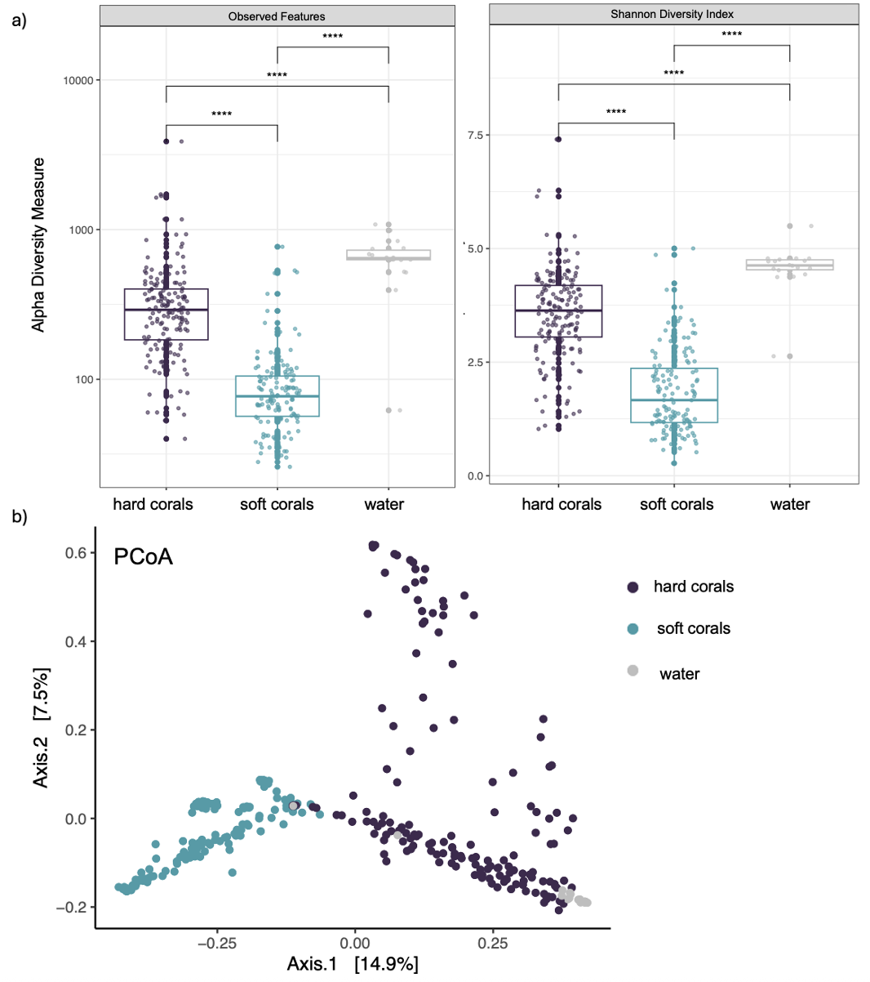
FigS1 Hard corals have distinct and more diverse microbiomes than soft corals. a) Alpha diversity (observed features in log scale and Shannon diversity index in linear scale) comparing hard corals, soft coral, and water sample microbiomes. Significance: **** P $≤$0.0001, ***P < 0.001, **P < 0.01, *P < 0.05. b) Beta diversity comparing hard corals, soft coral, and water sample microbiomes plotted using Principal Coordinate Analysis and Bray-Curtis

Table S3: Pairwise Wilcoxon rank-sum tests with Benjamini-Hochberg adjustment for observed ASV richness. Comparisons were performed among hard corals, soft corals, and water samples.
Group 1 | Group 2 | n1 | n2 | Statistic | p.adj
hard coral | soft coral | 159 | 132 | 19282.5 | < 0.001*
hard coral | water | 159 | 18 | 400 | < 0.001*
soft coral | water | 132 | 18 | 109 | < 0.001*
* P > 0.05

Table S4: Pairwise Wilcoxon rank-sum tests with Benjamini-Hochberg adjustment for Shannon diversity. Comparisons were performed among hard corals, soft corals, and water samples.
Group 1 | Group 2 | n1 | n2 | Statistic | p.adj
hard coral | soft coral | 159 | 132 | 19100 | < 0.001*
hard coral | water | 159 | 18 | 336 | < 0.001*
soft coral | water | 132 | 18 | 40 | < 0.001*
* P > 0.05

Table S5: Pairwise PERMANOVA (beta diversity) between hard and soft corals, and water samples.
pairs | Df | SumsOfSqs | F.Model | R2 | p.adj
hard coral vs soft coral | 1 | 14.61 | 37.16 | 0.13 | 0.003*ª
hard coral vs water | 1 | 2.63 | 7.59 | 0.04 | 0.003*ª
soft coral vs water | 1 | 7.14 | 18.43 | 0.11 | 0.003*ª
*PERMANOVA P > 0.05, ªPERMDISP P < 0.05

Table S6: Pairwise Wilcoxon rank-sum tests with Benjamini-Hochberg adjustment for observed ASV richness. Comparisons were performed between coral types.
Group 1 | Group 2 | n1 | n2 | Statistic | p.adj
Montastraea cavernosa | Muricea spp. | 60 | 65 | 3823 | < 0.001*
Agaricia spp. | Muricea spp. | 60 | 65 | 3635 | < 0.001*
Porites astreoides | Muricea spp. | 39 | 65 | 2461.5 | < 0.001*
Montastraea cavernosa | Malacalcyonacea | 60 | 20 | 1182 | < 0.001*
Montastraea cavernosa | Gorgoniidae | 60 | 23 | 1293 | < 0.001*
Porites astreoides | Malacalcyonacea | 39 | 20 | 757 | < 0.001*
Agaricia spp. | Malacalcyonacea | 60 | 20 | 1109.5 | < 0.001*
Porites astreoides | Gorgoniidae | 39 | 23 | 815 | < 0.001*
Montastraea cavernosa | Cladiellidae | 60 | 24 | 1203 | < 0.001*
Gorgoniidae | Muricea spp. | 23 | 65 | 1230.5 | < 0.001*
Agaricia spp. | Gorgoniidae | 60 | 23 | 1144.5 | < 0.001*
Porites astreoides | Cladiellidae | 39 | 24 | 777 | < 0.001*
Gorgoniidae | Malacalcyonacea | 23 | 20 | 408 | < 0.001*
Cladiellidae | Muricea spp. | 24 | 65 | 1240 | < 0.001*
Agaricia spp. | Cladiellidae | 60 | 24 | 1082 | < 0.001*
Cladiellidae | Malacalcyonacea | 24 | 20 | 373 | 0.002*
Malacalcyonacea | Muricea spp. | 20 | 65 | 833 | 0.072
Agaricia spp. | Montastraea cavernosa | 60 | 60 | 1538 | 0.153
Agaricia spp. | Porites astreoides | 60 | 39 | 1025.5 | 0.274
Montastraea cavernosa | Porites astreoides | 60 | 39 | 1264.5 | 0.526
Cladiellidae | Gorgoniidae | 24 | 23 | 272 | 0.941
* P > 0.05

Table S7: Pairwise Wilcoxon rank-sum tests with Benjamini-Hochberg adjustment for Shannon diversity. Comparisons were performed between coral types.
Group1 | Group2 | n1 | n2 | statistic | p.adj
Agaricia spp. | Muricea spp. | 60 | 65 | 3897 | < 0.001*
Montastraea cavernosa | Muricea spp. | 60 | 65 | 3855 | < 0.001*
Porites astreoides | Muricea spp. | 39 | 65 | 2267 | < 0.001*
Agaricia spp. | Malacalcyonacea | 60 | 20 | 1175 | < 0.001*
Montastraea cavernosa | Malacalcyonacea | 60 | 20 | 1156 | < 0.001*
Gorgoniidae | Muricea spp. | 23 | 65 | 1360 | < 0.001*
Agaricia spp. | Gorgoniidae | 60 | 23 | 1262 | < 0.001*
Montastraea cavernosa | Gorgoniidae | 60 | 23 | 1187 | < 0.001*
Agaricia spp. | Cladiellidae | 60 | 24 | 1247 | < 0.001*
Montastraea cavernosa | Cladiellidae | 60 | 24 | 1222 | < 0.001*
Cladiellidae | Muricea spp. | 24 | 65 | 1271 | < 0.001*
Porites astreoides | Malacalcyonacea | 39 | 20 | 649 | < 0.001*
Gorgoniidae | Malacalcyonacea | 23 | 20 | 381 | < 0.001*
Agaricia spp. | Porites astreoides | 60 | 39 | 1705 | < 0.001*
Montastraea cavernosa | Porites astreoides | 60 | 39 | 1554 | 0.008*
Cladiellidae | Malacalcyonacea | 24 | 20 | 339 | 0.025*
Porites astreoides | Cladiellidae | 39 | 24 | 614 | 0.048*
Porites astreoides | Gorgoniidae | 39 | 23 | 569 | 0.094
Agaricia spp. | Montastraea cavernosa | 60 | 60 | 2146 | 0.108
Malacalcyonacea | Muricea spp. | 20 | 65 | 808 | 0.108
Cladiellidae | Gorgoniidae | 24 | 23 | 212 | 0.178
* P > 0.05

Table S8: Pairwise PERMANOVA (beta diversity) of all coral microbiomes by coral groups.
pairs | Df | SumsOfSqs | F.Model | R2 | p.adj
Cladiellidae vs Muricea spp. | 1 | 3.36 | 9.58 | 0.10 | 0.02*
Montastraea cavernosa vs Gorgoniidae | 1 | 5.91 | 18.61 | 0.19 | 0.02*
Cladiellidae vs Agaricia spp. | 1 | 5.03 | 14.41 | 0.15 | 0.02*
Agaricia spp. vs Muricea spp. | 1 | 10.06 | 29.41 | 0.19 | 0.02*
Montastraea cavernosa vs Agaricia spp. | 1 | 3.26 | 9.94 | 0.08 | 0.02*
Agaricia spp. vs Gorgoniidae | 1 | 5.47 | 16.23 | 0.17 | 0.02*
Cladiellidae vs Montastraea cavernosa | 1 | 5.45 | 16.55 | 0.17 | 0.02*
Cladiellidae vs Gorgoniidae | 1 | 1.44 | 4.12 | 0.08 | 0.04*
Muricea spp. vs Gorgoniidae | 1 | 4.78 | 14.09 | 0.14 | 0.02*
Montastraea cavernosa vs Muricea spp. | 1 | 10.79 | 32.76 | 0.21 | 0.02*
Porites astreoides vs Malacalcyonacea | 1 | 6.80 | 26.81 | 0.32 | 0.02*
Porites astreoides vs Gorgoniidae | 1 | 5.91 | 20.44 | 0.25 | 0.02*
Porites astreoides vs Montastraea cavernosa | 1 | 6.78 | 22.94 | 0.19 | 0.02*
Porites astreoides vs Cladiellidae | 1 | 5.50 | 18.00 | 0.23 | 0.02*
Gorgoniidae vs Malacalcyonacea | 1 | 4.73 | 16.81 | 0.29 | 0.02*
Porites astreoides vs Agaricia spp. | 1 | 5.02 | 16.10 | 0.14 | 0.02*
Porites astreoides vs Muricea spp. | 1 | 9.65 | 30.65 | 0.23 | 0.02*ª
Montastraea cavernosa vs Malacalcyonacea | 1 | 6.97 | 23.78 | 0.23 | 0.02*ª
Cladiellidae vs Malacalcyonacea | 1 | 4.11 | 13.47 | 0.24 | 0.02*ª
Agaricia spp. vs Malacalcyonacea | 1 | 6.60 | 21.05 | 0.21 | 0.02*ª
Muricea spp. vs Malacalcyonacea | 1 | 6.62 | 20.87 | 0.20 | 0.02*ª
*PERMANOVA P > 0.05, ªPERMDISP P < 0.05

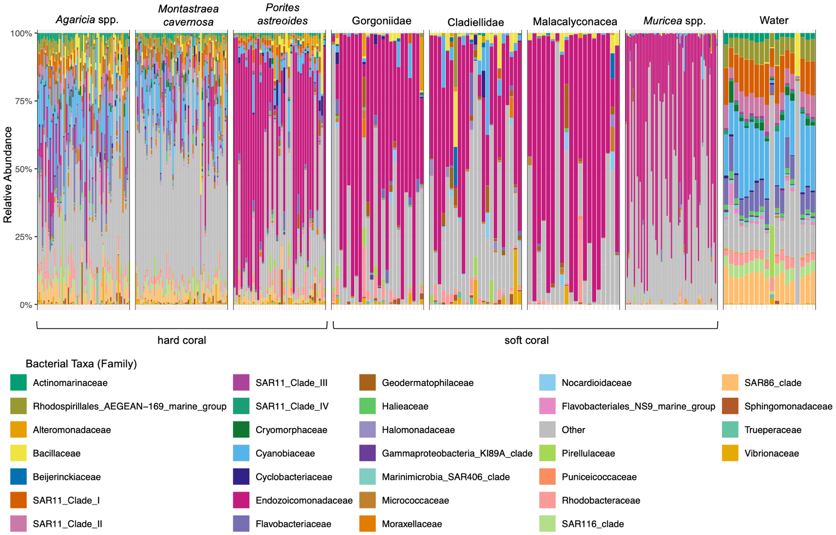
FigS2 Porites astreoides, Gorgoniidae, Cladiellidae, Malacalyconacea and Muricea spp. microbiomes are dominated by Endozoicomonadaceae. Microbiome community composition by bacterial family with ASVs detected with a minimum relative abundance of 25% (detection) in 50% of all samples (prevalence). All soft corals, and one hard coral microbiome, P. astreoides, were dominated by Endozoicomonadaceae. The other hard corals, Agaricia spp. and M. cavernosa, microbiomes family with the highest relative abundance was Cyanobiaceae. Water samples had a distinct microbial community compared to corals. Other represents all ASVs that did not reach the detection and prevalence limits

Table S9: Pairwise Kruskal-Wallis test of soft coral Endozoicomonas relative abundance by site. Ron’s Rock and The Edge have significantly higher Endozoicomonas relative abundance than McCoy’s Wall. Ron’s Rock also has significantly higher Endozoicomonas relative abundance than Crystal Palace Wall.
group1 | group2 | n1 | n2 | statistic | p.adj
Mccoy’s Wall | Ron’s Rock | 35 | 35 | 339 | 0.01*
Crystal Palace Wall | Ron’s Rock | 31 | 35 | 349 | 0.04*
Mccoy’s Wall | The Edge | 35 | 31 | 363 | 0.04*
Crystal Palace Wall | Mccoy’s Wall | 31 | 35 | 643 | 0.24
Crystal Palace Wall | The Edge | 31 | 31 | 384 | 0.24
Ron’s Rock | The Edge | 35 | 31 | 593 | 0.52
* P > 0.05

Table S10: Pairwise Kruskal-Wallis test of hard coral Endozoicomonas relative abundance by depth (m). There were significantly higher relative abundances of Endozoicomonas at 9.1 m compared to 32 and 26.6 m, and 13.7 m compared to 26.6 m.
group1 | group2 | n1 | n2 | statistic | p.adj
32 | 9.1 | 27 | 15 | 69 | 0.01*
36.6 | 9.1 | 19 | 15 | 45 | 0.01*
13.7 | 36.6 | 17 | 19 | 258 | 0.02*
13.7 | 32 | 17 | 27 | 340 | 0.05*
18.3 | 36.6 | 25 | 19 | 342 | 0.07
27.5 | 36.6 | 18 | 19 | 242 | 0.14
27.5 | 32 | 18 | 27 | 325.5 | 0.19
4.5 | 9.1 | 15 | 15 | 66 | 0.19
13.7 | 4.5 | 17 | 15 | 175 | 0.21
18.3 | 32 | 25 | 27 | 434.5 | 0.21
13.7 | 22.8 | 17 | 23 | 251 | 0.3
18.3 | 9.1 | 25 | 15 | 137 | 0.3
22.8 | 36.6 | 23 | 19 | 273 | 0.3
22.8 | 9.1 | 23 | 15 | 120 | 0.3
27.5 | 9.1 | 18 | 15 | 95 | 0.3
18.3 | 4.5 | 25 | 15 | 224.5 | 0.53
13.7 | 18.3 | 17 | 25 | 245 | 0.55
13.7 | 9.1 | 17 | 15 | 105 | 0.55
22.8 | 32 | 23 | 27 | 357 | 0.55
27.5 | 4.5 | 18 | 15 | 159.5 | 0.55
32 | 36.6 | 27 | 19 | 293 | 0.55
13.7 | 27.5 | 17 | 18 | 175 | 0.58
36.6 | 4.5 | 19 | 15 | 122 | 0.58
18.3 | 22.8 | 25 | 23 | 320 | 0.59
22.8 | 4.5 | 23 | 15 | 190 | 0.67
32 | 4.5 | 27 | 15 | 188.5 | 0.77
18.3 | 27.5 | 25 | 18 | 236.5 | 0.82
22.8 | 27.5 | 23 | 18 | 200 | 0.86
* P > 0.05

Table S11: Pairwise Kruskal-Wallis test of hard coral Endozoicomonas relative abundance by depth (category). There were significantly higher relative abundances of Endozoicomonas at shallow and mid photic depths compared to upper mesophotic.
group1 | group2 | n1 | n2 | statistic | p.adj
upper mesophotic | mid photic | 46 | 42 | 557.5 | 0.004*
upper mesophotic | shallow photic | 46 | 30 | 424.5 | 0.01*
upper mesophotic | deep photic | 46 | 41 | 688.5 | 0.06
deep photic | mid photic | 41 | 42 | 739.5 | 0.4
deep photic | shallow photic | 41 | 30 | 564.5 | 0.67
shallow photic | mid photic | 30 | 42 | 618.5 | 0.9
* P > 0.05

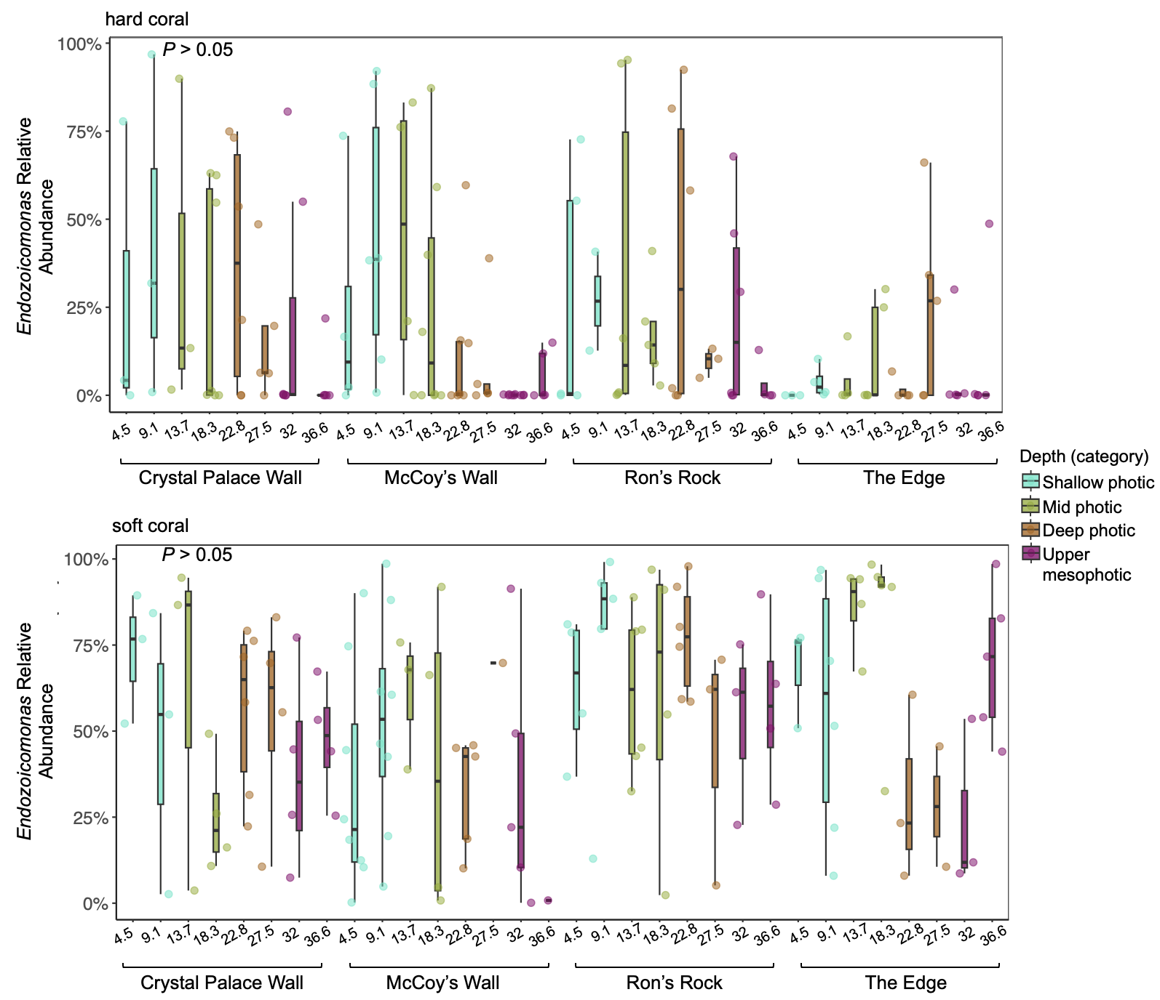
FigS3: Endozoicomonas relative abundance does not vary by depth at any site. Hard and soft coral Endozoicomonas relative abundance plotted for every depth (m) at every site shows no significant differences (Kruskal Wallace test, P > 0.05)

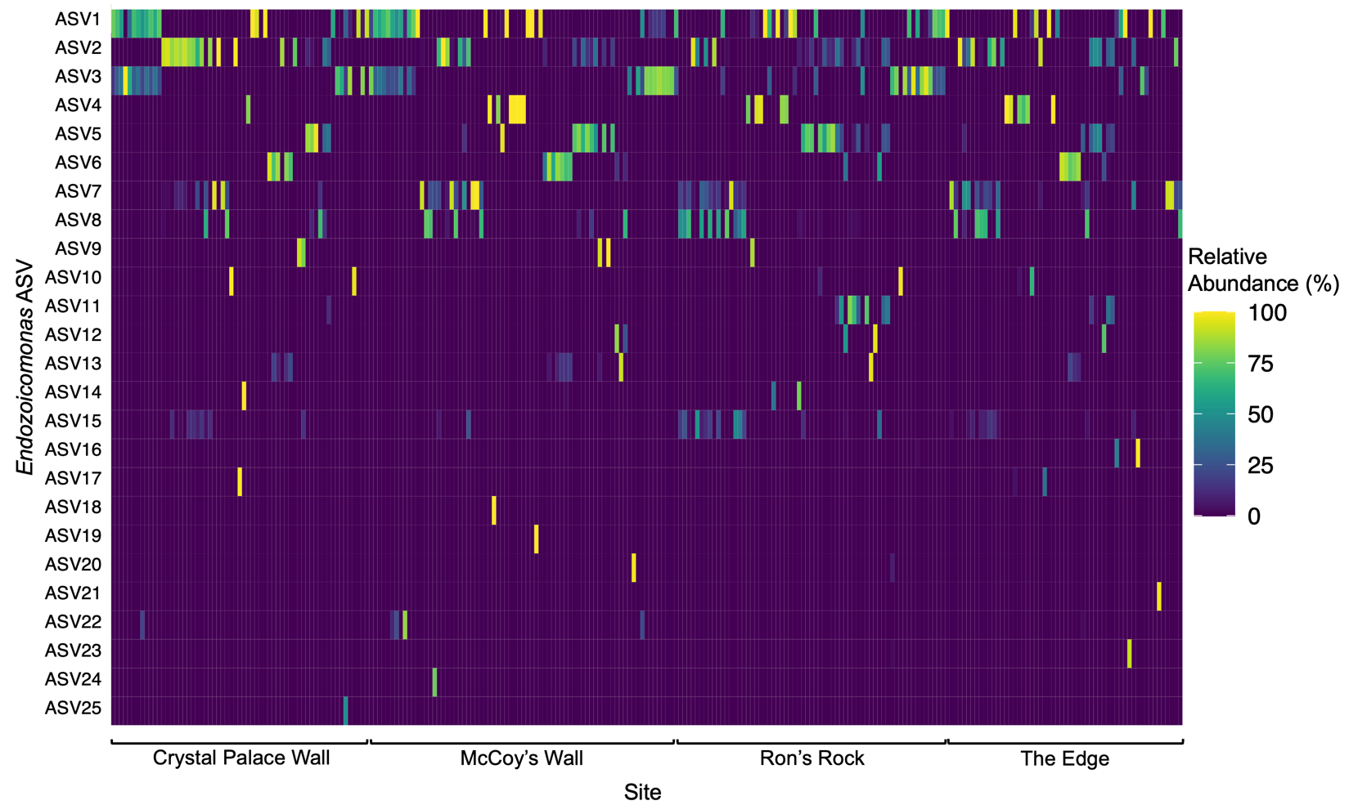
FigS4 Endozoicomonas ASV diversity is not shaped by sample site. ASVs identified as Endozoicomonas with a relative abundance $≥$50% in at least one coral sample were plotted and organized by sample site. Crystal Palace Wall and McCoy’s Wall are MPAs while Ron’s Rock and The Edge are not. There are no patterns between Endozoicomonas ASV diversity and site
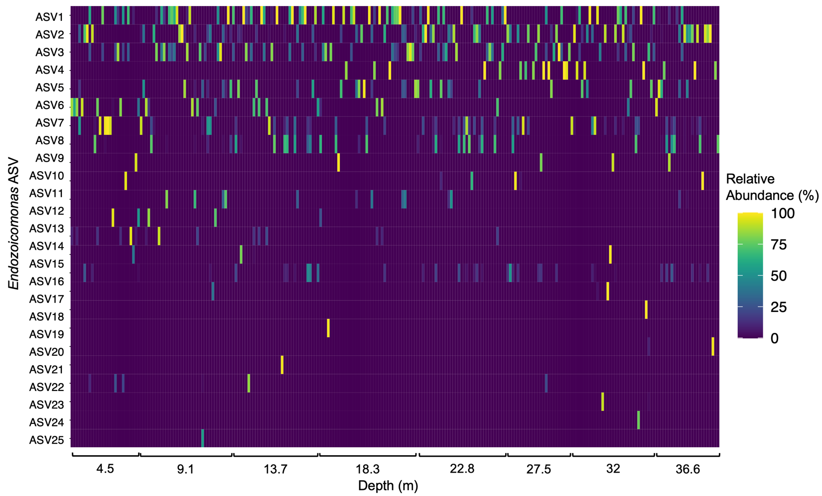
FigS5 Endozoicomonas ASV diversity is not shaped by depth (m). ASVs identified as Endozoicomonas with a relative abundance $≥$50% in at least one coral sample were plotted and organized by sample cite. Depths (m) 4.5 and 9.1 represent shallow photic reefs, 13.7 and 18.3 mid photic reefs, 22.8 and 27.5 deep photic, and 32 and 36.6 upper mesophotic reefs. There are no patterns between Endozoicomonas ASV diversity and depth (m)

Table S12: Endozoicomonas ASV reference matches (BLASTn). ASVs identified as Endozoicomonas with a relative abundance $≥$50% in at least one coral sample and their closest reference match using BLASTn.
ASV | Accession | Host type | Host | Per. Identity | Reference
ASV1 | NR_199442.1 | soft coral | Litophyton sp. | 96.1% | (da Silva et al., 2025)
ASV2 | NR_199442.1 | soft coral | Litophyton sp. | 95.7% | (da Silva et al., 2025)
ASV3 | NR_199442.1 | soft coral | Litophyton sp. | 98.7% | (da Silva et al., 2025)
ASV4 | NR_109684.2 | soft coral | Eunicea fusca and Plexaura sp. | 100% | (Pike et al., 2013)
ASV5 | NR_199442.1 | soft coral | Litophyton sp. | 100% | (da Silva et al., 2025)
ASV6 | NR_109684.2 | soft coral | Eunicea fusca and Plexaura sp. | 99.6% | (Pike et al., 2013)
ASV7 | NR_199442.1 | soft coral | Litophyton sp. | 100% | (da Silva et al., 2025)
ASV8 | NR_109684.2 | soft coral | Eunicea fusca and Plexaura sp. | 100% | (Pike et al., 2013)
ASV9 | NR_199442.1 | soft coral | Litophyton sp. | 98.7% | (da Silva et al., 2025)
ASV10 | NR_116609.1 | hard coral | Montipora aequituberculata | 100% | (Yang et al., 2010)
ASV11 | NR_146692.1 | sea squirt | Scandinavian ascidians | 92.6% | (Schreiber et al., 2016)
ASV12 | NR_199442.1 | soft coral | Litophyton sp. | 98.7% | (da Silva et al., 2025)
ASV13 | NR_199442.1 | soft coral | Litophyton sp. | 98.7% | (da Silva et al., 2025)
ASV14 | NR_199442.1 | soft coral | Litophyton sp. | 99.6% | (da Silva et al., 2025)
ASV15 | NR_109684.2 | soft coral | Eunicea fusca and Plexaura sp. | 99.6% | (Pike et al., 2013)
ASV16 | NR_116609.1 | hard coral | Montipora aequituberculata | 99.6% | (Yang et al., 2010)
ASV17 | NR_116609.1 | hard coral | Montipora aequituberculata | 100% | (Yang et al., 2010)
ASV18 | NR_199442.1 | soft coral | Litophyton sp. | 96.8% | (da Silva et al., 2025)
ASV19 | NR_146692.1 | sea squirt | Scandinavian ascidians | 97.4% | (Schreiber et al., 2016)
ASV20 | NR_116609.1 | hard coral | Montipora aequituberculata | 99.6% | (Yang et al., 2010)
ASV21 | NR_158127.1 | hard coral | Acropora sp. | 98.7% | (Sheu et al., 2017)
ASV22 | NR_146692.1 | sea squirt | Scandinavian ascidians | 96.8% | (Schreiber et al., 2016)
ASV23 | NR_199442.1 | soft coral | Litophyton sp. | 97.8% | (da Silva et al., 2025)
ASV24 | NR_146692.1 | sea squirt | Scandinavian ascidians | 96.8% | (Schreiber et al., 2016)
ASV25 | NR_199442.1 | soft coral | Litophyton sp. | 98.3% | (da Silva et al., 2025)

References
da Silva, D. M. G., Marques, M., Couceiro, J. F., Santos, E., Baylina, N., Costa, R., & Keller-Costa, T. (2025). Endozoicomonas lisbonensis sp. nov., a novel marine bacterium isolated from the soft coral Litophyton sp. at Oceanario de Lisboa in Portugal. Int J Syst Evol Microbiol, 75(3). https://doi.org/10.1099/ijsem.0.006696
Pike, R. E., Haltli, B., & Kerr, R. G. (2013). Description of Endozoicomonas euniceicola sp. nov. and Endozoicomonas gorgoniicola sp. nov., bacteria isolated from the octocorals Eunicea fusca and Plexaura sp., and an emended description of the genus Endozoicomonas. Int J Syst Evol Microbiol, 63(Pt 11), 4294-4302. https://doi.org/10.1099/ijs.0.051490-0
Schreiber, L., Kjeldsen, K. U., Obst, M., Funch, P., & Schramm, A. (2016). Description of Endozoicomonas ascidiicola sp. nov., isolated from Scandinavian ascidians. Syst Appl Microbiol, 39(5), 313-318. https://doi.org/10.1016/j.syapm.2016.05.008
Sheu, S. Y., Lin, K. R., Hsu, M. Y., Sheu, D. S., Tang, S. L., & Chen, W. M. (2017). Endozoicomonas acroporae sp. nov., isolated from Acropora coral. Int J Syst Evol Microbiol, 67(10), 3791-3797. https://doi.org/10.1099/ijsem.0.002194
Yang, C. S., Chen, M. H., Arun, A. B., Chen, C. A., Wang, J. T., & Chen, W. M. (2010). Endozoicomonas montiporae sp. nov., isolated from the encrusting pore coral Montipora aequituberculata. Int J Syst Evol Microbiol, 60(Pt 5), 1158-1162. https://doi.org/10.1099/ijs.0.014357-0

