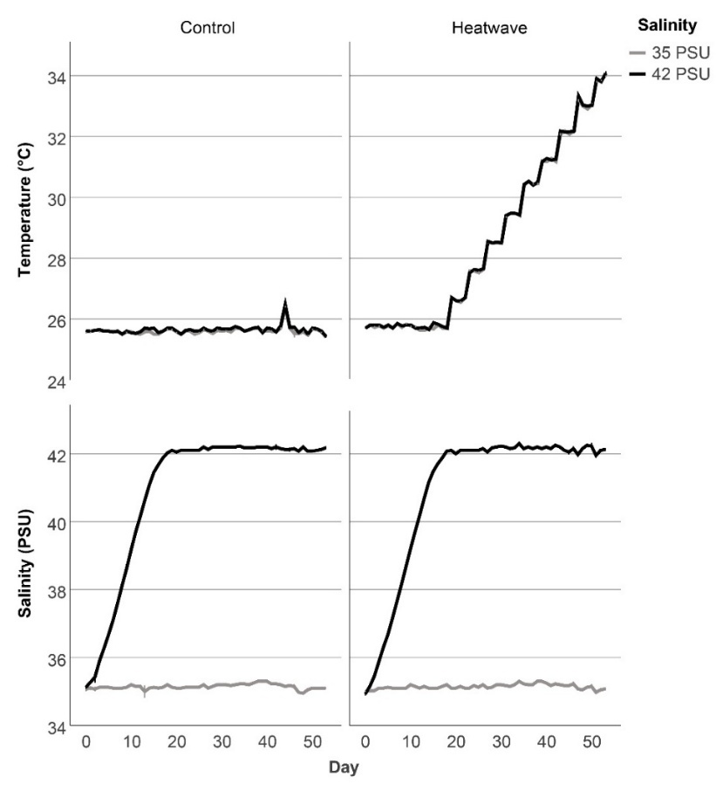
Supplementary Fig. 1 Temperature and salinity values in the 16 aquaria over the course of the experiment. Values are means ± s.e.m. (N=4 aquaria per treatment combination).

