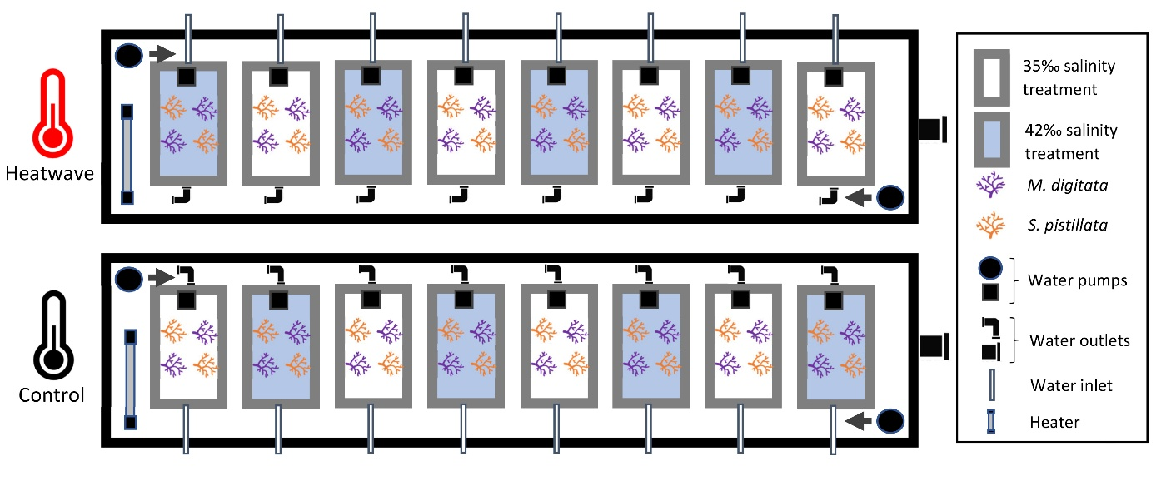
Supplementary Fig. 2 Overview of experimental setup. Replicates existed of 12L plastic aquaria (filled to ~8L seawater) each containing 2 S. pistillata (depicted in red) and 2 M. digitata (depicted in purple) microcolonies. Two basins each contained 8 aquaria, forming a control and heatwave group. All 16 aquaria were partially submerged in the water basins to ensure stable temperatures. Grey arrows depict circular water flow through the basins created by 8000 L h⁻¹ water pumps to prevent temperature gradients. Within each temperature treatment, 4 aquaria were exposed to a salinity of 42 PSU, while the other 4 aquaria were maintained at the control salinity of 35 PSU. Salinity treatments were placed alternated. Seawater was pumped into the aquaria through individual water inlets, while water outlets (20 mm PVC bulkheads) in each aquarium allowed excess seawater to flow out. This water was then released out of the system through water outlets in the basins. The seawater did not mix between any two aquaria, ensuring authentic replication. One 300 L h⁻¹ water pump within each aquarium created water motion. Heaters (300W in the control and 600W in the heatwave treatment) controlled by thermostats maintained the basins at the desired temperature.

