Balancing the benefits and risks of population connectivity to coral restoration in the age of emergent disease

Daniel M. Holstein, Thomas Dobbelaere, Lew Gramer, Lucas McEachron, Erinn Muller, Sara Williams, Emmanuel Hanert

Supporting Information

Supplemental Methods:
Weighted in- and out-degree:
In- and out-degree ($k_{i}$) is an integer count of the number of incoming or outgoing reef-to-reef connections from any single reef, represented as a node, respectively:
$$k_{i}=\sum_{j}^{N}{x_{i,j}}$$
Where x is the logical {0,1} extracted from an adjacency matrix that indicates whether a connection exists between any i and j pair. In our coral and disease dispersal networks, connections have weights which indicate their probability. Weighted (in- or out-) degree is a relative measure that incorporates both the number of incoming or outgoing connections and the probablity (weight, $w_{i,j}$) of those connections (sensu Opsahl et al. 2010). The sum of the weights of incoming or outgoing connections is given by:
$$s_{i}=\sum_{j}^{N}{w_{i,j}}$$
Where w_{i,j} is the weight [0,1] extracted from the connectivity matrix M_{ij} that indicates the probability of connection from i to j. The weighted out-degree is estimated as:
$${C_{out}^{coral}}_{i}={k_{out}^{coral}}_{i}×{\left(\frac{{s_{out}^{coral}}_{i}}{{k_{out}^{coral}}_{i}}\right)}^{α}$$
Where $α$ is a positive tuning parameter that tunes the relative importance of the number of connections versus the weights of connections. An $α$ of 0.5 is typical (Opsahl et al. 2010).

Similarly, we used weighted in-degree to describe each node’s incoming disease connectivity:
$${C_{in}^{dis}}_{i}={k_{in}^{dis}}_{i}×{\left(\frac{{s_{in}^{dis}}_{i}}{{k_{in}^{dis}}_{i}}\right)}^{α_{dis}}$$
Theoretically, the tuning parameter, $α_{dis}$, could be distinct from that for coral larvae. For example, if a very small amount or likelihood of connectivity can result in disease transmission between habitats, $α$ should be set low, close to 0, to indicate that edge weight is less important than the number of incoming connections. Conversely, if high amounts of incoming infectious material are necessary to initiate disease onset, $α$ could be set high to prioritize the importance of strong connections. We set $α_{dis}$ to 0.5 for simplicity.

Supplemental Figures:
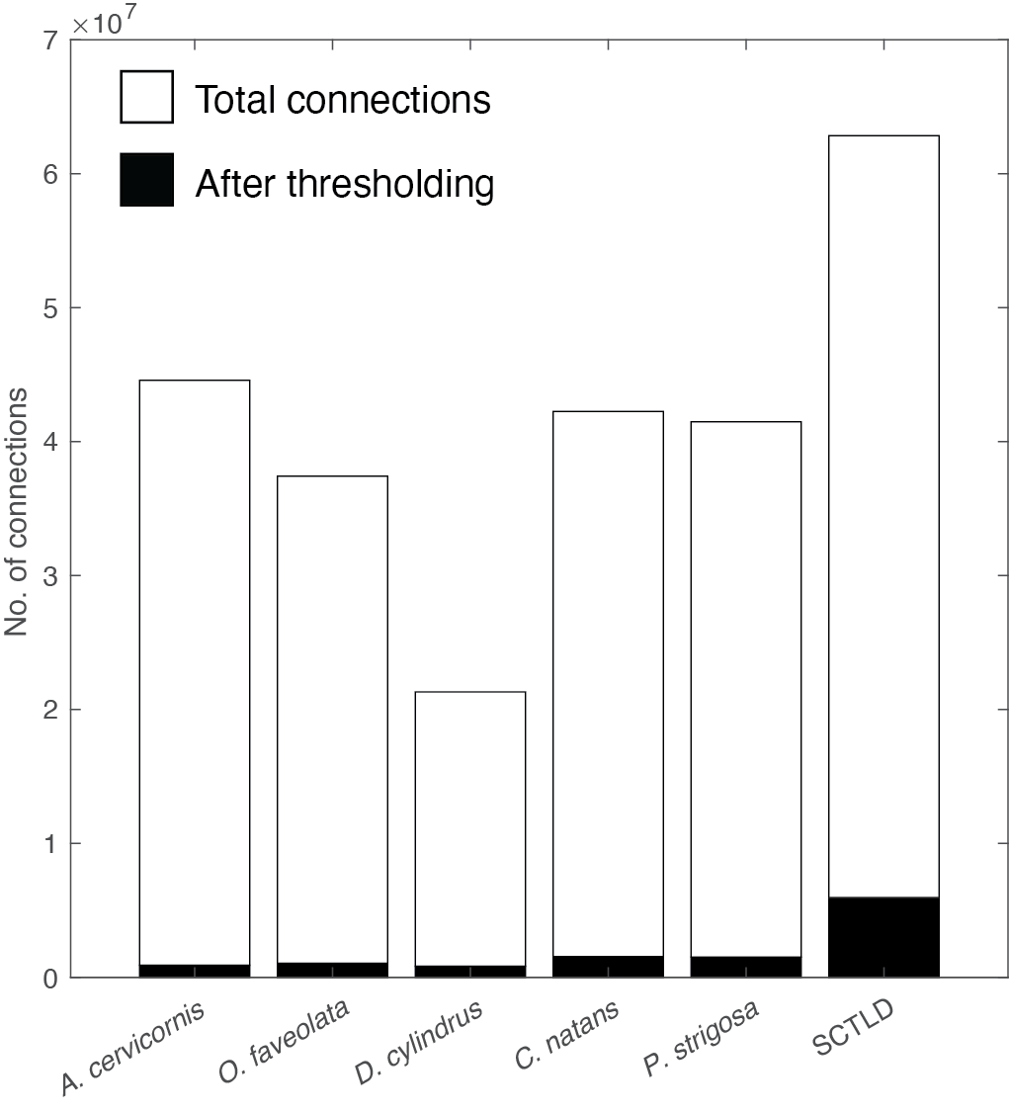
Figure S1. Total number of connections in the network of each species and SCTLD, and the total number following thresholding (0.001 probability threshold).

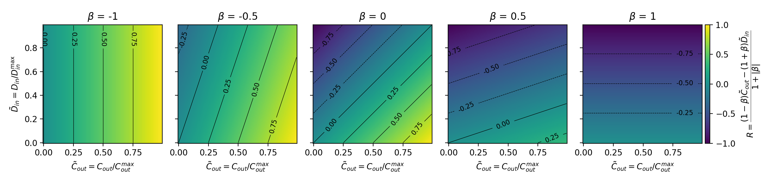
Figure S2. These heatmaps demonstrate the behavior of R in response to varying normalized weighted coral out-degree (${\tilde{C}}_{out}^{}$), normalized weighted disease in-degree (${\tilde{D}}_{in}^{}$, but in the text, ${\tilde{C}}_{in}^{dis}$), and $β$.

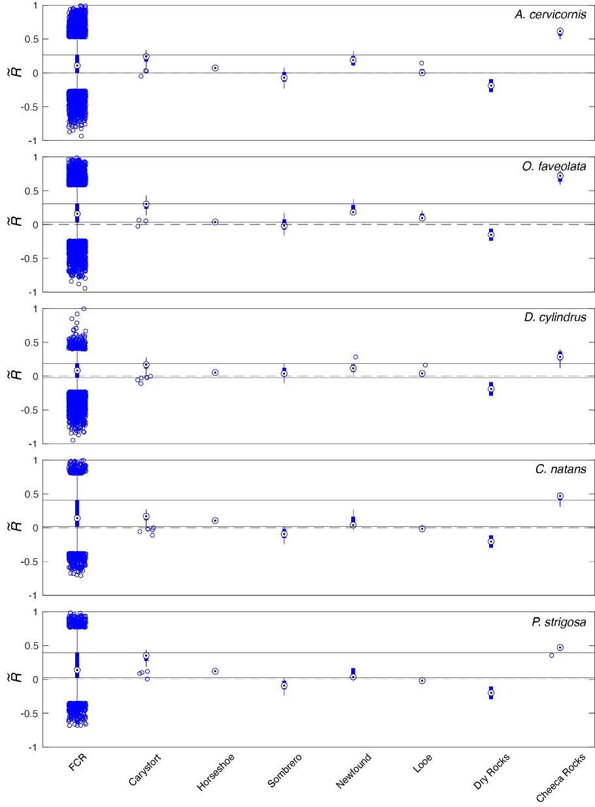
Figure S3. Median R scores for each location in the FCR, and within the boundaries of the Mission Iconic Reefs restoration sites, for each species. Blue boxes are the interquartile range (IQR), and whiskers are 1x IQR. A dashed line denotes 0, and solid horizontal lines project the IQR for the whole FCR across the plot for reference.

Supporting References:
Opsahl, T., Agneessens, F. & Skvoretz, J. (2010) Node centrality in weighted networks: Generalizing degree and shortest paths. Soc. Networks, 32, 245–251.

