Supplementary Information

Synthesis of smooth amorphous thin films of silicon carbide with controlled properties through pulsed laser deposition

Mohamed Oujja*, Karima Tabakkouht, Mikel Sanz⊥, Esther Rebollar, María Sánchez-Arenillas, José Francisco Marco, Marta Castillejo, Rebeca de Nalda*

Instituto de Química Física Rocasolano, CSIC, Serrano 119, 28006 Madrid, Spain
⊥Present address: Facultad de Ciencias, Universidad Nacional de Educación a Distancia (UNED), Senda del Rey 9, 28040 Madrid, Spain

*corresponding authors: m.oujja@iqfr.csic.es, r.nalda@iqfr.csic.es
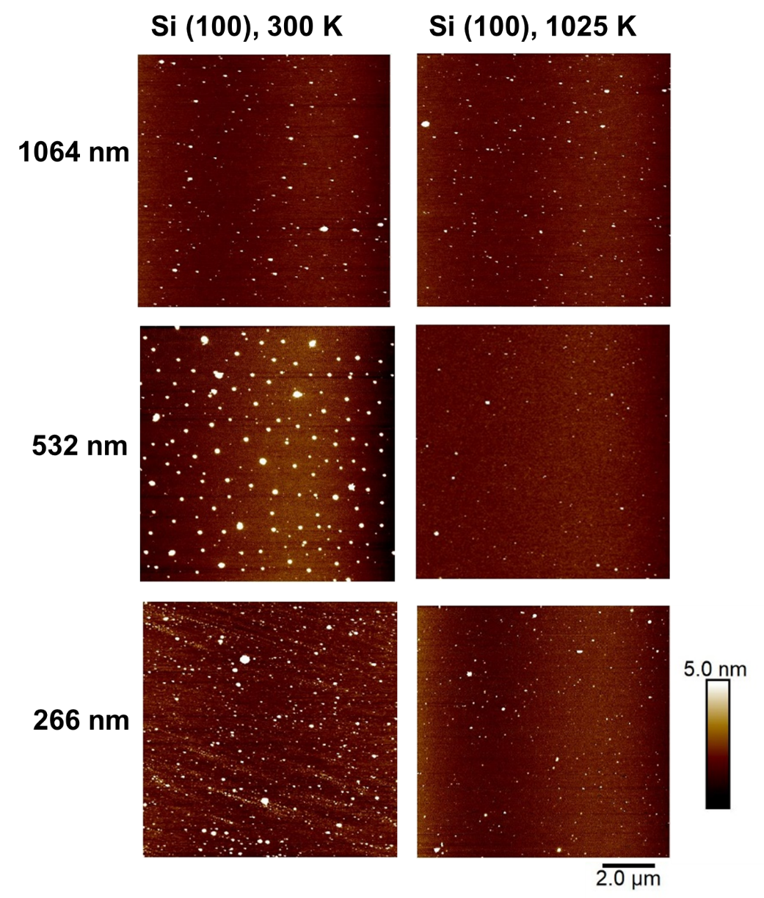
Figure S1. Height AFM images of SiC deposits obtained on Si (100) at the laser wavelengths and substrate temperatures indicated on the figure.

