Supplementary Information:

PLD plasma plume analysis, a summary of the PSI contribution
Christof W. Schneider¹ & Thomas Lippert^{1,2}
¹Laboratory for Multiscale Materials Experiments, Paul Scherrer Institute, 5232 Villigen PSI, Switzerland
²Department of Chemistry and Applied Biosciences, Laboratory of Inorganic Chemistry, ETH Zurich, Switzerland

Figure S1

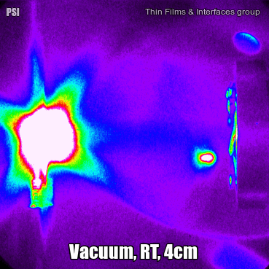
Figure S1: Video of the plasma expansion of silver in vacuum as recorded between the initial impact of the laser beam on the target and 10µsec with a time resolution of 500nsec for each frame. After approx. 2µsec a rebound of the impinging Ag species from the heater (TD-distance 4 cm) is observed. These rebounded species travel back even as far as the target.

