Supplementary Materials: Resolving Transient Temperature and Density during Ultrafast Laser Ablation of Aluminum
Jan Winter^{1,3}, David Redka^{1,4}, Ján Minár⁴, Michael Schmidt² and Heinz P. Huber^{1,*}
¹Department of Applied Sciences and Mechatronics, Hochschule München University of Applied Sciences, Lothstr. 34, 80335 Munich, Germany
²Lehrstuhl für Photonische Technologien, Friedrich-Alexander-Universität Erlangen-Nürnberg, Konrad-Zuse-Straße 3-5, 91052 Erlangen, Germany
³Erlangen Graduate School in Advanced Optical Technologies (SAOT), Friedrich-Alexander-Universität Erlangen-Nürnberg, Paul-Gordon Straße 6, 91052 Erlangen, Germany
⁴New Technologies-Research Center, University of West Bohemia, Univerzitní 8, 30100 Plzeň, Czech Republic
*heinz.huber@hm.edu (corresponding author)

S1. Electron-Phonon Coupling Factor
The novel approach for calculating the strength of the electron-phonon coupling $g_{e}$ is mainly based on the classical work by Kaganov et al. and was derived for the first time in the work by Petrov et al. and Inogamov et al. [1,2]. A characteristic feature was the separated consideration of the probability change for s/p- and d-band electrons under interaction with longitudinal collective motion of atoms or phonons in terms of the Fourier transform of the screened Coulomb potential. The electron temperature dependent electron-phonon coupling factor can be then calculated individually for the s- and d-band. For a simple metal as it is the case for aluminum (Al) containing only a s/p-band, $g\left(T_{e}\right)$ can be calculated as
$$g_{s}\left(T_{e}\right)=\frac{m_{s}^{2}}{4π^{3}ℏ^{7}}\frac{k_{B}^{2}T_{e}}{ρc_{s}} \int_{0}^{q_{D}}{dq q^{2} U^{2}\left(q\right)\ln\left(\frac{e_{1}\left(ϵ_{s}\right)+1}{e_{1}\left(ϵ_{s}\right)+e_{2}}\right)},$$
Where $e_{1}$ and $e_{2}$ are the introduced expressions in the form of
$$e_{1}\left(ϵ\right)=\exp\left(\frac{ϵ-μ-ℏω_{q}}{k_{B}T_{e}}\right) and e_{2\left(ϵ\right)}=\exp\left(-\frac{ℏω_{q}}{k_{B}T_{e}}\right),$$
where $m_{s}$ is the electron mass of the s/p-electrons, $μ\left(T_{e}\right)$ is the electron temperature dependent chemical potential and $c_{s}$ the speed of sound of the metal and the Debye vector $q_{D}={\left(6⋅π⋅n_{at}\right)}^{1/3}$.
The expression $U\left(q\right)$ is the Fourier transform of the screened Coulomb potential has the following form
$$U\left(q\right)=\frac{4πe^{2}ℏ^{2}Z}{q^{2}ε\left(q\right)},$$
where $Z$ is the ion charge number for the s/p-band ($Z=3$) and $ε_{TF}\left(q\right)$ is the dielectric constant as a function of the wave vector q, given by
$$ε_{TF}\left(q\right)=1+\frac{k_{TF}^{2}}{q^{2}}=\frac{1}{q^{2}+λ_{TF}}.$$
Here $k_{TF}$ is the Coulomb screening length. In the framework of the Thomas-Fermi approximation the screening length $λ_{TF}=1/{k_{TF}\left(T_{e}\right)}$ can be calculated from the chemical potential$,$ the electron concentration $n_{e}$ and the derivative ${∂μ\left(T_{e}\right)}/{∂n_{e}}$
$$k_{TF}\left(T_{e}\right)=\sqrt{\frac{4πe^{2}}{{∂μ\left(T_{e}\right)}/{∂n_{e}}} }.$$
In general is the screening length $λ_{TF}$ increasing with electron temperature and therefore the screened Coulomb field of a charge increases also with electron temperature. All used parameters for calculating the electron-phonon coupling are given in STable 1, and the functions $μ\left(T_{e}\right)$ and ${μ\left(T_{e}\right)}/{∂n_{e}}$ are given in SFig. 1.
STable 1. Material parameter for Al to numerically calculate the electron-phonon coupling factor.
$ρ$ [kg/cm₃] | $c_{s}$ [km/s] | $m_{s}$ / m_{e} | $$Z$$ | $n_{at}$ [1/cm³]
2.7 | 6.4 | 1.05 | 3 | 6.02e22

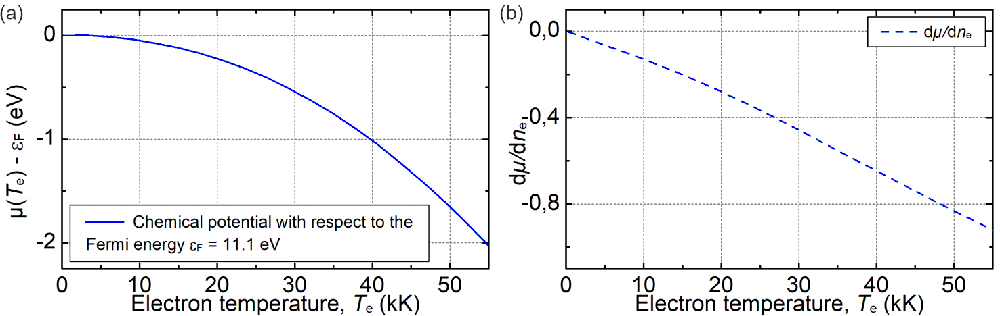
SFigure 1. (a) Chemical potential of A with respect to the Fermi energy as a function of the electron temperature, calculated from the FEG DOS. (b) Derivative of $μ\left(T_{e}\right)$ with respect to the electron density for varying electron temperatures.
In order to efficiently implement the complex integral representation of the electron-phonon coupling in the TTM-HD simulation, an analytical function was fitted to the numerically solved integral. The final representation of $g_{0}$ as a function of electron temperature (caution $T_{e}$ is in eV) is thus
$$g_{0}\left(T_{e}\right)=a_{0}+\frac{a_{1}T_{e}^{p_{1}}}{1+T_{e}^{p_{2}}+0.9 T_{e}^{p_{3}}+a_{2}T_{e}^{p4}}=3.5e17 [W/m³/K]+\frac{1.0e16 [W/m³/K] T_{e}^{3.0}}{1+T_{e}^{0.5}+0.9 T_{e}^{1.9}+0.0224 T_{e}^{3.7}}.$$
The fit parameters can be taken from STable 2. In addition, the density dependence of the electron-phonon coupling factor by means of $g_{e}\left(x,T_{e}\right)=xg_{0}(T_{e})$ is included (see main article).
STable 2. Fit-constants for analytical implementation of electron-phonon coupling into TTM code.
$a_{0}$ [W/m³/K] | $a_{1}$ [W/m³/eV] | $$p_{1}$$ | $$p_{2}$$ | $$p_{3}$$ | $$a_{2}$$ | $$p_{4}$$
3.5e17 | 1.0e16 | 3.0 | 0.5 | 1.9 | 0.0224 | 3.7

S2. Two-Temperature, Wide-Range Thermal Conductivity of Al
In the following section a semi-empirical (SE) model for the thermal conductivity of solid and liquid Al are derived. Especially the dependence on electron and ion temperatures and also the density in both is studied. The principles are based on suggestions in prior works of Petrov et al. [3,4].
In general is the total thermal conductivity, according to the Matthiessen rule, composed by two parallel conduction channels, namely the contributions of electron-electron $\left(se\right)$ and electron-ion $\left(si\right)$, which is written as
$$\frac{1}{k_{tot}}=\frac{1}{k_{se}}+\frac{1}{k_{si}}.$$
  - S2.1. Electron-Electron Contribution${ k}_{se}$:
The pure electron-electron contribution to the total thermal conductivity is derived from the Drude relation $k_{se}={v_{F}^{2}c_{se}}/{\left(3ν_{se}\right)}$, which is well established for cryogenic temperatures, but also may be extended towards higher energy densities [5]. Hereby knowledge on the electron heat capacity $c_{se}$ and electron-electron collision rate $ν_{se}$ is mandatory. The latter is given from Landau [6] in the form of $ν_{se}= \left({ϵ_{F}}/ℏ\right){\left({k_{B}T_{e}}/{ϵ_{F}}\right)}^{2}$ [6]. The heat capacity of s/p-electrons in the FEG model is $c_{se} =\left({π^{2}}/2\right)n_{s} k_{B}\left({k_{B} T_{e}}/{ϵ_{F}}\right)$, with the Planck constant $ℏ$ and $k_{B}$ Boltzmann’s constant. It follows for the electron-electron thermal conductivity
$$k_{se}=\frac{1}{3}\frac{v_{F}^{2}c_{se}}{ν_{se}}=\frac{π^{2}}{6} n_{s}k_{B}\frac{k_{B}T_{e}}{ϵ_{F}}v_{F}^{2}\frac{ℏ}{ϵ_{F}}{\left(\frac{ϵ_{F}}{k_{B}T_{e}}\right)}^{2}.$$
From density functional theory (DFT) calculations of the density of states (DOS), it was found that the Fermi energy in general exhibits a density dependence [7]. For Al, it was found that the effective mass of the s/p-electrons remains insensitive to density variations ($m_{s}≈const.$) and further electronic properties of Al can be well described within the free electron gas model (FEG). It follows that the Fermi energy may be rewritten as $ϵ_{F}=ϵ_{F0} x^{2/3}$, with $ϵ_{F0}=11.1 eV$ the Fermi energy at $x=ρ/{ρ_{0}}=n/{n_{0}}=1$, external zero pressure ($P=1 atm.≈0 GPa$) and a so-called “cold” state at $T_{e} = T_{i} = 0 K$. Hereby the corresponding density $ρ_{0}=2.735 g/cm³$ and atomic concentration $n_{0}$ are referred to this state. Consequently for the Fermi velocity it follows that $v_{F} = {ℏ k_{F}}/{m_{s}}=v_{F0} x^{1/3}$ [7] , where $k_{F} ={\sqrt{2m_{s}ϵ_{F}}}/ℏ=k_{F0} x^{1/3}$ is the the Fermi wave vector and $m_{s}$ the electron mass.
The density dependence of the thermal conductivity of electrons can then be written as followed for low electron temperatures
$$k_{se}∝\frac{1}{6}\frac{ℏk_{B}}{m_{s}} n_{s}\frac{ϵ_{F}}{k_{B}T_{e}}∝x\frac{ϵ_{F}}{6k_{B}T_{e}}∝x=k_{se0}x.$$
$k_{se0}$ represents electronic temperature dependent heat conductivity of s/p-electrons at an external pressure $P=1 atm.≈0 GPa$.
The numerical solution for $k_{se0}$ in wide range of electron temperature is however calculated from the relaxation time approximation (see SFigure 3, left) according to Ingoamov et al. [8] and may be fit by a polynomial (see SFigure 3, right) in order to implement the data efficiently into the TTM hydrodynamic code. Here for the following form is used
$$k_{se}\left(x,T_{e}\right)=1/{S_{e}}=x k_{se0}=x\frac{1+b_{0}t^{1/2}+b_{1}t+b_{2}t^{2}}{a_{0}t}=x\frac{1-0.91906 t^{1/2}+0.79564 t+0.13456 t^{2}}{4⋅{10}^{-4} t}[\frac{W}{m⋅K}],$$
where the fit constants are given in Stable 3. The introduced expression $t={6k_{B}T_{e}}/{ϵ_{F}}={6k_{B}T_{e}}/{\left(ϵ_{F0}x^{2/3}\right)}$ represents the normalized temperature with respect to the Fermi temperature $T_{F}$ and the Fermi energy${ ϵ}_{F0}=k_{B}T_{F}$.
STable 3. Fit-constants for analytical implementation of electron-electron contribution to total thermal conductivity.
$a_{0}$ [m*K/W] | $$b_{0}$$ | $$b_{1}$$ | $$b_{2}$$
4e-4 | -0.91906 | 0.79564 | 0.13456

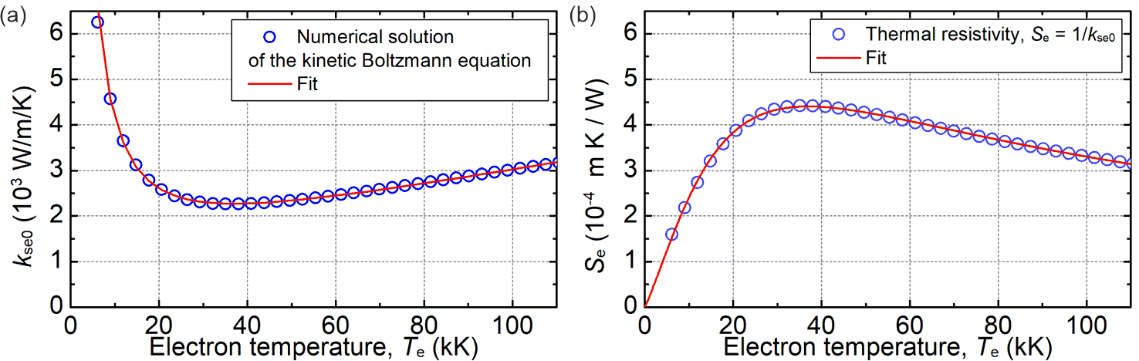
SFigure 3. (a) Calculated electron-electron contribution of thermal conductivity of Al within the relaxation time approximation.
(b) Thermal resistivity (inverse conductivity) with blue open circles and polynomial fit by red line.
  - S2.2 Electron-Ion Contribution in the Solid Phase $k_{si}^{sol}$
The contribution to the thermal conductivity due to the electron-ion interaction in the solid phase is again given from the Drude relation with
$$k_{si}=\frac{1}{3} c_{se}\left(T_{e},x\right)v_{s}\left(T_{e},x\right)λ_{si}\left(T_{i},x\right).$$
Here $v_{s}=\sqrt{v_{F}^{2}+{3k_{B}T_{e}}/{m_{s}}}$ is the mean velocity of s/p-electrons, $λ_{si}$ the mean free path between electron collisions with ions, and $c_{se}\left(T_{e},x\right)$ the electron heat capacity, calculated from FEG DOS and the chemical potential$μ\left(T_{e}\right)$.
For simplicity, the product $c_{se}\left(T_{e},x\right)v_{s}\left(T_{e},x\right)$ is expressed as a dimensionless function in dependence on the density, which is normalized with respect to the room temperature by
$$\frac{c_{se}\left(T_{e},x=1\right)v_{s}\left(T_{e},x=1\right)}{c_{se}\left(T_{rt},x=1\right)v_{s}\left(T_{rt},x=1\right)}=x^{4/3}C\left(t\right).$$
With this $C(t)$ is fitted by means of an analytical function
$$C\left(t\right)=t a_{0}\frac{1+a_{1}t^{p_{1}}}{1+a_{2}t^{p_{2}}}=t 68.745\frac{1+0.24284 t^{2}}{1+0.27722 t^{2.34127}}.$$
The fitting parameter are given in STable 4. It should be noted that the electron temperature has to be taken in eV in order to reproduce the given fit function, as can be seen by the red line in SFigure4a.
STable 4. Fit-constants for analytical implementation of electron-electron contribution to total thermal conductivity.
$$a_{0}$$ | $$a_{1}$$ | $$p_{1}$$ | $$a_{2}$$ | $$p_{2}$$
68.745 | 0.24284 | 2.0 | 0.27722 | 2.34127

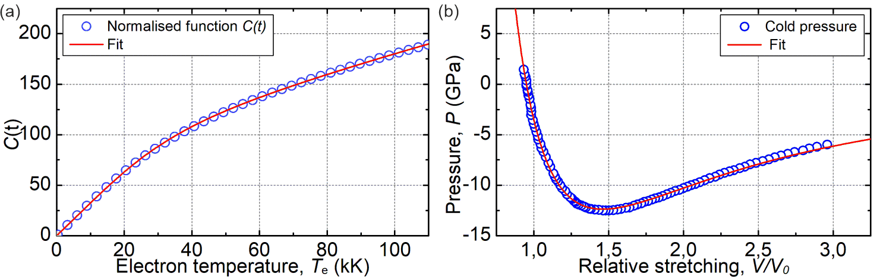
SFigure 4. (a) Function $C\left(t\right)$ together with the fit. (b) Cold curve for pressure versus density and fit to the given model.
Next, the mean free path will be expressed by the cross section $σ_{si}$ of the electron-ion interaction and the atomic concentration $n_{0}$ at $T_{e}=0 K$ and $P=0 GPa$ with $λ_{si}=1/{\left(n_{0}σ_{si}\right)}$. In general is the cross section proportional to the mean squared amplitude of thermal lattice vibrations $u_{th}$ by $σ_{si}∝u_{th}^{2}∝{u_{0}^{2}T_{i}}/{θ_{D}}$. Here $u_{0}$ is mean squared amplitude of the harmonic zero-point oscillations at $0 K$ with $u_{0}\sim {ℏ^{2}}/{\left(mk_{B}θ_{D}\right)}$, where $m$ is the atomic mass and $θ_{D}$ the Debye temperature. The Debye temperature $θ_{D}={ℏc_{s}\left(x\right)k_{D}\left(x\right)}/{k_{B}}$ also depends on the density with the Debye wave vector $k_{D}={\left(6π^{2}n\right)}^{1/3}∝x^{1/3}$ and the density dependent speed of sound.
The change of the speed of sound with density variation is described by the cold pressure $P_{c}\left(x\right)$ as known from equation of states construction in the form
$$P_{c}\left(x\right)=\left(A/{V_{0}}\right)x\left(x^{a}-x^{b}\right)=p_{c,0}x\left(x^{a}-x^{b}\right)=p_{c,0} x\left(x^{1.425}-x^{1.359}\right),$$
where $V_{0}$ is the volume per atom at $ρ =ρ_{0}$, $T=0 K$ and $P = 0 GPa$. $p_{c,0}=1179 GPa$, $a=1.425$, $b=1.359$ are fitting parameters in order to reproduce the reference values of the cohesive energy and the bulk modulus under normal conditions. The fit to the data from [9] is shown in SFigure 4b.
Finally, the speed of sound is given by $c_{s}\left(x\right)∝\sqrt{{\left(x{V ∂P_{c}}/{∂xV}\right)}/x}∝\sqrt{\left(a+1\right)x^{a}-\left(b+1\right)x^{b}}$ and hence the Debye temperature in dependence of the density is
$$θ_{d}∝x^{1/3}\sqrt{\left(a+1\right)x^{a}-\left(b+1\right)x^{b}}∝x^{1/3}\sqrt{y\left(x\right)}.$$
In order to avoid negative values in the root function at small densities$x$, $y(x)$ is replaced by $y_{0}(x)$ with
$$y_{0}\left(x\right)=\frac{\left(1+c_{ab}\right)x^{2a+1}}{\left(1+c_{ab}\right)x^{a+1}} with c_{ab}=\frac{a-b}{b+1}.$$
The electron-ion thermal conductivity can finally be written after all substitutions with following proportionality
$$k_{si}∝x^{4/3}C\left(t\right)λ_{si}∝x^{4/3}C\left(t\right)\frac{θ_{D}^{2}\left(x\right)}{xT_{i}}∝x^{4/3}C\left(t\right)\frac{y_{0\left(x\right)}}{x^{1/3}T_{i}}∝xC\left(t\right)\frac{y_{0}\left(x\right)}{T_{i}}.$$
The final expression is normalized with respect to the room temperature value, which is given by
$$k_{si}^{sol}=k_{rt}\left(\frac{x}{x_{rt}}\right)\frac{y_{0}\left(x\right)}{y_{0}\left(x_{rt}\right)}\frac{T_{rt}}{T_{i}}\frac{C\left(t\right)}{C\left(t_{rt}\right)},$$
where $x_{rt}={ρ_{rt}}/{ρ_{0}}$ with $ρ_{rt}=2.71213 g/cm³$,$T_{rt}$ the room temperature and $t_{rt}={6k_{B}T_{rt}}/{ϵ_{F0}x_{rt}^{2/3}}$ with the corresponding dependence on the density of the Fermi energy. The room temperature value of the thermal conductivity is $k_{rt}=237.0 W/m/K$ [10]. The total thermal conductivity in the solid state is given in SFigure 5a for varying electron temperatures and two distinct lattice temperatures. The thermal conductivity in solid phase on the binodal curve as a function of equilibrium temperature can be seen in Figure 6b at a temperature below the melting point.
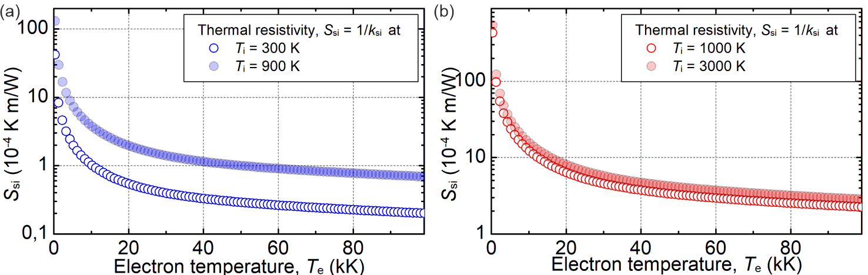
SFigure 5. Thermal resistivity (inverse thermal conductivity) of electron - ion contribution versus electron temperature (a) in solid and (b) in liquid phase at two distinct temperatures.
  - S2.3 Electron-Ion Contribution in the Liquid Phase $k_{si}^{liq}$
The thermal conductivity due to electron-ion scattering in the liquid phase is obtained in a very similar way as for the solid phase, namely from the Drude relation and by assuming an expression of the mean free path in the liquid phase, given by$λ_{si}^{liq}={n_{0}^{-1/3}x^{β-1/3}}/{w\left(T_{i}\right)}$. Using the Drude formula of electrical resistivity and the mean free path $λ_{si}^{liq}$ the following expression for the thermal conductivity due to electron – ion scattering is given
$$k_{si}^{liq}∝x^{4/3}C\left(t\right)λ_{si}^{liq}.$$
Hereby the mean free path is again direct proportional to the electrical resistivity of the liquid, with known quantitative values from experiments and quantum molecular dynamics (QMD) simulations.
With this the thermal conductivity dependency on temperature and density can be rewritten by introducing a weight function to reproducing experimental and QMD resistivity values in the form of
$$k_{si}^{liq}\left(T_{e},T_{i},x\right)∝C\left(t\right)\frac{x^{β+1}}{w\left(T_{i}\right)}.$$
In order to obtain the quantitative thermal conductivity the expression is normalized in the same way as in the solid phase, namely with respect to the melting point by
$$k_{si}^{liq}=k_{m}\frac{C\left(t\right)}{C\left(t_{m}\right)}\frac{w\left(T_{m}\right)}{w\left(T_{i}\right)}{\left(\frac{x}{x_{m}}\right)}^{2/3}{\left(\frac{x}{x_{m}}\right)}^{β+1/3},$$
where $k_{m}=89.3 W/m/K$ [11] is the liquid thermal conductivity at the melting temperature $T_{m}$, $x_{m}={ρ_{m}}/{ρ_{0}}$ is the relative density at $T_{m}$ with $ρ_{m}=2.45 g/cm³$ [11], and $t_{m}$ is the normalized temperature at melting temperature $t_{m}={6k_{B}T_{m}}/{ϵ_{F0}x_{m}^{2/3}}$. The thermal resistivity as the inverse of the thermal conductivity for liquid Al is shown in Figure 5b.
The applied exponent $β+1/3$ was derived from the following relation
$$\frac{r_{c}}{r_{QMD}}={\left(\frac{ρ_{QMD}}{ρ_{c}}\right)}^{β+1/3},$$
where $r_{c}$ and $r_{QMD}$ are electrical resistivity values taken from experiments and QMD simulations at corresponding densities of $ρ_{c}= 0.75 g/{cm}^{3}$ [12] and $ρ_{QMD}= 2.35 g/{cm}^{3}$ [13], respectively. With this we get at the critical point a value of $β\left(T=6.5 kK\right)+1/3=2.2$, which is in agreement with the critical density of $x_{c}^{7/3}≈x_{c}^{2.3}$ [12,14].
However a minor temperature dependence has to be taken into account, which is given by
$$β\left(T_{i}\right)=\frac{\ln{r_{c}}-\ln{r_{QMD}}}{\ln{ρ_{QMD}}-\ln{ρ_{c}}}-1/3=\frac{a}{1+b\left({T_{i}}/{T_{c}}\right)}=\frac{2}{1+0.1\left({T_{i}}/{T_{c}}\right)},$$
where $a$ and $b$ are the estimated constants from a set of QMD calculations and experiments which are evaluated for a temperature range of $6 kK$ to $30 kK$. The weight function is given in the form of
$$w\left(T_{i}\right)=a_{0}\frac{1+a_{1}\frac{T_{i}}{T_{c}}}{1+a_{2}\frac{T_{i}}{T_{c}}}=0.13381404⋅ \frac{1+2.17823351 \frac{T_{i}}{T_{c}}}{1+0.66530391 \frac{T_{i}}{T_{c}}},$$
and can be determined by fitting the liquid electrical resistivity to experimental and QMD values at a constant density of $2.35 g/{cm}^{3}$ with $r_{exp}\left(T_{m}\right)=0.25 µΩm$ [15], $r_{QMD}\left(T_{c}\right)=0.38 µΩm$ [13] and $r_{QMD}\left(30 kK\right)=0.60 µΩm$ [16].
For the verification with literature the thermal conductivity in liquid phase as a function of equilibrium temperature is compared with QMD simulations, as can be seen in SFigure 6.
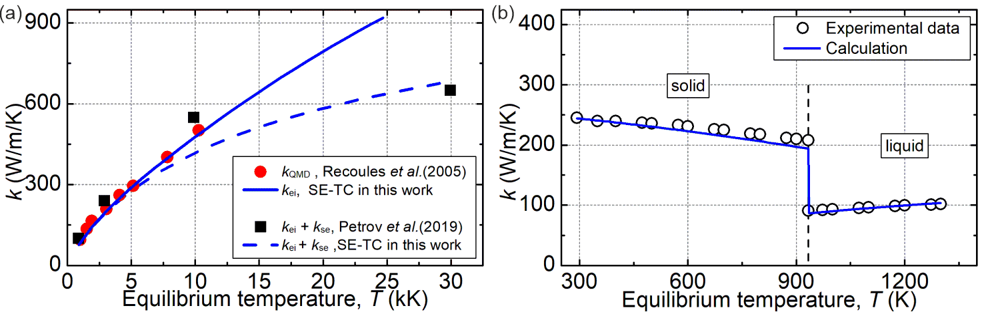
SFigure 6. (a) Thermal conductivity in the liquid phase without electron-electron contribution (blue line) compared to QMD simulation data [17] and when the electron-electron contribution is additionally taken into account (dashed blue line) together with the results of the calculation using the Ziman-Evans formula (black squares) [18] at the equal temperature for electrons and ions. (b) Calculated total thermal conductivity in solid and liquid phase as a function of the equilibrium temperature (equal temperature for electrons and ions) on the binodal curve (blue line) in comparison to the experimental data (black circles) [10].

S3. Dielectric Function (Wide Range, Multi-Phase)
The dielectric function for Al is determined by the DCP model in combination with a density and temperature dependent collision frequency. This is given by
$ϵ\left(ω,x\right)=1-\frac{ω_{p}{\left(x\right)}^{2}}{ω_{L}(ω_{L}+iν_{eff}\left(T_{e},T_{i},x\right)}+\sum_{p}{A_{p}Ω_{p}\left(\frac{e^{iΦ_{p}}}{Ω_{p}-ω-iΓ_{p}}+\frac{e^{-iΦ_{p}}}{Ω_{p}+ω+iΓ_{p}}\right)}= 1-\frac{ω_{p}{\left(x\right)}^{2}}{ω_{L}(ω_{L}+iν_{eff}\left(T_{e},T_{i},x\right)}+ϵ_{b,0}\left(ω\right),$
Herein, the DCP parameters were determined from an ellipsometry measurement at RT are shown in STable 6. A comparison of fit and measurement can be found in the main article. Also described in the main article is the density dependence of the plasma frequency and the contribution of the bound electrons which result in $ω_{p}^{2}=x ω_{p0}^{2}$ and $ϵ_{b,0}\left(ω,x\right)=x ϵ_{b,0}\left(ω\right)$.
STable 6. Room temperature DCP model parameter and summation of collision frequency of Al.
$$ω_{p0}$$ | $$ν_{eff,0}$$
16.4868 [1e15/s] | 0.1778 [1e15/s]
$$A_{1}$$ | $$Ω_{p1}$$ | $$Γ_{p1}$$ | $$Φ_{p1}$$
2.17020801 | 2.25028 [1e15/s] | 0.268726 [1e15/s] | -0.52279535
$$A_{2}$$ | $$Ω_{p2}$$ | $$Γ_{p2}$$ | $$Φ_{p2}$$
3.95505075 | 2.26699 [1e15/s] | 1.16111 [1e15/s] | 0.12358051

Besides the density influence in the bound part of the critical points, as well as the plasma frequency, the variation of the collision frequency with temperature and density must be considered. Analogous to the Matthiessen rule of thermal conductivity, the following applies to the collision frequency of electron-electron and el-ion collisions and the effective collision frequency is then given for the solid and liquid state (see main article)
$$ν_{eff}^{(s/l)}=ν_{ee}+ ν_{ei}^{(s/l)}.$$
The dependence of collision frequency on temperatures and density will be examined in the following subsection for both solid and liquid phases from the electrical resistivity, which are given by the Drude relation from thermal conductivity.
  - S3.1 Electron-Electron Contribution $ν_{ee}$
The wide temperature range electron-electron collision frequency $ν_{ee}$ is calculated from the Drude relation where density dependent thermal conductivity of s/p-electrons is $k_{se}∝x$, the Fermi velocity $v_{F}∝x^{1/3}$ and heat capacity $c_{se}∝n_{s}∝ x$. The dependence on the density for electron-electron collision frequency for s/p-electrons is finally expressed as $ν_{ee}∝x^{2/3}$. The fit to the calculated data of $ν_{se,0}$ (from thermal conductivity calculations, see above) at $T_{e}=0 K$ yields an analytical representation as
$$ν_{ee}\left(x,T_{e}\right)=η_{ee}⋅ν_{se,0}=η_{ee}⋅x^{2/3}a_{0}t^{2}\frac{1+a_{1}t^{p1}}{1+a_{2}t^{p2}}=0.75⋅x^{2/3}⋅0.49188 \left[1e15s^{-1}\right]⋅ t^{2}\frac{1+1.2 t^{0.75}}{1+0.8 t^{2.25}} ,$$
where $η_{ee}=0.75$ is the effective weight factor, $x=ρ/{ρ_{0}}$ represents the normalized density and $t={6k_{B}T_{e}}/{\left(ϵ_{F0}x^{2/3}\right)}$ is the normalized temperature. The parameters are given in Stable 7.
STable 7. Parameter for electron-electron collision frequency.
$$η_{ee}$$ | $$a_{0}$$ | $$a_{1}$$ | $$p_{1}$$ | $$a_{2}$$ | $$p_{2}$$
0.75 | 0.49188[1e15/s] | 1.2 | 0.75 | 0.8 | 2.25

  - S3.2 Solid Phase
The Drude relation for electrical resistivity in solid phase is given in terms of the free mean path of electron-ion collision rate by [4]
$$r_{si}=\frac{m_{s}v_{F}}{Z_{s}ne^{2}λ_{si}}=\frac{ℏk_{F}}{Z_{s}ne^{2}λ_{si}}=\frac{{\left(3π^{2}\right)}^{1/3}}{2π}\frac{R_{0}}{n^{2/3}}\frac{\sqrt{1+t/4}}{z_{s}λ_{si}},$$
where $v_{F}=v_{F}\sqrt{1+t/4}={ℏk_{F}}/{m_{s}}\sqrt{1+t/4}$ is the expression of the Fermi velocity, $k_{F}={\left(3 π n\right)}^{1/3 }$ is the Fermi wave vector, Z is the number of electrons in the s/p-band and $R_{0}=h/{e^{2}}=258128 Ω$ is the Klitzing constant. After substitution of the expression $λ_{si}∝{y_{0}\left(x\right)}/{\left(x^{1/3}T_{i}\right)}$ and division by $r_{si}$ at ambient condition values, the expression of electrical resistivity in the solid phase yields
$$r_{si}^{sol}=r_{rt}\frac{T_{i}}{T_{rt}}{\left(\frac{x}{x_{rt}}\right)}^{1/3}\frac{y_{0}\left(x_{rt}\right)}{y_{0}\left(x\right)}\sqrt{1+t/4}.$$
Here $r_{rt}=2.65⋅{10}^{-8} Ωm$ [15]is the resistivity at room temperature. Finally, the electron - ion collision frequency in dependence on the density and ion temperature can be obtained by using the expression of the mean free path between electron-ion collisions in solid phase $λ_{si}∝{y_{0}\left(x\right)}/{\left(x^{1/3}T_{i}\right)}$
$$ν_{si}^{sol}=\frac{v_{F}}{λ_{si}}∝v_{F}\frac{x^{1/3}T_{i}}{y_{0}\left(x\right)}.$$
After the normalization on the room temperature values and substitution of the density dependence of the Fermi velocity $v_{F}=v_{F0}x^{1/3}$ the expression of electron - ion collision frequency in solids results into
$$ν_{si}^{sol}=ν_{rt}^{sol}+η_{sol} ν_{rt}^{sol}{\left(\frac{x_{rt}}{x}\right)}^{2/3}\frac{y_{0}\left(x_{rt}\right)}{y_{0}\left(x\right)}\frac{T_{i}}{T_{rt}}=ν_{rt}^{sol}\left(1+η_{sol}{\left(\frac{x_{rt}}{x}\right)}^{2/3}\frac{y_{0}\left(x_{rt}\right)}{y_{0}\left(x\right)}\frac{T_{i}}{T_{rt}}\right)$$
Here $y_{0}\left(x\right)$ is the same function as used in the thermal conductivity due to electron-ion scattering in the solid phase, and $ν_{rt}^{sol}= Z{ n}_{at} r_{rt} e^{2}/ m_{eff}= 1.167022⋅{10}^{14} 1/s$ is the collision frequency at room temperature, while the $m_{eff}=m_{e}⋅1.15$ is the effective mass and $x_{rt}$ is the density ratio at room temperature with $ρ_{rt}=2.71 g/cm³$.
The factor $η_{sol}=0.5175$ is calculated in order to fit the experimental self-reflectance measurement (influence on electron temperature and dominating $ν_{ee}$ term) and also to fit the experimental calculated effective collision frequency from the DCP model at room temperature.
  - S3.3 Liquid Phase
The expression of resistivity in the liquid phase may be obtained similar as in the solid phase by the Drude equation, yielding [4]
$$r_{si}^{liq}=\frac{{\left(3π^{2}\right)}^{1/3}}{2π}\frac{R_{0}}{n_{0}^{1/3}x^{2/3}}\frac{\sqrt{1+t/4} w\left(T_{i}\right)}{Z_{s}x^{β-1/3}}=\frac{r_{0} \sqrt{1+t/4} }{Z_{s}}\frac{w\left(T_{i}\right)}{x^{β-1/3}}.$$
Comparable to the expression in the solid phase, the electron-ion collision frequency in the liquid phase can be derived by using the expression $ν_{si}=v_{F}/λ_{si}$ with the mean free path $λ_{si}^{liq}$ and the Fermi velocity $v_{F}=v_{F0}x^{1/3}$ as followed
$$ν_{si}^{liq}=η_{liq}⋅ν_{si,liq}{\left(\frac{x}{x_{m}}\right)}^{\frac{2}{3}}{\left(\frac{x_{m}}{x}\right)}^{β}\frac{w\left(T_{i}\right)}{w\left(T_{m}\right)}.$$
Thereby, the weight function $w\left(T\right)$ and the exponent $β$ are given in the previous subsection of the thermal conductivity in the liquid phase and $ν_{si}^{liq}= Z⋅n_{at} ⋅r_{melt}⋅e^{2}/ m_{eff}=1.09084⋅{10}^{15} 1/s$ with the electrical resistivity $r_{melt}=24.77⋅{10}^{-8} Ωm$ [15] at melting point. The parameter $η_{liq}=0.4025$ is in the same way calculated as $η_{sol}$. STable 8 summarizes all relevant collision frequencies and effective parameter.

STable 8. Parameter for electron-electron collision frequency.
$$η_{ee}$$ | $$η_{sol}$$ | $$η_{liq}$$ | $$ν_{rt}^{sol}$$ | $$ν_{si,liq}$$
$$0.75$$ | $$0.5175$$ | $$0.4025$$ | $$1.167022⋅{10}^{14} 1/s$$ | $$1.09084⋅{10}^{15} 1/s$$

S4. Analysis of Reflectance Behaviour in Pump-Probe Ellipsometry Measurement
In the pump-probe ellipsometry (PPE) measurements, we assess an average medium within the optical penetration depth (where a 1/e Intensity decrease occurs) and recognize that the calculated complex refractive index might not precisely represent the surface properties of the substrate.
For materials like aluminum, which boast high electronic thermal conductivity, temperature fields typically do not show considerable variations within the optical penetration depth, especially for long pulses such as 500 fs. As seen in SFig. 7, our simulations demonstrate that after a delay time of 1 ps, the presence of a temperature gradient within the optical penetration depth is negligible. Lattice (T_{i}) and electron temperatures (T_{e}) versus penetration depth, presented in the accompanying figure, reiterate this assertion. After 1 ps delay time, the electron temperature is not influenced by any gradient within the optical penetration depth. Similarly, the lattice temperature remains relatively constant, with a marginal increase of roughly 20 % at the 3 ps delay time. However, the density reveals a strong decrease with increasing surface displacement at longer delay times, and may change up to 50 %.
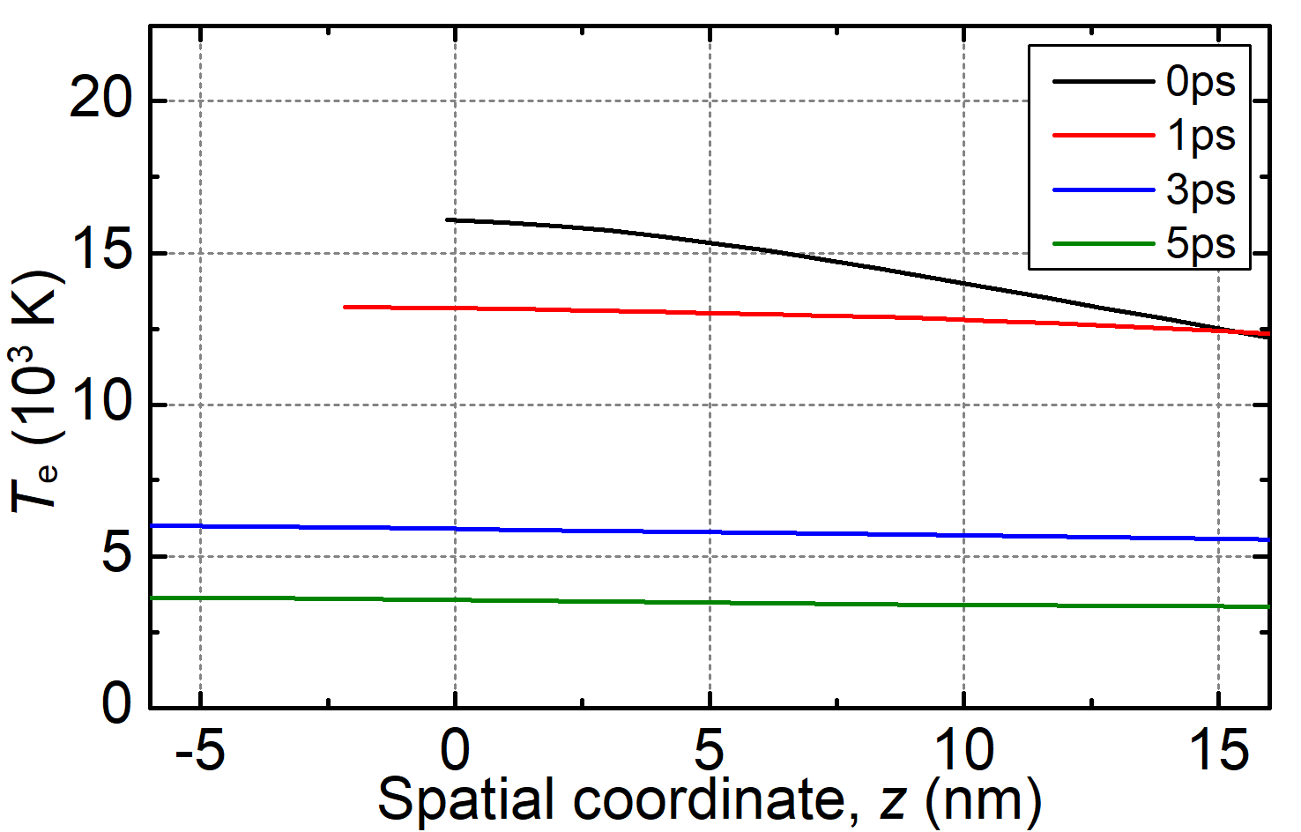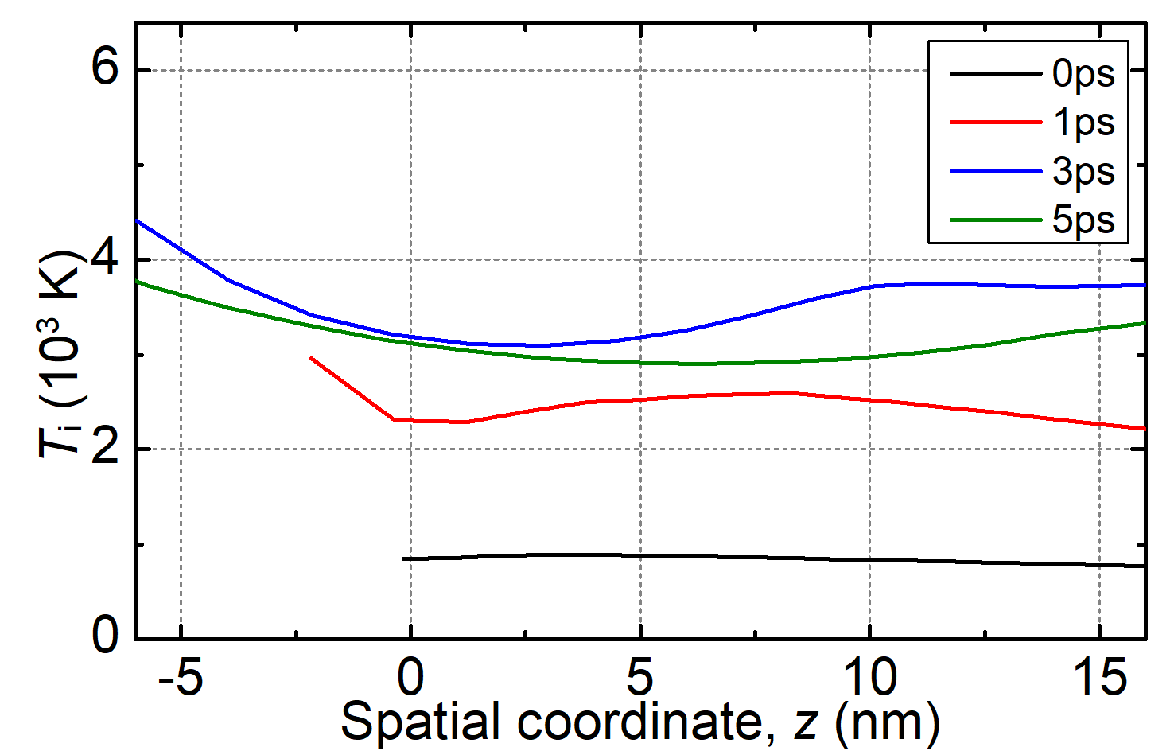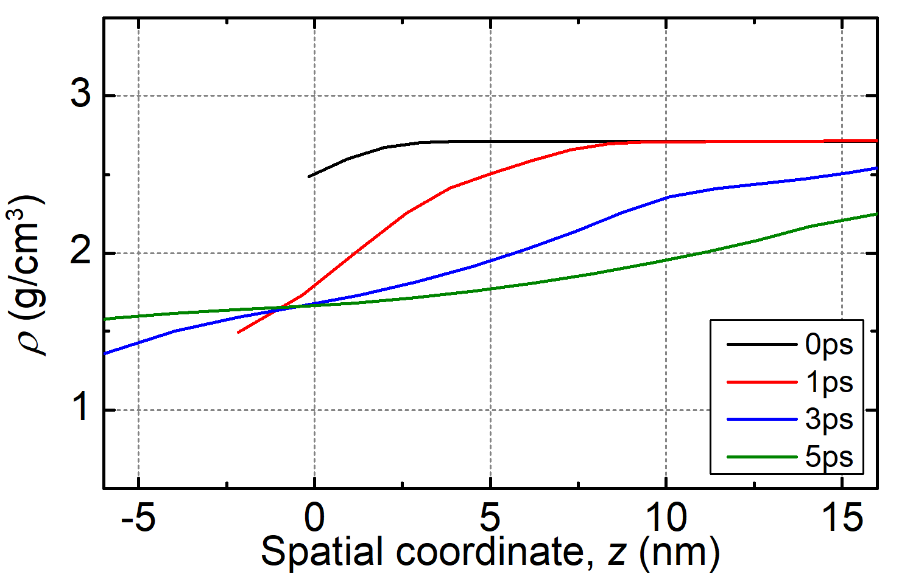
SFigure 7. (a) Retrieved electron temperature versus spatial coordinate from the TTM-HD simulation for distinct delay times, (b) lattice temperature, (c) density.
In order to examine the influence of temperatures and density on n&k, the corresponding time and spatially resolved complex refractive index is shown in SFigure 8. Since the influence of the thermodynamic variables on the optical response was shown and discussed above and in the main manuscript, it becomes apparent that n remains quite constant, while k qualitatively resembles the density curve.
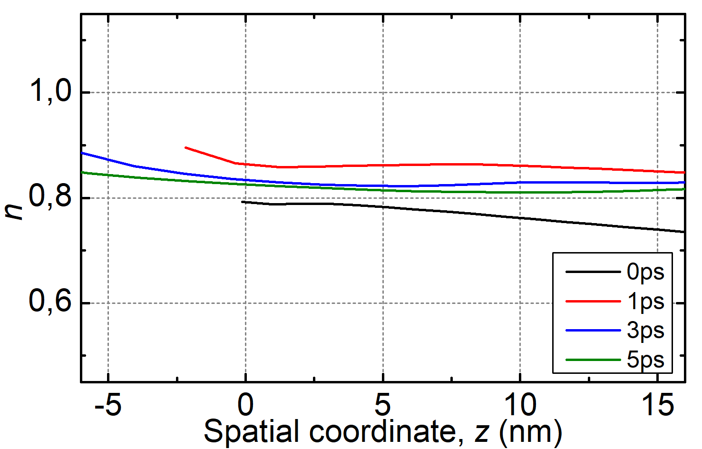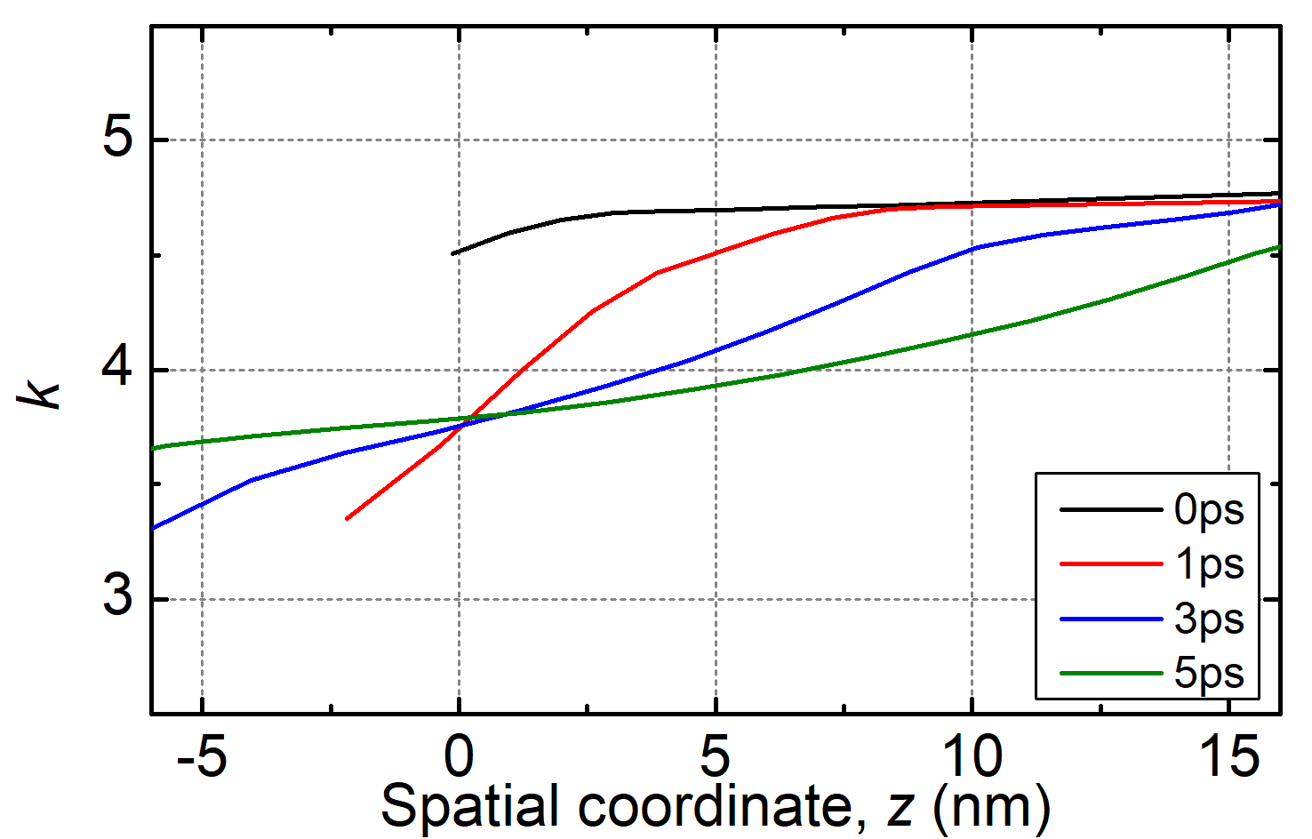
SFigure 8. (a) Real part of complex refractive index according to temperatures and densities from SFigure 7; (b) imaginary part for several simulation time steps.

Using these time and space-resolved n&k curves, we execute a reflectance calculation at normal incidence using the Finite-Difference-Time-Domain method (FDTD, Ansys Optics 2023 R1.3, Lumerical Inc.), comparing the results with Fresnel reflection calculations. The simulations are performed on a perfectly smooth surface in 2D geometry with periodic (Bloch) boundary conditions in the lateral dimension and in the axial dimension we used PML boundary conditions. The incident pulse is at the probe wavelength of 520 nm, where the n&k values are given corresponding to the TTM-HD simulations from SFigure 8.
In order to understand the reflectance behaviour we contemplate two scenarios for calculating the Fresnel reflection as comparison to the pure Maxwell equations solution from FDTD: one using n&k are deduced from the surface values, and another using n&k are represented by an average value within the optical penetration depth. The results are presented in SFigure 9.
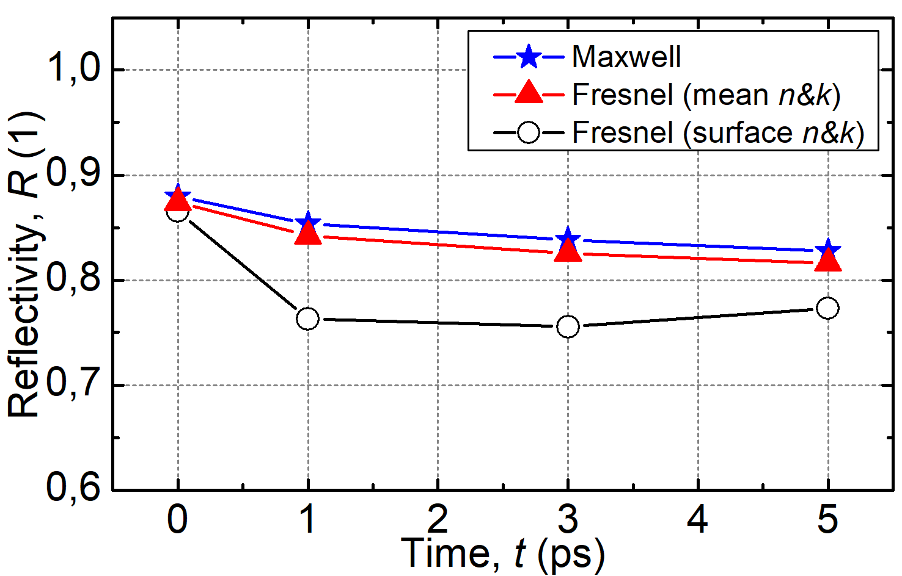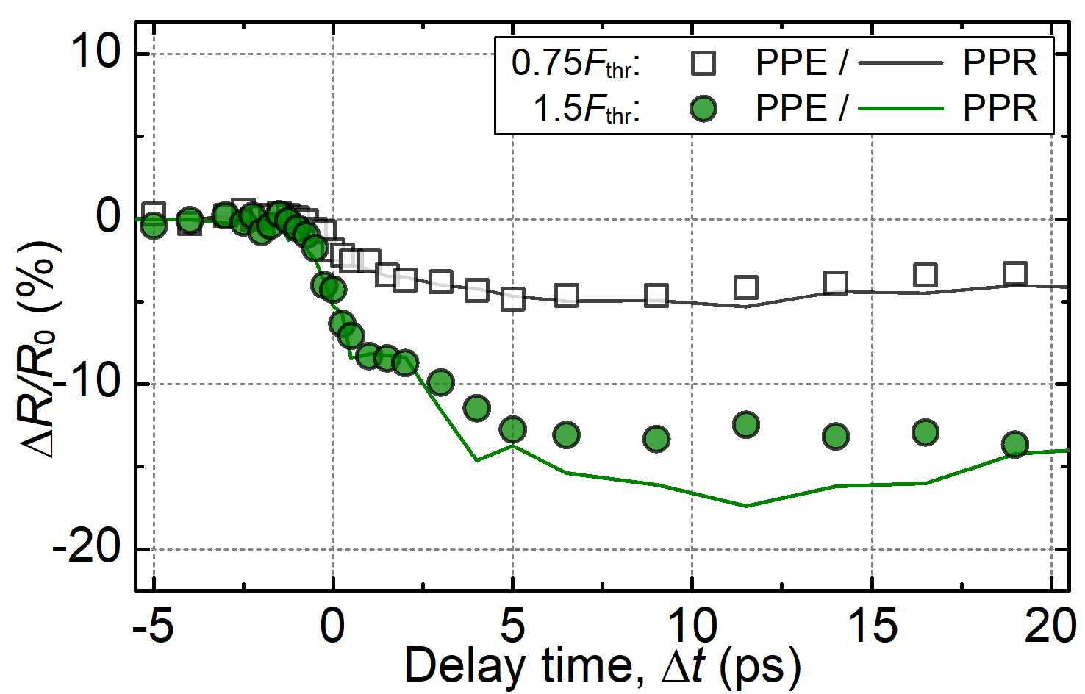
SFigure 9. (a) Comparison of solution of Maxwell equations (FDTD, blue stars) for the reflectance at normal incidence for the given complex refractive index from SFigure 8, with solution according to Fresnel equations using the surface n&k (black open circles) and the mean n&k value within the optical penetration depth (red triangles); (b) Recalculated $ΔR/R_{0}$ value from PPE curves in comparison to the measured PPR measurements for fluences of 0.75 F_{thr} and 1.5 F_{thr}.
Our findings indicate that n&k taken from the surface does not match well with the reflectance values simulated by Maxwell equations, while the average n&k entered into Fresnel equations provides a satisfactory agreement. The deviation is minor, less than 2%, for all displayed delay times. This outcome bolsters our assertion that our experiments probe approximately the average n&k within the optical penetration depth and should be analysed in this context. The coherence of this method is further validated when we compare the measured n&k from PPE with ΔR/R₀ curves from pump-probe reflectometry. The congruence of these two results, as seen in SFigure 9 reaffirms our standpoint.

References
1. Y. V. Petrov, Laser Part. Beams 23, 283 (2005).
2. Y. V Petrov, N. A. Inogamov, and K. P. Migdal, Phys. Extrem. States Matter JIHT, Mosc, 33 (2013).
3. Y. V Petrov, N. A. Inogamov, S. I. Anisimov, K. P. Migdal, K. A., and K. V Khishchenko, J. Phys. Conf. Ser. 653, 12087 (2015).
4. Y. V. Petrov, K. P. Migdal, N. A. Inogamov, and S. I. Anisimov, JETP Lett. 104, 431 (2016).
5. N. W. Ashcroft and N. D. Mermin, Solid State Physics, Repr (Brooks/Cole Thomson Learning, South Melbourne, 2012).
6. P. K. Misra, in Phys. Condens. Matter, edited by P. K. Misra (Academic Press, Boston, 2012), pp. 199–242.
7. Y. V. Petrov, K. P. Migdal, N. A. Inogamov, and V. V. Zhakhovsky, Appl. Phys. B Lasers Opt. 119, 401 (2015).
8. N. A. Inogamov and Y. V Petrov, J. Exp. Theor. Phys. 110, 446 (2010).
9. V. V. Zhakhovskii, N. A. Inogamov, Y. V. Petrov, S. I. Ashitkov, and K. Nishihara, Appl. Surf. Sci. 255, 9592 (2009).
10. C. Y. Ho, R. W. Powell, and P. E. Liley, J. Phys. Chem. Ref. Data 1, 279 (1972).
11. M. Leitner, T. Leitner, A. Schmon, K. Aziz, and G. Pottlacher, Metall. Mater. Trans. A 48, 3036 (2017).
12. A. W. DeSilva and J. D. Katsouros, Phys. Rev. E 57, 5945 (1998).
13. D. V. Knyazev and P. R. Levashov, Comput. Mater. Sci. 79, 817 (2013).
14. M. P. Desjarlais, J. D. Kress, and L. A. Collins, Phys. Rev. E - Stat. Physics, Plasmas, Fluids, Relat. Interdiscip. Top. 66, 2 (2002).
15. P. D. Desai, H. M. James, and C. Y. Ho, J. Phys. Chem. Ref. Data 13, 1131 (1984).
16. Y. V. Petrov, N. A. Inogamov, A. V. Mokshin, and B. N. Galimzyanov, J. Phys. Conf. Ser. 946, 012096 (2018).
17. V. Recoules and J.-P. Crocombette, Phys. Rev. B 72, 104202 (2005).
18. Y. V. Petrov, N. A. Inogamov, K. P. Migdal, A. V. Mokshin, and B. N. Galimzyanov, J. Phys. Conf. Ser. 1147, 012069 (2019).

