Supplemental Information for

Laser-induced incandescence (2λ and 2C) for estimating absorption efficiency of differently matured soot

Sandra Török*, Manu Mannazhi, Per-Erik Bengtsson
Division of Combustion Physics, Lund University, Box 118, 221 00 Lund, Sweden. *Corresponding author; contact: sandra.torok@forbrf.lth.se

S1. LIF interference

As freshly emitted OP6 soot from the mini-CAST generator contains of a large mass fraction of PAHs and other organic species [1], the influence of polycyclic aromatic hydrocarbon (PAH) laser-induced fluorescence (LIF) on the fluence curve obtained with λ_{excitation} = 532 nm is investigated. Initially, the fluence curves from the delayed LII signal (50 ns after the laser pulse, see Figure 4) using two excitation wavelengths (532 nm and 1064 nm) have to be considered. In Figure S1a, the fluence curves are overlapped as the 532 nm fluence curve has been shifted by a factor of x, corresponding to the ratio between the two energies (at 532 nm and 1064 nm) needed to reach the same LII signal. The x-axis is therefore converted to absorbed energy by the soot, with an arbitrary unit. By overlapping the fluence curve obtained from the peak LII signal using the ratio x, one can observe the discrepancy between the 532 nm and 1064 nm fluence curves, seen in Figure S1b. The difference between the curves at low energies can therefore be related to LIF from PAHs and other organic species. This PAH interference is observed for the young OP6 and OP7 soot.

a
b
c
Fig. S1. In a) the overlapped fluence curves from delayed (50 ns) LII signal are shown for OP6. The ratio between the curves is x = 3.15, corresponding to ξ = 1.68. In b) the fluence curves using the peak LII signal (average of 4 ns at peak) are overlapped using the ratio of 3.15, and in c) the the peak LII signals in b) are scaled according to the curves in a).
As the LIF contribution may be “filtered out” by the method described above, it may also be of interest to quantify the influence of the LIF on the fluence curve. Hence, by normalizing the peak LII intensity to the overlapped and matched fluence curves in Fig. S1a, the fluence curves in Fig. S1b may be rescaled and result in Fig. S1c. By detecting the LII+LIF signal at two wavelengths, one may obtain the relative amount of fluorescence at the two wavelengths, of which the ratio may be related to the size of aromatic structures fluorescing [2]. In Fig. S2, the temporal signal is shown for the 532 nm (LII+LIF) and 1064 nm (LII) excitation from the same position on the fluence curve. As shown, there is a discrepancy between the two curves, which corresponds to the contribution from LIF when laser heating using 532 nm. This contribution appears to end at approximately 30 ns after peak LII, which agrees well with observations made by [3] and motivates the use of 50 ns as a safe normalization point.
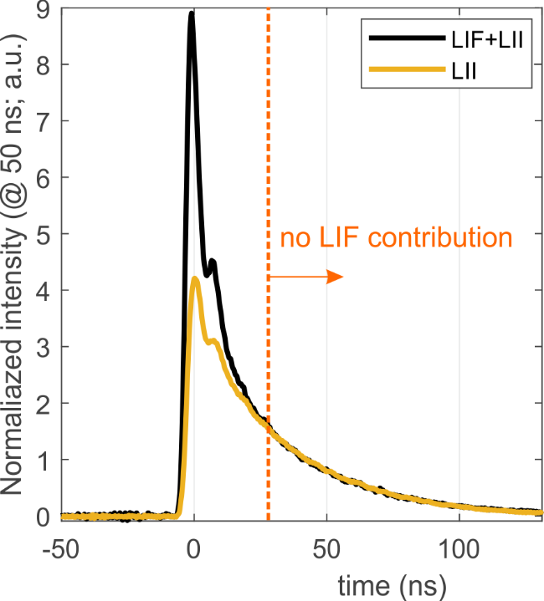
Fig. S2. The temporal LII signal for LII only (1064 nm excitation) and LII+LIF (532 nm excitation). The signals are from the same part of the 50 ns delayed fluence curve (Figure S1a). At approximately 30 ns, the LIF contribution appears to end.

S2. LII model parameters

The Lund LII model has been previously described in [4]. The material parameters used for the different types of soot are as specified in Table S1. The temperature dependent volumetric heat capacity ρc_{S} is based on the expressions specified in [5] for the density ρ and specific heat capacity c_{S} separately. The thermal accommodation coefficient of 0.48 is used as in the work by [6]. The current environment, where the soot particle sizes (specified in [1]) and the mean free path is in the same order of magnitude, will suggest to operate in the free molecular or transition regime and therefore we apply the Fuchs heat transfer model, which is most accurate of the different available methods [7]. Further we employ the sublimation model as described and discussed in [4, 8]. The primary particle sizes were obtained by analysis of TEM images of OP1 soot and the sizes used for OP6 and OP7 were based on other less mature soot, which was not included in this work.

Table S1. Specifications of the LII model parameters and models used for our fluence curve simulations using the Lund LII model.
Parameter/model | Description | Value/model type
t_{FWHM} | Laser pulse length (s) | 6.0000e-09
q_pulse | Laser pulse shape | Gaussian
T_{g} | Surrounding gas temperature | 300 K
D | Primary particle size (diameter) | [2.24 1.57 1.57 ]e-08^{*a}
N_{p} | Aggregate size (nbr of pp) | 1
ρ_{S} | Soot density | Michelsen model [5]
c_{S} | Soot specific heat capacity | Michelsen model [5]
α_{T} | Soot thermal accommodation coefficient | 0.4800 [6]
E(m) | Soot absorption function | 0.35-0.05 (fitted parameters)
Q_{con} | Heat conduction model | Fuchs model [4]
Q_{sub} | Sublimation model | Based on [4, 8]
^{*a} Sizes obtained from TEM images of OP1 and OP5 (not used in this work).

S3. Uncertainty analysis

In this section we discuss the soot sublimation and heat conduction parameters, which may vary with soot maturity. More specifically we consider how the variation of these parameters may influence our E(m) estimations for young soot, in this case the “youngest”, OP7 soot.
Volumetric heat capacity ρc_{S}
In [9, 10] and extensive discussion around the influence of soot temperature and maturity on the volumetric heat capacity is done. It was concluded that the volumetric heat capacity can be considered independent on temperature (flame and LII temperatures) and maturity. Nevertheless, we consider a 5 % variation of ρc_{S}, as specified in Table S2.
Heat accommodation coefficient
As discussed by many groups, the thermal accommodation coefficient α_{T}, which indicates the efficiency of energy transfer through collisions between soot and surrounding gas molecules, is known to vary with soot maturity. For young soot the values are higher than for mature soot, according to the discussion in [11], where this subject is reviewed. The use of an accurate value for α_{T} is especially of great importance when conducting primary particle sizing by fitting LII signal decays. We investigate the influence on our fluence curves as specified in Table S2.
Primary particle size
With smaller particles, the surface-to-volume ratio increases and hence, the conductive cooling will increase. We consider a possible error in our d_{pp} estimations and consider the influence. We use a single primary particle and do not include the influence of bridging and shielding, as the young soot aggregates of OP7 are relatively small [1]. Also, from observations in [12], the normalized fluence curve of fresh and collapsed soot were compared and showed good overlap, hence indicating no influence of shielding on the fluence curve.
Sublimation efficiency
As observed in the work by [6], the sublimation temperature will increase with soot maturity. To represent this type of variation when conducting LII modeling, we consider the mass accommodation coefficient β, which describes the efficiency of the sublimation procedure. By varying this parameter, we change the efficiency of sublimation as shown in Table S2 and hence, indirectly observing a simplified influence of soot maturity.

In Fig. S3, the fluence curves for all material parameter variations are shown. By normalizing, the fluence curve shift, the fluence curves influence can be observed. In Table S2, the investigated ranges of the heat conduction, sublimation and absorption parameters of soot are summarized. The fluence curve shift according to a change of E(m,λ) ± 0.01 is included for comparison. As can be observed, non of the other soot material parameters influence the fluence curve to the same extent, and hence we conclude that our E(m,λ) estimations are not influenced significantly as the influence would be < 0.01.

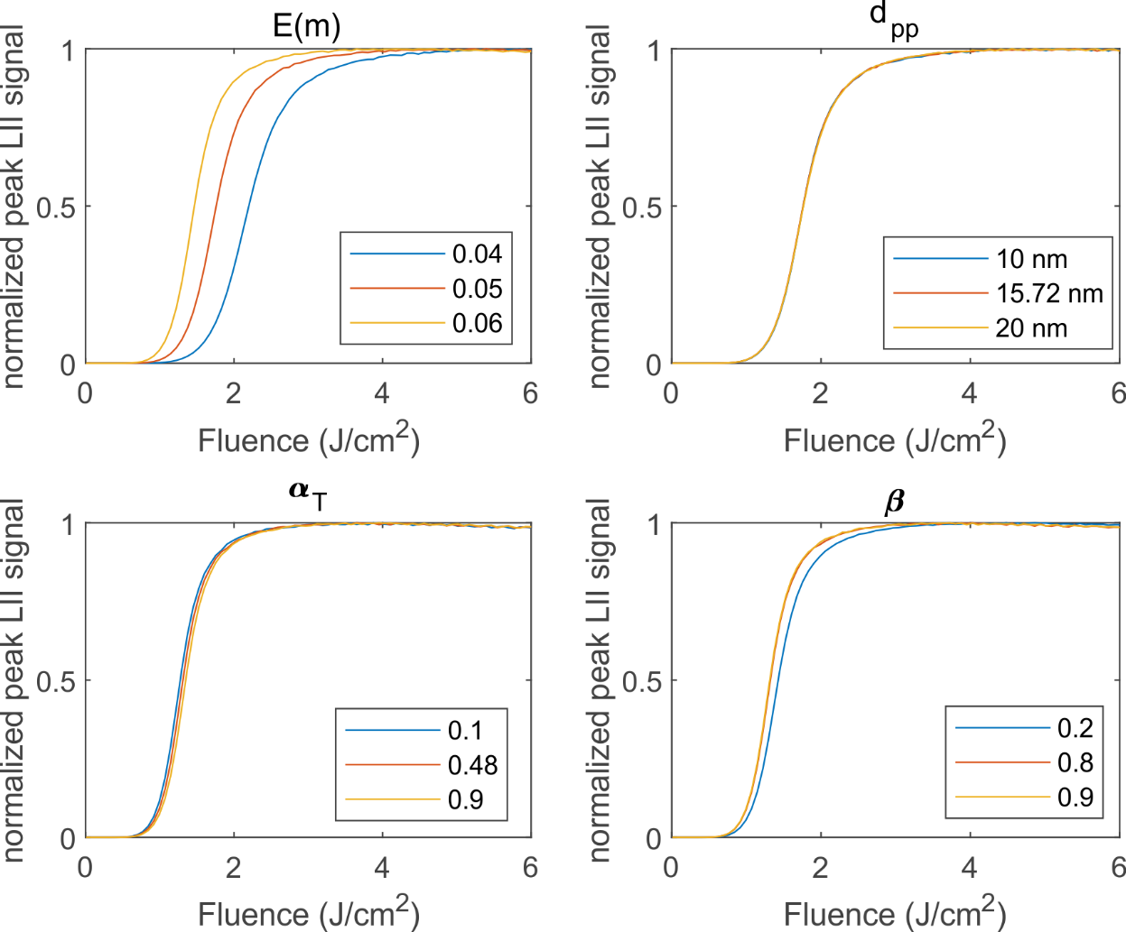
Fig. S3. The shifted fluence curves depending on variations in a) E(m,λ), b) primary particle size d_{pp}, c) thermal accommodation coefficient α_{T} and d) mass accommodation coefficient β. The changing of the E(m,λ) do cause the largest fluence curve shift in this investigation.

Table S2. Investigation of the parameters influencing the sublimation and heat conduction properties of soot are summarized. Only minor influence is observed in estimations of our E(m,λ).
Parameter | Mature soot | Younger soot | Min | Max | Fluence curve shift/ E(m,λ) influence | Comment
E(m) | 0.32-0.4 [13] | Lower  (0.05 estimated for OP7 at 1064 nm) | 0.04 | 0.06 | ±20% | For comparison, with other parameters.
α_{T} | 0.48 [6] | Higher [11, 14] | 0.1 | 0.9 | ±3% | These results were done using the model by McCoy and Cha where the influence was much larger than for the Fuchs model.
d_{pp} | 15.7 nm *ª | - | 10 | 20 | <1% | Large influence on max T_{LII}, however minor influence on fluence curve shift.
β | 0.5-1 [15] | Lower sublimation temperature [16] | 0.2 | 0.9 | ±4% | Large influence on max T_{LII}, however minor influence on fluence curve shift.
ρc_{S} | Eq 8 in [10] | - | -5% | +5% | ±5% | Small influence on immature soot.
^{*a)} from TEM analysis of OP5 soot, see table S2.

S4. Investigation of the potential influence of volatiles

In [12], the influence of oleic acid coating on soot particles was studied by fluence curve analysis. The fluence curves were shifted along the fluence axis, according to the amount of coating on the soot particles. We use the results from this paper to estimate the potential influence of volatiles on OP6 and OP7 soot as we know from [1], that a substantial amount of mass is evaporated when heated to 550 K and 800 K. As the soot is heated to 800 K, approximately 20% and 74% of the OP6 and OP7 soot mass is evaporated according to [1]. If assuming that the thermal properties of the evaporated species are comparable to oleic acid, we may estimate the influence on our flunce curves.

From Bambha et.al a shift of approximately 0.02 J/cm² and 0.07 J/cm² was measured for 0.20 and 0.86 mass fraction of oleic acid [12], roughly corresponding to the mass-fraction of volatiles on OP6 and OP7 soot. Considering the shift of the fluence curve at 50% of max LII for the mature soot used in [12], we may translate the amount of extra energy which would be needed to heat the volatile material on OP6 and OP7 soot. The relative shift will depend on the ability of the soot to absorb light, which is related to the shift of the fluence curves. Hence we obtain the shift to estimate the influence on E(m,λ).
Mass fraction 0.2 | Mass fraction 0.86
50% of max = 0.21 J/cm²  Shift = 0.02J/cm2 9.5% shift | 50% of max = 0.21 J/cm²  Shift = 0.07J/cm2 33.3% shift

A shift of 9.5% and 33 % of the OP6 and OP7 fluence curves would roughly result in a E(m,1064 nm) increase to 0.175 and 0.065 for OP6 and OP7, respectively.
References
1. S. Török, et al., Investigation of the absorption Ångström exponent and its relation to physicochemical properties for mini-CAST soot. Aerosol Science and Technology. 52 (7) (2018) 757-767.
2. S. Bejaoui, et al., Laser induced fluorescence spectroscopy of aromatic species produced in atmospheric sooting flames using UV and visible excitation wavelengths. Combustion and Flame. 161 (10) (2014) 2479-2491.
3. S.M. Musikhin, R.; Smallwood, G. J.; Dreier, T.; Daun, K. J.; Schulz, C., Spectrally and temporally resolved LII interference emission in a laminar diffusion flame. 2019: Proceedings of Combustion Institute - Canadian Section.
4. H. Bladh, et al., On the dependence of the laser-induced incandescence (LII) signal on soot volume fraction for variations in particle size. Applied Physics B. 90 (1) (2008) 109-125.
5. H.A. Michelsen, Understanding and predicting the temporal response of laser-induced incandescence from carbonaceous particles. The Journal of chemical physics. 118 (15) (2003) 7012-7045.
6. N.-E. Olofsson, et al., Evolution of properties for aging soot in premixed flat flames studied by laser-induced incandescence and elastic light scattering. Applied Physics B. 119 (4) (2015) 669-683.
7. F. Liu, et al., Heat conduction from a spherical nano-particle: status of modeling heat conduction in laser-induced incandescence. Applied Physics B. 83 (3) (2006) 355-382.
8. G.J. Smallwood, et al., Clouds Over Soot Evaporation: Errors in Modeling Laser-Induced Incandescence of Soot. Journal of Heat Transfer. 123 (4) (2000) 814-818.
9. K.O. Johansson, et al., Evolution of maturity levels of the particle surface and bulk during soot growth and oxidation in a flame. Aerosol Science and Technology. 51 (12) (2017) 1333-1344.
10. H.A. Michelsen, Effects of maturity and temperature on soot density and specific heat. Proceedings of the Combustion Institute. (2020).
11. H.A. Michelsen, et al., Laser-induced incandescence: Particulate diagnostics for combustion, atmospheric, and industrial applications. Progress in Energy and Combustion Science. 51 (2015) 2-48.
12. R.P. Bambha, et al., Effects of volatile coatings on the laser-induced incandescence of soot. Applied Physics B. 112 (3) (2013) 343-358.
13. F. Liu, et al., Review of recent literature on the light absorption properties of black carbon: Refractive index, mass absorption cross section, and absorption function. Aerosol Science and Technology. (2019) 1-19.
14. X. López-Yglesias, et al., Soot maturity and absorption cross sections. Journal of Aerosol Science. 75 (2014) 43-64.
15. H. Michelsen, et al., Modeling laser-induced incandescence of soot: a summary and comparison of LII models. Applied physics B. 87 (3) (2007) 503-521.
16. J. Simonsson, et al., Wavelength dependence of extinction in sooting flat premixed flames in the visible and near-infrared regimes. Applied Physics B. 119 (4) (2015) 657-667.

