Journal of Plant Growth Regulation
Supplementary Material
Role in Phenylpropanoid Biosynthesis of the grapevine plastidic phosphoenolpyruvate translocator VviPPT1
Angélica Silva¹, Henrique Noronha^{1*}, Dorotea Ricci², Sarah Frusciante², Gianfranco Diretto², Carlos Conde^{3,4}, Antonio Granell⁵, Hernâni Gerós¹
*Corresponding author; email: henriquenoronha@bio.uminho.pt

Affiliations:
¹Department of Biology, Centre of Molecular and Environmental Biology (CBMA), University of Minho, Braga, Portugal
²Division of Biotechnology and Agroindustry, Biotechnology Laboratory, ENEA, Casaccia Research Center, Rome, Italy
³i3S, Instituto de Investigação e Inovação em Saúde, Universidade do Porto, Porto, Portugal
⁴IBMC, Instituto de Biologia Molecular e Celular, Universidade do Porto, Porto, Portugal
⁵Institute of Molecular and Cellular Biology of Plants, Spanish National Research Council (CSIC), Valencia, Spain

Supplementary Figures
Supplementary Figure S1- Phylogenetic tree of several PPTs after aligning sequences from grapevine (Vitis vinifera), Arabidopsis thaliana, tobacco (Nicotiana tabacum), Eucalyptus grandis, Poplar (Populus trichocarpa), potato (Solanum tuberosum) and tomato (Solanum lycopersicum). Amino acid sequences were obtained through NBCI (VviPPT1, XP_002282424; VviPPT2, XP_002276496; AtPPT1, AAF63704; AtPPT2, NP_566142; SlPPT1, XP_004236213; SlPPT2, XP_004232311; PtPPT1, XP_002322169; PtPPT2, XP_002298531; StPPT1¸ XP_006344403; StPPT2, XP_006338579; EgPPT1, KCW49270; EgPPT2, XP_010033295; NtPPT1, XP_016469580; NtPPT2, XP_016486275) and aligned using PRANKSTER (Whelan and Goldman, 2001). This alignment was used to do tree construction using the Maximum Likelihood method based on the JTT matrix-based model (Jones et al. 1992). The tree with the highest log likelihood (-6766.2743) is shown. The percentage of trees in which the associated taxa clustered together is shown next to the branches. The tree is drawn to scale, with branch lengths measured in the number of substitutions per site. Evolutionary analyses were conducted in MEGA7 (Kumar et al. 2016).
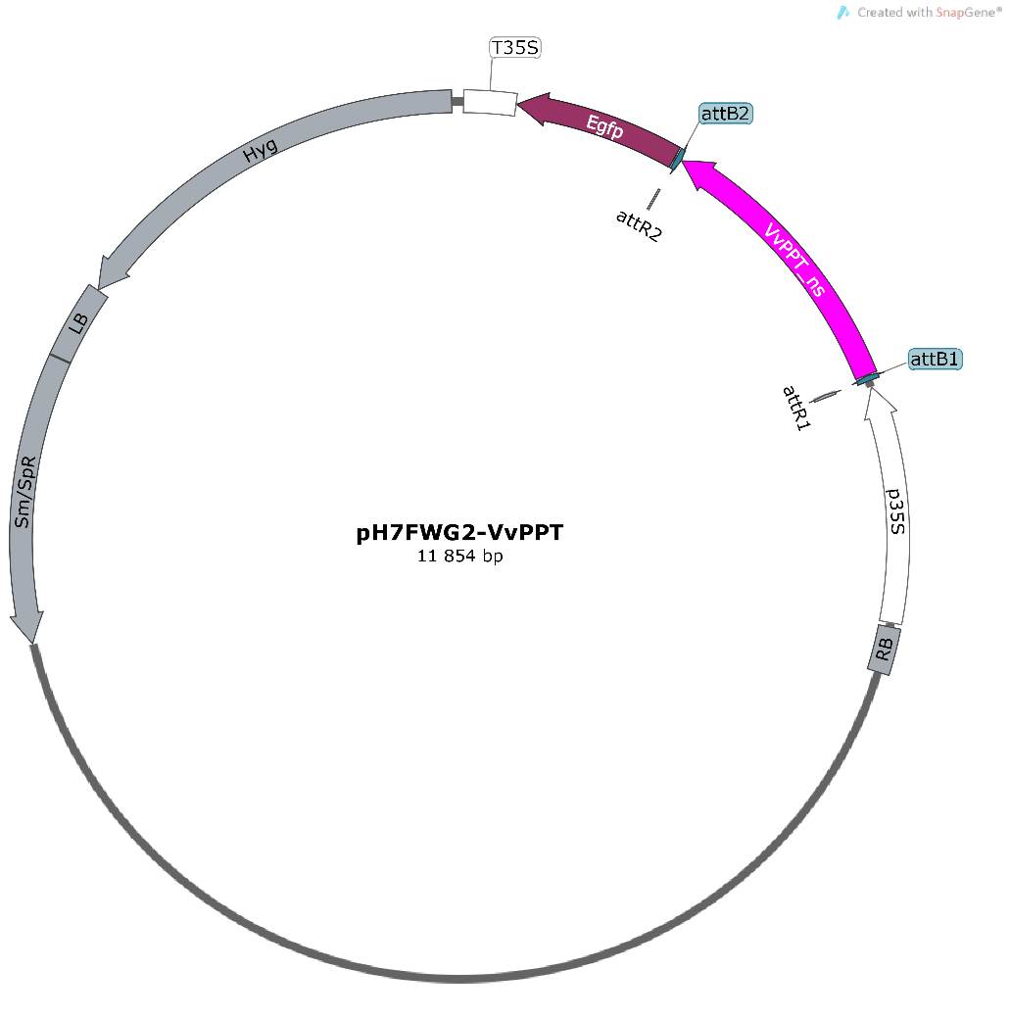
Supplementary Figure S2- T-DNA region of binary vector pH7FWG2 (Karimi et al. 2002) containing VviPPT1 used for subcellular localization. P35S, CaMV 35S promoter; Hyg, hygromycin phosphotransferase; Egfp, green fluorescent protein with the ER signal sequence T35S, CaMV 35S terminator; LB, left border; RB, right border; attB1 and attB2, attB sites for Gateway® recombination.
Supplementary Figure S3- Expression of VviPPT2 in different grapevine tissues.

Supplementary Figure S4- Analysis of off-target events in putative off-target sites. Sequencing results of DNA fragments containing the putative off-target sites of sgRNA3.

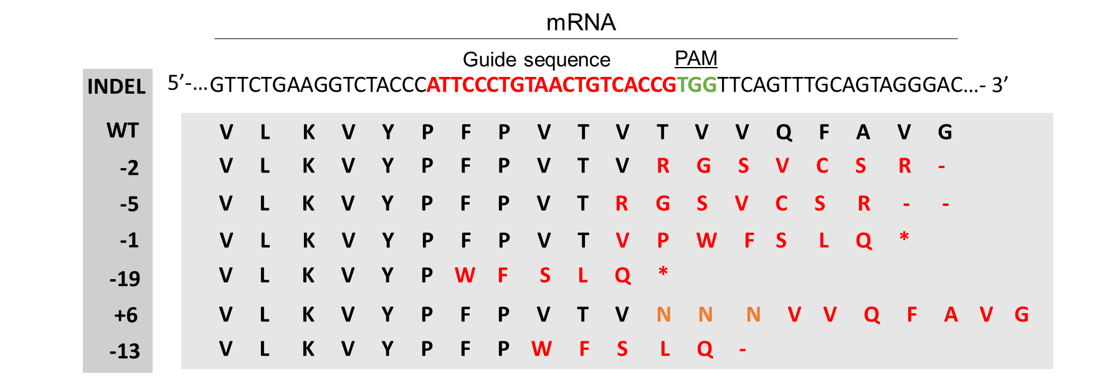
Supplementary Figure S5- Mutations of amino acids in the corresponding inferred sequences present in the edited population.

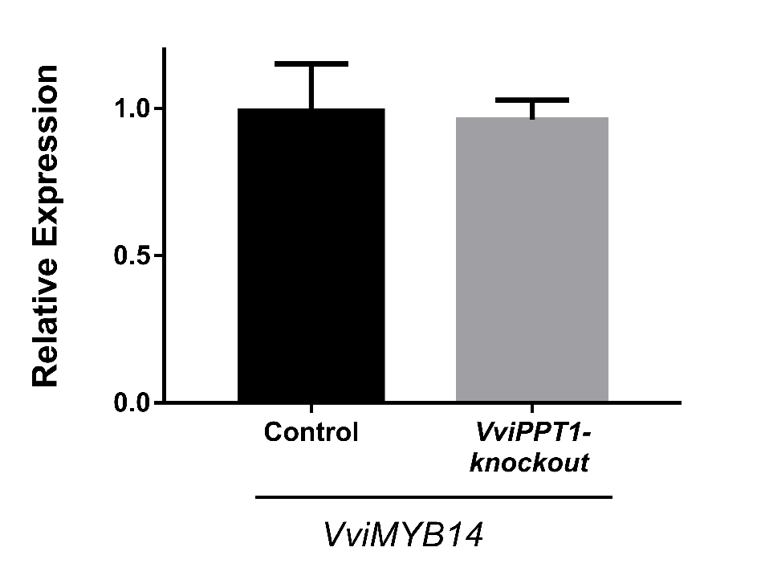
Supplementary Figure S6- Transcriptional analysis of VviMYB14 transcription factor in the cv. Gamay fréaux control line and VviPPT1-knockout line. Results indicate the mean ± SD of three independent experiments.
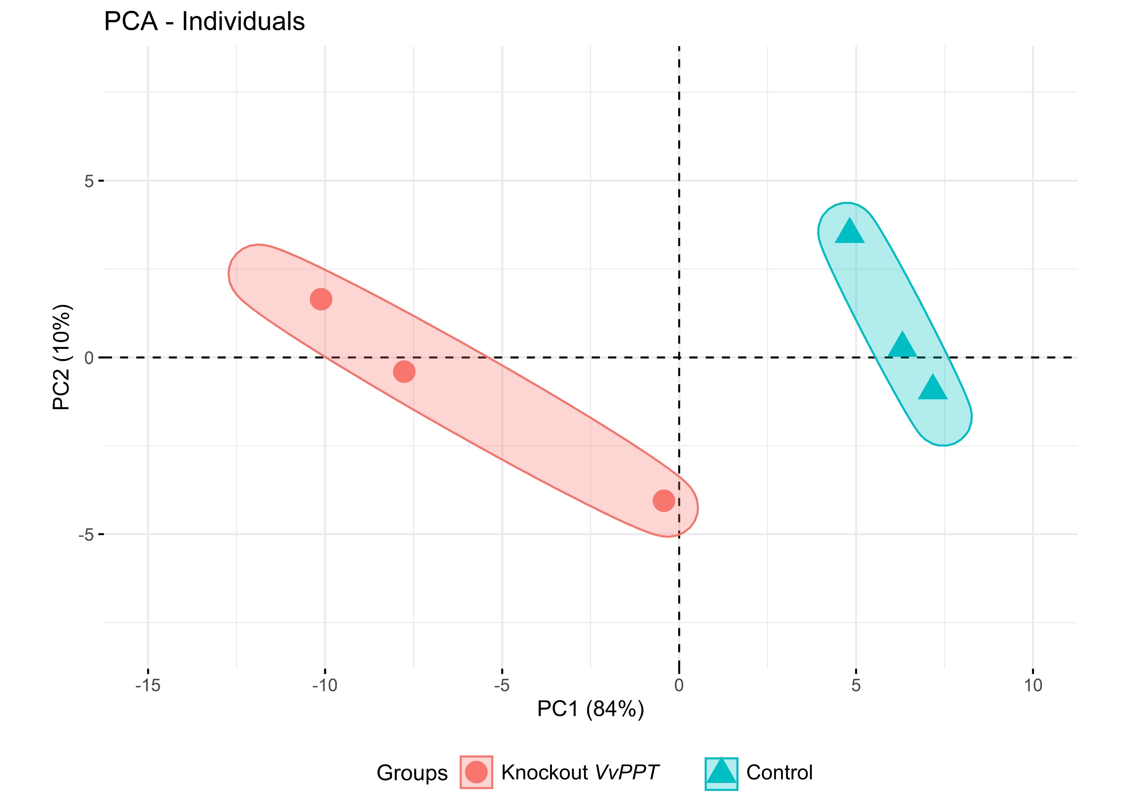
Supplementary Figure S7- Principal Component Analysis (PCA) biplot of PC1 (84 %) and PC2 (10 %) of the metabolomic analysis by HPLC-ESI-HRMS.

Supplementary Tables
Supplementary Table S1- gRNAs characteristics. On-target and off-target scores were evaluated using CRISPR tool from the Benchling online platform (https://benchling.com/), ranging both scores between 0-100, and higher is better. On this platform, the on-target score is optimized for 20bp guides with NGG PAMs according to Doench et al. (2016), and the off-target specificity score optimized by Hsu et al. (2013).
 | Position | Strand | Sequence | PAM | On-target score | Off-target score
gRNA1 | 9851568 | + | CGCAGCCGGCGTCCGAACGG | AGG | 63.6 | 100.0
gRNA2 | 9851448 | - | TTCGGTGCCGGAGAGCGCCG | GGG | 68.7 | 99.5
gRNA3 | 9850412 | - | ATTCCCTGTAACTGTCACCG | TGG | 76.7 | 98.5

Supplementary Table S2- Off-target prediction to gRNA3, the guide that successfully produced the knock-out. The off-score ranges between 0-1.0, low is better, and was optimized according to Doench et al. (2016). The number of off-targets was confirmed by the online tool Cas-OFFinder. MMs-mismatches (the mismatch sites are highlighted with red color and PAM in green).
Sequence  (with PAM) | Off-score | MMs | Locus | Gene | Putative function | Region
CTTCACTGAAACTGTCACCAGGG | 0.426 | 4MMs | 4:-23603893 | Vitvi04g01741 | Disulfide  oxidoreductase | exon
AGTCCCTGTAATTATAACCGAGG | 0.339 | 4MMs | 5:+23747633 | Vitvi05g01592 | 5’-3’ Exonuclease family protein | intron

Supplementary Table S3- Primers used in this study. Accession numbers of V. vinifera genes were obtained using Vcost_V3 annotation.
Gateway cloning
Gene | Accession number |  | Oligonucleotide sequence (5’-3’)
VviPPT1 | Vitvi17g00833 |  | Fw | GGGGACAAGTTTGTACAAAAAAGCAGGCTATATGCAGAGCACCGCTTTCA
VviPPT1 |  |  | Rv | GGGGACCACTTTGTACAAGAAAGCTGGGTTAGCTGTCTTTGGCTTGATGC
CRISPR/Cas9 edition
guide RNA | Oligonucleotide sequence (5’-3’)
gRNA1 | Fw | GTGCACCGTTCGGACGCCGGCTGCG
gRNA1 | Rv | AAACCGCAGCCGGCGTCCGAACGGT
gRNA2 | Fw | GTGCACGGCGCTCTCCGGCACCGAA
gRNA2 | Rv | AAACTTCGGTGCCGGAGAGCGCCGT
gRNA3 | Fw | GTGCACGGTGACAGTTACAGGGAAT
gRNA3 | Rv | AAACATTCCCTGTAACTGTCACCGT
Validation of the transformation/genomic amplification
Gene | Reference | Oligonucleotide sequence (5’-3’)
NptII | Garcia et al. 2015 | Fw | GGATTGCACGCAGGTTCTCC
NptII | Garcia et al. 2015 | Rv | AACTCGTCAAGAAGGCGATA
Seq1 | Designed according to Synthego Genotyping guidelines | Fw | CCTTGCCTAAAATGCAGAGC
Seq1 | Designed according to Synthego Genotyping guidelines | Rv | TTACGTCAGTTCATCAGAGG
Seq2 | Designed according to Synthego Genotyping guidelines | Fw | GGTGGCAATACATGGATTAT
Seq2 | Designed according to Synthego Genotyping guidelines | Rv | GGATTGCTACAAGCTGTAAA
Off-target1 | Designed according to Synthego Genotyping guidelines | Fw | TGAAGTGTTGCCCAGACTTTCTG
Off-target1 | Designed according to Synthego Genotyping guidelines | Rv | GAACGCGTCCCTTCTGTGAATG
Off-target2 | Designed according to Synthego Genotyping guidelines | Fw | TCACAATGGATTAAGACATGGACT
Off-target2 | Designed according to Synthego Genotyping guidelines | Rv | TGGGACACATAGGTTGGCTTC
qPCR analysis
Gene | Accession number | Reference | Oligonucleotide sequence (5’-3’)
VviGAPDH | Vitvi17g01598 | Gainza-Cortés et al. 2012 | Fw | TTCCGTGTTCCTACTGTTG
VviGAPDH | Vitvi17g01598 | Gainza-Cortés et al. 2012 | Rv | CCTCTGACTCCTCCTTGAT
VviACTIN | Vitvi04g01613 | Conde et al. 2015 | Fw | GTGCCTGCCATGTATGTTGCCATTCAG
VviACTIN | Vitvi04g01613 | Conde et al. 2015 | Rv | GCAAGGTCAAGACGAAGGATAGCATGG
VviPPT1 | Vitvi17g00833 | Designed with QuantPrime  (Arvidsson et al. 2008) | Fw | GGGAACTTGGTTCAGACGTT
VviPPT1 | Vitvi17g00833 | Designed with QuantPrime  (Arvidsson et al. 2008) | Rv | CCTTCAGAACCTGCTTGTTG
VviPPT2 | Vitvi14g01739 | Designed with QuantPrime | Fw | TGTGACACACACCATGGGTAAC
VviPPT2 | Vitvi14g01739 | Designed with QuantPrime | Rv | AATCGGGAGAGTGGGTTTCTCC
VviCAT1 | Vitvi10g00902 | Designed with QuantPrime | Fw | CCGTCTTCTGCTACACTGAGTTGG
VviCAT1 | Vitvi10g00902 | Designed with QuantPrime | Rv | AAGTAGGCAAACGACCCACCAG
VviGPT1 | Vitvi19g00457 | Noronha et al. 2015 | Fw | TCAATGCTCTTGGAGCTGCCATC
VviGPT1 | Vitvi19g00457 | Noronha et al. 2015 | Rv | CTTCCTCACTGCTTTGCCTGAG
VviTPT1 | Vitvi10g00499 | Designed with QuantPrime | Fw | AGGACAGTCGATACCCTTAACCC
VviTPT1 | Vitvi10g00499 | Designed with QuantPrime | Rv | CAATGATGCCATTGACACACCAG
VviDAHPS1 | Vitvi07g03049 | Zhang et al. 2012 | Fw | TGCTGCTGGACTCACAGTT
VviDAHPS1 | Vitvi07g03049 | Zhang et al. 2012 | Rv | CATGAGCA CATCCAGTTG
VviDAHPS2 | Vitvi18g00436 | Zhang et al. 2012 | Fw | CACCGGAGGGTATGCTTCTA
VviDAHPS2 | Vitvi18g00436 | Zhang et al. 2012 | Rv | ACCAAGGGCTTCATCAACAC
VviDAHPS3 | Vitvi02g01749 | Zhang et al. 2012 | Fw | TGCTTTGGGTAGGTGAGAGAA
VviDAHPS3 | Vitvi02g01749 | Zhang et al. 2012 | Rv | GGTTTGTTGCGAGGGTTTAG
VvDHQS | Vitvi04g01492 | Designed with QuantPrime | Fw | GGCAATTGAGTCACGGTTGGAT
VvDHQS | Vitvi04g01492 | Designed with QuantPrime | Rv | CCCTTGCCATTAATGCCTGCA
VviSDH1 | Vitvi05g00364 | Bontpart et al. 2016 | Fw | GGCAGGCATATGAGCAGTTT
VviSDH1 | Vitvi05g00364 | Bontpart et al. 2016 | Rv | CAGCTCTCAACAGGACAGCTC
VviSDH2 | Vitvi14g00340 | Bontpart et al. 2016 | Fw | AGTTCTGATACACTGCCTCATG
VviSDH2 | Vitvi14g00340 | Bontpart et al. 2016 | Rv | ACCCTTATTGAAATGTGCTTGGA
VviSDH3 | Vitvi14g00339 | Bontpart et al. 2016 | Fw | AGAGATGTTGATCCGCCAAG
VviSDH3 | Vitvi14g00339 | Bontpart et al. 2016 | Rv | AACTGACTGCCCAAGCAAAT
VviSDH4 | Vitvi14g00338 | Bontpart et al. 2016 | Fw | TCAGGGAAGTTTTGGTGAGGA
VviSDH4 | Vitvi14g00338 | Bontpart et al. 2016 | Rv | ACTCAGCAGCTAATCACAAAGA
VviSK | Vitvi07g01835 | Zhang et al. 2012 | Fw | TTGTTGGGATGATGGGTTCT
VviSK | Vitvi07g01835 | Zhang et al. 2012 | Rv | CCCTCGCCATAGAGGTTAAA
VviEPSPS | Vitvi12g02550 | Zhang et al. 2012 | Fw | AGCATGAGAGGGCAGTTAGC
VviEPSPS | Vitvi12g02550 | Zhang et al. 2012 | Rv | ATGGGTTGCAGGACAATCTC
VviCS1 | Vitvi13g00597 | Zhang et al. 2012 | Fw | ATCGCTCTGGTGGGATACAG
VviCS1 | Vitvi13g00597 | Zhang et al. 2012 | Rv | TCGTGGAACAACACATGGAT
VviCM1 | Vitvi04g00594 | Zhang et al. 2012 | Fw | AGGCCGGTAGATATGAGAAC
VviCM1 | Vitvi04g00594 | Zhang et al. 2012 | Rv | TCACAAGCTGCAGTTAGTCC
VviCM2 | Vitvi14g02011 | Zhang et al. 2012 | Fw | CTGCCATCAAAGCACAAGAC
VviCM2 | Vitvi14g02011 | Zhang et al. 2012 | Rv | CCATCCCATTCACCACTACC
VviAS | Vitvi06g00617 | Zhang et al. 2012 | Fw | CATCTGGAAGCCGTTTTGAC
VviAS | Vitvi06g00617 | Zhang et al. 2012 | Rv | CATCAGCGGGAACACTATCA
VviADT1 | Vitvi10g00088 | Designed with QuantPrime | Fw | TGCCTGGTGTAAGAAAGGATGAGC
VviADT1 | Vitvi10g00088 | Designed with QuantPrime | Rv | GGCCATCAGAAGCGACAATCTGAG
VviADT2 | Vitvi12g00380 | Designed with QuantPrime | Fw | GGTGGGAATTGATCAGCTAAGACG
VviADT2 | Vitvi12g00380 | Designed with QuantPrime | Rv | GGCCATGTGAGGCTACATACTGAG
VviENO1 | Vitvi08g01520 | Designed with QuantPrime | Fw | CTTGCAATGCCCTTCTTCTC
VviENO1 | Vitvi08g01520 | Designed with QuantPrime | Rv | CCAAGCTCCTCTTCAATTCG
VviPPDK | Vitvi05g00387 | Designed with QuantPrime | Fw | CGAGCAATCTTTCAGGCTGCTG
VviPPDK | Vitvi05g00387 | Designed with QuantPrime | Rv | TCGCTTGGTGTCCTAGTTCCTGAG
VviPPK1 | Vitvi05g00612 | Designed with QuantPrime | Fw | TTCAGCTGCCAAGATGGCGAAC
VviPPK1 | Vitvi05g00612 | Designed with QuantPrime | Rv | TGCAAAGATTGGGCAGTCAGGTC
VviPPK2 | Vitvi16g01182 | Designed with QuantPrime | Fw | ACATGCAGTTCTCAGACGATGCC
VviPPK2 | Vitvi16g01182 | Designed with QuantPrime | Rv | TCCTTCACCATCCCTTGCTTCTGC
VviPPK3 | Vitvi02g00684 | Designed with QuantPrime | Fw | CGAGCCCTCAGCATACTAGTGAAC
VviPPK3 | Vitvi02g00684 | Designed with QuantPrime | Rv | TGCTCCACTTTGAACAAGAGTCAC
VviDFR | Vitvi18g00988 | Bogs et al. 2006 | Fw | GGCTTTCTAGCGAGAGCGTA
VviDFR | Vitvi18g00988 | Bogs et al. 2006 | Rv | ACTCTCATTTCCGGCACATT
VviLDOX | Vitvi13g00055 | Bogs et al. 2005 | Fw | ACCTTCATCCTCCACAACAT
VviLDOX | Vitvi13g00055 | Bogs et al. 2005 | Rv | AGTAGAGCCTCCTGGGTCTT
VviUFGT1 | Vitvi16g00156 | Badim et al. 2022 | Fw | TGCAGGGCCTAACTCACTCT
VviUFGT1 | Vitvi16g00156 | Badim et al. 2022 | Rv | GCAGTCGCCTTAGGTAGCAC
VviPAL1 | Vitvi08g01022 | Boubakri et al. 2013 | Fw | CCGAACCGAATCAAGGACTG
VviPAL1 | Vitvi08g01022 | Boubakri et al. 2013 | Rv | GTTCCAGCCACTGAGACAAT
VviPAL2 | Vitvi06g00256 | Zhao et al. 2021 | Fw | CATAGAAGAACCAAACAAGGAAA
VviPAL2 | Vitvi06g00256 | Zhao et al. 2021 | Rv | GCAATGTAAGAAAGAGGGACGA
VviPAL3 | Vitvi11g00116. | Zhao et al. 2021 | Fw | TTACACAGATGAAGATGGGACG
VviPAL3 | Vitvi11g00116. | Zhao et al. 2021 | Rv | TCGGAGTTGAGGCAAAAAA
VviPAL5 | Vitvi13g00622 | Zhao et al. 2021 | Fw | TCATCAACCACAACATTACCC
VviPAL5 | Vitvi13g00622 | Zhao et al. 2021 | Rv | CATGCCAGACCCAACAGC
VviSTS1 | Vitvi16g01486 | Boubakri et al. 2013 | Fw | CGAAGCAACTAGGCATGTGT
VviSTS1 | Vitvi16g01486 | Boubakri et al. 2013 | Rv | CTCCCCAATCCAATCCTTCA
VviMYBF1 | Vitvi07g00393 | Czemmel et al. 2009 | Fw | GGAGGTTGAGGGGTTGTG
VviMYBF1 | Vitvi07g00393 | Czemmel et al. 2009 | Rv | AAGTTGGGGAAGAGCAGGAG
VviMYBA1 | Vitvi02g01019 | Xie et al. 2020 | Fw | AGAACAGGTTCGAGGTTG
VviMYBA1 | Vitvi02g01019 | Xie et al. 2020 | Rv | TCTATTCAACCCTGCTCGG
VviMYB5a | Vitvi08g01797 | Höll et al. 2013 | Fw | CTAGAACTGTCTGGGAACCT
VviMYB5a | Vitvi08g01797 | Höll et al. 2013 | Rv | TGCAAGGATCCATTTCACATAC
VviMYB14 | Vitvi07g00598 | Höll et al. 2013 | Fw | TCTGAGGCCGGATATCAAAC
VviMYB14 | Vitvi07g00598 | Höll et al. 2013 | Rv | GGGACGCATCAAGAGAGTGT

Supplementary Table S4- Compounds detected through HPLC-ESI-HRMS analysis in the cv. Gamay fréaux control line and VviPPT1-knockout line.
 |  | Control line |  |  | VviPPT1-knockout
Pathway | Metabolite | AVG | St.  Dev | % | AVG | St.  Dev | % | p-value
Amino acids | Phenylalanine | 523,631 | 37,723 | 7,204 | 315,456 | 80,522 | 25,525 | 0,046
Amino acids | Tyrosine | 15,825 | 2,816 | 17,792 | 15,146 | 2,092 | 13,814 | 0,754
Amino acids | Tryptophane | 16,450 | 3,629 | 22,064 | 12,661 | 3,548 | 28,025 | 0,266
Flavan-3-ol | Gallocatechin | 7,360 | 2,986 | 40,567 | 0,798 | 0,432 | 54,158 | 0,020
Flavan-3-ol | D-Catechin | 46,312 | 10,565 | 22,813 | 18,824 | 3,685 | 19,575 | 0,013
Flavanones, glycosides, and derivatives | Pentahydroxyflavanone | 13,641 | 5,281 | 38,717 | 2,087 | 0,969 | 46,451 | 0,020
Flavanones, glycosides, and derivatives | Hydroxylated naringenin chalcone | 6,295 | 0,167 | 2,648 | 2,635 | 0,283 | 10,739 | 0,000
Flavanones, glycosides, and derivatives | Eriodictyol | 45,837 | 2,786 | 6,077 | 9,399 | 0,964 | 10,254 | 0,000
Flavanones, glycosides, and derivatives | Naringenin  dihexose I | 0,323 | 0,071 | 21,902 | 0,023 | 0,009 | 40,011 | 0,002
Flavanones, glycosides, and derivatives | Eriodictyol  hexose | 13,425 | 3,152 | 23,478 | 2,898 | 0,598 | 20,643 | 0,005
Flavanones, glycosides, and derivatives | Naringenin  chalcone glucoside | 11,588 | 2,709 | 23,377 | 4,331 | 1,053 | 24,306 | 0,012
Flavanones, glycosides, and derivatives | Naringenin | 1,660 | 0,353 | 21,247 | 0,589 | 0,281 | 47,657 | 0,015
Flavones, glycosides, and derivatives | Laricitrin  3-O-hexoside | 0,006 | 0,001 | 17,063 | n.d | n.d | n.d
Flavones, glycosides, and derivatives | Myricetin | 0,196 | 0,022 | 11,426 | 0,021 | 0,001 | 2,536 | 0,000
Flavones, glycosides, and derivatives | Myricetin  O-di-hexoside | 0,068 | 0,041 | 60,454 | 0,040 | 0,030 | 74,208 | 0,399
Flavones, glycosides, and derivatives | Pentahydroxyflavone | 0,331 | 0,087 | 26,410 | 0,080 | 0,025 | 30,897 | 0,009
Flavones, glycosides, and derivatives | Myricetin  3-O-galactoside | 1,098 | 0,314 | 28,578 | 0,388 | 0,110 | 28,216 | 0,021
Flavones, glycosides, and derivatives | Laricitrin | 0,407 | 0,159 | 39,142 | 0,020 | 0,009 | 45,578 | 0,014
Flavonoids, glycosides, and derivatives | Phloretin di-C-hexose | 2,020 | 0,462 | 22,855 | n.d | n.d | n.d
Flavonols, glycosides, and derivatives | Dihydroquercetin (Taxifolin) | n.d | n.d | n.d | 0,275 | 0,127 | 46,282
Flavonols, glycosides, and derivatives | Kaempferol 3-O-glucuronide | 0,618 | 0,247 | 39,950 | n.d | n.d | n.d
Flavonols, glycosides, and derivatives | Kaempferol 3-O-glucoside  (Astragalin) | 24,519 | 5,765 | 23,512 | 4,430 | 1,079 | 24,352 | 0,004
Flavonols, glycosides, and derivatives | Isorhamnetin  3-O-glucoronide | 0,170 | 0,031 | 18,075 | 0,028 | 0,013 | 45,542 | 0,002
Flavonols, glycosides, and derivatives | Quercetin dihexose deoxyhexose p-coumaric | 0,117 | 0,046 | 39,420 | n.d | n.d | n.d
Flavonols, glycosides, and derivatives | Dihydrokaempferol  (Aromadendrin) | 6,462 | 0,185 | 2,855 | 2,612 | 0,311 | 11,889 | 0,000
Flavonols, glycosides, and derivatives | Kaempferol  manolylglucoside | 0,439 | 0,080 | 18,190 | 0,013 | 0,005 | 35,827 | 0,001
Flavonols, glycosides, and derivatives | Syringetin | 0,198 | 0,070 | 35,235 | 0,018 | 0,007 | 37,047 | 0,011
Flavonols, glycosides, and derivatives | Rutin | 0,098 | 0,046 | 46,292 | 0,043 | 0,028 | 66,321 | 0,148
Flavonols, glycosides, and derivatives | Dihydroquercetin  3-O-rhamnoside (Astilbin) | 13,173 | 2,819 | 21,402 | 2,924 | 0,621 | 21,219 | 0,004
Flavonols, glycosides, and derivatives | Quercetin  3-O-glucoronide | 0,683 | 0,207 | 30,294 | 0,659 | 0,175 | 26,500 | 0,887
Flavonols, glycosides, and derivatives | Quercetin  malonylhexose | 0,031 | 0,011 | 36,654 | 0,044 | 0,012 | 26,839 | 0,231
Flavonols, glycosides, and derivatives | Isorhamnetin  3-O-hexoside | 0,009 | 0,003 | 39,050 | n.d | n.d | n.d
Flavonols, glycosides, and derivatives | Kaempferol  O-rhamnosyl-hexoside | 0,078 | 0,028 | 35,798 | n.d | n.d | n.d
Flavonols, glycosides, and derivatives | Morin | 1,073 | 0,262 | 24,394 | 0,295 | 0,082 | 27,937 | 0,008
Flavonols, glycosides, and derivatives | Quercetin | 3,629 | 0,935 | 25,774 | 0,982 | 0,294 | 29,971 | 0,009
Flavonols, glycosides, and derivatives | Isorhamnetin | 2,415 | 0,696 | 28,826 | 0,528 | 0,138 | 26,202 | 0,010
Flavonols, glycosides, and derivatives | Dihydrokaempferol 3-O-rahmnoside | n.d | n.d | n.d | 0,616 | 0,247 | 40,151
Flavonols, glycosides, and derivatives | Syringetin 3-O-galactoside | 2,681 | 0,854 | 31,867 | 0,821 | 0,120 | 14,611 | 0,020
Organic acids and derivatives (Shikimate pathway) | Anthranilic  acid | 84,719 | 5,524 | 6,521 | 63,173 | 5,634 | 8,918 | 0,009
Organic acids and derivatives (Shikimate pathway) | Shikimic  acid | 0,687 | 0,136 | 19,859 | 0,184 | 0,013 | 7,220 | 0,003
Organic acids and derivatives (Shikimate pathway) | Arogenate | 0,295 | 0,138 | 46,687 | 0,354 | 0,160 | 45,389 | 0,658
Organic acids and derivatives (Shikimate pathway) | Shikimate  3-phosphate | 0,129 | 0,024 | 18,316 | 0,042 | 0,010 | 24,717 | 0,004
Organic acids and derivatives (Shikimate pathway) | Chorismic  acid | 0,117 | 0,005 | 4,575 | 0,078 | 0,022 | 28,590 | 0,043
Organic acids and derivatives (Shikimate pathway) | 4-Hydroxyphenylpyruvate | 0,413 | 0,022 | 5,209 | 0,071 | 0,013 | 18,924 | 0,000
Sugars and derivatives (Shikimate pathway) | Erythrose  4-phosphate | 0,044 | 0,014 | 32,281 | 0,023 | 0,009 | 37,724 | 0,093
Phenolic acids, glycosides, and derivatives | Gallic acid | 0,275 | 0,020 | 7,102 | 0,054 | 0,004 | 6,699 | 0,000
Phenolic acids, glycosides, and derivatives | Beta-glucogallin | 3,372 | 0,480 | 14,242 | n.d | n.d | n.d
Phenolic acids, glycosides, and derivatives | Fertaric acid | 0,013 | 0,003 | 20,052 | 0,009 | 0,006 | 66,853 | 0,384
Phenolic acids, glycosides, and derivatives | Hydroxybenzoic  acid hexose | 0,518 | 0,135 | 26,115 | 0,169 | 0,043 | 25,332 | 0,013
Phenolic acids, glycosides, and derivatives | N-Feruloylputrescine II | 0,111 | 0,037 | 33,182 | 0,126 | 0,039 | 30,888 | 0,640
Phenolic acids, glycosides, and derivatives | Hydrocinnamic  acid hexose | 0,038 | 0,015 | 38,274 | 0,053 | 0,010 | 19,001 | 0,236
Phenolic acids, glycosides, and derivatives | Sinapoyl  malate II | 0,064 | 0,013 | 20,232 | 0,007 | 0,004 | 66,019 | 0,002
Phenolic acids, glycosides, and derivatives | Caffeic acid  hexose IV | 2,669 | 0,542 | 20,303 | 2,021 | 0,491 | 24,296 | 0,200
Phenolic acids, glycosides, and derivatives | Caffeic acid | 2,074 | 0,423 | 20,400 | 0,385 | 0,078 | 20,307 | 0,002
Phenolic acids, glycosides, and derivatives | p-coumaric acid  glucoside | 15,124 | 5,182 | 34,266 | 7,342 | 1,675 | 22,812 | 0,069
Phenolic acids, glycosides, and derivatives | 5-caffeoyl  quinic acid | 0,687 | 0,151 | 21,939 | 0,266 | 0,049 | 18,415 | 0,010
Phenolic acids, glycosides, and derivatives | Ferulic acid  hexose I/III | 0,186 | 0,051 | 27,400 | 0,037 | 0,009 | 23,758 | 0,008
Phenolic acids, glycosides, and derivatives | Sinapic acid | 0,344 | 0,104 | 30,117 | 0,121 | 0,020 | 16,632 | 0,022
Phenolic acids, glycosides, and derivatives | Dicaffeoylquinic  acid | 0,066 | 0,013 | 19,506 | n.d | n.d | n.d
Stilbenes | Resveratrol-glucoside I | 130,465 | 25,303 | 19,394 | 3,018 | 0,808 | 26,760 | 0,001
Stilbenes | Resveratrol-glucoside II | 306,497 | 39,307 | 12,825 | 51,796 | 11,452 | 22,110 | 0,000
Stilbenes | Viniferin | n.d | n.d | n.d | 0,006 | 0,005 | 81,697
Stilbenes | Trans-resveratrol | 8,820 | 2,153 | 24,407 | 0,545 | 0,156 | 28,546 | 0,003

References
Arvidsson S, Kwasniewski M, Riano-Pachon DM, Mueller-Roeber B (2008) QuantPrime - a flexible tool for reliable high-throughput primer design for quantitative PCR. BMC Bioinformatics 9:465. https://doi.org/10.1186/1471-2105-9-465.
Conde A, Regalado A, Rodrigues D, Costa JM, Blumwald E, Chaves MM, Gerós H (2015) Polyols in grape berry: transport and metabolic adjustments as a physiological strategy for water stress tolerance in grapevine. J Exp Bot 66(3):889-906. https://doi.org/10.1093/jxb/eru446.
Badim H, Vale M, Coelho M, Granell A, Gerós H, Conde A (2022) Constitutive expression of VviNAC17 transcription factor significantly induces the synthesis of flavonoids and other phenolics in transgenic grape berry cells. Front Plant Sci 13:964621. https://doi.org/10.3389/fpls.2022.964621.
Bogs J, Ebadi A, McDavid D, Robinson SP (2006) Identification of the flavonoid hydroxylases from grapevine and their regulation during fruit development. Plant Physiol 140(1):279-291. https://doi.org/10.1104/pp.105.073262.
Bogs J, Jaffé FW, Takos AM, Walker AR, Robinson SP (2007) The grapevine transcription factor VvMYBPA1 regulates proanthocyanidin synthesis during fruit development. Plant Physiol 143(3):1347-1361. https://doi.org/10.1104/pp.106.093203.
Bontpart T, Marlin T, Vialet S, Guiraud JL, Pinasseau L, Meudec E, Sommerer N, Cheynier V, Terrier N (2016) Two shikimate dehydrogenases, VvSDH3 and VvSDH4, are involved in gallic acid biosynthesis in grapevine. J Exp Bot 67(11):3537-3550. https://doi.org/10.1093/jxb/erw184.
Boubakri H, Poutaraud A, Wahab MA, Clayeux C, Baltenweck-Guyot R, Steyer D, Marcic C, Mliki A, Soustre-Gacougnolle I (2013) Thiamine modulates metabolism of the phenylpropanoid pathway leading to enhanced resistance to Plasmopara viticola in grapevine. BMC Plant Biol 13(1):31. https://doi.org/10.1186/1471-2229-13-31.
Czemmel S, Stracke R, Weisshaar B, Cordon N, Harris NN, Walker AR, Robinson SP, Bogs J (2009) The Grapevine R2R3-MYB transcription factor VvMYBF1 regulates flavonol synthesis in developing grape berries. Plant Physiol 151(3):1513-1530. https://doi.org/10.1104/pp.109.142059.
Doench J, Fusi N, Sullender M, Hegde M, Vaimberg EW, Donovan KF, Smith I, Tothova Z, Wilen C, Orchard R, Virgin HW, Listgarten J, Root DE (2016) Optimized sgRNA design to maximize activity and minimize off-target effects of CRISPR-Cas9. Nat Biotechnol 34(2):184-191. https://doi.org/10.1038/nbt.3437.
Gainza-Cortés F, Pérez-Dïaz R, Pérez-Castro R, Tapia J, Casaretto JA, González S, Peña-Cortés H, Ruiz-Lara S, González E (2012) Characterization of a putative grapevine Zn transporter, VvZIP3, suggests its involvement in early reproductive development in Vitis vinifera L. BMC Plant Biol 12:111. https://doi.org/10.1186/1471-2229-12-111.
Garcia D, Narváez-Vásquez J, Orozco-Cárdenas ML (2015) Tomato (Solanum lycopersicum). Methods Mol Biol 1223: 349-361. https://doi.org/10.1007/978-1-4939-1695-5_28.
Höll J, Vannozzi A, Czemmel S, D'Onofrio C, Walker AR, Rausch T, Lucchin M, Boss PK, Dry IB, Bogs J (2013) The R2R3-MYB transcription factors MYB14 and MYB15 regulate stilbene biosynthesis in Vitis vinifera. Plant Cell 25(10):4135-4149. https://doi.org/10.1105/tpc.113.117127.
Hsu PD, Scott DA, Weinstein JA, Ran AF, Konermann S, Agarwala V, Li Y, Fine EJ, Wu X, Shalem O, Cradick TJ, Marraffini LA, Bao G, Zhang F (2013) DNA targeting specificity of RNA-guided Cas9 nucleases. Nat Biotechnol 31(9):827-832. https://doi.org/10.1038/nbt.2647.
Jones DT, Taylor WR and Thornton JM (1992) The rapid generation of mutation data matrices from protein sequences. Computer Applications in the Biosciences 8:275-282.
Karimi M, Inzé D, Depicker A (2002) GATEWAY™ vectors for Agrobacterium-mediated plant transformation. Trends Plant Sci 7(5):193-195. https://doi.org/10.1016/S1360-1385(02)02251-3.
Kumar S, Stecher G and Tamura K (2016) MEGA7: Molecular Evolutionary Genetics Analysis version 7.0 for bigger datasets. Molecular Biology and Evolution 33:1870-1874. https://doi.org/10.1093/molbev/msw054.
Noronha H, Conde C, Delrot S, Gerós H (2015) Identification and functional characterization of grapevine transporters that mediate glucose-6-phosphate uptake into plastids. Planta 242(4):909-920. https://doi.org/10.1007/s00425-015-2329-x.
Xie S, Lei Y, Chen H, Li J, Chen H, Zhang Z (2020) R2R3-MYB transcription factors regulate anthocyanin biosynthesis in grapevine vegetative tissues. Front Plant Sci 11:527. https://doi.org/ 10.3389/fpls.2020.00527.
Whelan S and Goldman N (2001) A general empirical model of protein evolution derived from multiple protein families using a maximum-likelihood approach. Molecular Biology and Evolution 18(5): 691-699. https://doi.org/10.1093/oxfordjournals.molbev.a003851.
Zhang ZZ, Li XX, Chu YN, Zhang MX, Wen YQ, Duan CQ, Pan QH (2012) Three types of ultraviolet irradiation differentially promote expression of shikimate pathway genes and production of anthocyanins in grape berries. Plant Physiol Biochem 57:74-83. https://doi.org/10.1016/j.plaphy.2012.05.005.
Zhao T, Li R, Yao W, Wang Y, Zhang C, Li Y (2021) Genome-wide identification and characterisation of phenylalanine ammonia-lyase gene family in grapevine. J Hortic Sci Biotechnol 96(4):456-468. https://doi.org/10.1080/14620316.2021.1879685.

