List of Supplementary Figures
Figure S1. Expression profile of auxins response factor MdARF5 (A), ethylene biosynthetic genes MdACS3 (B) and MdACO1 (C), ethylene receptor MdETR1 (D) and ethylene response factors MdERF1 (E), MdERF2 (F) and MdERF3 (G) during the development of ‘Granny Smith’ (), ‘Opal®’ () and ‘Royal Gala’ () apples. Each point represents the mean of four biological replicates. Error bars represent the LSD values (p=0.05) for the interaction cultivar × sampling point for all cultivars from S1 to S4 (LSD1) and for the interaction cultivar × sampling point for ‘Opal®’ and ‘Granny Smith’ from S1 to S6 (LSD2).
Figure S2. Expression profile of MdANS (A), MdUFGT (B), MdMATE (C) and MdMYB1 (D) during the development of ‘Granny Smith’ (), ‘Opal®’ () and ‘Royal Gala’ () apples. Each point represents the mean of four biological replicates. Error bars represent the LSD values (p=0.05) for the interaction cultivar × sampling point for all cultivars from S1 to S4 (LSD1) and for the interaction cultivar × sampling point for ‘Opal®’ and ‘Granny Smith’ from S1 to S6 (LSD2).
Figure S3. Levels of total carotenoids (A) and expression profile of MdPIF1 (B), MdGGPPS (C) and MdPSY (D) during the development of ‘Granny Smith’ (), ‘Opal®’ () and ‘Royal Gala’ () apples. Each point represents the mean of four biological replicates. Error bars represent the LSD values (p=0.05) for the interaction cultivar × sampling point for all cultivars from S1 to S4 (LSD1) and for the interaction cultivar × sampling point for ‘Opal®’ and ‘Granny Smith’ from S1 to S6 (LSD2).
Figure S4. Evolution of phaseic acid (PA, A), dihydrophaseic acid (DPA, B), ABA-glucose ester (ABA-GE, C), neophaseic acid (neo-PA, D) and 7’-hydroxy ABA (7’-OH ABA, E) during the development of ‘Granny Smith’ (), ‘Opal®’ () and ‘Royal Gala’ () apples. Dashed lines indicate that some steps in the metabolic pathway have been omitted. Each point represents the mean of four biological replicates. Error bars represent the LSD values (p=0.05) for the interaction cultivar × sampling point for all cultivars from S1 to S4 (LSD1) and for the interaction cultivar × sampling point for ‘Opal®’ and ‘Granny Smith’ from S1 to S6 (LSD2).
Figure S5. Expression profile of MdGLK1 (A), MdNYC1 (B) and MdPPH (C) during the development of ‘Granny Smith’ (), ‘Opal®’ () and ‘Royal Gala’ () apples. Each point represents the mean of four biological replicates. Error bars represent the LSD values (p=0.05) for the interaction cultivar × sampling point for all cultivars from S1 to S4 (LSD1) and for the interaction cultivar × sampling point for ‘Opal®’ and ‘Granny Smith’ from S1 to S6 (LSD2).
Figure S6. Correlations amongst the different parameters (metabolites, enzymatic activities, and gene expression) studied during the development of ‘Royal Gala’, ‘Opal®’ and ‘Granny Smith’ apples. The size of the circle for each correlation and the colour depict the significance and the correlation coefficient, respectively. Positive correlation coefficients are displayed in blue and negative correlation coefficients in red.

Figure S1
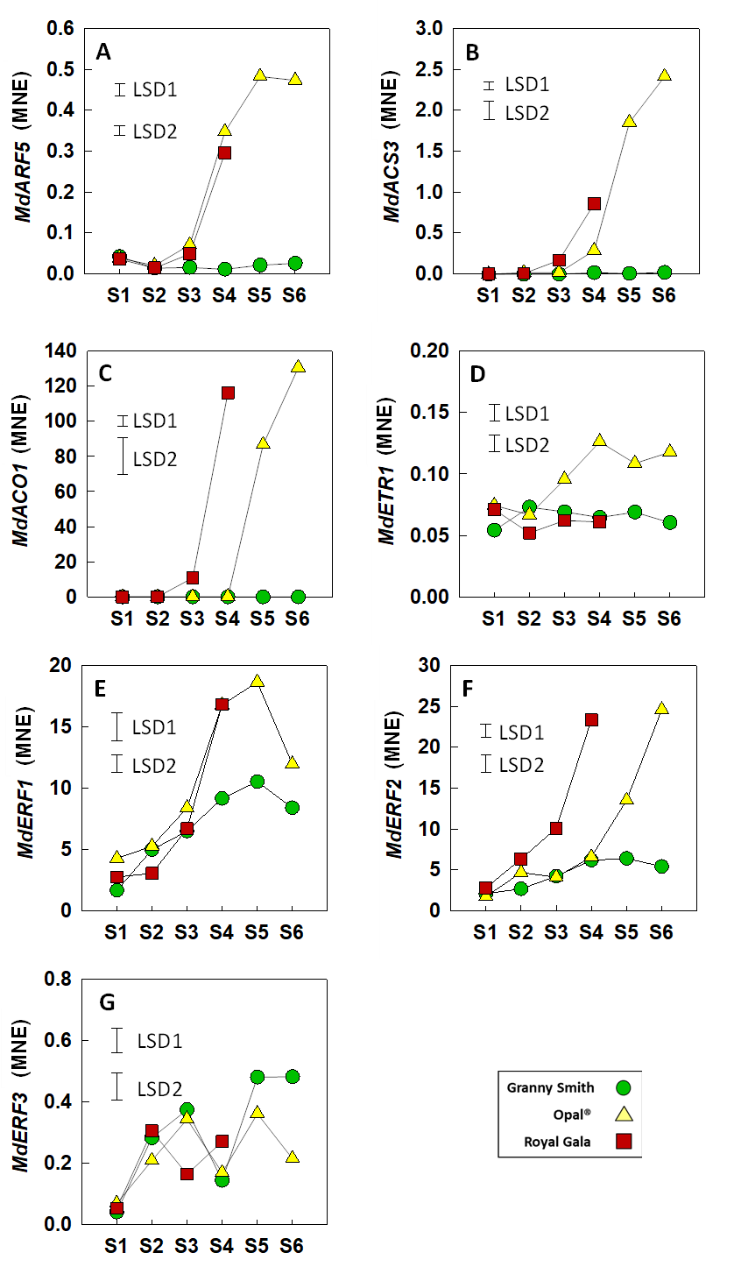
Figure S2
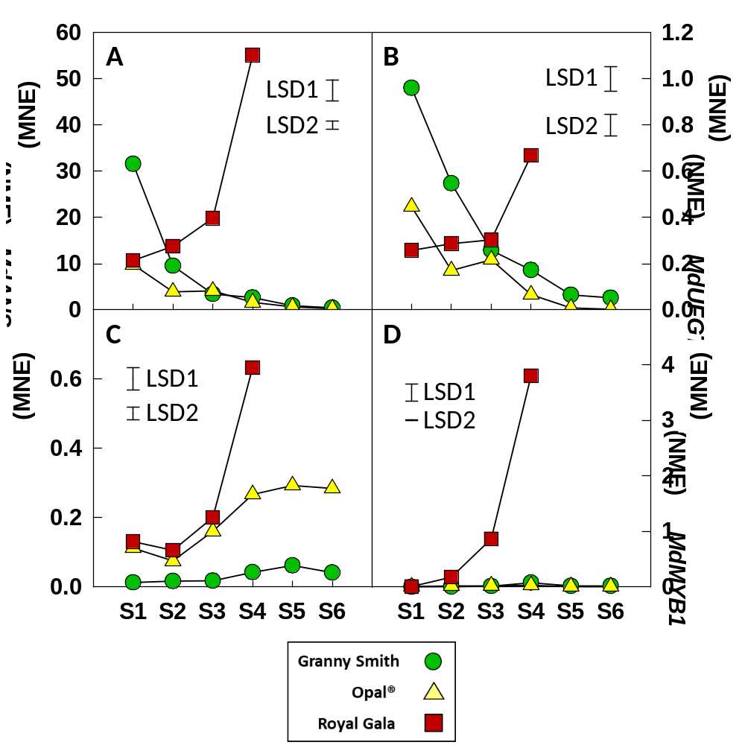
Figure S3
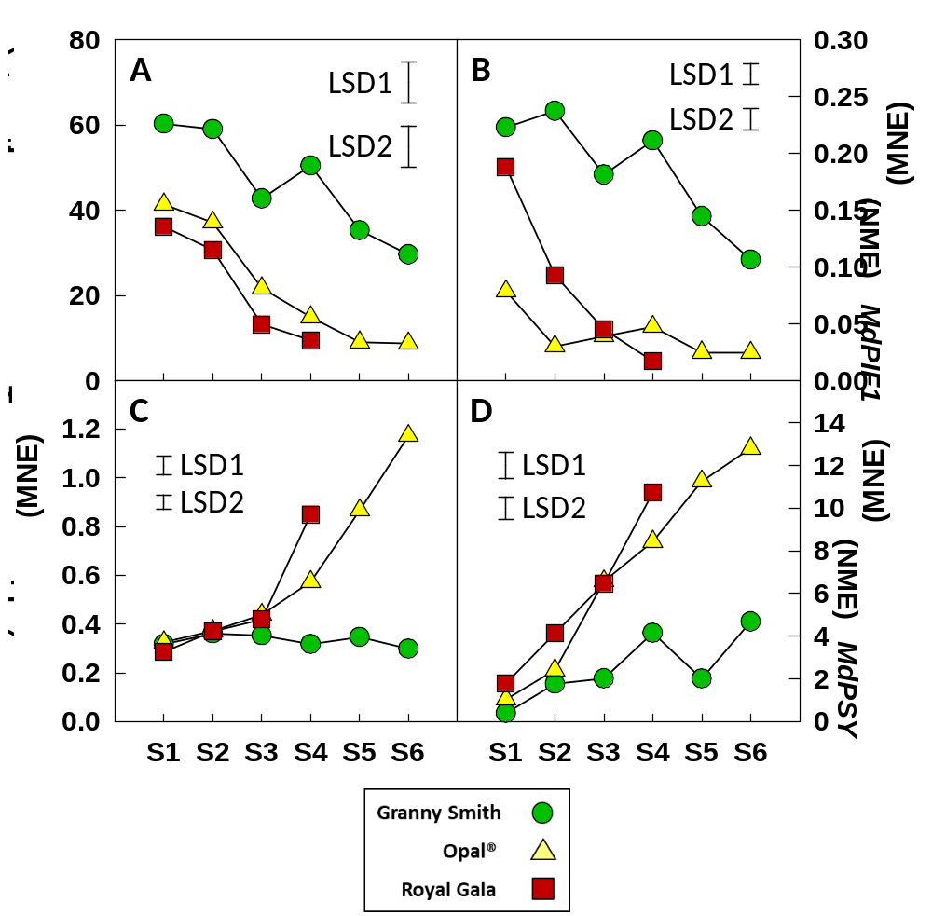

Figure S4
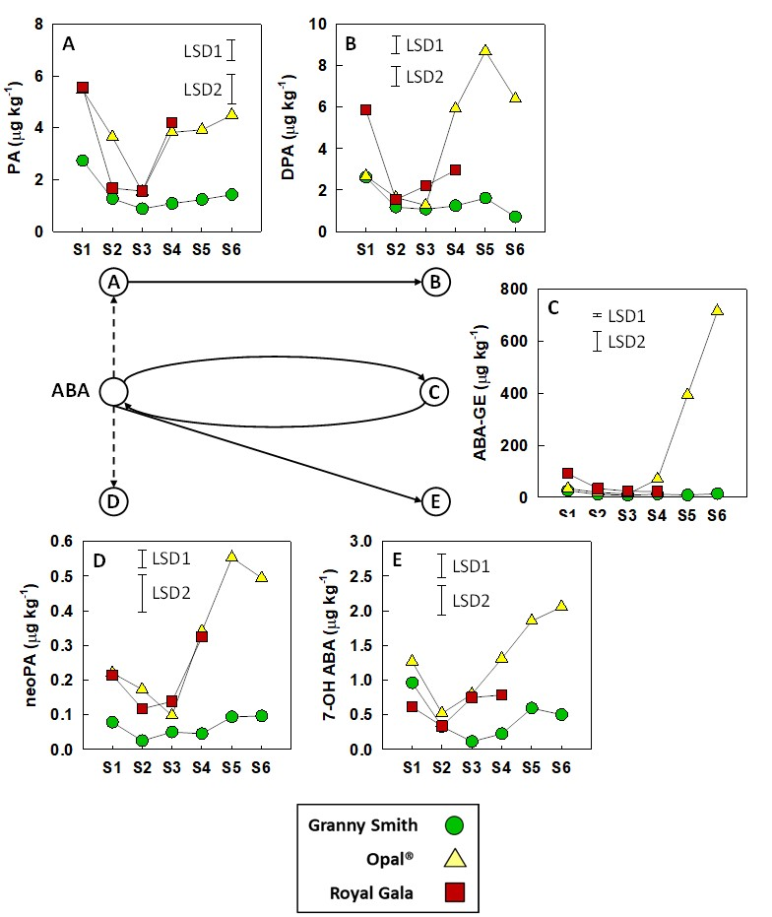
Figure S5
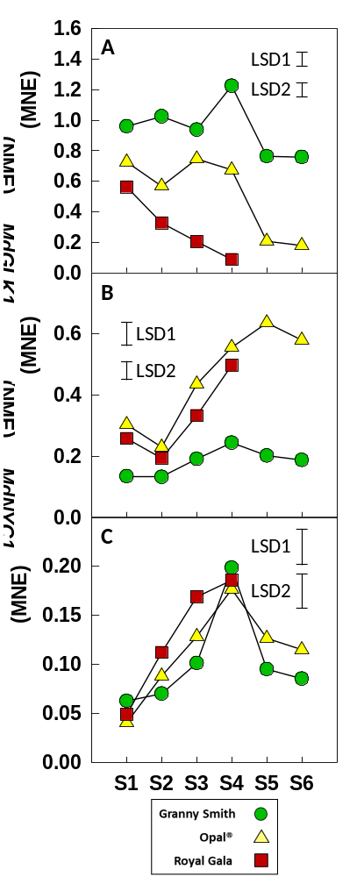
Figure S6
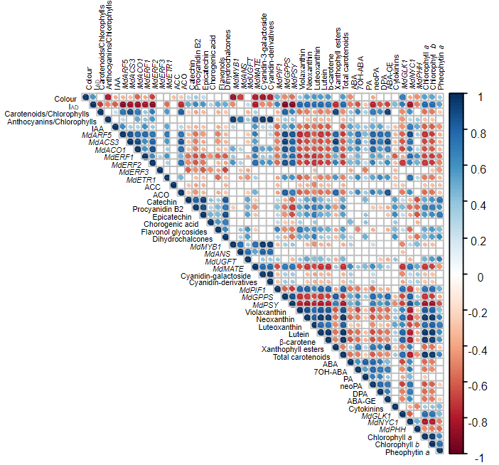
SUPLEMENTARY TABLES
Table S1. Primers used in the present study.
Primer name | Gene | Primer sequence (5’ – 3’)
MdACS3-Fw | MdACS3 | CGAGTTGGCACTGTGTACTCTTA
MdACS3-Rv | MdACS3 | ATAACATGGAAGCCAAGAGATGT
MdACO1-Fw | MdACO1 | ATCAATGATGCTTGTGAGAACTG
MdACO1-Rv | MdACO1 | GGTCTTCTTGTAGTGATCCTTGG
MdERF1-Fw | MdERF1 | TCCAGACCGGTTCTTACTATTAT
MdERF1-Rv | MdERF1 | CAGCATCCACAGGTACAAC
MdERF2-Fw | MdERF2 | TAAAATTGGCAGCAACGCCA
MdERF2-Rv | MdERF2 | GTGGGCTCGTGACTTTCGTTA
MdERF3-Fw | MdERF3 | TGGAAATGGGAGCAGGGATG
MdERF3-Rv | MdERF3 | ATTACAGCGTCCTCCGCAAC
MdETR1-Fw | MdETR1 | CATTTCTCACTTGTCAGGCATGTA
MdETR1-Rv | MdETR1 | CAATTCATCAGCCGGCCATT
MdARF5-Fw | MdARF5 | GCTCTTTCCTCCGCTGGATT
MdARF5-Rv | MdARF5 | TCCAGTTGTGAGAAGGTGTCG
MdANS-Fw | MdANS | GGCCTTCTTTGACCTTCCCA
MdANS-Rv | MdANS | GGCGGTTGCCTCAATGTAAT
MdUFGT-Fw | MdUFGT | CGACACTATTGGAACTCAAGGTAT
MdUFGT-Rv | MdUFGT | TGATTCGTACATTGGAGAGACC
MdMATE-Fw | MdMATE | GGTCATCTCGGAACTATTGAGC
MdMATE-Rv | MdMATE | ACTCCCCATCCCAAGCATGA
MdMYB1-Fw | MdMYB1 | GTCGTCGTCAACAAAGAATGG
MdMYB1-Rv | MdMYB1 | GGTCCGTGCTAAAGGAGAAT
MdPIF1-Fw | MdPIF1 | CCCAGAAAATCAACCATGCCG
MdPIF1-Rv | MdPIF1 | AAGCCACGAGGCCATTTCAT
MdGGPPS-Fw | MdGGPPS | TTACGATCCACGAGGCGATG
MdGGPPS-Rv | MdGGPPS | ATGGATTCCGACCCACCAAC
MdPSY-Fw | MdPSY | CAGAGACATGGTAGAAGGAATGAG
MdPSY-Rv | MdPSY | CCAACAGTTCCAGCAACATAGTAG
MdGLK1-Fw | MdGLK1 | TCCTCCAGACGCTTCGTACT
MdGLK1-Rv | MdGLK1 | CAGATTGTGGTGGAGTGGGG
MdNYC1-Fw | MdNYC1 | GTTTCAGTTGTCAGGTGGAGAC
MdNYC1-Rv | MdNYC1 | CCAGCTCGACAGTGATCCTC
MdPPH-Fw | MdPPH | TCTCGAAAGGAAGAAGAAGCG
MdPPH-Rv | MdPPH | CAGTTGCGATGGCTTTCGTG
Md8282-Fw | Reference gene | CTCGTCGTCTTGTTCCCTGA
Md8282-Rv | Reference gene | GCCTAAGGACAGGTGGTCTATG

