Supplementary materials

(a)
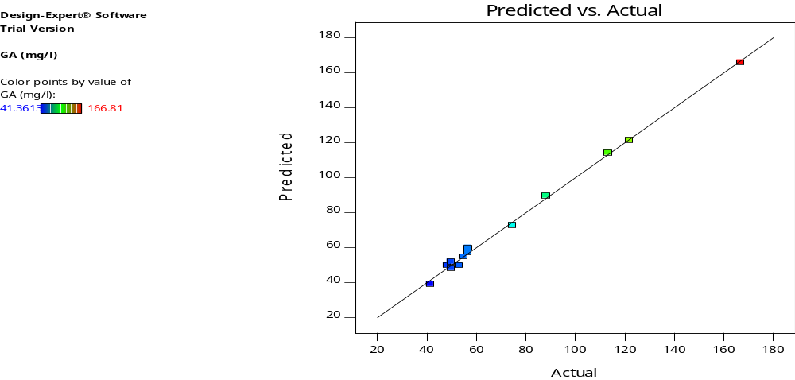
(b)
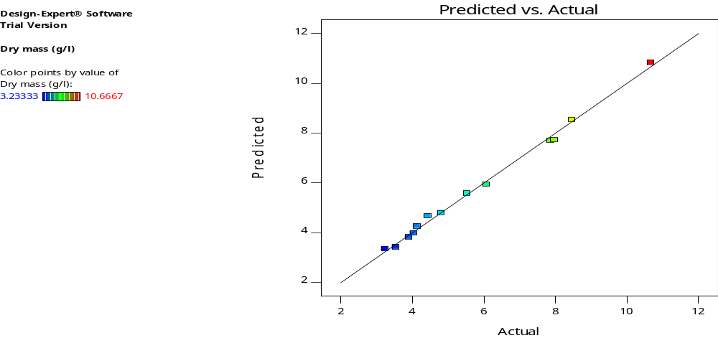

Fig. S1 (a) Actual and the predicted values of GA₃ production (mg/l). (b) Fungal growth (g/l) by Fusarium incarnatum- ASU19 (MK387876).

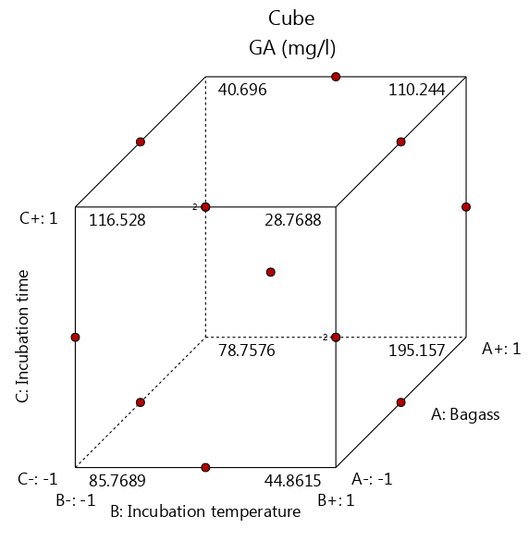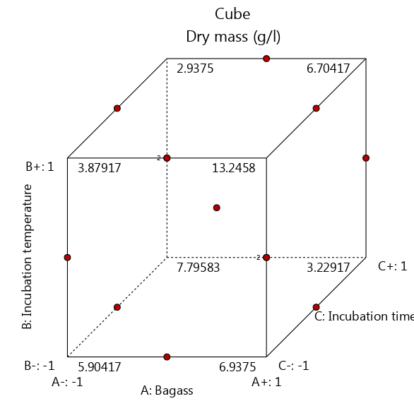

Fig. S2 Statistical desirability ramp plot of the experimental design for GA₃ production (mg/l), and fungal growth (g/l) by Fusarium incarnatum- ASU19 (MK387876).

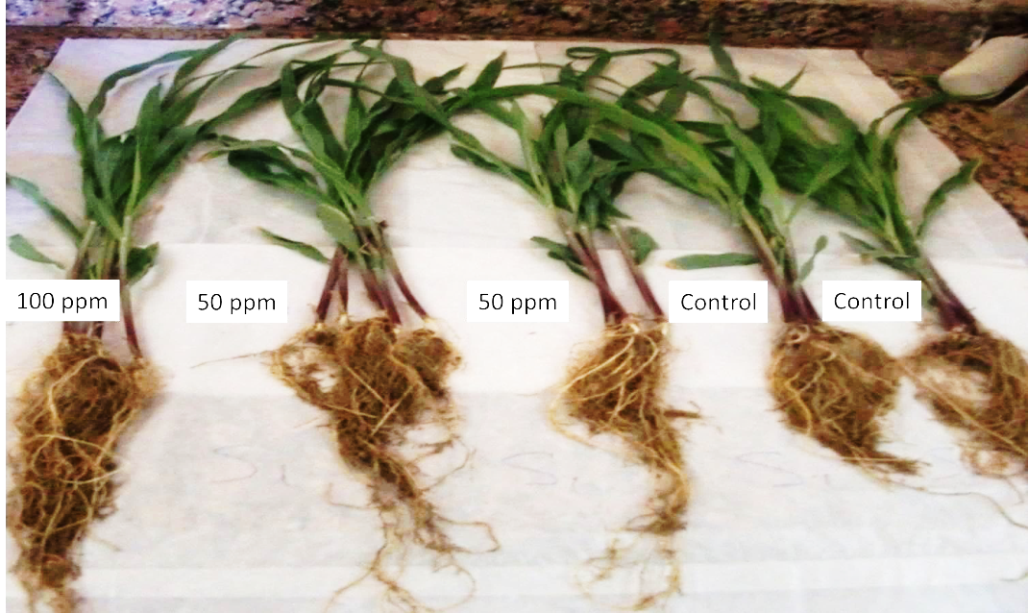
Fig. S3 Effect of different GA3 concentrations (50 ppm and 100 ppm) produced by Fusarium incarnatum-ASU19 (MK387876) on maize growth.

