Online Supplementary Figure 1 - 2

Effect of Foliar Treatment with Organic Acids and Inorganic Nutrients on Yield Retention and Secondary Metabolite Profiles under Heat Stress in Soybean

Hakyung Kwon, Hong-Ju Lee, Dong Yeol Song, Sang Hun Kim, Chan Hui Lee, Kyung-Hee Kim, Byung-Moo Lee,
Sung Don Lim*, Jungmin Ha*

Supplementary figure S1

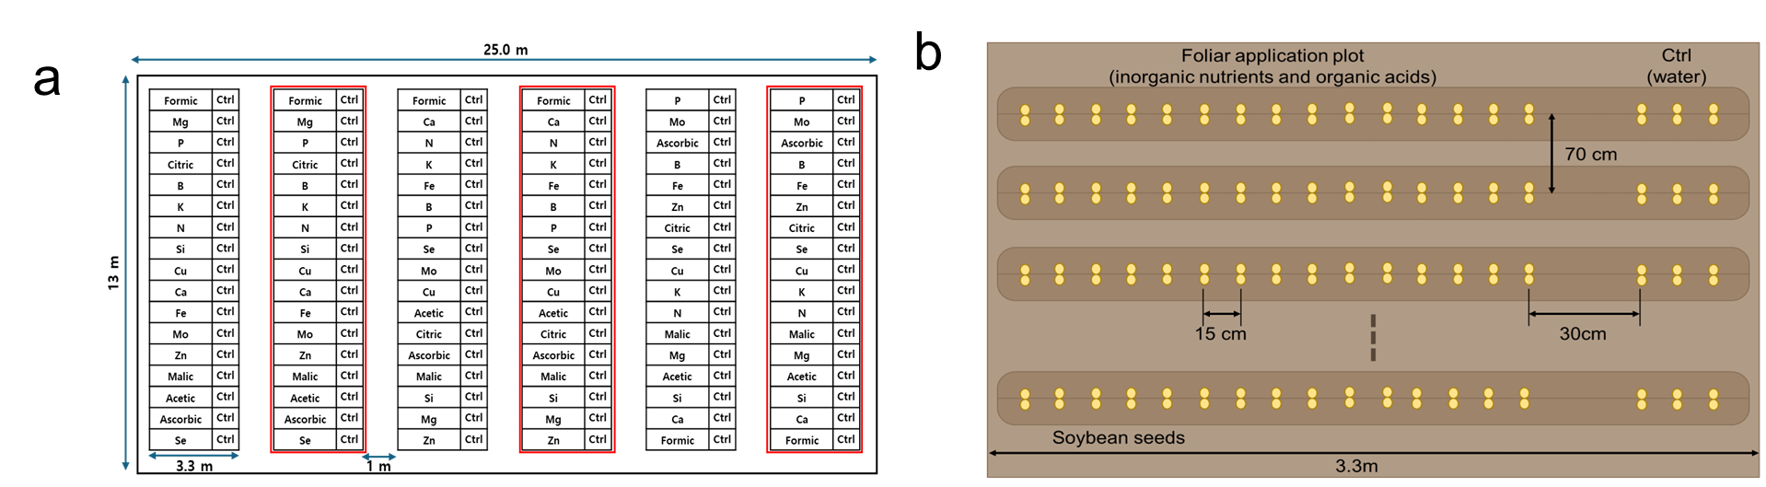
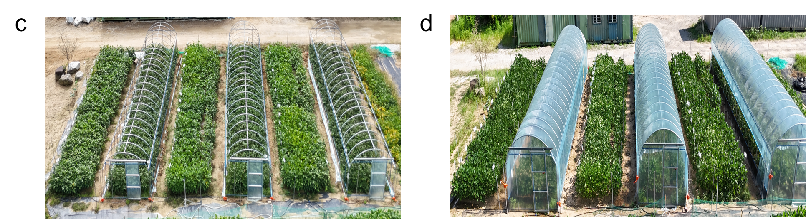

Fig. S1. Overview and design of the experimental field for foliar application and heat stress treatments. (a) Layout of the experimental field showing treatment plots arranged in a randomized block design. Red-outlined plots indicate those assigned to the heat stress treatment. Each plot received either a foliar application of inorganic nutrients and organic acids or served as a Ctrl (control). (b) Schematic diagram of a foliar application plot. Soybean seeds were sown in 17 rows per plot (3.3 m wide), with 15 cm between plants within a row and 70 cm between adjacent plots. A 30 cm buffer space was maintained between the foliar application plots and control (Ctrl) plots to physically separate the treatments. (c) Aerial view of the experimental field before heat stress treatment. (d) Field view during the heat stress treatment period, showing polyethylene-covered temporary shelters installed over designated plots to maintain elevated temperature conditions.

Supplementary figure S2
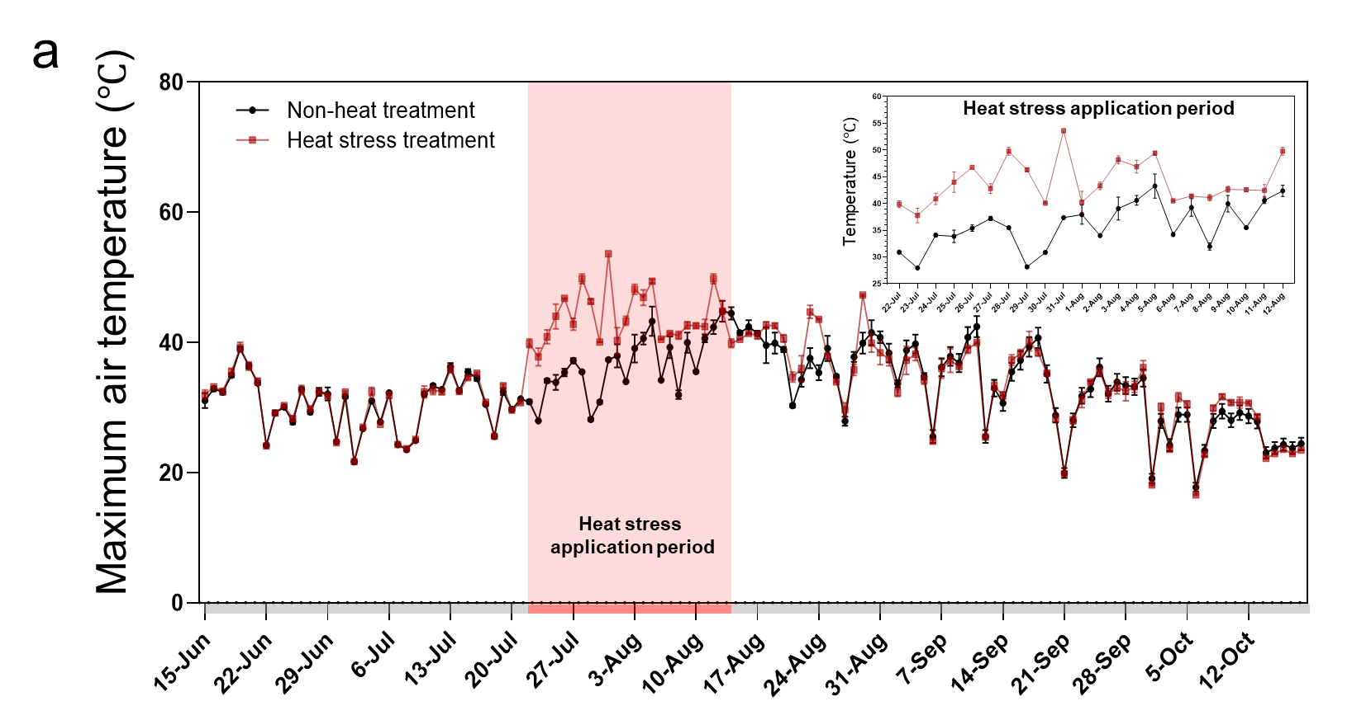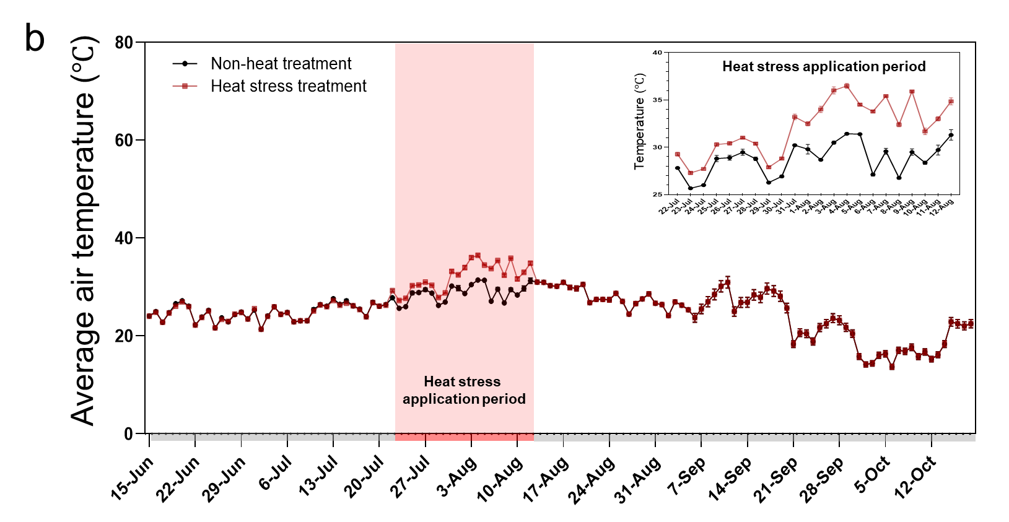

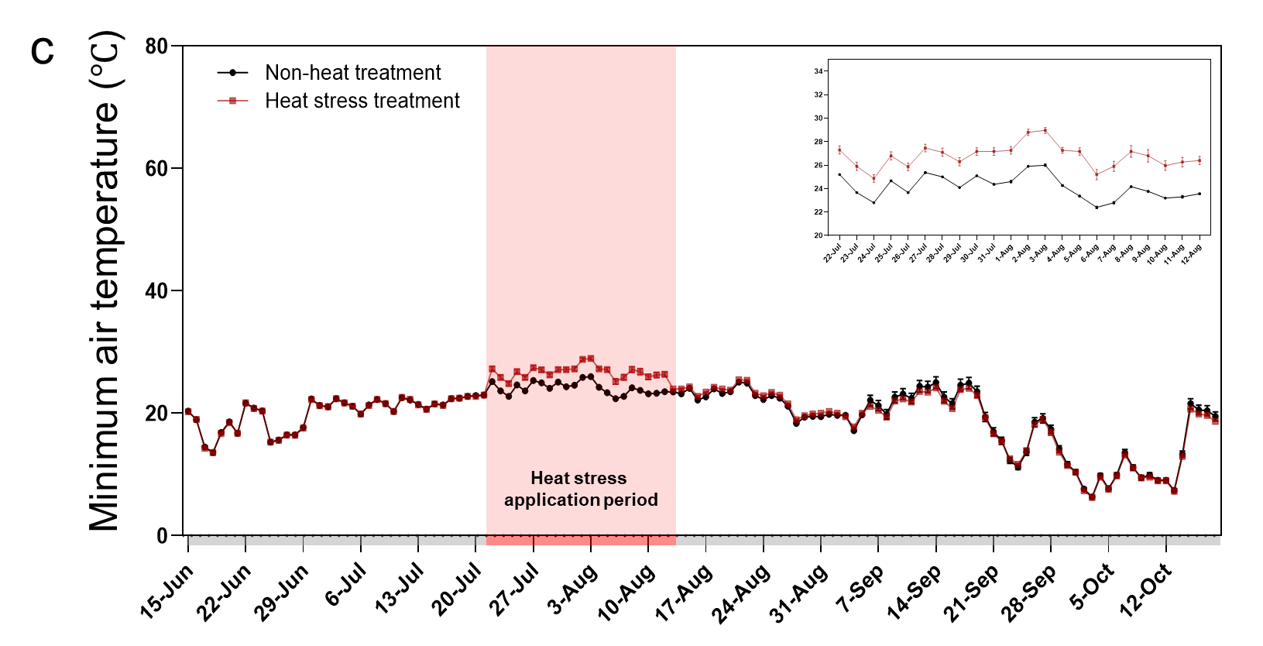

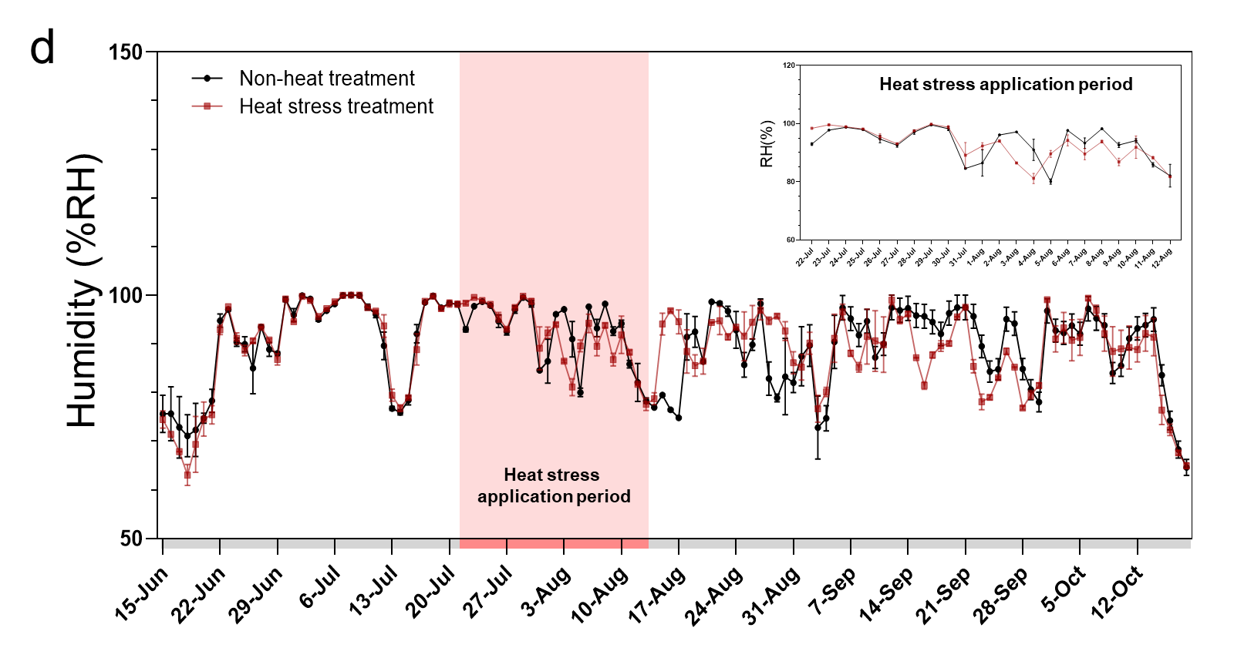

Supplementary figure S2 continued
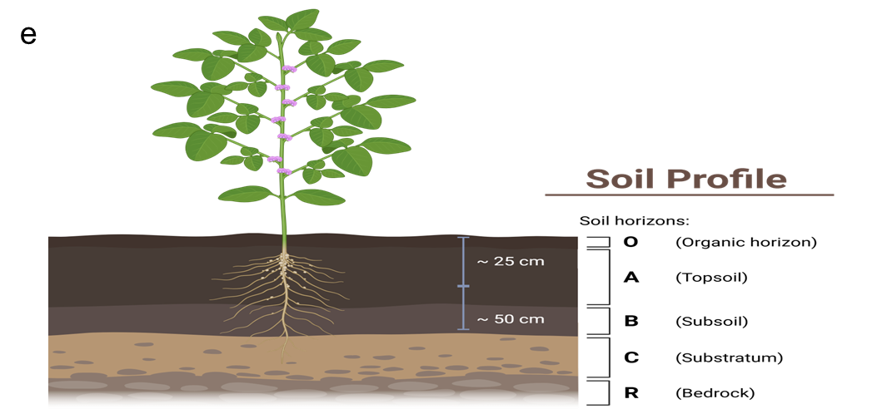
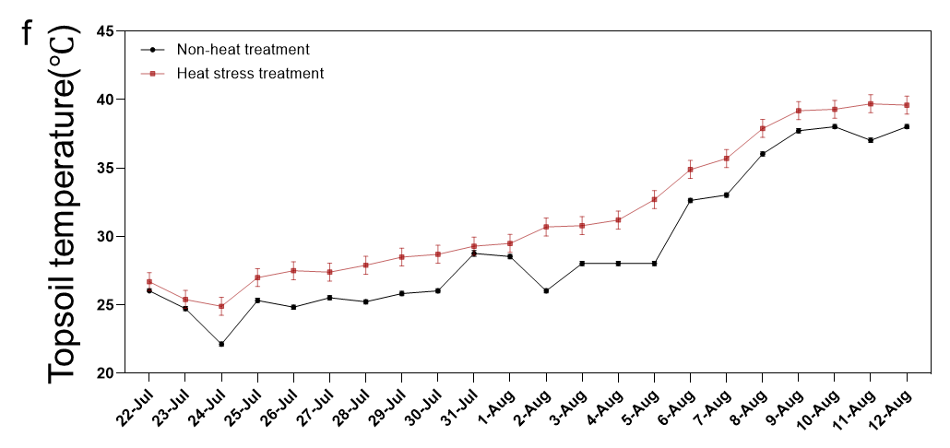
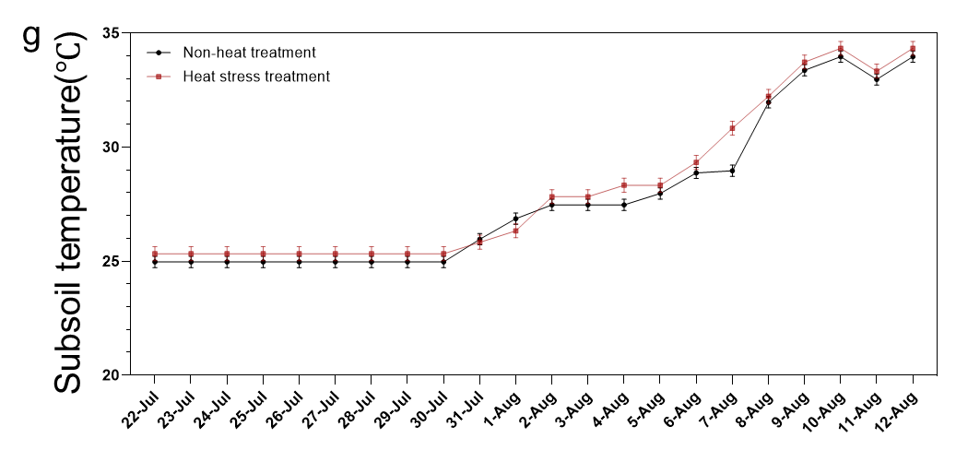
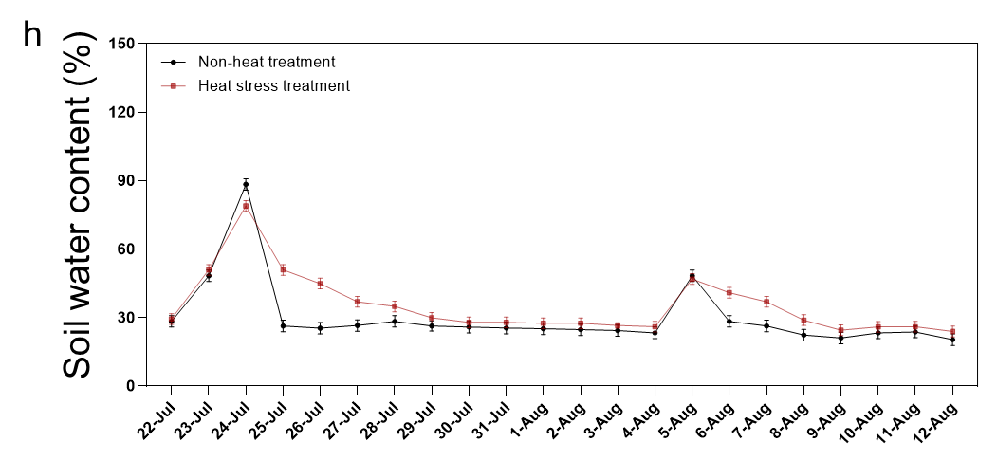

Fig. S2. Environmental conditions during the heat stress treatment period. (a–d) Changes in (a) maximum, (b) average, and (c) minimum air temperatures, and (d) relative humidity (RH%) in heat-stressed and non-heat-stressed plots. The shaded red area indicates the period of heat stress application. Insets in (a–c) show enlarged views of the heat stress treatment period. (e) Diagram of the soil profile showing major soil layers. Soil temperature was measured at depths of 25 cm and 50 cm, corresponding to the data presented in (f) and (g), respectively. (f–g) Soil temperature at (f) 25 cm and (g) 50 cm soil depths under heat stress and non-heat stress conditions. (h) Soil water content (%) dynamics over time in both treatments. Black lines represent non-heat-stressed (ambient) plots, and red lines indicate heat-stressed plots. Data represent means ± SE (n = 3).

