Supplementary material
Scientific Journal: Journal of Plant Growth Regulation.

Distinct and combined applications of biochar and wood distillate modulate functional responses in young Vitis vinifera L.

Silvia Celletti^{1,2,*}, Riccardo Fedeli², Martina Grattacaso², Luisella Celi¹, Claudio Zaccone³, Stefano Loppi^{2,4}

¹ Department of Agricultural, Forest and Food Sciences, University of Turin, Largo P. Braccini 2, 10095, Grugliasco, Turin, Italy;
² BioAgry Lab,Department of Life Sciences, University of Siena, Via P. A. Mattioli 4, 53100, Siena, Italy;
³ Department of Biotechnology, University of Verona, Strada Le Grazie 15, 37134, Verona, Italy;
⁴ National Biodiversity Future Center, Palermo, Italy.

*Corresponding author: silvia.celletti@unito.it

Table S1 Main chemical characteristics of the amendments [biochar (BC) and wood distillate (WD) starting materials] and the peat-based commercial substrate (peat), used as treatments for potted young grapevine plants. Part of the WD characterization data was derived from previously published data (Celletti et al. 2023a). Cation exchange capacity (CEC) was not determined for WD, as it is not applicable to liquid organic materials without a solid exchange matrix.
 |  | BC | WD | Peat
 | pH | 10.3 ± 0.2 | 3.2 ± 0.0 | 5.3 ± 0.0
 | EC (mS cm⁻¹) | 1.1 ± 0.1 | 2.5 ± 0.0 | 1.1 ± 0.1
 | CEC (cmol⁺ kg⁻¹) | 8.0 ± 0.9 | – | 56.9 ± 2.7
 |  | BC  (g kg⁻¹ DW) | WD  (mg L⁻¹) | Peat  (g kg⁻¹ DW)
Macronutrients | Ca | 20.6 ± 0.1 | 325.5 ± 5.7 | 23.2 ± 0.3
Macronutrients | K | 14.8 ± 0.1 | 23.5 ± 0.2 | 1.2 ± 0.0
Macronutrients | Mg | 2.0 ± 0.0 | 6.8 ± 0.0 | 2.8 ± 0.0
Macronutrients | P | 0.9 ± 0.0 | 7.3 ± 0.0 | 0.6 ± 0.0
 |  | BC  (mg kg⁻¹ DW) | WD  (µg L⁻¹) | Peat  (mg kg⁻¹ DW)
Micronutrients | Cu | 31.3 ± 0.3 | 181.0 ± 2.0 | 22.9 ± 0.2
Micronutrients | Fe | 2171.0 ± 6.0 | 21160.0 ± 310.0 | 1097.0 ± 10.0
Micronutrients | Mn | 110.0 ± 1.0 | 575.0 ± 4.0 | 31.0 ± 1.0
Micronutrients | Mo | 1.0 ± 0.0 | 0.7 ± 0.0 | 0.9 ± 0.0
Micronutrients | Zn | 49.1 ± 0.8 | 3221.0 ± 19.0 | 38.3 ± 0.7
 |  | BC  (g kg⁻¹ DW) | WD  (mg L⁻¹) | Peat  (g kg⁻¹ DW)
Others | Na | 1.4 ± 0.0 | 103.6 ± 0.2 | 1.4 ± 0.0

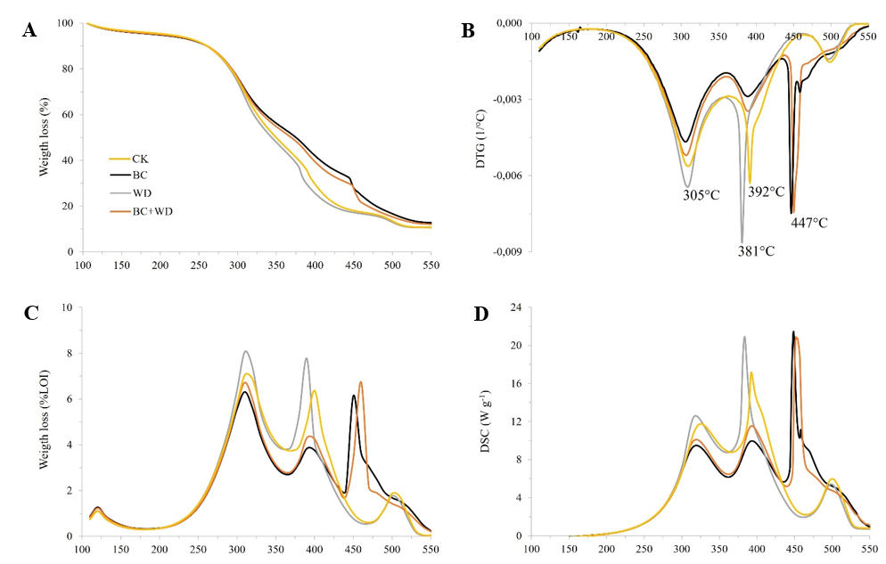
Fig. S1 Thermogravimetric (TG) (A), derivative thermogravimetric (DTG) curves (B), weight losses (WL) (C), and differential scanning calorimetry (DSC) curves (D) in the four different treatments of the growing medium: CK = control; BC = growing medium amended with biochar (BC); WD = growing medium amended with wood distillate (WD); BC+WD = growing medium amended with both biochar and wood distillate. In panel (c), WL are expressed as % of the loss-of-ignition (LOI) at 550 °C, and integrated each 10 °C. See also Table 2 for further thermal data.

