Early-onset dynamics of arbuscular mycorrhizal symbiosis reprogram metabolic and physiological responses in tomato roots
Ilaria Ragnoli¹, Leilei Zhang^{1*}, Florencia Asinari^{2,3}, Tito Caffi^{2,4}, Luigi Lucini¹

¹ Department for Sustainable Food Process, Università Cattolica del Sacro Cuore, Piacenza, Italy
² Department of Sustainable Crop Production, Università Cattolica del Sacro Cuore, Piacenza, Italy
³ Instituto Nacional de Tecnología Agropecuaria, Instituto de Patología Vegetal, Consejo Nacional de Investigaciones Científicas y Técnicas, Unidad de Fitopatología y Modelización Agrícola, Córdoba, Argentina
⁴ Research Center on Plant Health Modelling, Department of Sustainable Crop Production, Università Cattolica del Sacro Cuore, Piacenza, Italy

Supplementary text

1. Untargeted metabolomics and root exudates profiling
The root tissues and root exudate metabolites were profiled through the 6560-drift tube-ion mobility-quadrupole-time of flight-high resolution mass spectrometer (DTIM-UHPLC-QTOF-HRMS; Agilent Technologies, Santa Clara, CA, USA). The chromatographic separation was achieved under a water-acetonitrile (both LC-MS grade, from Sigma-Aldrich, Milan, Italy) gradient elution (6–94 % acetonitrile in 32 min), flow rate of 0.2 mL/min and injection volume of 6 μL, using 0.1 % (v/v) formic acid as phase modifier on an - InfinityLab Poroshell 120 pentafluorophenyl (PFP) column (2.1 × 100 mm, 1.9 μm). The QTOF mass analyzer operated in positive mode (ESI+) for both MS and MS/MS acquisition with nitrogen as both sheath gas (12 L/min and 315 ◦C) and drying gas (14 L/min and 250 ◦C). The nebulizer pressure was 45 psi, the nozzle voltage was 350 V, and the capillary voltage was 4.0 kV. For MS acquisition, the full scan mode was performed within the range of m/z 100–1200 (1 spectra/s), mass resolution of 30,000 full width at half maximum (FWHM), m/z = 200. The data-dependent mode was performed for precursor fragmentation (10, 20, and 40 eV) and acquisition of MS/MS data from QC samples, with a mass resolution of 30,000 (FWHM), selecting 8 precursors per cycle (1 Hz, m/z 80–1200, positive polarity, and active exclusion after 2 spectra). The processing of the chromatograms was carried out using the MassHunter Qualitative Analysis software (version B.06.00, Agilent Technologies). The collected data (.d files) were processed using MS-DIAL software (version 4.70) for automatic peak finding, LOWESS normalization, and annotation via spectral matching, exploiting the comprehensive BMDMS-NP, and Fiehn/Vaniya natural product library. The mass range 100–1200 m/z was searched for features with a minimum peak height of 10,000 cps, using an accurate mass tolerance for peak centroiding of 0.05 and 0.1 Da, for MS and MS/MS, respectively. Retention time information was excluded from the calculation of the total score. The identification step was based on mass accuracy, isotopic pattern, and spectral matching. These criteria were used to calculate a total identification score, using a minimum cut-off value of 70 %, considering the most common HESI + adducts.

2. Statistical Analysis
Root tissues and root exudate profile raw data were processed using Mass Profiler Professional 12.6 (Agilent Technologies). The raw data underwent log2 transformation, 75th percentile normalization, and baseline correction against each compound’s median. The unsupervised hierarchical cluster analysis (HCA) and Principal Component Analysis (PCA) were conducted to explore sample patterns. Subsequently, to identify the contribution in discrimination capacity of time and AMF factors on the overall data variance, a supervised ANOVA Multiblock Orthogonal Partial Least Squares (AMOPLS) analysis was performed using the rAMOPLS package in R (version 4.2.1). Statistical significance for AMOPLS was set at α = 0.01 and validated through 100 permutation tests. Results were expressed as Relative Sum of Squares (RSS), indicating the percentage of variability attributed to each factor; RSS p-value, denoting statistical significance; and block contribution, representing the percentage associated with each effect.
To identify Variable Importance in Projection (VIP) markers associated with different treatments compared with the control untreated sample, the supervised orthogonal projection to latent structures discriminant analysis (OPLS-DA), using the SIMCA software (v.16, Umetrics®, Malmö, Sweden), were carried out separately for [AMF-S vs. C] and [AMF-I vs. C] for each time point. The quality of OPLS-DA models was further evaluated in terms of goodness-of-fit (R²Y) and goodness-of-prediction (Q²Y), being statistically validated through cross-validation analysis of variance (CV-ANOVA) and excluding the overfitting by permutation test (n = 100). Specifically, those metabolites showing the highest influence in the discrimination between treatments, assuming a VIP score threshold of 1.3, were selected for each model.

SUPPLEMENTARY FIGURES

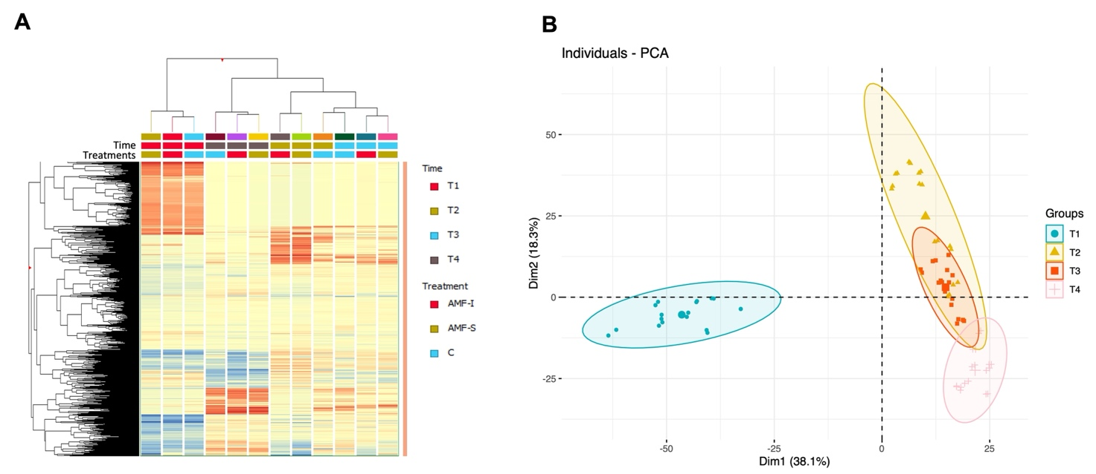
Figure S1. Hierarchical clustering analysis (HCA) and principal component analysis (PCA) of root metabolomics data of tomato plants treated with Arbuscular Mycorrhizal Fungi (AMF) by inoculation (AMF-I) and seed-priming (AMF-S) compared to the control (C) at 19 (T1), 23 (T2), 27 (T3), and 35 (T4) days after sowing (DAS).

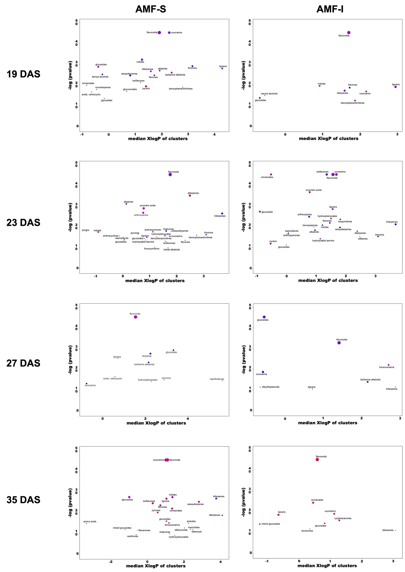
Figure S2. ChemRICH plots of tomato plants treated with Arbuscular Mycorrhizal Fungi (AMF) by inoculation (AMF-I) and seed-priming (AMF-S) compared to the control at 19, 23, 27, and 35 days after sowing (DAS).

SUPPLEMENTARY TABLE

Table S1. Biomass parameters for leaves and roots at each of the four samplings. No letter indicates no significant difference.
Time | Treatment | Leaves FW* | Roots FW* | Shoot/Root FW* | Leaves DW** | Roots DW** | Shoot/Root DW**
T1 | Control | 1.05 ± 0.13 a | 0.08 ± 0.04 | 12.92 ± 4.70 | 0.09 ± 0.01 | 0.004 ± 0.005 | 22.22 ± 38.35
T1 | AMF-S | 0.67 ± 0.15 b | 0.03 ± 0.01 | 24.97 ± 1.97 | 0.08 ± 0.04 | 0.001 ± 0.000 | 96.00 ± 11.03
T1 | AMF-I | 0.57 ± 0.07 b | 0.04 ± 0.01 | 14.67 ± 1.97 | 0.05 ± 0.01 | 0.001 ± 0.000 | 53.85 ± 19.10
T2 | Control | 3.91 ± 0.36 | 0.31 ± 0.05 | 12.57 ± 1.03 | 0.30 ± 0.03 | 0.005 ± 0.001 | 54.48 ± 4.83
T2 | AMF-S | 3.67 ± 0.58 | 0.28 ± 0.03 | 13.11 ± 0.77 | 0.26 ± 0.06 | 0.006 ± 0.002 | 43.43 ± 3.89
T2 | AMF-I | 3.65 ± 0.47 | 0.28 ± 0.06 | 13.25 ± 1.75 | 0.26 ± 0.04 | 0.005 ± 0.001 | 49.35 ± 7.04
T3 | Control | 12.26 ± 0.38 a | 1.15 ± 0.14 | 10.61 ± 1.28 | 0.72 ± 0.04 ab | 0.037 ± 0.003 a | 19.62 ± 1.74 b
T3 | AMF-S | 11.95 ± 0.94 a | 1.02 ± 0.04 | 11.70 ± 1.35 | 0.83 ± 0.08 a | 0.034 ± 0.005 a | 24.18 ± 1.19 ab
T3 | AMF-I | 9.87 ± 0.77 b | 0.93 ± 0.08 | 10.64 ± 0.19 | 0.65 ± 0.05 b | 0.024 ± 0.001 b | 27.15 ± 3.15 a
T4 | Control | 29.76 ± 2.66 | 5.72 ± 0.69 a | 5.28 ± 1.00 b | 3.29 ± 0.21 a | 0.197 ± 0.019 | 16.70 ± 2.50
T4 | AMF-S | 28.27 ± 2.98 | 2.87 ± 0.88 b | 9.87 ± 2.99 a | 2.58 ± 0.49 ab | 0.107 ± 0.062 | 24.10 ± 14.29
T4 | AMF-I | 27.70 ± 1.41 | 3.58 ± 0.77 b | 7.73 ± 1.23 ab | 2.29 ± 0.16 b | 0.118 ± 0.013 | 19.38 ± 0.91

*FW: fresh weight; **DW: dry weight. All data are expressed as the mean ± standard error, n = 3. p-values were determined by univariate and multivariate analysis considering factors: time (T), treatment. Different letters within each column indicate analysis of variance (p-value < 0.05) + Tukey’s post hoc test (p = 0.05).

