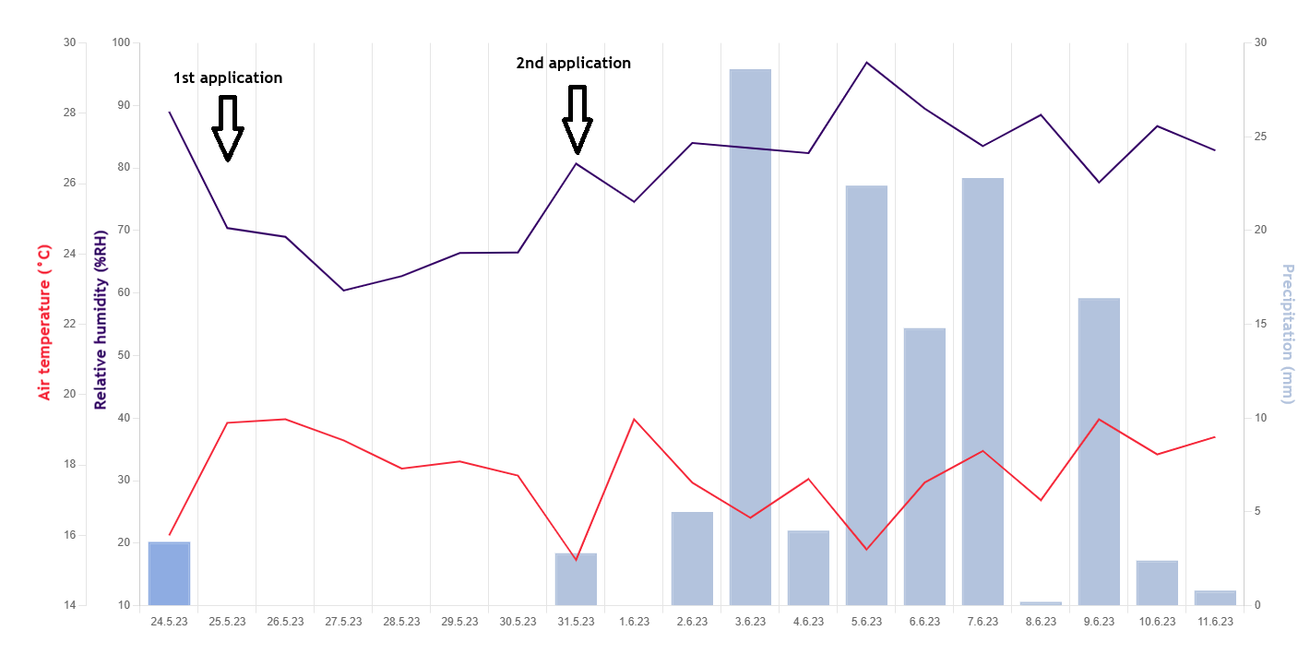
Fig. S1 Daily air temperature (°C), relative humidity (%RH), and precipitation (mm) recorded from 24 May to 11 June 2023 during the experimental period.

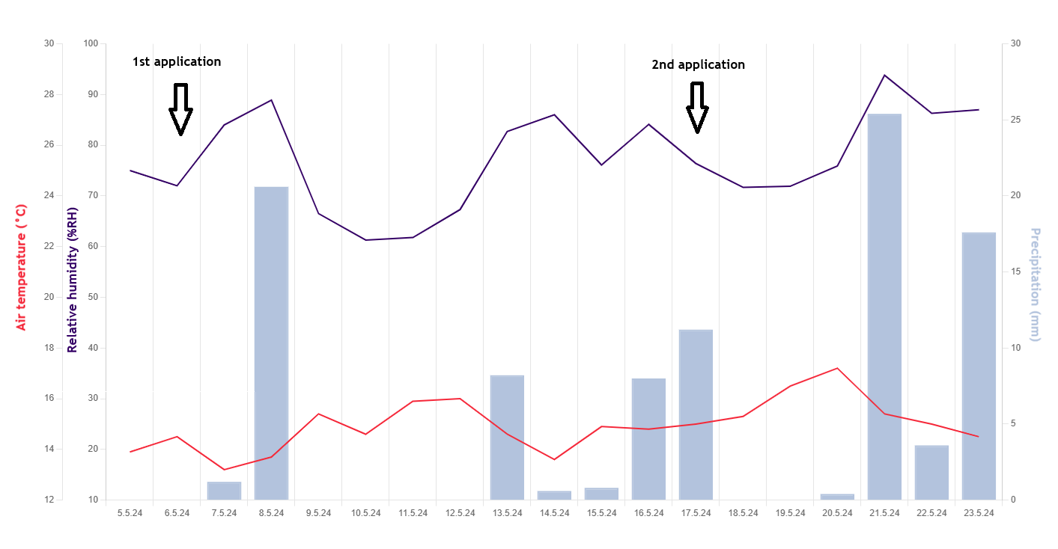
Fig. S2 Daily air temperature (°C), relative humidity (%RH), and precipitation (mm) recorded from 5 May to 17 May 2024 during the experimental period.

