Supplementary Information

Supplementary Figure.1: Receiver operating characteristic (ROC) curves to assess the optimal cut-off values of (A) serum prostate specific antigen (PSA), (B) alkaline phosphatase (ALP), (C) hemoglobin (Hb), and (D) lactate dehydrogenase (LDH) for overall survival (OS)

(A) PSA (B) ALP
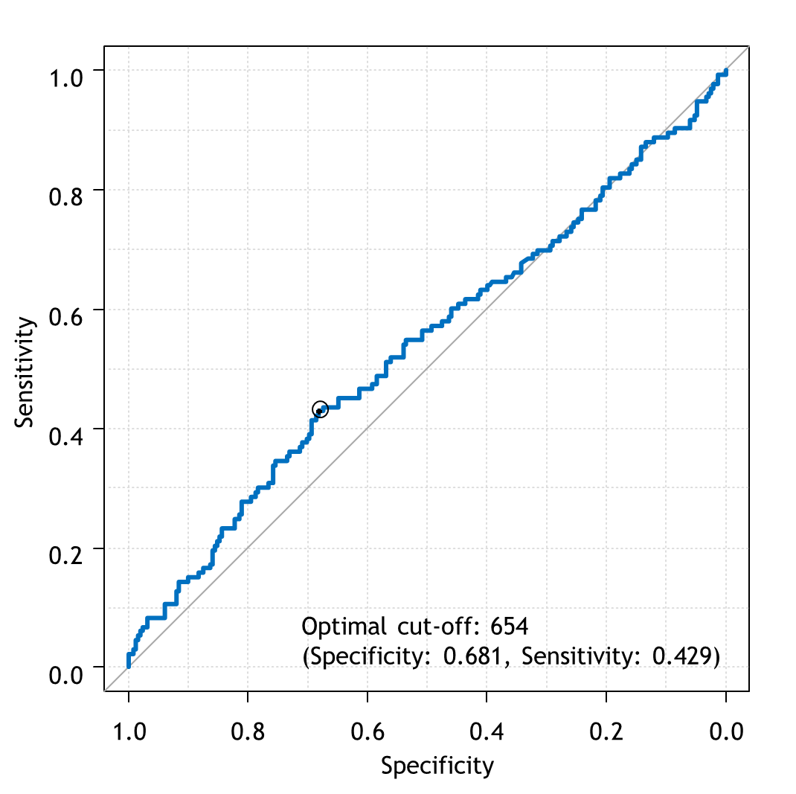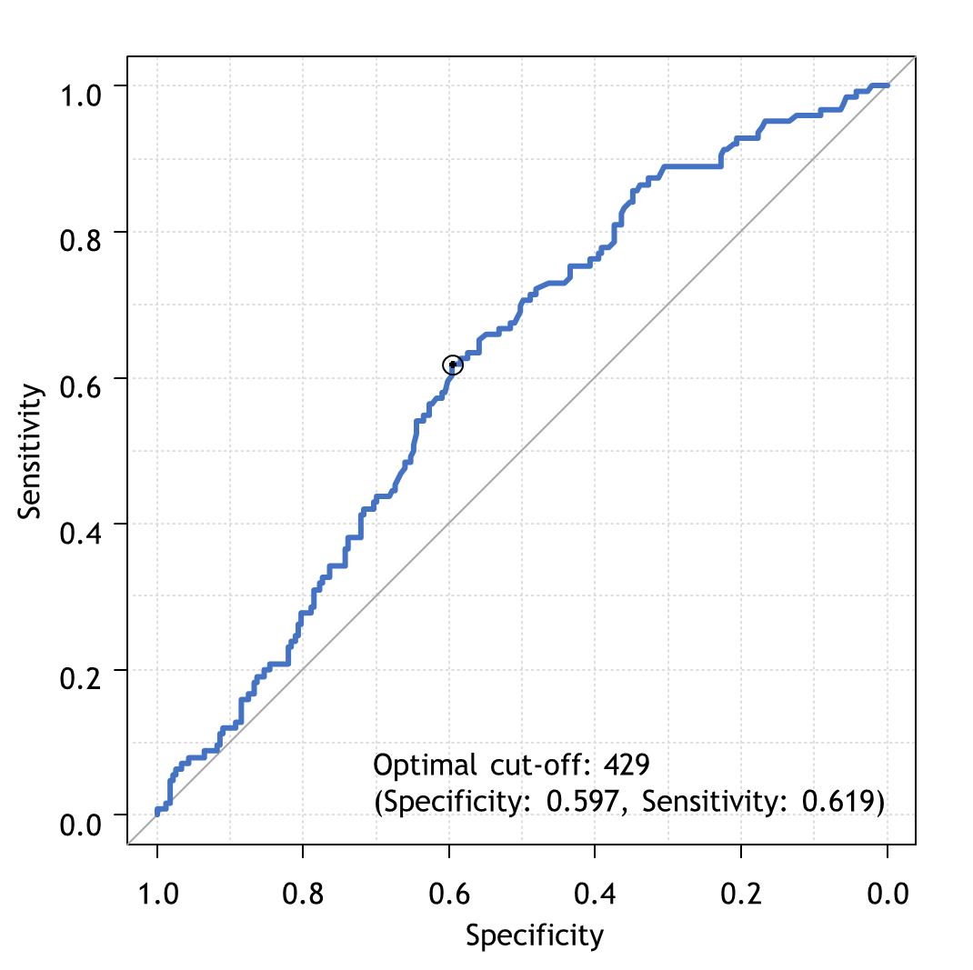

(C) Hb (D) LDH
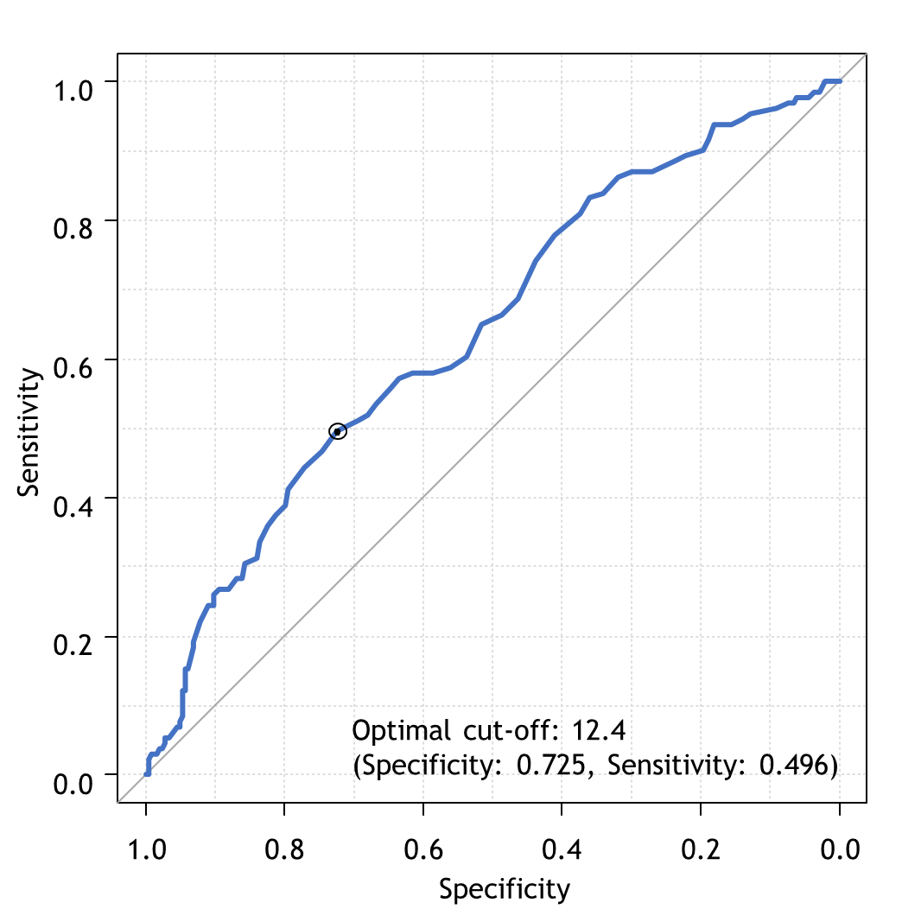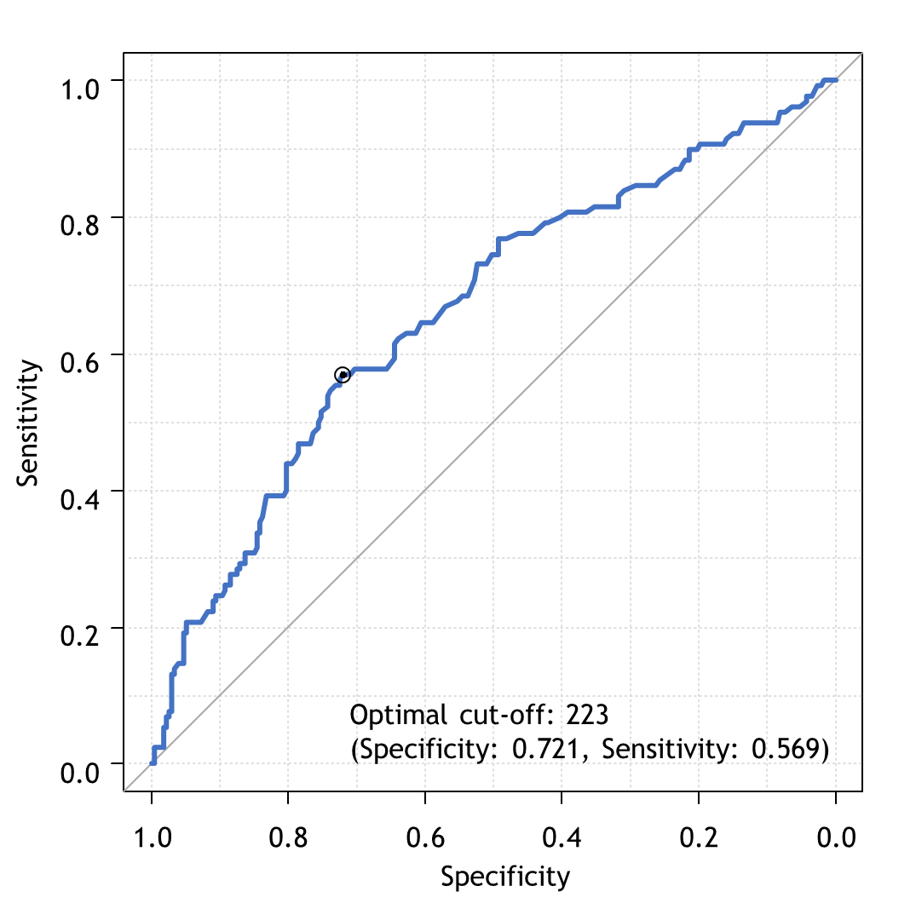

Supplementary Figure.2: Receiver operating characteristic (ROC) curves to assess the optimal cut-off values of (A) serum prostate specific antigen (PSA), (B) alkaline phosphatase (ALP), (C) hemoglobin (Hb), and (D) lactate dehydrogenase (LDH) for time to CRPC

(A) PSA (B) ALP
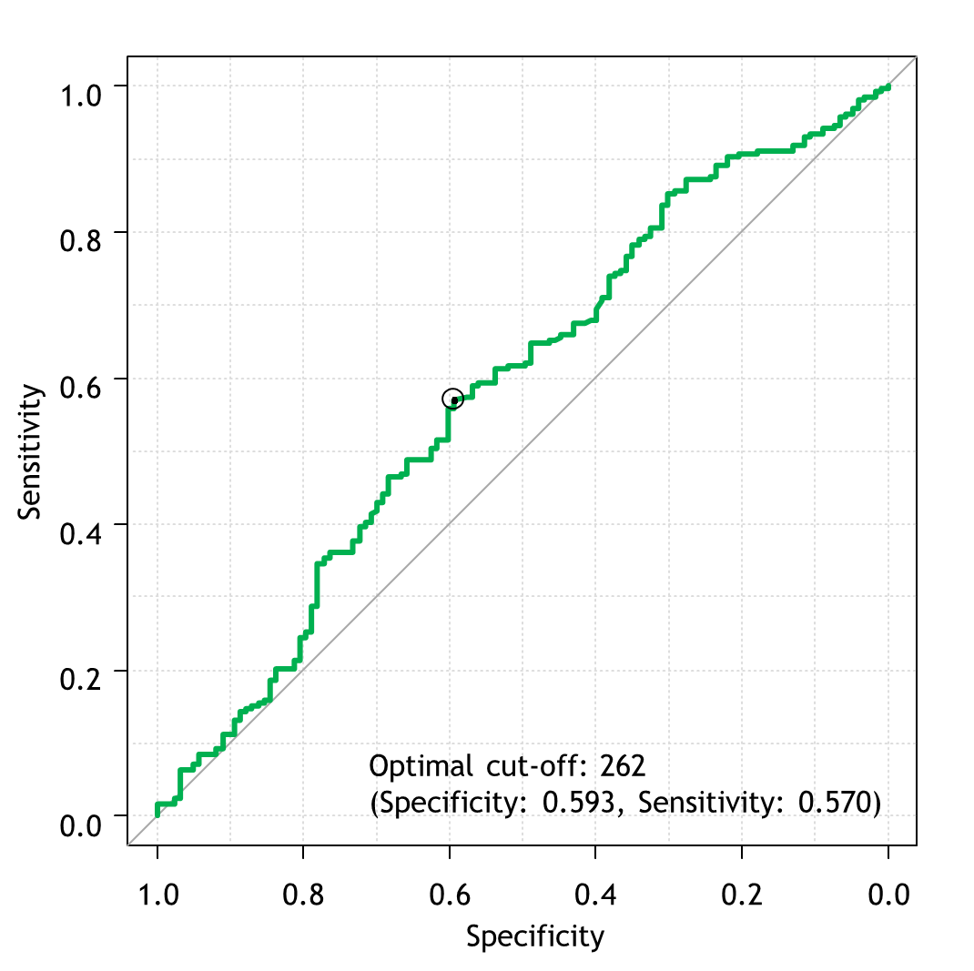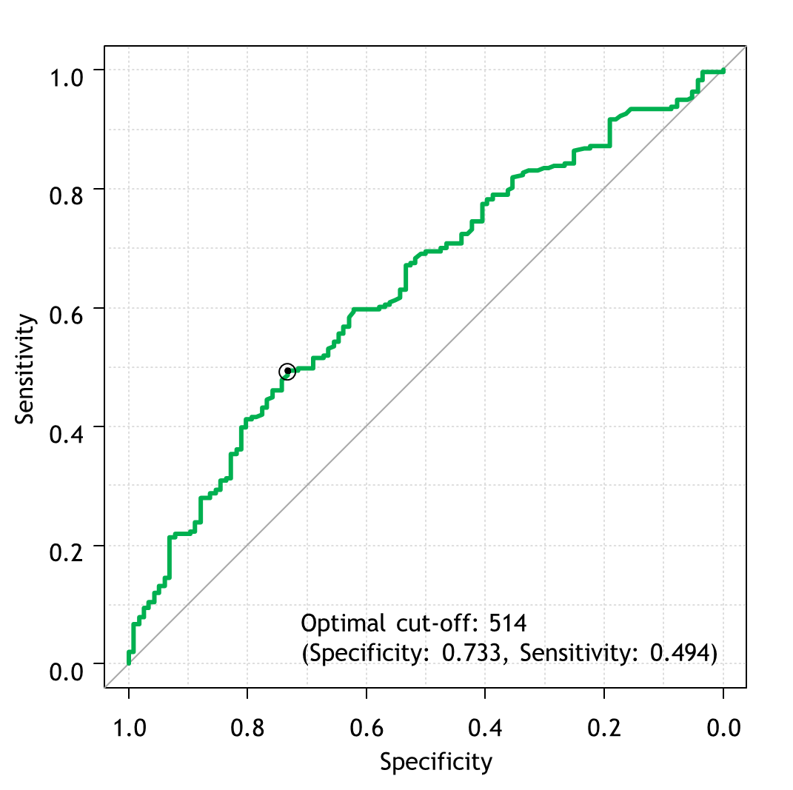

(C) Hb (D) LDH
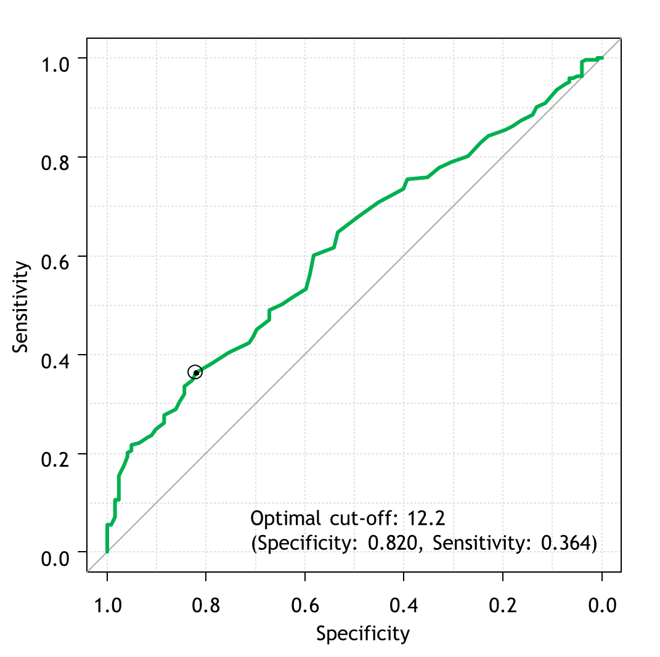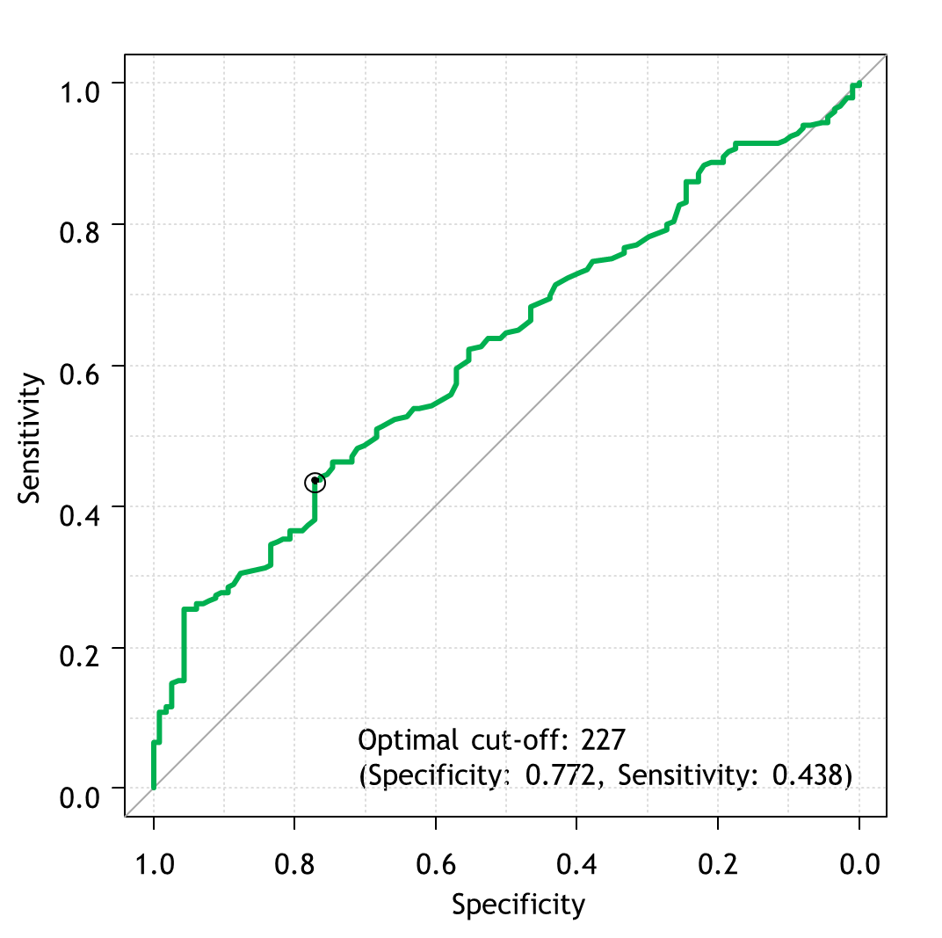

Supplementary Table 1 Impact of possible prognostic factors on time to CRPC in entire cohort
 | Univariable |  | Multivariable
 | HR (95% CI) | P value | HR (95% CI) | P value
Age≧75 | 1.18 (0.92-1.51) | 0.2
PS≧2 | 1.34 (0.83-2.16) | 0.24
PSA≧262 | 1.53 (1.20-1.96) | <0.001 | 0.88 (0.65-1.20) | 0.42
Gleason score≧9 | 2.08 (1.52-2.86) | <0.001 | 1.87 (1.34-2.61) | <0.001
Number of bone metastasis (EOD≧Ⅲ) | 1.88 (1.32-2.69) | <0.001 | 0.92 (0.65-1.29) | 0.63
ALP≧514 | 2.27 (1.75-2.94) | <0.001 | 1.58 (1.16-2.14) | 0.003
LDH≧227 | 2.30 (1.78-2.97) | <0.001 | 1.72 (1.27-2.32) | <0.001
Hb<12.2 | 2.57 (1.97-3.35) | <0.001 | 1.73 (1.28-2.36) | <0.001
Lung metastasis | 0.54 (0.39-0.73) | <0.001 | 0.66 (0.46-0.95) | 0.02
Liver metastasis | 1.81 (1.03-3.16) | 0.04 | 2.06 (1.07-3.96) | 0.03
LHRH agonist vs. antagonist | 0.99 (0.75-1.30) | 0.95
NSAA vs. docetaxel | 1.58 (1.18-2.12) | 0.002 | 1.48 (1.07-3.96) | 0.03
HR: Hazard Ratio, CI: Confidential Intervals, PS: Performance Status, PSA: Prostate-Specific Antigen,
EOD: Extent of Disease, ALP: Alkaline Phosphatase, LDH: Lactate Dehydrogenase, Hb: hemoglobin, LHRH: Luteinizing Hormone Releasing Hormone, NSAA: Nonsteroidal Antiandrogen
※EODⅠ: 1 to 5 lesions, Ⅱ: 6 to 20 lesions, Ⅲ: more than 20 but less than EOD Ⅳ, Ⅳ: generalized uptake, super scan or more than 75% of axial skeleton

Supplementary Table 2. Differential impact of possible prognostic factors on time to CRPC between NSAA+ADT and DOC+ADT
 | Docetaxel |  |  |  | NSAA
 | Univariable |  | Multivariable |  | Univariable |  | Multivariable
 | HR (95% CI) | P value | HR (95% CI) | P value | HR (95% CI) | P value | HR (95% CI) | P value
Age≧75 | 1.41 (0.81-2.47) | 0.22 |  |  | 1.01 (0.76-1.34) | 0.95
PS≧2 | 2.32 (0.56-9.69) | 0.25 |  |  | 1.15 (0.69-1.92) | 0.59
PSA≧262 | 2.27 (1.33-3.88) | 0.003 | 1.19 (0.64-2.21) | 0.59 | 1.35 (1.02-1.79) | 0.04 | 0.82 (0.58-1.17) | 0.27
Gleason score≧9 | 1.44 (0.79-2.64) | 0.23 | 1.13 (0.59-2.18) | 0.71 | 2.48 (1.71-3.59) | <0.001 | 2.39 (1.62-3.53) | <0.001
Number of bone metastasis (EOD≧Ⅲ) | 2.43 (1.41-4.18) | 0.001 | 1.07 (0.50-2.29) | 0.87 | 1.47 (1.11-1.94) | 0.007 | 0.83 (0.57-1.22) | 0.35
ALP≧514 | 2.82 (1.65-4.82) | <0.001 | 2.19 (1.25-3.85) | 0.006 | 2.08 (1.55-2.80) | <0.001 | 1.41(1.00-2.00) | 0.05
LDH≧227 | 2.49 (1.42-4.36) | 0.001 | 1.37 (0.74-2.55) | 0.31 | 2.15 (1.61-2.88) | <0.001 | 2.11 (1.51-2.95) | <0.001
Hb<12.2 | 3.15 (1.73-5.76) | <0.001 | 3.17 (1.64-6.11) | <0.001 | 2.33 (1.73-3.13) | <0.001 | 1.78 (1.27-2.51) | <0.001
Lung metastasis | 0.41 (0.21-0.82) | 0.01 | 0.33 (0.16-0.67) | 0.002 | 0.59 (0.41-0.83) | 0.003 | 0.83 (0.54-1.27) | 0.38
Liver metastasis | 1.14 (0.36-3.66) | 0.82 |  |  | 2.41 (1.26-4.59) | 0.007 | 2.07 (0.95-4.51) | 0.07
LHRH agonist vs. antagonist | 1.07 (0.60-1.93) | 0.81 |  |  | 0.89 (0.65-1.22) | 0.47
HR: Hazard Ratio, CI: Confidential Intervals, PS: Performance Status, PSA: Prostate-Specific Antigen,
EOD: Extent of Disease, ALP: Alkaline Phosphatase, LDH: Lactate Dehydrogenase, Hb: hemoglobin, LHRH: Luteinizing Hormone Releasing Hormone, NSAA: Nonsteroidal Antiandrogen
※EODⅠ: 1 to 5 lesions, Ⅱ: 6 to 20 lesions, Ⅲ: more than 20 but less than EOD Ⅳ, Ⅳ: generalized uptake, super scan or more than 75% of axial skeleton

