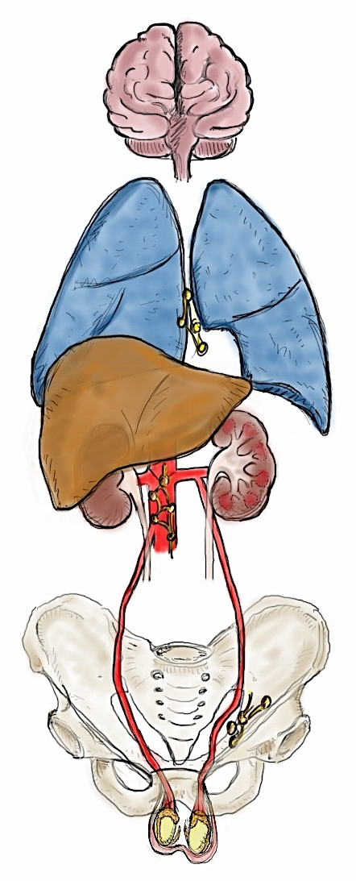
Unkown location
8 / 16 (50%)

pelvic
lymph nodes
1 / 16 (6%)

mediastinal
lymph nodes
1 / 16 (6%)

Retroperitoneal
lymph nodes
8 / 16 (50%)

Lungs
1 / 16 (6%)

Brain
1 / 16 (6%)

