Efficacy of TAC-302 for patients with detrusor underactivity and overactive bladder: A randomized, double-blind, placebo-controlled phase 2 study

Journal name: World Journal of Urology

Masaki Yoshida¹, Momokazu Gotoh², Osamu Yokoyama³, Hidehiro Kakizaki⁴, Tomonori Yamanishi⁵, Osamu Yamaguchi⁶

¹Department of Urology, Sakurajyuji Hospital, Kumamoto, Japan and National Center for Geriatrics and Gerontology, Aichi, Japan
²Chukyo Hospital, Aichi, Japan
³Department of Urology, University of Fukui Faculty of Medical Sciences, Fukui, Japan
⁴Department of Urology, Asahikawa Medical University, Hokkaido, Japan
⁵Department of Urology, Continence Center, Dokkyo Medical University, Tochigi, Japan
⁶Fukushima Medical University, Fukushima, Japan

Corresponding author:
Osamu Yamaguchi
Fukushima Medical University
1 Hikarigaoka, Fukushima-shi, Fukushima, 960-1295, Japan
Email: oyamagu52@gmail.com
Online Resource 1 Study design
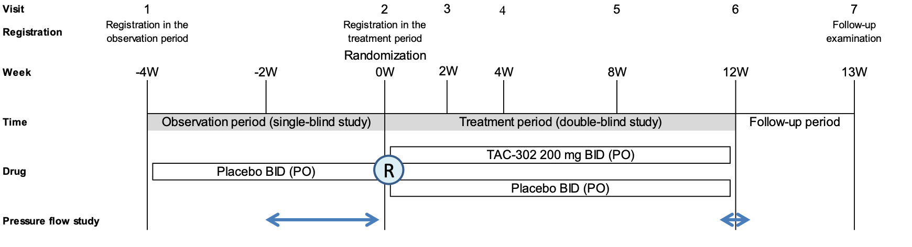
BID, twice daily; PO, per oral; R, randomization; W, week

Online Resource 2 Patient disposition
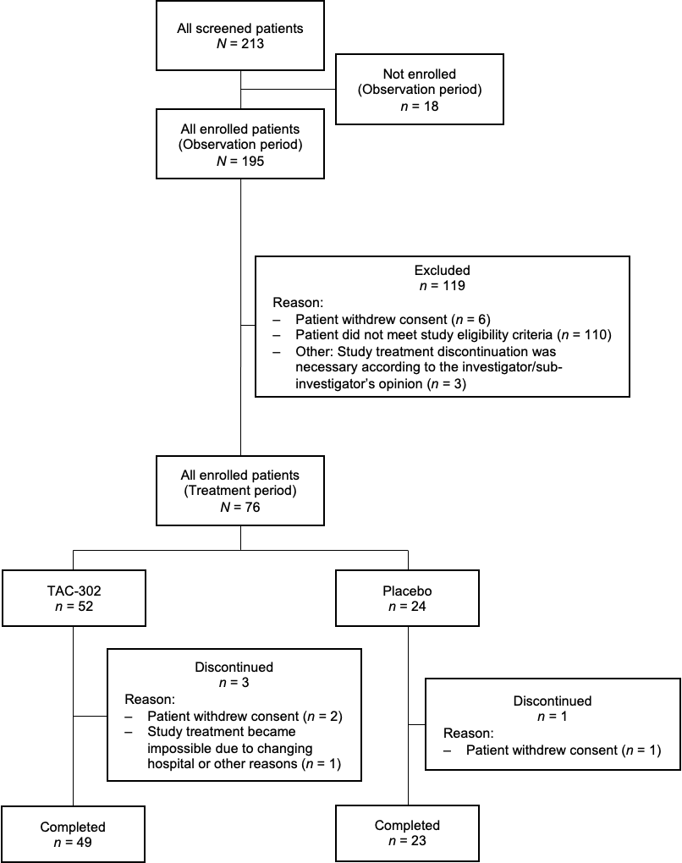

Online Resource 3 Storage symptoms
 | TAC-302 | Placebo
Micturitions per 24 h (average)
Baseline | n = 52 | n = 24
Mean (SD) | 11.8 (3.1) | 11.8 (3.1)
Week 12 | n = 49 | n = 23
Mean (SD) | 10.8 (4.0) | 10.2 (2.3)
Urinary urgency episodes per 24 h (average)
Baseline | n = 52 | n = 24
Mean (SD) | 5.5 (4.6) | 5.7 (3.9)
Week 12 | n = 49 | n = 23
Mean (SD) | 4.5 (6.1) | 2.5 (3.6)
OABSS total score
Baseline | n = 52 | n = 24
Mean (SD) | 8.7 (2.9) | 8.9 (2.4)
Week 12 | n = 49 | n = 23
Mean (SD) | 6.5 (3.2) | 7.3 (3.0)
OABSS, overactive bladder symptom score; SD, standard deviation

