Records identified through PUBMED and Web of Science:
Search Query:
"((bladder OR urothelial) AND (cancer OR carcinoma) OR (bladder Neoplasms [Mesh])) AND (Neoadjuvant OR chemotherapy [Mesh]) AND external beam radiotherapy OR radiotherapy [Mesh]) AND (cystectomy [Mesh])" in PubMed and "((bladder OR urothelial) AND (cancer OR carcinoma)) AND (Neoadjuvant OR chemotherapy) AND (external beam radiotherapy OR radiotherapy) AND (radical cystectomy)" in Web of Science
(n= 2887)
Records screened
(n =527)
Records after duplicates removed
(n = 527)

Identification

Records excluded after title and abstract review (n=507)
Non-relevant according to inclusion criteria (468)
Review article (18)
Case report (21)
Abstract only (78)
Other than English language (62).

Screening

Full-text articles assessed for eligibility
(n = 20)
Articles excluded after evaluation
(n = 5)

Duo to trials phase lower than Ⅲ or inappropriate control group.

Eligibility

15 Studies included in qualitative and quantitative syntheses
(n =15)

Included

Figure 1: The selection process of the articles to assess survival outcomes among bladder cancer who received neoadjuvant chemotherapy compared to locoregional treatment.

Supplementary Figure 2: Risk of bias assessment for randomized control trials that included in the systematic review and network meta-analysis.

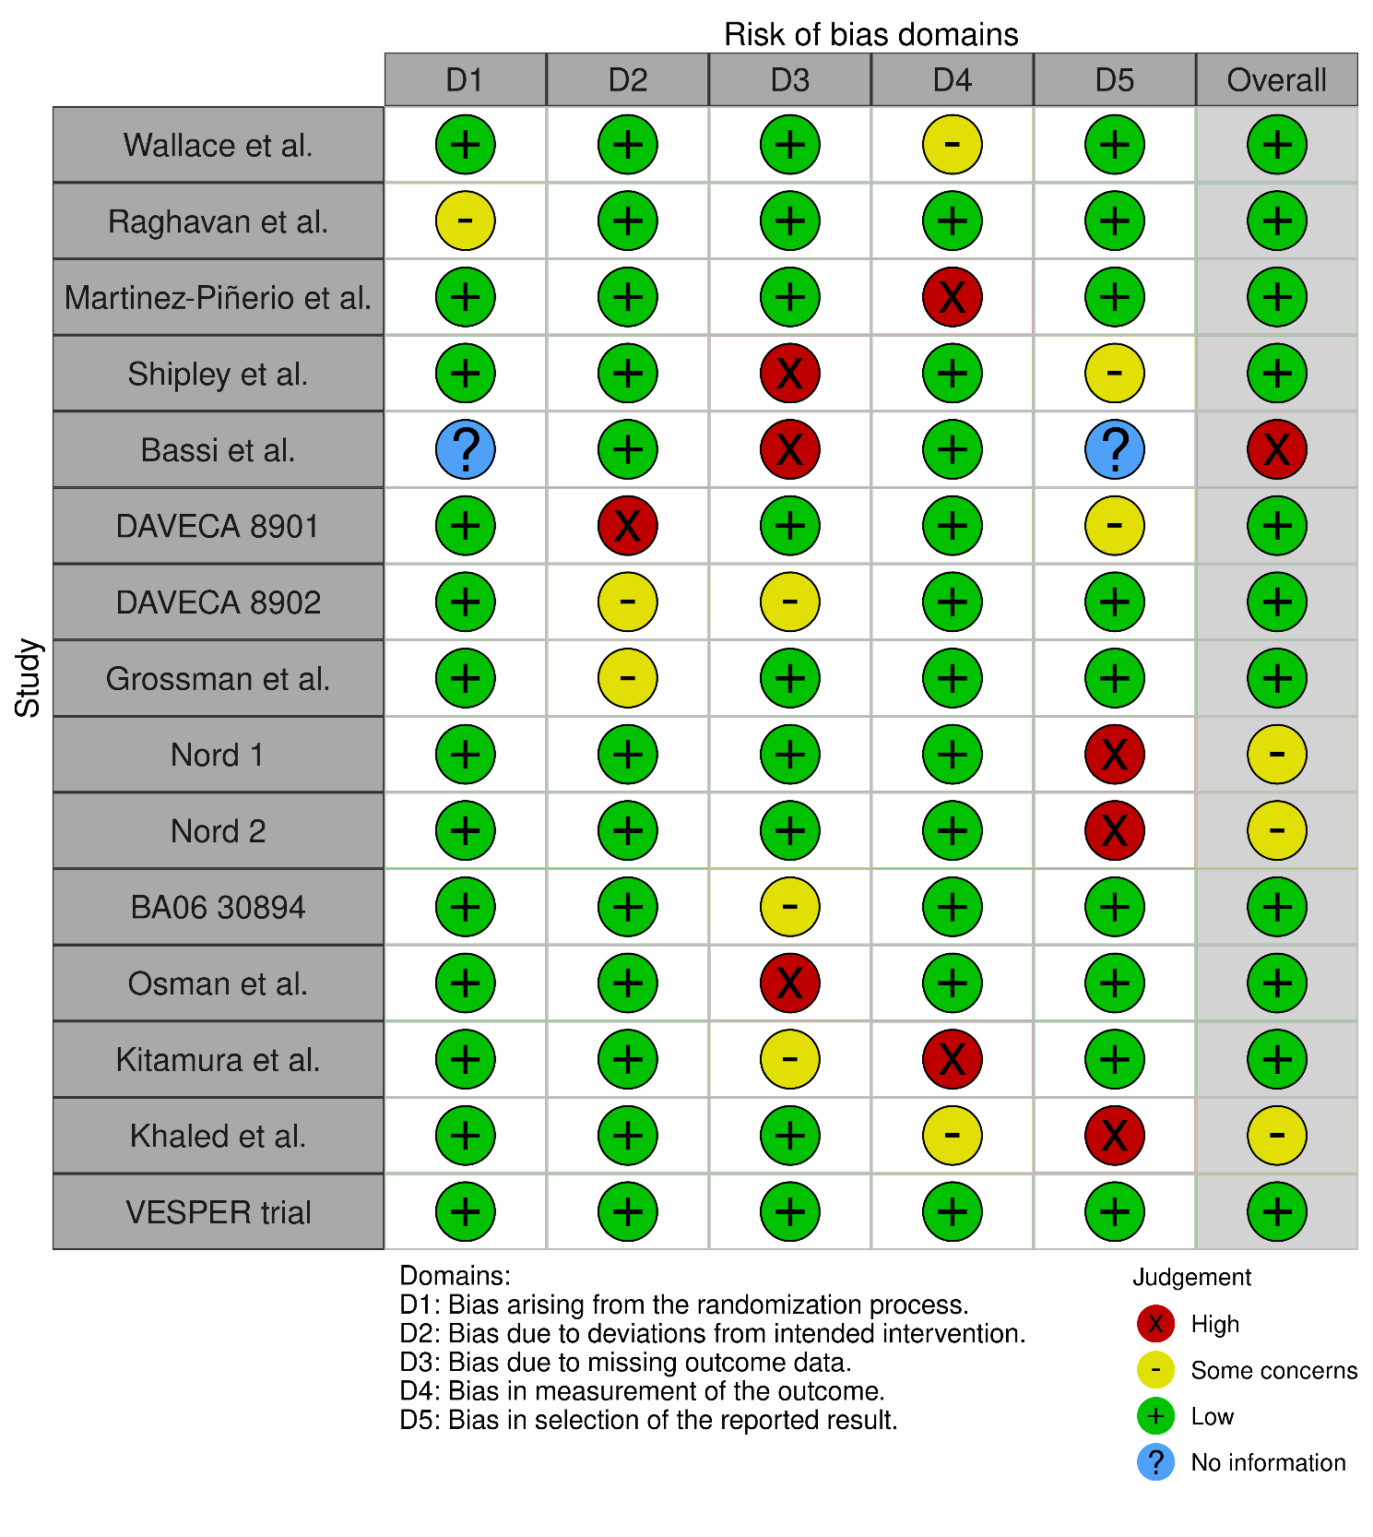
Supplementary Figure 3. Main and sensitivity analyses of overall mortality rate in patients treated with neoadjuvant chemotherapy for bladder cancer.
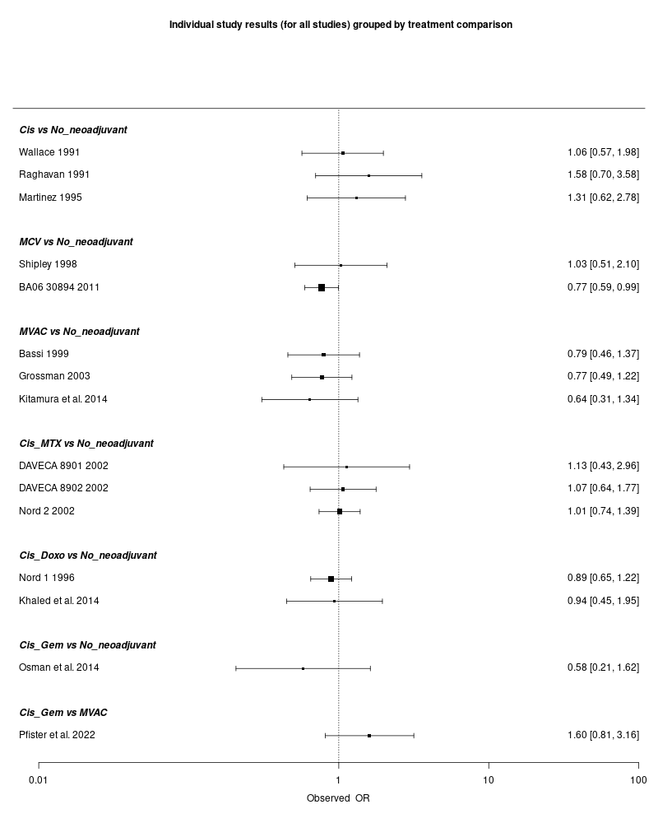

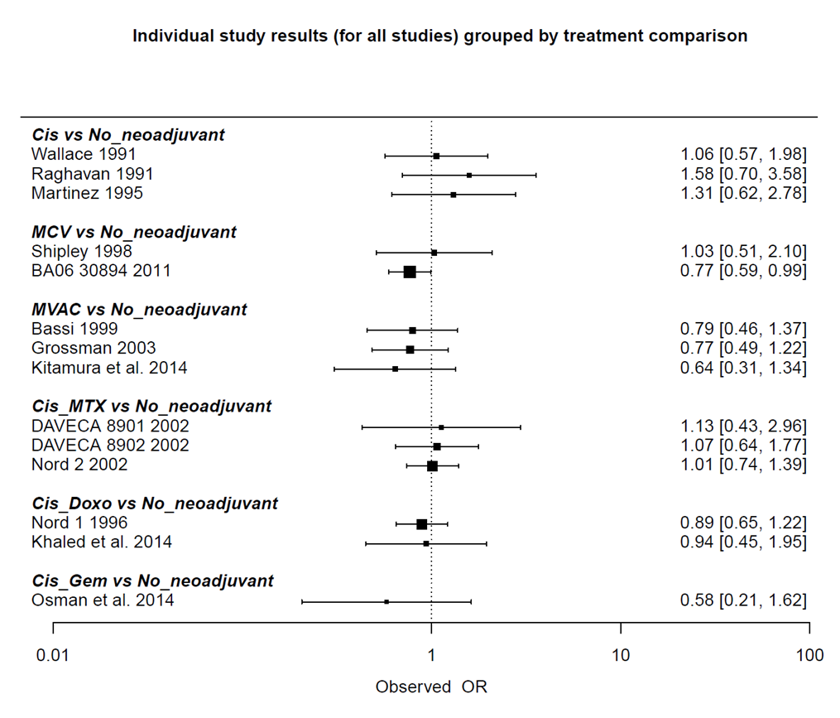

Supplementary Figure 4. Main analysis of overall mortality rate excluding RT only studies in patients treated with neoadjuvant chemotherapy for bladder cancer.
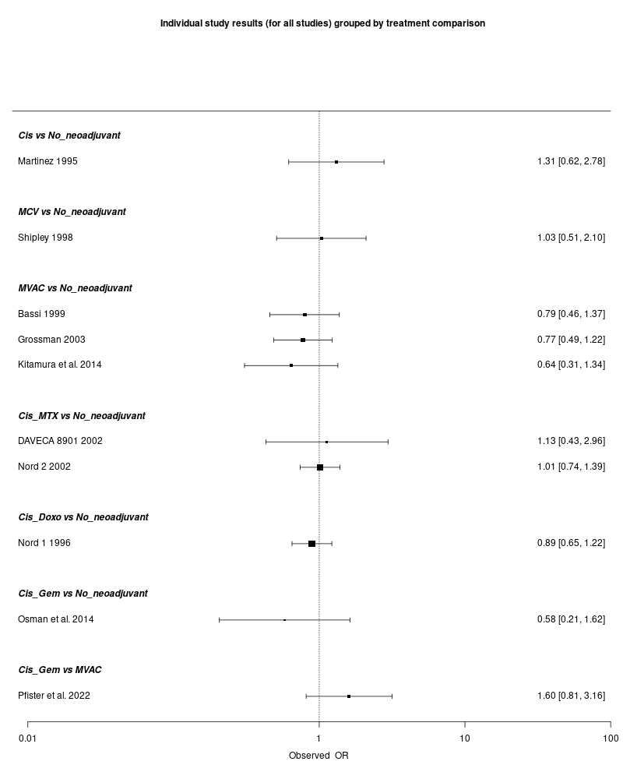

Supplementary Figure 5. Main analysis of disease progression rate in patients treated with neoadjuvant cheomotherapy for bladder cancer.
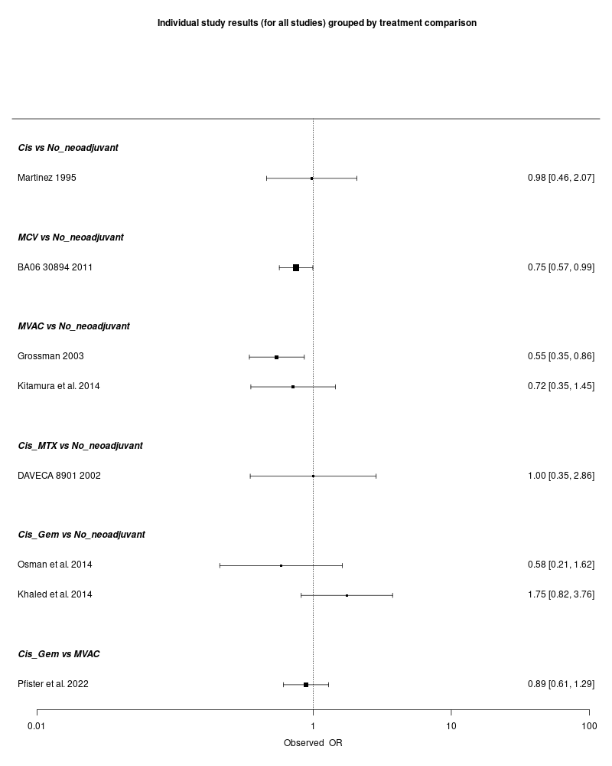
Supplementary Figure 6. Main analysis of disease progression rate excluding RT only studies in patients treated with neoadjuvant cheomotherapy for bladder cancer.
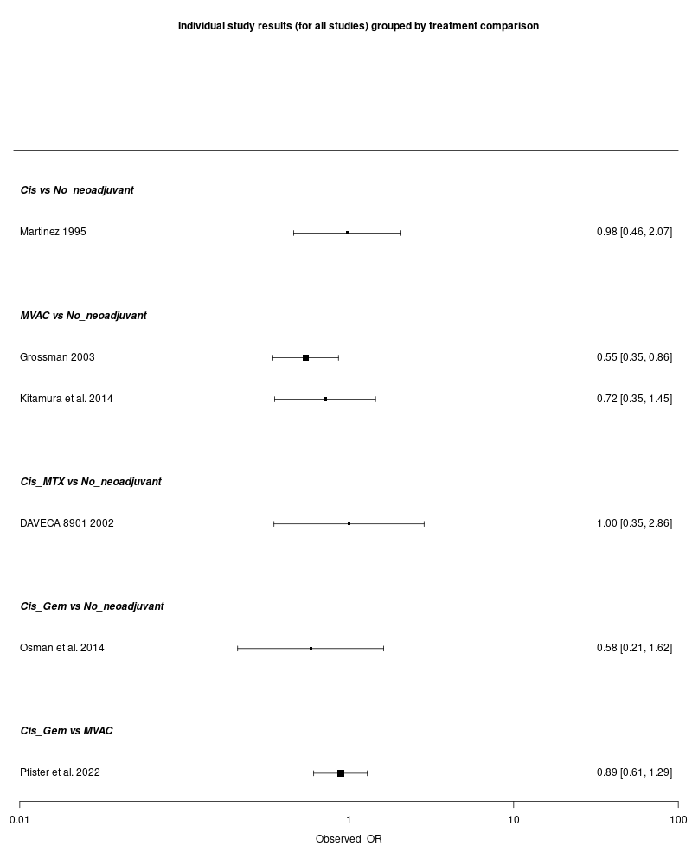
Supplementary Figure 7. Main analysis of downstaging in patients treated with neoadjuvant cheomotherapy for bladder cancer.

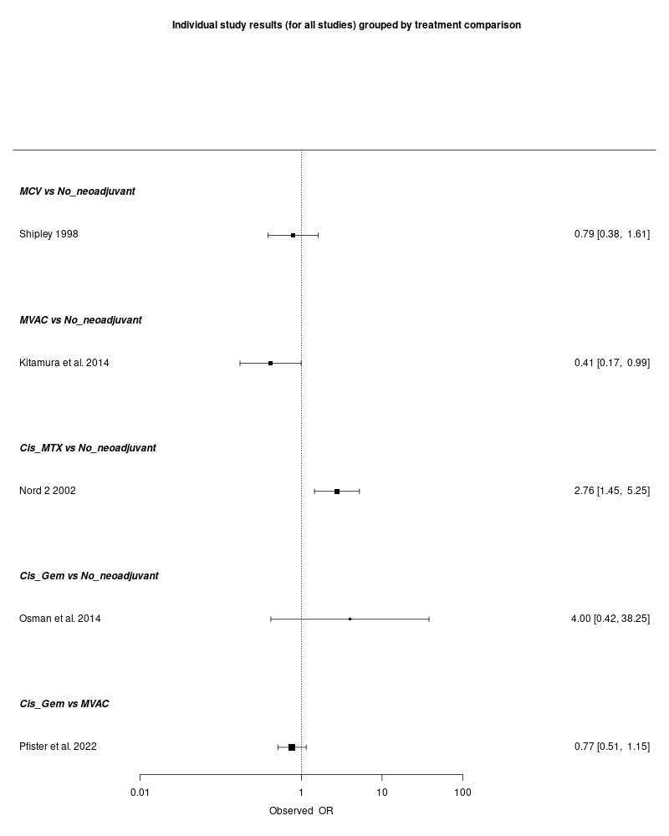
Relative Effects | Rankings Results | Summary of Evidence
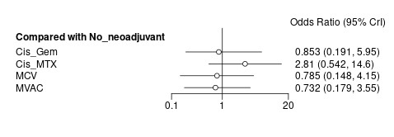  Between-study standard deviation (log-odds scale): 0.67. 95% credible interval: 0.05, 1.08.  (A) Forest plot of relative effects from Bayesian random effect consistency model  Number of Interventions: 6; Number of Studies: 8; Total Number of Patients in Network: 2212; Total Possible Pairwise Comparisons: 15; Total Number of Pairwise Comparisons With Direct Data: 6; Number of Two-arm Studies: 8; Total Number of Events in Network:1300; Number of Studies With No Zero Events: 8. | 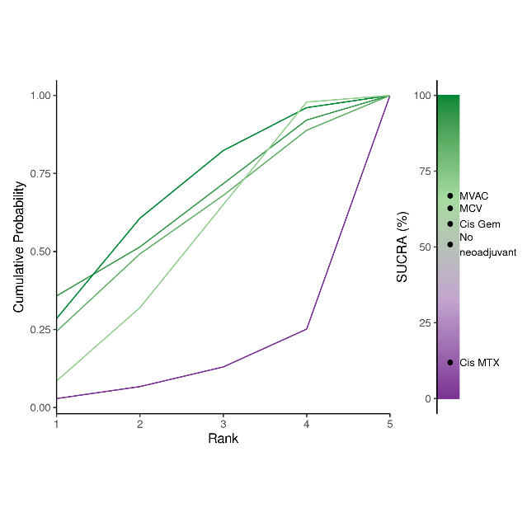  (B) Litmus Rank-O-Gram: Higher SUCRA (Surface Under the Cumulative Ranking Curve) values and cumulative ranking curves nearer the top left indicate better performance | 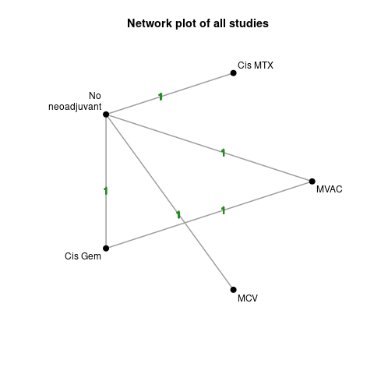  (C) Numbers on the line indicate number of trials conducted for the comparison. Any shaded areas indicate existence of multi-arm trials between the comparisons.
Supplementary Figure 8: Summary of the Bayesian network meta-analysis of local control (i.e. complete response and/or down-staging) in patients treated with neoadjuvant chemotherapy for bladder cancer. Cisplatin (Cis), cisplatin/doxorubicin (Cis_Doxo), or Cisplatin and Gemcitabine (Cis_Gem), cisplatin/methotrexate (Cis_MTX), cisplatin, methotrexate and vinblastine (CMV) and Methotrexate, Vinblastine, Doxorubicin (Adriamycin), and Cisplatin MVAC

