Online Resource:
A US real-world study of treatment patterns and outcomes in localized or locally advanced prostate cancer patients
Stephen J. Freedland • Sandhya Nair • Xiwu Lin • Lawrence Karsh • Christopher Pieczonka • Ravi Potluri • Sabine D. Brookman-May • Suneel D. Mundle • Sarah Fleming • Neeraj Agarwal

Supplementary Fig. 1 Patient identification

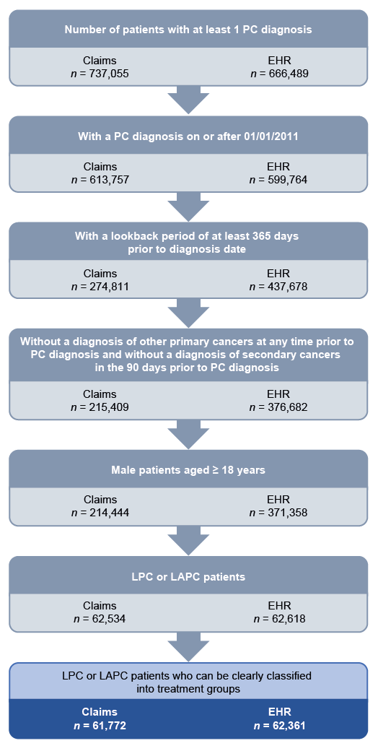
EHR electronic health records, LAPC locally advanced prostate cancer, LPC localized prostate cancer, PC prostate cancer

Supplementary Table 1 Comparison of Optum’s claims and EHR databases^{1,2}
 |  | Optum’s Clinformatics® Extended Data Mart database (claims) | Optum’s PAN-Therapeutic EHR database (EHR)
General description |  | - Derived from a database of administrative health claims for members of large commercial and Medicare Advantage health plans.  - Adjudicated US administrative health claims database describing people with private health insurance | - Derived from dozens of healthcare provider organizations in the United States
Country |  | - United States | - United States
Patient population |  | - Representative of commercial claims patients (aged 0–65 years)  - Some Medicare patients (aged 65+ years)  - Patients in the database are capped at age 90 | - > 80 million patients  - At least 7 million patients in each US Census region  - > 7700 hospitals and clinics
 |  | - Overlap of patients between the databases (estimated to be 10–26% of EHR)
Data source |  | - Closed (sourced from payers)  - Complete record of healthcare encounters of a patient) insurance claims database | - Data sourced from multiple EHR vendors
Payer |  | - Single payer (United Healthcare) | - NA
Available data | General | - Demographic variables, clinical variables, coded diagnoses and procedures  - Information from administrative claims processed from inpatient, emergency department, outpatient medical services and dispensed prescriptions  - Information from outpatient lab result tests processed by large national laboratory vendors that participate in data exchange with Optum | - Demographic variables, race/ethnicity, clinical variables, coded diagnoses and procedures  - Information on outpatient visits, diagnostic procedures, medications, laboratory results, hospitalizations, clinical notes and patient outcomes  - No curated data from patient charts  - Contains structured data created from physician notes using Optum’s proprietary natural language processing algorithms
Available data | Drug | - Available from actual prescription fills at pharmacies and procedures undertaken | - Available by way of prescriptions written (but not of actual fills) and procedures undertaken
 | Cost | - Standardized costs corresponding to allowed amounts but not actual costs | - No cost data
 | Death | - Date of death (month and year only) for members with both medical and pharmacy coverage from the Social Security Death Master File | - Date of death
EHR electronic health record
¹ Khera R, Schuemie MJ, Lu Y, et al (2022) Large-scale evidence generation and evaluation across a network of databases for type 2 diabetes mellitus (LEGEND-T2DM): a protocol for a series of multinational, real-world comparative cardiovascular effectiveness and safety studies. BMJ Open 12:e057977. https://doi.org/10.1136/bmjopen-2021-057977.
² Choi YC, Zhang D, Tyczynski JE (2021) comparison between health insurance claims and electronic health records (ehrs) for metastatic non-small-cell lung cancer (nsclc) patient characteristics and treatment patterns: a retrospective cohort study. Drugs Real World Outcomes 8:577-587. https://doi.org/10.1007/s40801-021-00269-0.

Supplementary Table 2 Definition of disease recurrence dates
RP ADT (> 180 days) - Start of ADT as progression date​
RP RT (> 180 days) - Start of RT as progression date​
RP ADT + RT (> 90 days) - Start of earlier of ADT and RT as progression date​
RT ADT (> 180 days) - Start of ADT as progression date​
RT RP (> 180 days) - Start of RP as progression date
ADT androgen deprivation therapy, RP radical prostatectomy, RT radiotherapy

Supplementary Table 3 Age, days to LPC/LAPC progression, comorbidity and demographic characteristics of two cohorts of men with LPC/LAPC based on claims and EHR data
 | Claims |  |  |  | EHR
 | Overall  (N = 61,772) | Starting with RP (n = 24,356) | Starting with RT (n = 31,507) | ADT only  (n = 5909) | Overall  (n = 62,361) | Starting with RP (n = 33,528) | Starting with RT (n = 21,803) | ADT only  (n = 7030)
Median age at diagnosis, years (IQR) | 69 (63–74) | 64 (59–69) | 71 (67–76) | 78 (71–83) | 66 (61–72) | 63 (58–68) | 70 (64–75) | 76 (69–80)
p Value | – | p < 0.0001 |  |  | – | p < 0.0001
Median time from diagnosis to progressionª, days (IQR) | 713 (290–1411) | 631 (259–1298) | 825 (353–1545) | 496 (156–1166) | 899 (351–1698) | 950 (365–1746) | 890 (353–1705) | 700 (293–1408)
p Value | – | p < 0.0001 |  |  | – | p < 0.0001
CCI—n (%)
0 | 40,021 (64.8) | 17,764 (72.9) | 19,249 (61.1) | 3008 (50.9) | 49,899 (80.0) | 27,692 (82.6) | 16,805 (77.1) | 5402 (76.8)
1 | 9442 (15.3) | 3070 (12.6) | 5240 (16.6) | 1132 (19.2) | 5955 (9.5) | 3087 (9.2) | 2155 (9.9) | 713 (10.1)
2 | 7469 (12.1) | 2462 (10.1) | 4115 (13.1) | 892 (15.1) | 4349 (7.0) | 2033 (6.1) | 1761 (8.1) | 555 (7.9)
3 | 2597 (4.2) | 615 (2.5) | 1525 (4.8) | 457 (7.7) | 1272 (2.0) | 448 (1.3) | 619 (2.8) | 205 (2.9)
4+ | 2243 (3.6) | 445 (1.8) | 1378 (4.4) | 420 (7.1) | 886 (1.4) | 268 (0.8) | 463 (2.1) | 155 (2.2)
p Value | – | p < 0.0001 |  |  | – | p < 0.0001
Race—n (%)
Caucasian | – | – | – | – | 51,023 (81.8) | 27,880 (83.2) | 17,457 (80.1) | 5686 (80.9)
African American | – | – | – | – | 8174 (13.1) | 4091 (12.2) | 3163 (14.5) | 920 (13.1)
Asian | – | – | – | – | 533 (0.9) | 281 (0.8) | 175 (0.8) | 77 (1.1)
Other/Unknown | – | – | – | – | 2631 (4.2) | 1276 (3.8) | 1008 (4.6) | 347 (4.9)
p Value | – |  |  |  | – | p < 0.0001
Ethnicity—n (%)
Non-Hispanic | – | – | – | – | 56,209 (90.1) | 30,503 (91.0) | 19,444 (89.2) | 6262 (89.1)
Hispanic | – | – | – | – | 1585 (2.5) | 925 (2.8) | 497 (2.3) | 163 (2.3)
Unknown | – | – | – | – | 4567 (7.3) | 2100 (6.3) | 1862 (8.5) | 605 (8.6)
p Value | – |  |  |  | – | p < 0.0001
US region—n (%)
Northeast | 7138 (11.6) | 2377 (9.8) | 4121 (13.1) | 640 (10.8) | 8477 (13.6) | 4230 (12.6) | 3231 (14.8) | 1016 (14.5)
West | 13,218 (21.4) | 4888 (20.1) | 6755 (21.4) | 1575 (26.7) | 5861 (9.4) | 3101 (9.2) | 1807 (8.3) | 953 (13.6)
Midwest | 14,652 (23.7) | 6888 (28.3) | 6473 (20.5) | 1291 (21.8) | 34,078 (54.6) | 18,651 (55.6) | 12,092 (55.5) | 3335 (47.4)
South | 26,619 (43.1) | 10,104 (41.5) | 14,122 (44.8) | 2393 (40.5) | 12,261 (19.7) | 6605 (19.7) | 4175 (19.1) | 1481 (21.1)
Unknown | 145 (0.2) | 99 (0.4) | 36 (0.1) | 10 (0.2) | 1684 (2.7) | 941 (2.8) | 498 (2.3) | 245 (3.5)
p Value | – | p < 0.0001 |  |  | – | p < 0.0001
ªTime from LAPC diagnosis to progression (including disease recurrence) or end of follow-up
There is no information regarding race and ethnicity in Optum claims
ADT androgen deprivation therapy, CCI Charlson Comorbidity Index, EHR electronic health records, IQR interquartile range, LAPC locally advanced prostate cancer, LPC localized prostate cancer, RP radical prostatectomy, RT radiotherapy
Supplementary Table 4 Comorbidities of two cohorts of men with LPC/LAPC based on claims and EHR data
Comorbidity—n.(%) | Claims |  |  |  |  | EHR
Comorbidity—n.(%) | Overall  (N = 61,772) | Starting with RP  (n = 24,356) | Starting with RT  (n = 31,507) | ADT only  (n = 5909) | Overall  (N = 62,361) |  | Starting with RP  (n = 33,528) | Starting with RT  (n = 21,803) | ADT only  (n = 7030)
Hypertension | 39,400 (64.1) | 14,006 (57.6) | 21,265 (67.9) | 4129 (70.9) | 24,879 (46.0) |  | 13,690 (44.4) | 8661 (49.5) | 2528 (43.9)
Chronic pulmonary disease | 7630 (12.4) | 2362 (9.7) | 4289 (13.7) | 979 (16.8) | 5007 (9.3) |  | 2423 (7.9) | 1982 (11.3) | 602 (10.4)
Cardiac arrhythmia | 9991 (16.3) | 3568 (14.7) | 5108 (16.3) | 1315 (22.6) | 7452 (13.8) |  | 4243 (13.7) | 2373 (13.6) | 836 (14.5)
Diabetes | 15,595 (25.4) | 4628 (19.0) | 9053 (28.9) | 1914 (32.9) | 8475 (15.7) |  | 4033 (13.1) | 3355 (19.2) | 1087 (18.9)
Fluid and electrolyte disorders | 3212 (5.2) | 856 (3.5) | 1789 (5.7) | 567 (9.7) | 1890 (3.5) |  | 900 (2.9) | 732 (4.2) | 258 (4.5)
Peripheral vascular disorders | 6994 (11.4) | 1723 (7.1) | 4179 (13.3) | 1092 (18.7) | 2910 (5.4) |  | 1188 (3.8) | 1299 (7.4) | 423 (7.3)
Depression | 3964 (6.4) | 1560 (6.4) | 1979 (6.3) | 425 (7.3) | 2893 (5.3) |  | 1693 (5.5) | 931 (5.3) | 269 (4.7)
Hypothyroidism | 4988 (8.1) | 1650 (6.8) | 2719 (8.7) | 619 (10.6) | 2465 (4.6) |  | 1337 (4.3) | 809 (4.6) | 319 (5.5)
Congestive heart failure | 3621 (5.9) | 708 (2.9) | 2205 (7.0) | 708 (12.2) | 1768 (3.3) |  | 566 (1.8) | 853 (4.9) | 349 (6.1)
Weight loss | 1240 (2.0) | 281 (1.2) | 695 (2.2) | 264 (4.5) | 635 (1.2) |  | 238 (0.8) | 282 (1.6) | 115 (2.0)
Renal failure | 6320 (10.3) | 1421 (5.8) | 3734 (11.9) | 1165 (20.0) | 2841 (5.2) |  | 1060 (3.4) | 1244 (7.1) | 537 (9.3)
Valvular disease | 4149 (6.7) | 1290 (5.3) | 2283 (7.3) | 576 (9.9) | 2108 (3.9) |  | 986 (3.2) | 824 (4.7) | 298 (5.2)
Obesity | 6722 (10.9) | 2614 (10.8) | 3572 (11.4) | 536 (9.2) | 5927 (11.0) |  | 3710 (12.0) | 1835 (10.5) | 382 (6.6)
Other neurological disorders | 1830 (3.0) | 450 (1.9) | 1036 (3.3) | 344 (5.9) | 1086 (2.0) |  | 442 (1.4) | 455 (2.6) | 189 (3.3)
Liver disease | 4684 (7.6) | 1826 (7.5) | 2459 (7.8) | 399 (6.8) | 2446 (4.5) |  | 1357 (4.4) | 900 (5.1) | 189 (3.3)
Pulmonary circulation disorders | 988 (1.6) | 232 (1.0) | 614 (2.0) | 142 (2.4) | 577 (1.1) |  | 212 (0.7) | 284 (1.6) | 81 (1.4)
Rheumatoid arthritis/collagen | 1563 (2.5) | 516 (2.1) | 869 (2.8) | 178 (3.1) | 810 (1.5) |  | 436 (1.4) | 294 (1.7) | 80 (1.4)
Deficiency anemia | 1944 (3.2) | 457 (1.9) | 1,158 (3.7) | 329 (5.6) | 650 (1.2) |  | 236 (0.8) | 289 (1.7) | 125 (2.2)
Alcohol abuse | 1082 (1.8) | 390 (1.6) | 581 (1.9) | 111 (1.9) | 985 (1.8) |  | 551 (1.8) | 338 (1.9) | 96 (1.7)
Coagulopathy | 1738 (2.8) | 501 (2.1) | 997 (3.2) | 240 (4.1) | 1003 (1.9) |  | 465 (1.5) | 388 (2.2) | 150 (2.6)
Drug abuse | 640 (1.0) | 203 (0.8) | 368 (1.2) | 69 (1.2) | 431 (0.8) |  | 252 (0.8) | 133 (0.8) | 46 (0.8)
Psychoses | 279 (0.5) | 74 (0.3) | 147 (0.5) | 58 (1.0) | 165 (0.3) |  | 61 (0.2) | 70 (0.4) | 34 (0.6)
Paralysis | 261 (0.4) | 50 (0.2) | 166 (0.5) | 45 (0.8) | 127 (0.2) |  | 37 (0.1) | 70 (0.4) | 20 (0.3)
Peptic ulcer disease excluding bleeding | 293 (0.5) | 83 (0.3) | 167 (0.5) | 43 (0.7) | 227 (0.4) |  | 90 (0.3) | 114 (0.7) | 23 (0.4)
Blood loss anemia | 331 (0.5) | 79 (0.3) | 191 (0.6) | 61 (1.0) | 153 (0.3) |  | 61 (0.2) | 64 (0.4) | 28 (0.5)
AIDS/HIV | 182 (0.3) | 76 (0.3) | 85 (0.3) | 21 (0.4) | 102 (0.2) |  | 57 (0.2) | 39 (0.2) | 6 (0.1)
Solid tumor | 1351 (2.2) | 385 (1.6) | 818 (2.6) | 148 (2.5) | 1155 (2.1) |  | 394 (1.3) | 650 (3.7) | 111 (1.9)
Lymphoma | 123 (0.2) | 31 (0.1) | 85 (0.3) | 7 (0.1) | 131 (0.2) |  | 32 (0.1) | 84 (0.5) | 15 (0.3)
Listed comorbidities are from the Elixhauser comorbidity table; comorbidities have been evaluated in the 180 days prior to start of respective settings
ADT androgen deprivation therapy, EHR electronic health records, LAPC locally advanced prostate cancer, LPC localized prostate cancer, RP radical prostatectomy, RT radiotherapy

Supplementary Table 5 Treatment trajectories in two cohorts of men with LPC/LAPC based on claims and EHR data
Treatment sequence | Patients—no. (%) |  | Time from start of first treatment to start of second treatment, days
Treatment sequence | Claims  (N = 61,772) | EHR  (N = 62,361)
Starting with RTª | 31,507 (51.0) | 21,803 (35.0) | –
Starting with RP | 24,356 (39.4) | 33,528 (53.8) | –
RP only | 18,885 (30.6) | 28,802 (46.2) | –
ADT (neoadjuvant) RP | 531 (0.9) | 270 (0.4) | 0–180 and > 180
RT^{b} RP | 217 (0.4) | 78 (0.1) | 0-180
RP ADT | 180 (0.3) | 387 (0.6) | > 180
RP RT | 1177 (1.9) | 1522 (2.4) | > 180
RP ADT+RT | 1461 (2.4) | 911 (1.5) | > 90
RP RT | 852 (1.4) | 639 (1.0) | 0–180
RP ADT | 363 (0.6) | 551 (0.9) | 0–180
RP ADT+RT | 690 (1.1) | 368 (0.6) | 0–90
ADT only | 5909 (9.6) | 7030 (11.3) | –
ªTreatment trajectories (time from start of first treatment to start of second treatment) were as follows: RT only, ADT+RT RP (0-180 days), ADT RT (>180 days), RT salvage RP (> 180 days), RT ADT (0–180 days or salvage ADT occurring after >180 days), and ADT+RT (RT received within 0-180 days of ADT was considered as concurrent treatment)
^{b}Patients changed their mind regarding primary treatment and changed to RP shortly after RT initiation
ADT androgen deprivation therapy, EHR electronic health records, LAPC locally advanced prostate cancer, LPC localized prostate cancer, RP radical prostatectomy, RT radiotherapy

Supplementary Table 6 Real-World oncological outcomes following primary treatment for LPC/LAPC
Oncological outcome | Primary treatment  Median (95% CI), months
Oncological outcome | Starting with RP | Starting with RT | ADT alone
Claims | n = 24,356 | n = 31,507 | n = 5909
Median rwOS | NR | 131.4 (129.7–NR) | 63.6 (61.1–66.5)
Median rwPFS | NR | NR | 50.1 (46.9–53.3)
Median rwEFS | NR | NR | 50.1 (46.9–53.3)
Median rwMFS | NR | NR | 53.3 (50.2–57.0)
EHR | n = 33,528 | n = 21,803 | n = 7030
Median rwOS | NR | 127.8 (121.8–NR) | 80.1 (77.4–82.8)
Median rwPFS | NR | NR | 50.9 (48.6–54.0)
Median rwEFS | NR | NR | 50.9 (48.6–54.0)
Median rwMFS | NR | NR | 71.4 (67.7–74.5)
ADT androgen deprivation therapy, EHR electronic health records, CI confidence interval, LAPC locally advanced prostate cancer, LPC localized prostate cancer, NR not reported, rwOS real-world overall survival, RP radical prostatectomy, RT radiotherapy, rwEFS real-world event-free survival, rwMFS real-world metastasis-free survival, rwPFS real-world progression-free survival
Supplementary Fig. 2 Real-world overall survival among men with LPC/LAPC identified from claims data with and without evidence of disease within (a) 1, (b) 3 and (c) 5 years of primary treatment, with 95% confidence intervals
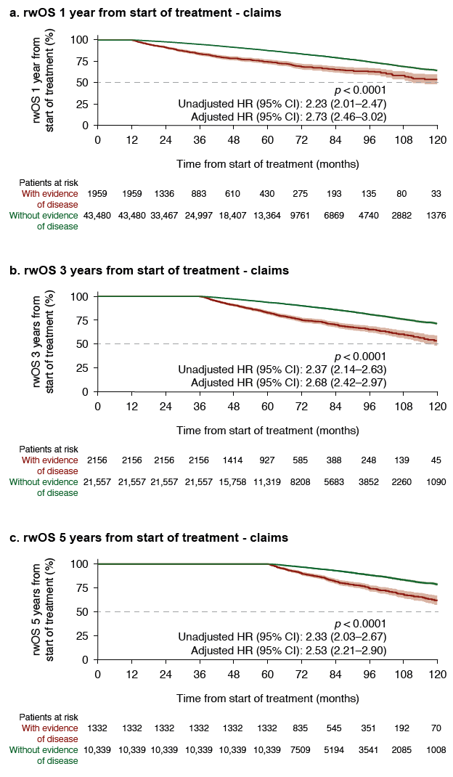
95% confidence intervals shown in shading around plotted lines
CI confidence interval, HR hazard ratio, LAPC locally advanced prostate cancer, LPC localized prostate cancer, rwOS real-world overall survival
Supplementary Fig. 3 Real-world overall survival among men with LPC/LAPC identified from EHR data with and without evidence of disease within (a) 1, (b) 3 and (c) 5 years of primary treatment, with 95% confidence intervals
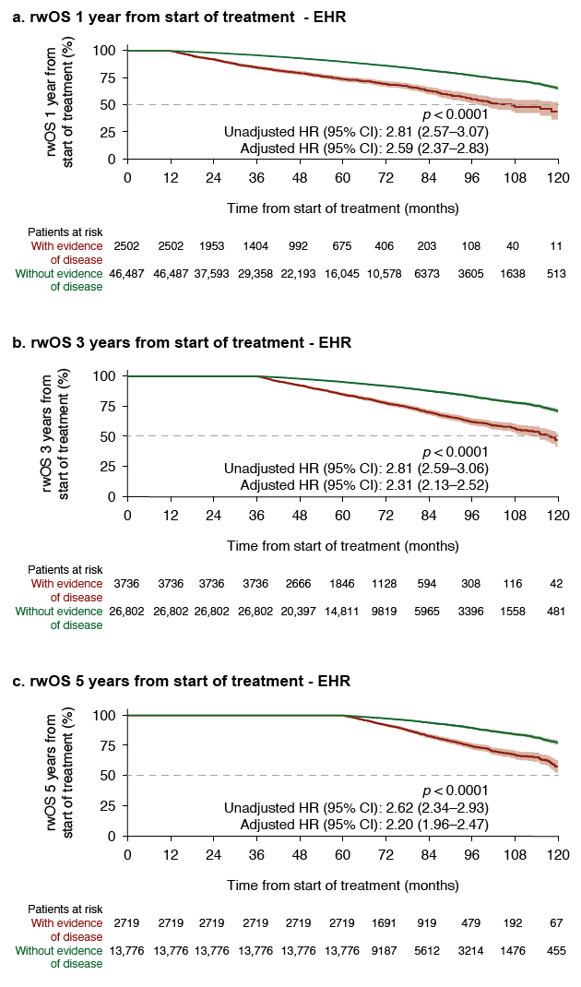
95% confidence intervals shown in shading around plotted lines
CI confidence interval, EHR electronic health records, HR hazard ratio, LAPC locally advanced prostate cancer, LPC localized prostate cancer, rwOS real-world overall survival

