SUPPLEMENTARY ANNEXE
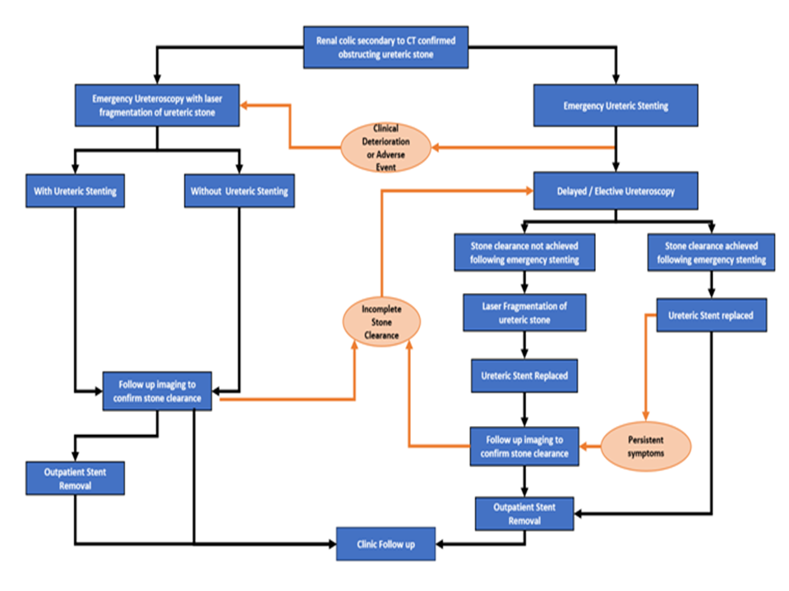
Figure A: Summary and flow of the study

Study (authors) | Khopekar et al. | Al-Ghazo et al.^{[12]} | Osorio et al.^{[13]} | Yang et al.^{[14]} | Youn et al.^{[15]}
Patients (numbers) | 100 | 244 | 144 | 49 | 67
Age (years) | 55.6 | 45.6 | 49.6 | NA | 47.8
Average Size | 8.24mm | 9.2mm | 9.1mm | 14.8mm | 2.41mm
Stone-Free Rate (%) | 85 | 90.6 | 92.4 | 91.8 | 89.55
Follow-up | 3 months | 4 weeks | 1 month | 3 months | 1 month
Hospital Stay | 3.8 days | 1.9 days | 2.5 days | NA | NA

Table A: Summary of studies reporting emergency ureteroscopies analyses comparison

Study (authors) | Khopekar et al. | Al-Ghazo et al.^{[12]} | Osorio et al.^{[13]} | Yang et al.^{[14]} | Youn et al.^{[15]}
Patients (numbers) | 100 | 244 | 144 | 49 | 67
Age (years) | 55.6 | 45.6 | 49.6 | NA | 47.8
Average Size | 8.24mm | 9.2mm | 9.1mm | 14.8mm | 2.41mm
Stone-Free Rate (%) | 85 | 90.6 | 92.4 | 91.8 | 89.55
Follow-up | 3 months | 4 weeks | 1 month | 3 months | 1 month
Hospital Stay | 3.8 days | 1.9 days | 2.5 days | NA | NA

