ONLINE SUPPLEMENT

Supplement Table 1. MEDLINE search strategy.ª
Diagnosis Search Terms
- Cancer
- Carcinoma
- Neoplasm
- Prostat*
Procedure Search Terms
- Ablation
- Focal
- HIFU
- High-intensity focused ultrasound
- Sonablate
- Transrectal
Combination Terms
- or/1-3
- 4
- or/5-10
- and/11-13
ªThe ‘*’ represents a wildcard symbol used in a search query to represent end truncation.

Supplement Table 2. Methodological study quality assessment using the National Institute of Health assessment tool for before-after studies.ª
Study | 1 | 2 | 3 | 4 | 5 | 6 | 7 | 8 | 9 | 10 | 11 | 12 | Quality  Rating
Bass [2019] [13] | Y | Y | Y | Y | Y | Y | Y | N | Y | Y | N | ^{b} | Good
Collins [2022] [14] | Y | N | Y | Y | Y | Y | Y | N | N | N | N | ^{b} | Fair
Khandwala [2022] [15] | Y | N | Y | Y | Y | Y | Y | N | Y | Y | N | ^{b} | Good
Muto [2008] [16] | Y | Y | Y | Y | N | Y | Y | N | Y | Y | N | ^{b} | Good
Reddy [2022] [17] | Y | Y | Y | Y | Y | Y | Y | N | Y | Y | N | ^{b} | Good
Shoji [2015] [18] | Y | Y | Y | Y | Y | Y | Y | N | Y | Y | N | ^{b} | Good
Shoji [2020] [19] | Y | Y | Y | Y | Y | Y | Y | N | Y | Y | N | ^{b} | Good
Yee [2021][20] | Y | Y | Y | Y | N | Y | Y | N | Y | Y | N | ^{b} | Good
N=no; Y=yes.

ªItem numbers and associated descriptions include: 1) objective clearly stated; (2) eligibility criteria described; (3) representative patient population; (4) all eligible participants enrolled in study; (5) sufficient sample size; (6) intervention described; (7) outcome measures specified; (8) outcome assessors blinded; (9) loss to follow-up and intention-to-treat analysis; (10) statistical analysis of outcome measures before and after intervention; (11) interrupted time-series design; (12) individual data used for group-level effects.

Supplement Table 3. One-study removed sensitivity analyses of main outcomes of focal treatment for localized prostate cancer using visually-directed high-intensity focused ultrasound.ª
Outcomes | Studies  reporting  outcome | All  studies | One-study removed,  lowest estimate | One-study removed,  highest estimate
PSA nadir (ng/ml) | 6 | 2.2  (0.9-3.5) | 2.0  (0.6-3.4) | 2.6  (1.9-3.4)
Clinically significant positive biopsy | 8 | 19.8%  (12.4%-28.3%) | 17.1%  (11.3%-25.1%) | 22.7%  (15.2%-32.4%)
Salvage treatment (focal or whole gland) | 6 | 16.2%  (9.7%-23.8%) | 13.9%  (7.9%-23.5%) | 21.7%  (16.6%-27.9%)
Salvage treatment (whole gland only) | 6 | 8.6%  (6.1%-11.5%) | 7.7%  (5.3%-10.5%) | 9.1%  (7.7%-10.7%)
Complications
de novo erectile dysfunction | 6 | 16.7%  (9.9%-24.6%) | 13.3%  (7.0%-24.0%) | 20.2%  (12.9%-30.1%)
Urinary retention | 4 | 6.2%  (0.0%-19.0%) | 3.6%  (0.4%-25.4%) | 11.6%  (6.8%-18.9%)
Urinary tract infection | 5 | 3.0%  (2.1%-3.9%) | 2.8%  (1.8%-3.9%) | 3.8%  (2.9%-4.9%)
Urinary incontinence | 4 | 1.9%  (0.1%-5.3%) | 0.4%  (0.0%-1.8%) | 2.9%  (1.0%-8.0%)
Bowel injury | 5 | 0.1%  (0.0%-1.4%) | 0.0%  (0.0%-0.0%) | 0.4%  (0.0%-2.2%)
PSA=prostate-specific antigen.

ªData reported as weighted mean or event rate (95% confidence interval).

Supplement Table 4. Univariable metaregression of the association of study-level factors with main outcomes after focal treatment for localized prostate cancer using visually-directed high-intensity focused ultrasound.ª
Moderators | PSA nadir | Clinically significant  positive biopsy | Salvage treatment  (focal or whole gland) | de novo erectile  dysfunction
Follow-up duration (mo) | z = -0.07; p = 0.95 | z = 1.08; p = 0.28 | z = 1.32; p = 0.19 | z = -2.71; p = 0.007
Median procedure year | z = 0.12; p = 0.90 | z = -0.51; p = 0.61 | z = -1.59; p = 0.11 | z = 1.52; p = 0.13
Percent cT3 patients | z = 0.33; p = 0.74 | z = 0.21; p = 0.83 | z = 1.19; p = 0.24 | z = -0.83; p = 0.41
Prostate volume (ml) | z = 1.14; p = 0.25 | z = 3.12; p = 0.002 | z = 0.87; p = 0.38 | z = 0.43; p = 0.67
Age (years) | z = 0.82; p = 0.41 | z = -0.02; p = 0.99 | z = -1.36; p = 0.17 | z = -0.21; p = 0.83
Pre-HIFU PSA (ng/ml) | z = 1.31; p = 0.19 | z = 0.70; p = 0.49 | z = 0.29; p = 0.77 | z = 0.41; p = 0.68
Percent receiving NADT | z = 1.11; p = 0.27 | z = -0.11; p = 0.91 | z = 0.00; p > 0.99 | z = -0.31; p = 0.76
NADT=neoadjuvant androgen deprivation therapy; PSA=prostate-specific antigen.

ªPositive z-score indicates a positive association with the outcome; a negative z-score indicates a negative association with the outcome. Bolded values indicate statistically significant associations.

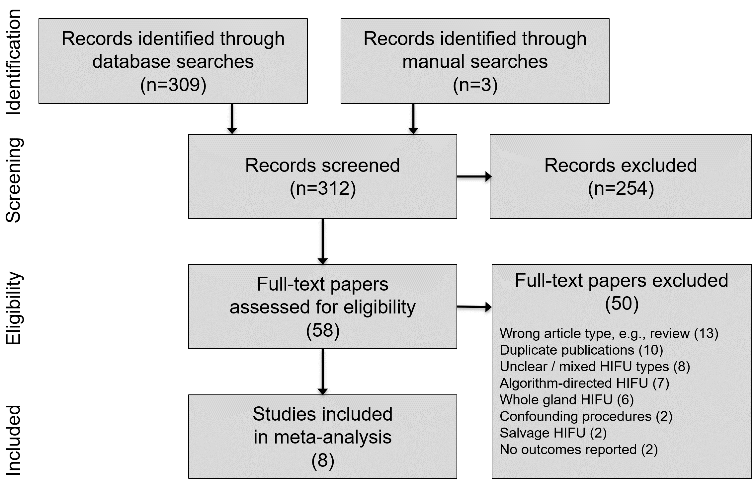
Supplement Figure 1. PRISMA study flow diagram.

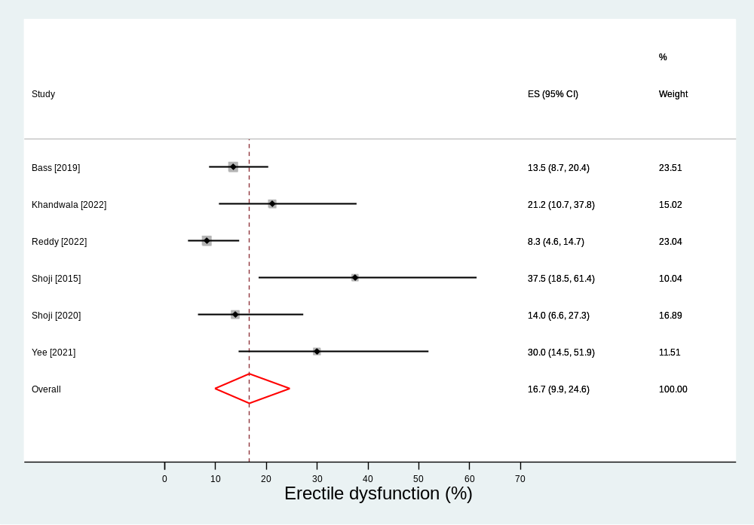
Supplement Figure 2. Weighted event rate of de novo erectile dysfunction after focal treatment for localized prostate cancer using visually-directed high-intensity focused ultrasound. Event rate=16.7% (95% CI: 9.9% to 24.6%); Heterogeneity: I²=63%.

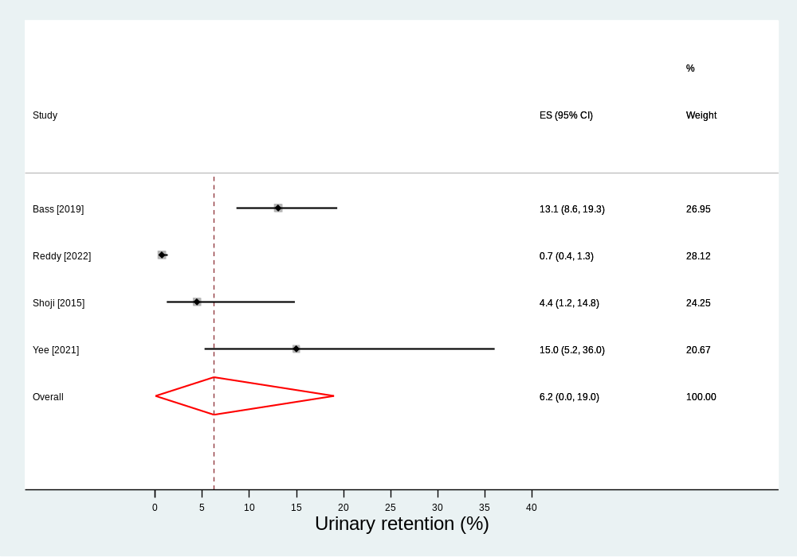
Supplement Figure 3. Weighted event rate of urinary retention after focal treatment for localized prostate cancer using visually-directed high-intensity focused ultrasound. Event rate=6.2% (95% CI: 0.0% to 19.0%); Heterogeneity: I²=95%.

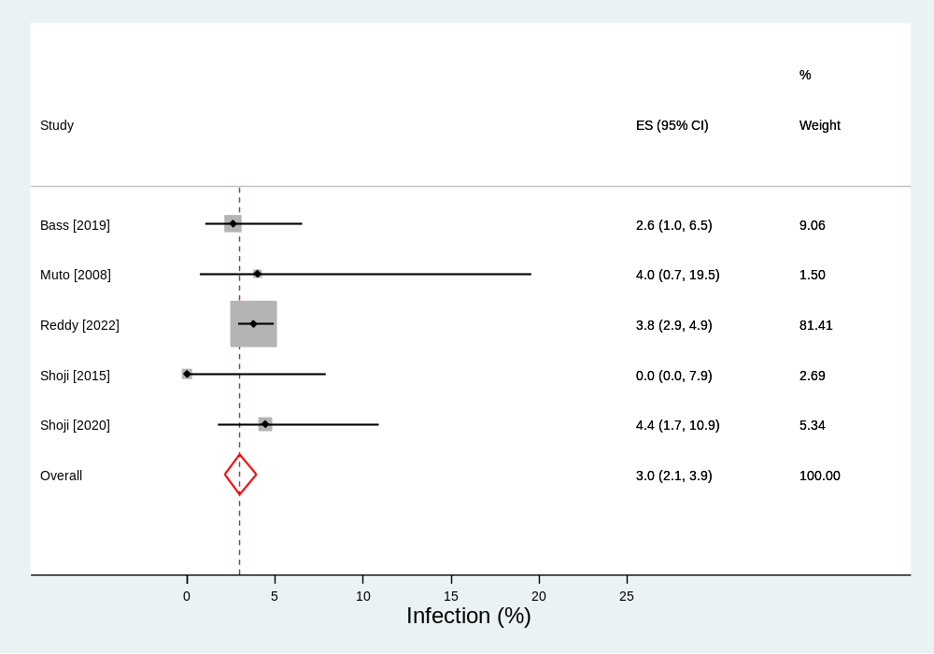
Supplement Figure 4. Weighted event rate of urinary tract infection after focal treatment for localized prostate cancer using visually-directed high-intensity focused ultrasound. Event rate=3.0% (95% CI: 2.1% to 3.9%); Heterogeneity: I²=0%.

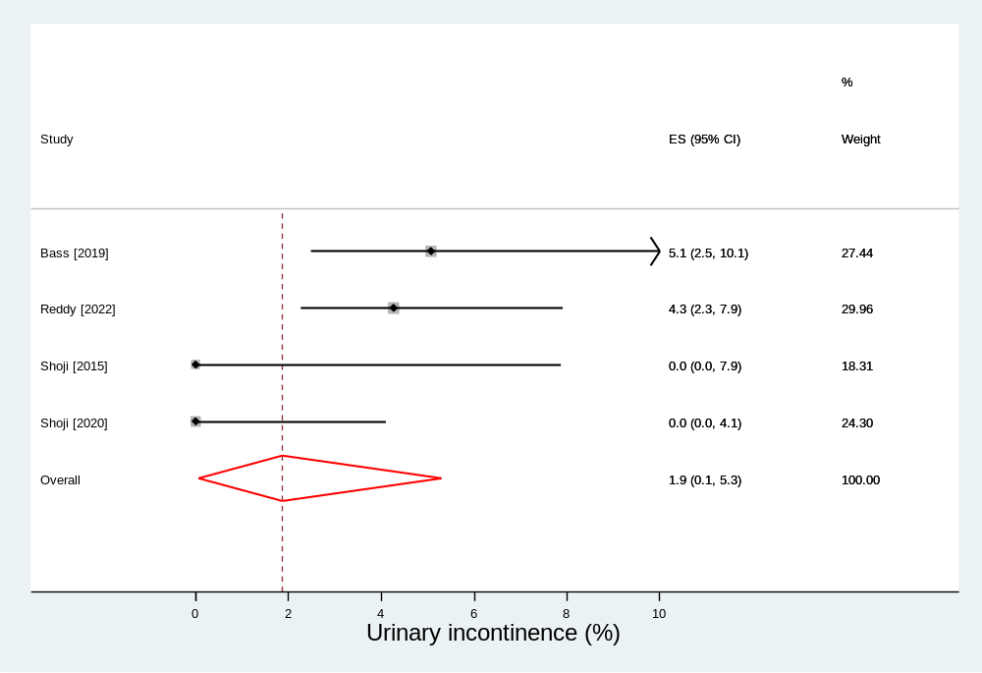
Supplement Figure 5. Weighted event rate of urinary incontinence after focal treatment for localized prostate cancer using visually-directed high-intensity focused ultrasound. Event rate=1.9% (95% CI: 0.1% to 5.3%); Heterogeneity: I²=71%.

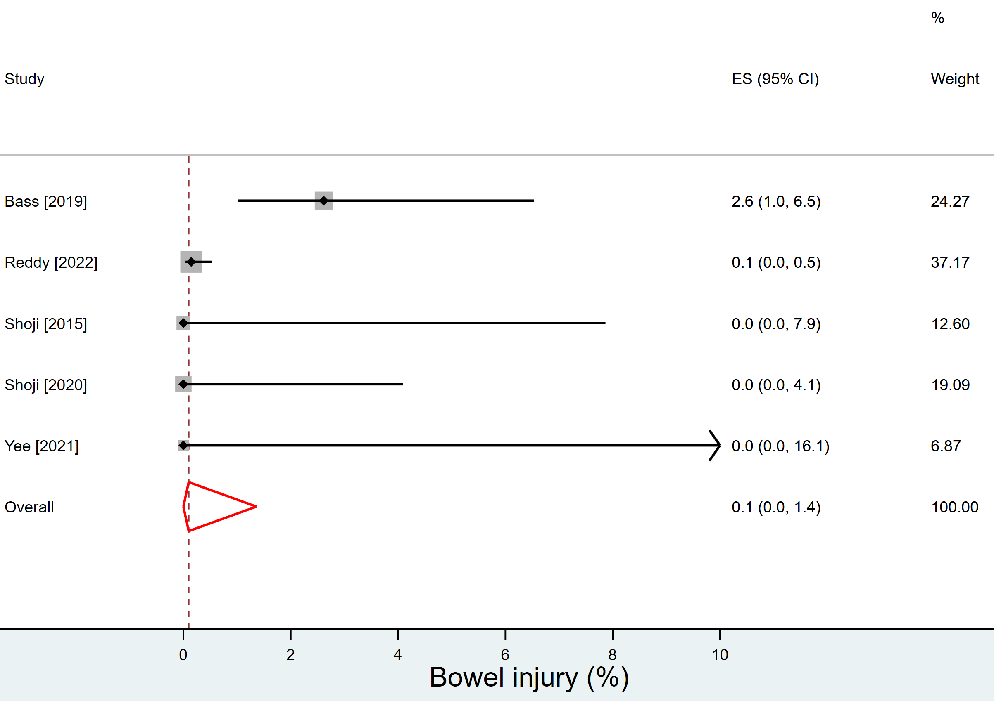
Supplement Figure 6. Weighted event rate of bowel injury after focal treatment for localized prostate cancer using visually-directed high-intensity focused ultrasound. Event rate=0.1% (95% CI: 0.0% to 1.4%); Heterogeneity: I²=66%.

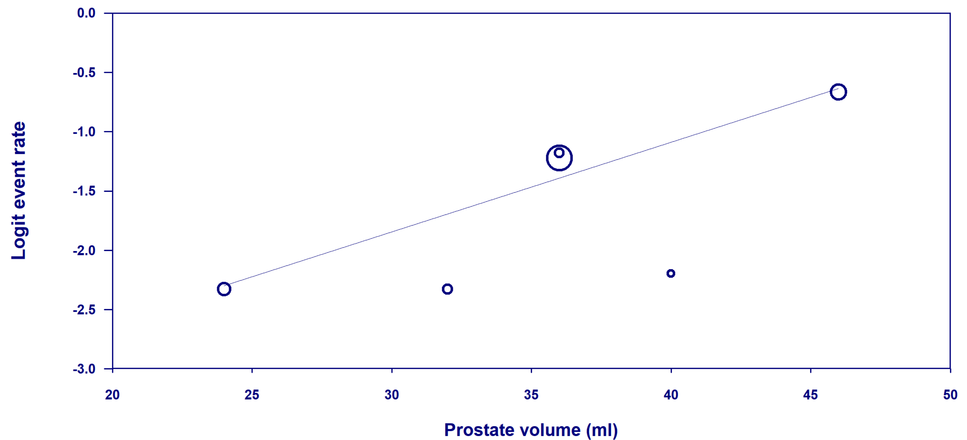
Supplement Figure 7. Bubble plot of the association between prostate volume and the logit event rate of clinically significant positive biopsy after focal treatment for localized prostate cancer using visually-directed high-intensity focused ultrasound. Open circles represent values of individual studies where the circle size is proportional to the study weight in the random-effects model. The line represents the regression line of best fit. P-value for association = 0.002. Logit event rates of 0, -1, -2, and -3 equate to probabilities of 50%, 27%, 12%, and 5%, respectively.

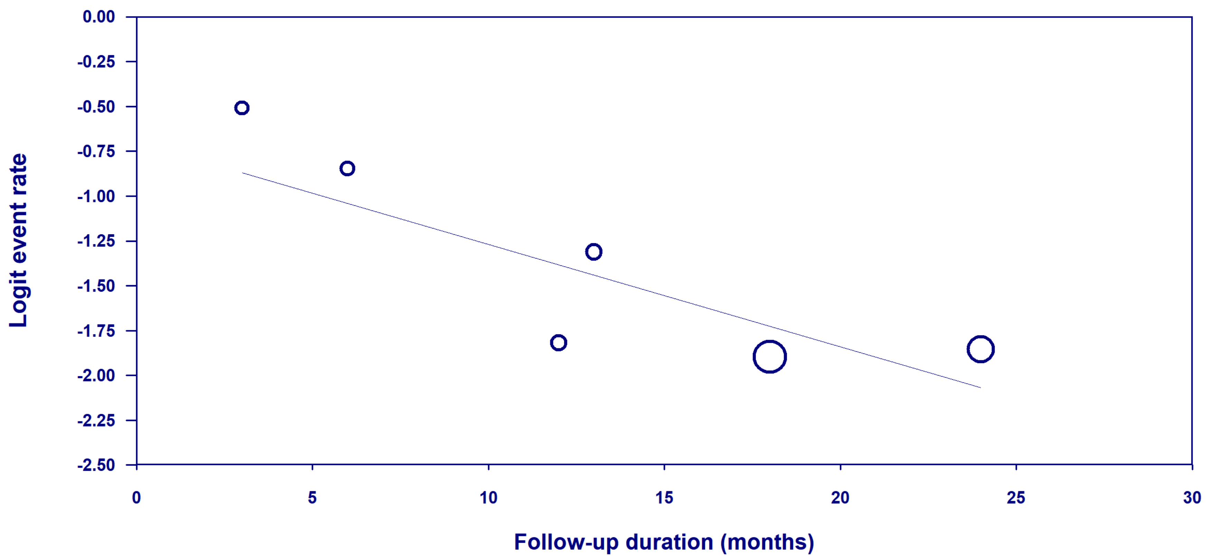
Supplement Figure 8. Bubble plot of the association between follow-up duration and the logit event rate of de novo erectile dysfunction after focal treatment for localized prostate cancer using visually-directed high-intensity focused ultrasound. Open circles represent values of individual studies where the circle size is proportional to the study weight in the random-effects model. The line represents the regression line of best fit. P-value for association = 0.007. Logit event rates of 0, -1, and -2 equate to probabilities of 50%, 27%, and 12%, respectively.

