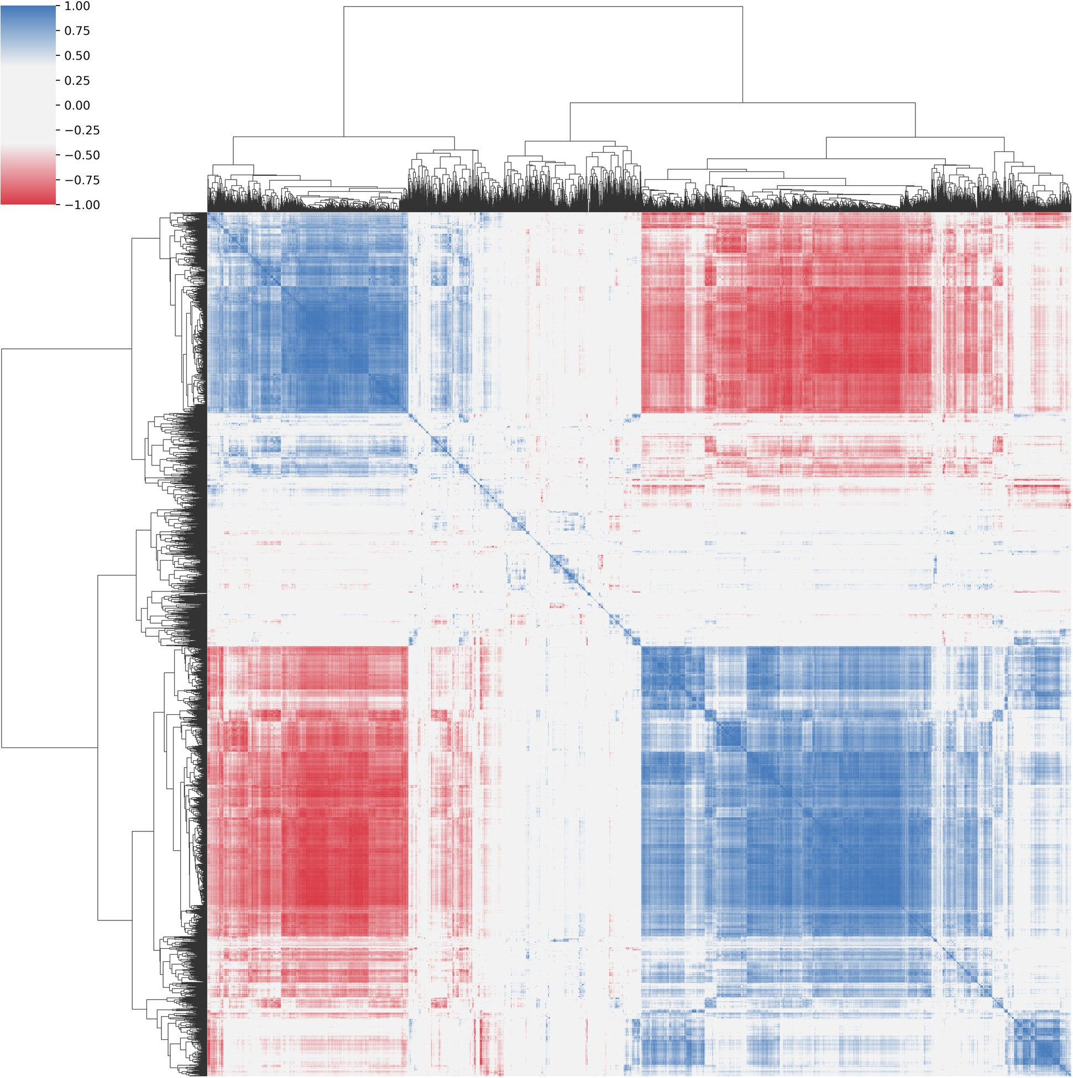

Supplementary Figure 5: Visualization of feature correlations through a heat map. The heat map exhibits symmetry about the diagonal. A value of -1 (deep blue) indicates a complete negative linear correlation, 0 (white) denotes no correlation, and +1 (deep red) signifies a complete positive correlation.

