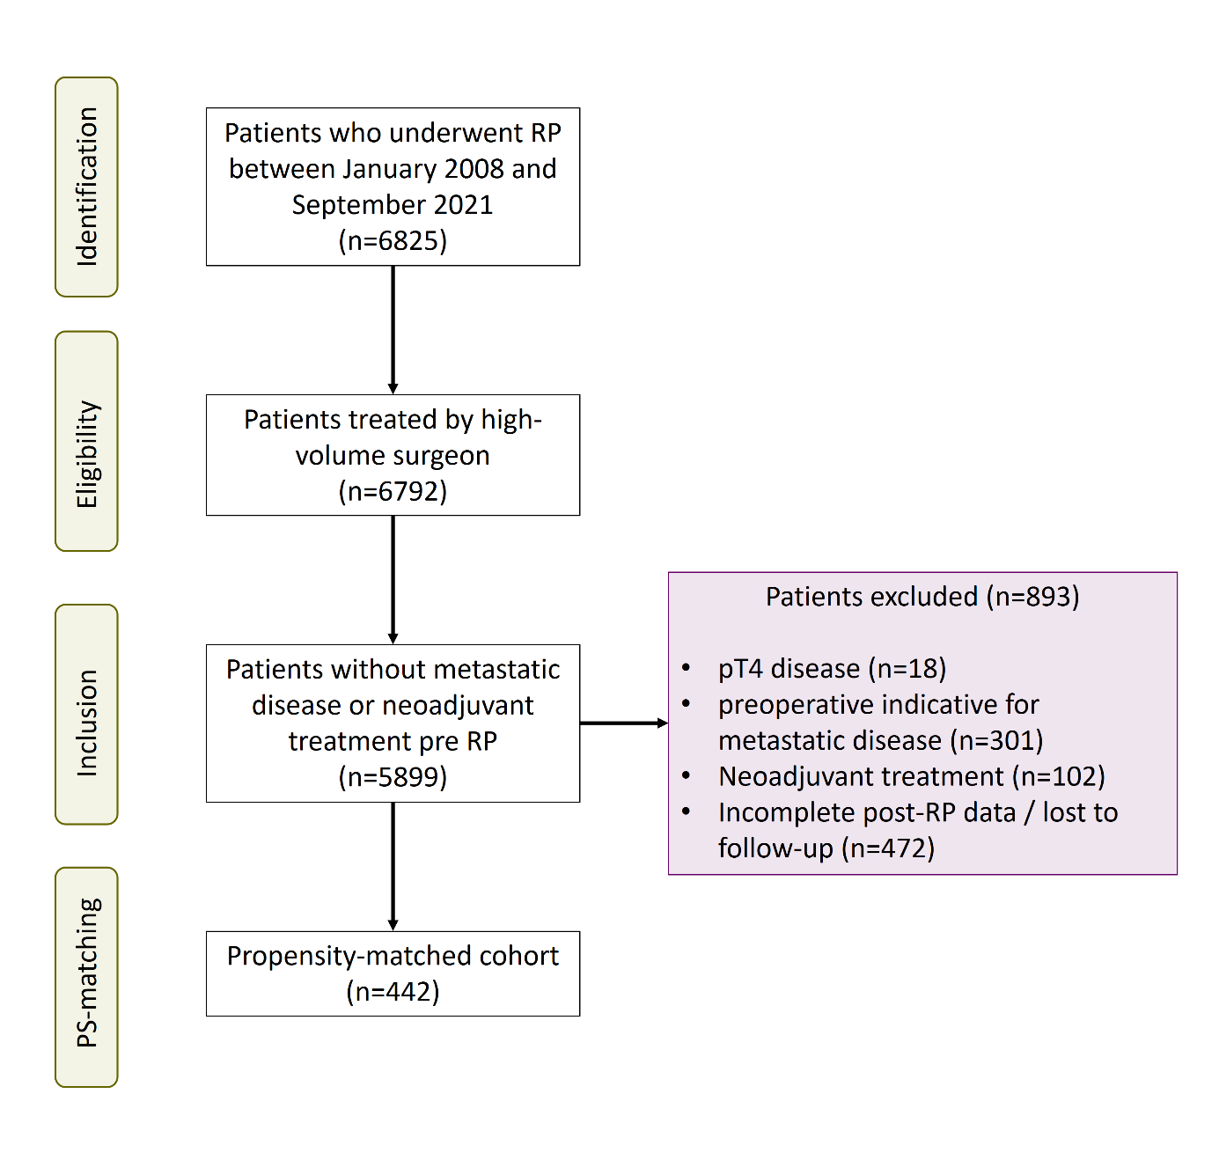
Suppl. Figure 1. Flow chart summarizing the inclusion process for eligible subjects including the propensity score (PS) matched cohorts of the current study (RP = radical prostatectomy).

