Supplementary materials
Enzalutamide versus abiraterone acetate in the development of new-onset or worsening type 2 diabetes mellitus in patients with metastatic castration-resistant prostate cancer: EVADE study Amit Bahlª, Hanna Sodatonou^{b*}, Robert Snjider^{b}, Andrew Chilelli^{b}, Alessandra Pranzo^{b}, Karla Martins^{b}, Axel Merseburger^{c}, Nigel Rozario^{b}, Danielle Crawley^{d,e}
ªBristol Haematology and Oncology Centre, University Hospitals Bristol NHS Foundation, Bristol, UK
^{b}Astellas Pharma Europe Ltd., Surrey, UK
^{c}University Hospital Schleswig-Holstein, Lübeck, Germany
^{d}Medical Oncology, Guy’s and St Thomas’ NHS Foundation Trust, London, UK
^{e}Translational Oncology Urology Research Group, King’s College London, UK
*Corresponding author. hanna.sodatonou@iqvia.com
Contents | Page number
Supplementary methods | 2
Supplementary Figure 1.  Patient attrition | 4
Supplementary Figure 2.  Partial-view Kaplan–Meier estimates of new-onset and worsening T2DM | 5
Supplementary Table 1.  Baseline clinical and demographic characteristics of the study population | 6
Supplementary Table 2.  Secondary endpoints: treatment exposure and persistence of treatment | 8

Supplementary methods

Assessment of endpoints
The primary outcome was either a new-onset type 2 diabetes mellitus (T2DM) case or T2DM disease progression in patients with T2DM at baseline, occurring between the index and exit dates.
Patients were classified as having new-onset T2DM if they did not have T2DM at the index date (date of initiation of androgen receptor pathway inhibitor [ARPI] therapy), but subsequently developed it during the follow-up period. For new-onset T2DM cases, the entire patient history was used to confirm the incident case. Any primary care prescription of antidiabetic medication coded (in the GOLD or Aurum databases) as any of the following was used as indirect evidence (proxy) of the onset of a problem with glucose metabolism, including diabetes mellitus: biguanides, sulfonylureas, meglitinides, alpha-glucosidase inhibitors, thiazolidinediones, glucagon-like peptide 1 receptor agonists, amylin analogue, dipeptidyl peptidase 4 inhibitors, insulins, and sodium-glucose cotransporter-2 inhibitors.
Patients were classified as having worsening of T2DM (deterioration of T2DM control) if they had T2DM at index date (i.e. they were on antidiabetic medication at the time of initiation of ARPI therapy or had a confirmed T2DM diagnosis) and required treatment intensification during their time in the study. Intensification was either a shift from conservative management (no treatment) to first-line treatment or progression through the National Institute for Health and Care Excellence (NICE) treatment pathway ([NICE Guidance NG28, 2015) for T2DM. Patients with conservative management at diagnosis (no treatment) were checked for initiation of first-line T2DM treatment post-index. Patients could experience worsening T2DM more than once during follow-up. For example, a patient could enter the study free of T2DM, develop T2DM as an incident case (first occurrence of the outcome), be treated with antidiabetic medication X, and later switch to antidiabetic medication Y (second occurrence of the outcome). The figure below outlines the possible disease evolution during follow-up, as well as potential outcomes observed.
Worsening/change in T2DM
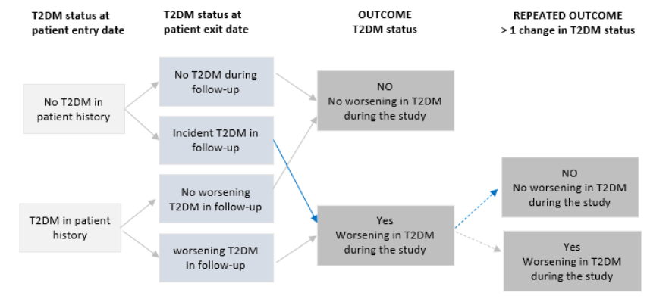

Subgroup analysis by HbA1c
A subgroup analysis was performed to evaluate changes in HbA_{1c} measurements to further characterise T2DM deterioration between exposure groups. This analysis included patients with at least two HbA_{1c} measures – one before and one after the index date. Using the cut-offs 42 and 48 mmol/mol, the HbA_{1c} outcome was categorized as normal (<42 mmol/mol), pre-diabetes (42–47 mmol/mol), and diabetes (≥48 mmol/mol). Progression or worsening was defined as a move from one status to the next. In the HbA_{1c} analysis, a patient could have a maximum of two progression events.

Calculation of persistence
Persistence was calculated separately for enzalutamide (ENZA) and abiraterone acetate (AA) from the earliest date of treatment to the date that treatment ended or the earliest date among the end of the study, the last data collection date, the date of transfer out of the general physician’s practice, and death. Persistence was calculated using methodology developed specifically for the Systematic Anti-Cancer Therapy database. The earliest treatment date was subtracted from the last date of administration, with the standard prescription length of 28 days added to this result. The date following which there were no further prescriptions was considered the discontinuation date.

Variables in the COX regression models
The full Cox proportional hazards model initially considered a comprehensive range of variables, including treatment duration, cardiovascular disease history, hypertension, body mass index (BMI), frequency of HbA_{1c} testing, cholesterol levels, age, ethnicity, smoking status at the index date, androgen-deprivation therapy presence and duration, prior or current steroid use, and taxane use. However, to improve the parsimony of the model and focus on the most impactful predictors, a reduced model was employed. This included BMI, race/ethnicity, and T2DM status at the index date, as these were determined to be the most significant factors in relation to the outcomes being studied.

Supplementary Figure 1. Patient attrition
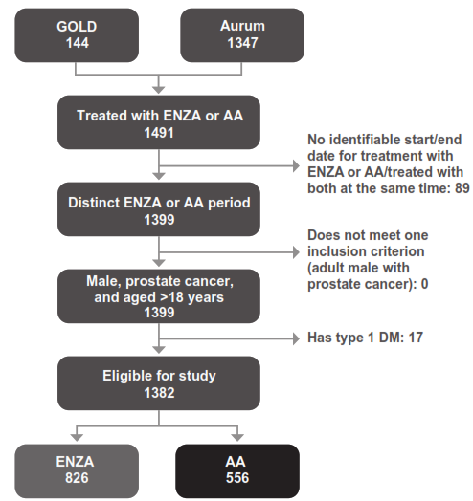

Supplementary Figure 2. Partial-view Kaplan–Meier estimates of new-onset and worsening T2DM
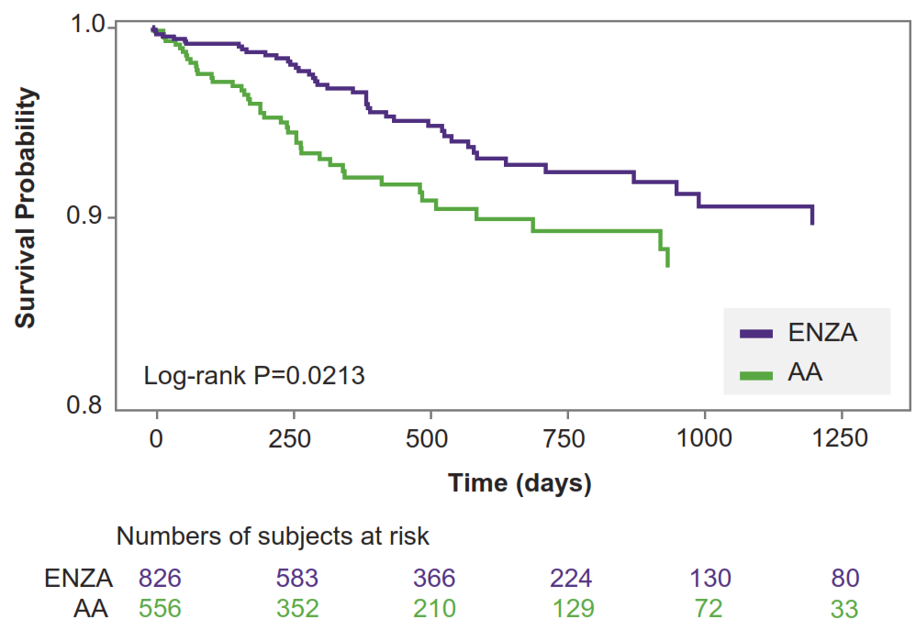

Supplementary Table 1. Baseline clinical and demographic characteristics of the study population
 | All patients |  |  | Patients without T2DM at baseline |  |  | Patients with T2DM at baseline
 | ENZA  n = 826 | AA  n = 556 | Total  N = 1382 | ENZA  n = 609 | AA  n = 440 | Total  N = 1049 | ENZA  n = 217 | AA  n = 116 | Total  N = 333
Age, years, mean (SD) | 72.4 (9.1) | 73.2 (9.1) | 72.7 (9.1) | 72.1 (9.1) | 73.0 (9.1) | 72.4 (9.1) | 73.1 (9.1) | 74.3 (8.9) | 73.5 (9.0)
Age group, n (%)
<60 years | 69 (8.4) | 47 (8.5) | 116 (8.4) | 54 (8.9) | 38 (8.6) | 92 (8.8) | 15 (6.9) | 9 (7.8) | 24 (7.2)
60–69 years | 212 (25.7) | 151 (27.2) | 363 (26.3) | 163 (26.8) | 122 (27.7) | 285 (27.2) | 49 (22.6) | 29 (25.0) | 78 (23.4)
>70 years | 545 (66.0) | 358 (64.4) | 903 (65.3) | 392 (64.4) | 280 (63.6) | 672 (64.1) | 153 (70.5) | 78 (67.2) | 231 (69.4)
Ethnicity, n (%)
White | 726 (87.9) | 504 (90.6) | 1230 (89.0) | 558 (91.6) | 408 (92.7) | 966 (92.1) | 168 (77.4) | 96 (82.8) | 264 (79.3)
Mixed | 6 (0.7) | 4 (0.7) | 10 (0.7) | 6 (1.0) | 4 (0.9) | 10 (1.0) | 0 (0) | 0 (0) | 0 (0)
Asian/Asian British | 17 (2.1) | 7 (1.3) | 24 (1.7) | 3 (0.5) | 3 (0.7) | 6 (0.6) | 14 (6.5) | 4 (3.4) | 18 (5.4)
Black/African/ Caribbean/  Black British | 38 (4.6) | 24 (4.3) | 62 (4.5) | 14 (2.3) | 14 (3.2) | 28 (2.7) | 24 (11.1) | 10 (8.6) | 34 (10.2)
Other | 30 (3.6) | 16 (2.9) | 46 (3.3) | 20 (3.3) | 10 (2.3) | 30 (2.9) | 10 (4.6) | 6 (5.2) | 16 (4.8)
Missing | 9 (1.1) | 1 (0.2) | 10 (0.7) | 8 (1.3) | 1 (0.2) | 9 (0.9) | 1 (0.5) | 0 (0) | 1 (0.3)
Smoking status, n (%)
Current smoker | 133 (16.1) | 80 (14.4) | 213 (15.4) | 92 (15.1) | 64 (14.5) | 156 (14.9) | 41 (18.9) | 16 (13.8) | 57 (17.1)
Ex-smoker | 227 (27.5) | 143 (25.7) | 370 (26.8) | 162 (26.6) | 114 (25.9) | 276 (26.3) | 65 (30.0) | 29 (25.0) | 94 (28.2)
Never | 427 (51.7) | 307 (55.2) | 734 (53.1) | 326 (53.5) | 243 (55.2) | 569 (54.2) | 101 (46.5) | 64 (55.2) | 165 (49.5)
Missing | 39 (4.7) | 26 (4.7) | 65 (4.7) | 29 (4.8) | 19 (4.3) | 48 (4.6) | 10 (4.6) | 7 (6.0) | 17 (5.1)
HbA_{1c} categoriesª n (%)
Normal | 111 (13.4) | 67 (12.1) | 178 (12.9) | 87 (14.3) | 55 (12.5) | 142 (13.5) | 24 (11.1) | 12 (10.3) | 36 (10.8)
Pre-diabetes | 48 (5.8) | 30 (5.4) | 78 (5.6) | 20 (3.3) | 14 (3.2) | 34 (3.2) | 28 (12.9) | 16 (13.8) | 44 (13.2)
Diabetes | 60 (7.3) | 24 (4.3) | 84 (6.1) | 3 (0.5) | 0 (0) | 3 (0.3) | 57 (26.3) | 24 (20.7) | 81 (24.3)
Missing | 607 (73.5) | 435 (78.2) | 1042 (75.4) | 499 (81.9) | 371 (84.3) | 870 (82.9) | 108 (49.8) | 64 (55.2) | 172 (51.7)
Cholesterol
LDL, mean (SD) | 103.7 (35.98) | 105.6 (34.74) | 104.5 (35.48) | 109.6 (35.00) | 107.3 (34.49) | 108.6 (34.78) | 89.6 (34.45) | 100.2 (35.15) | 93.4 (35.02)
LDL Missing | 202 (24.5) | 127 (22.8) | 329 (23.8) | 168 (27.6) | 114 (25.9) | 282 (26.9) | 34 (15.7) | 13 (11.2) | 47 (14.1)
HDL, mean (SD) | 51.3 (14.11) | 54.2 (16.86) | 52.5 (15.33) | 52.9 (14.38) | 54.7 (17.56) | 53.6 (15.81) | 47.5 (12.64) | 52.6 (14.21) | 49.3 (13.41)
HDL missing | 111 (13.4) | 76 (13.7) | 187 (13.5) | 98 (16.1) | 70 (15.9) | 168 (16.0) | 13 (6.0) | 6 (5.2) | 19 (5.7)
Total cholesterol, mean (SD) | 183.0 (39.48) | 186.3 (48.53) | 184.4 (43.62) | 188.0 (39.69) | 186.4 (46.06) | 187.3 (42.56) | 165.4 (33.54) | 185.6 (58.37) | 173.6 (46.08)
Total cholesterol Missing | 623 (75.4) | 399 (71.8) | 1022 (74.0) | 451 (74.1) | 314 (71.4) | 765 (72.9) | 172 (79.3) | 85 (73.3) | 257 (77.2)
Comorbidities
Cardiovascular disease^{b} | 329 (39.8) | 212 (38.1) | 541 (39.1) | 233 (38.3) | 164 (37.3) | 397 (37.8) | 96 (44.2) | 48 (41.4) | 144 (43.2)
Hypertension | 391 (47.3) | 240 (43.2) | 631 (45.7) | 250 (41.1) | 175 (39.8) | 425 (40.5) | 141 (65.0) | 65 (56.0) | 206 (61.9)
Angina or ischaemia | 151 (18.3) | 98 (17.6) | 249 (18.0) | 97 (15.9) | 72 (16.4) | 169 (16.1) | 54 (24.9) | 26 (22.4) | 80 (24.0)
BMI, mean (SD) | 27.7 (4.86) | 26.9 (4.86) | 27.4 (4.88) | 27.2 (4.71) | 26.7 (4.53) | 27.0 (4.64) | 29.2 (4.97) | 27.8 (5.84) | 28.7 (5.32)
BMI categories
Normal BMI ≤25 | 236 (28.6) | 176 (31.7) | 412 (29.8) | 197 (32.3) | 140 (31.8) | 337 (32.1) | 39 (18.0) | 36 (31.0) | 75 (22.5)
Overweight  25 < BMI < 30 | 320 (38.7) | 227 (40.8) | 547 (39.6) | 235 (38.6) | 180 (40.9) | 415 (39.6) | 85 (39.2) | 47 (40.5) | 132 (39.6)
Obese  30 ≤ BMI < 40 | 199 (24.1) | 109 (19.6) | 308 (22.3) | 118 (19.4) | 83 (18.9) | 201 (19.2) | 81 (37.3) | 26 (22.4) | 107 (32.1)
Severe obese BMI ≥40 | 17 (2.1) | 4 (0.7) | 21 (1.5) | 10 (1.6) | 1 (0.2) | 11 (1.0) | 7 (3.2) | 3 (2.6) | 10 (3.0)
Missing | 54 (6.5) | 40 (7.2) | 94 (6.8) | 49 (8.0) | 36 (8.2) | 85 (8.1) | 5 (2.3) | 4 (3.4) | 9 (2.7)
ªLast measurement available prior to the index date. Normal: <42 mmol/mol, pre-diabetes: 42–48 mmol/mol, diabetes: >48 mmol/mol.
^{b}Not including hypertension, angina, and ischaemia.
The total may not be 100% for the categorial variables due to missing information.
AA: abiraterone acetate; BMI: body mass index; ENZA: enzalutamide; HbA_{1c}: haemoglobin A1C; HDL: high-density lipoprotein cholesterol; LDL: low-density lipoprotein cholesterol; SD: standard deviation; T2DM: type 2 diabetes mellitus.

Supplementary Table 2. Secondary endpoints: treatment exposure and persistence of treatment
 | All patients |  |  | Patients without T2DM at baseline |  |  | Patients with T2DM at baseline
 | ENZA  n = 826 | AA  n = 556 | Total  N = 1382 | ENZA  n = 609 | AA  n = 440 | Total  n = 1049 | ENZA  n = 217 | AA  n = 116 | Total  n = 333
Duration of follow-up (days)
Mean (SD) | 573.3 (451.09) | 526.4 (437.06) | 554.3 (445.89) | 570.0 (442.47) | 527.1 (426.26) | 551.8 (435.99) | 582.5 (475.27) | 524.0 (478.21) | 562.1 (476.42)
Median (Q1–Q3) | 445.0 (209.0–793.0) | 408.0 (185.0–768.0) | 432.0 (202.5–790.5) | 452.0 (225.0–792.0) | 417.0 (191.0–764.0) | 436.0 (207.0–788.0) | 439.5 (198.0–813.0) | 335.0 (151.0–828.5) | 414.0 (190.5–814.5)
Duration of AA or ENZA treatment (days)
Mean (SD) | 224.5 (208.98) | 224.7 (236.58) | 224.6 (220.51) | 224.6 (205.21) | 233.6 (244.57) | 228.4 (222.67) | 224.5 (219.67) | 190.7 (200.27) | 212.7 (213.42)
Median (Q1–Q3) | 164.0 (84.0–296.0) | 139.0 (72.0–296.0) | 146.5 (84.0–296.0) | 168.0 (84.0–301.0) | 140.0 (82.0–312.0) | 150.0 (84.0–308.0) | 146.5 (84.0–295.5) | 125.5 (59.0–229.0) | 140.0 (70.0–265.0)
Persistence groups, n (%)
0–3 months | 312 (36.7) | 242 (41.7) | 554 (38.7) | 227 (36.2) | 188 (40.8) | 415 (38.1) | 85 (37.9) | 54 (45.0) | 139 (40.4)
4–6 months | 206 (24.2) | 114 (19.6) | 320 (22.3) | 148 (23.6) | 90 (19.5) | 238 (21.9) | 58 (25.9) | 24 (20.0) | 82 (23.8)
7–12 months | 181 (21.3) | 121 (20.8) | 302 (21.1) | 136 (21.7) | 98 (21.3) | 234 (21.5) | 45 (20.1) | 23 (19.2) | 68 (19.8)
12–24 months | 125 (14.7) | 75 (12.9) | 200 (14.0) | 98 (15.6) | 61 (13.2) | 159 (14.6) | 27 (12.1) | 14 (11.7) | 41 (11.9)
>24 months | 27 (3.2) | 29 (5.0) | 56 (3.9) | 18 (2.9) | 24 (5.2) | 42 (3.9) | 9 (4.0) | 5 (4.2) | 14 (4.1)
Median persistence (days)ª
Median (Q1–Q3) | 176 (85–334 ) | 162 (85–329 ) | 169 (85–333 ) | 188 (86–337 ) | 167 (85–341 ) | 170 (85–337 ) | 169 (85–314 ) | 142 (83–263 ) | 156 (85–293 )
ªPersistence as per time to event Kaplan–Meier analysis, accounting for censoring.
AA: abiraterone acetate; ENZA: enzalutamide; Q1/Q3: quartile 1/3; SD: standard deviation; T2DM: type 2 diabetes mellitus.

