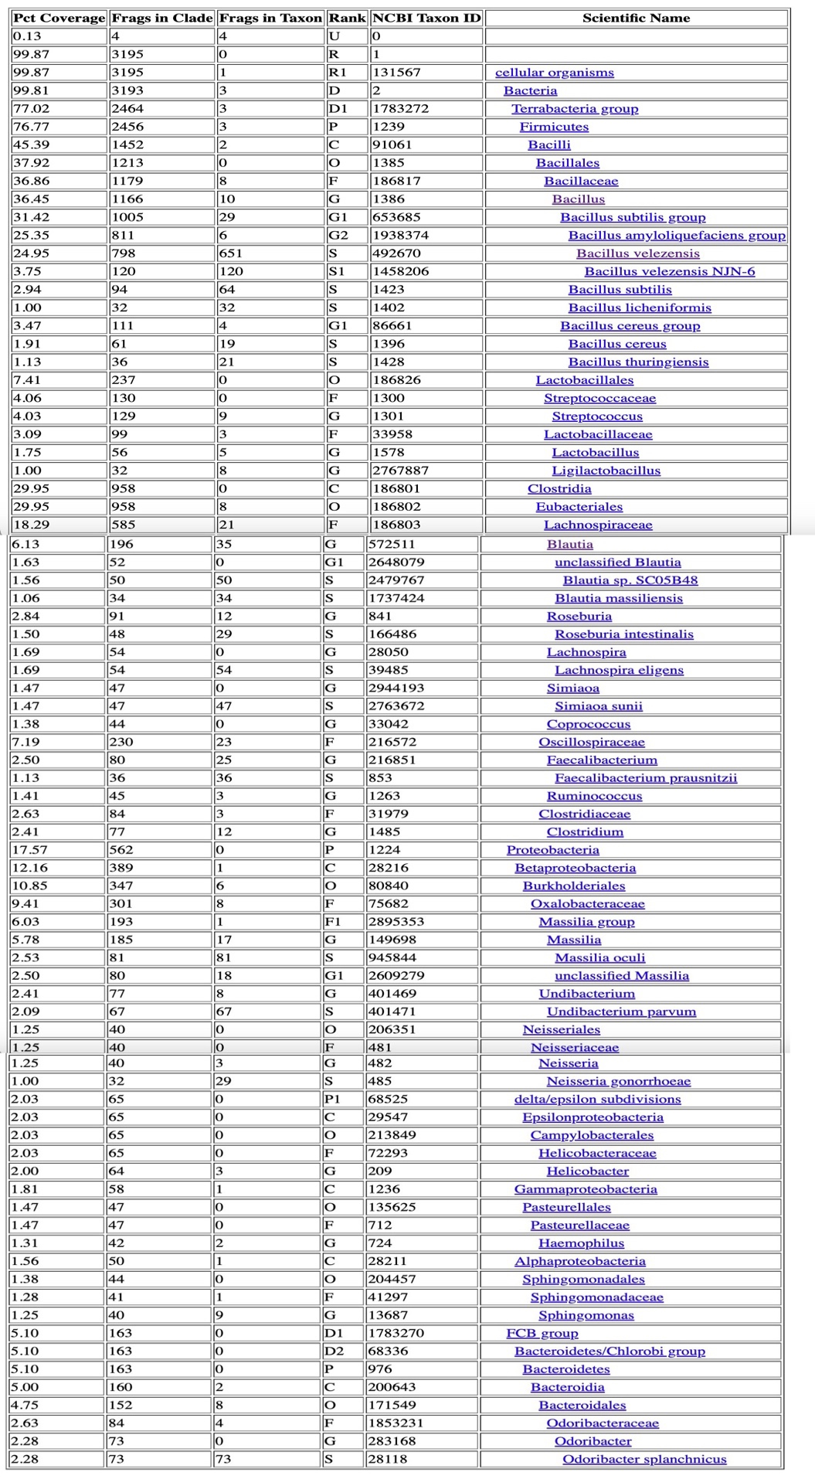
Table 1: Taxonomic Classification Report for group 1. Input data: Single-end Libraries.

Table 2: Taxonomic Classification Report for group 2. Input data: Single-end Libraries.
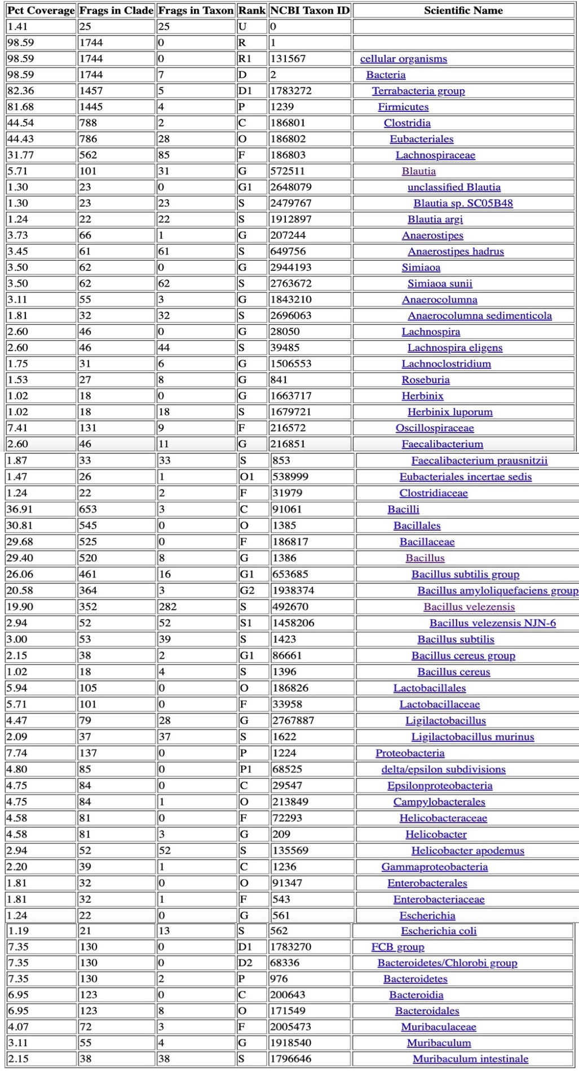

Table 3: Taxonomic Classification Report for group 3. Input data: Single-end Libraries.

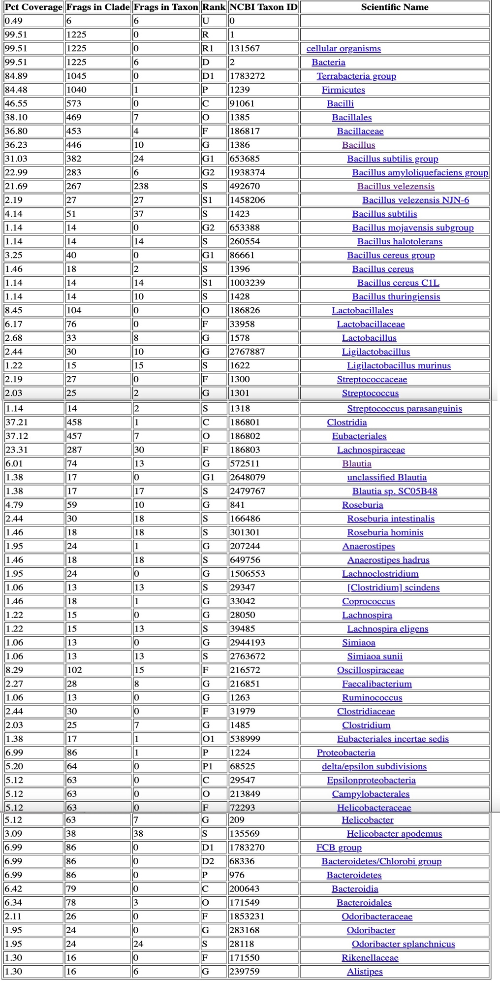

Table 4: Taxonomic Classification Report for control group. Input data: Single-end Libraries.

