Table S1: Search Strategy
Database | Search string | Records
PubMed/MEDLINE | (tamsulosin AND tadalafil) AND (benign prostatic hyperplasia OR BPH OR enlarged prostate) AND ("randomized controlled trial"[Publication Type] OR "randomized controlled trials as topic"[MeSH Terms] OR "RCT"[All Fields]) | 26
Embase | tamsulosin AND tadalafil AND (benign prostatic hyperplasia OR BPH OR enlarged prostate) | 360
Cochrane Library | (tamsulosin AND tadalafil) AND (benign prostatic hyperplasia OR BPH OR enlarged prostate) AND ("randomized controlled trial" OR "RCT") | 38

Figure S1: Risk of bias assessment of included studies
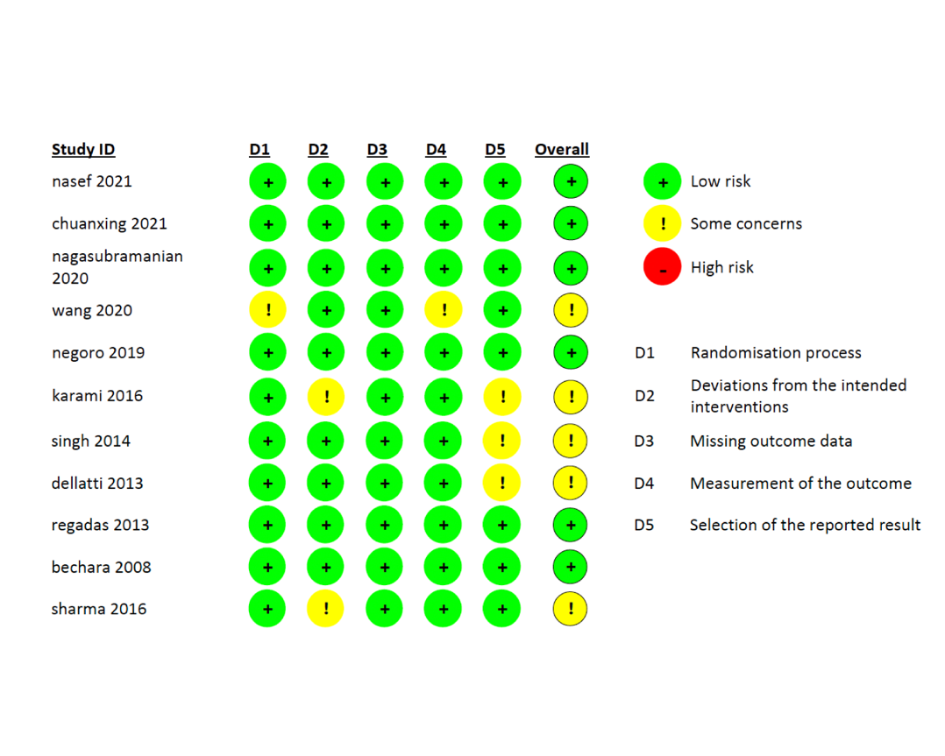

Figure S2: Leave-one-out sensitivity analysis for overall IPSS

Figure S3: Funnel plot assessing the risk of publication bias for overall IPSS
Figure S4: Meta-regression plot showing the effect of age on overall IPSS
Figure S5: Meta-regression plot showing the effect of follow-up duration on overall IPSS

Figure S6: Forest plot for IPSS storage score
Figure S7: Forest plot for IPSS voiding score
Figure S8: Leave-one-out sensitivity analysis for IPSS storage subscore
Figure S9: Leave-one-out sensitivity analysis for IIEF
Figure S10: Leave-one-out sensitivity analysis for QoL
Figure S11: Leave-one-out sensitivity analysis for PRV
Figure S12: Funnel plot assessing the risk of publication bias for PRV
Figure S13: Meta-regression plot showing the effect of age on PRV
Figure S14: Meta-regression plot showing the effect of follow-up duration on PRV
Figure S15: Leave-one-out sensitivity analysis for Qmax
Figure S16: Funnel plot assessing the risk of publication bias for Qmax
Figure S17: Meta-regression plot showing the effect of age on Qmax
Figure S18: Meta-regression plot showing the effect of follow-up duration on Qmax
Figure S19: Leave-one-out sensitivity analysis for overall adverse events

