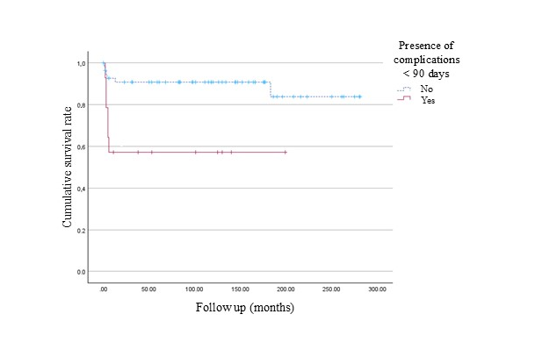
Figure 2. Kaplan-Meier plot of recurrence during follow-up in patients with and without postoperative complications within 90 days

