Appendix A. Images displaying functionality of CVAC 2.0 Device.
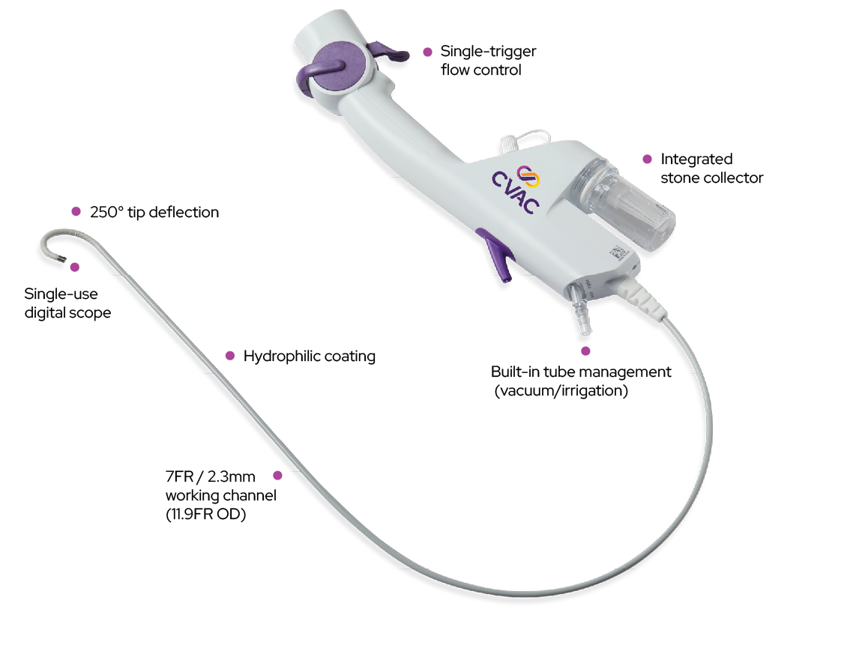 | CVAC 2.0 ureteroscope from https://calyxoinc.com/calyxo-cvac-system/
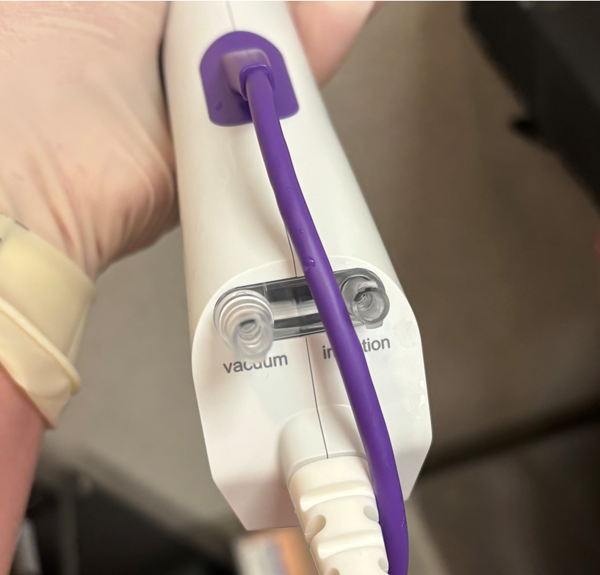 | The scope contains simultaneous (dual) vacuum (aspiration) and irrigation channels.
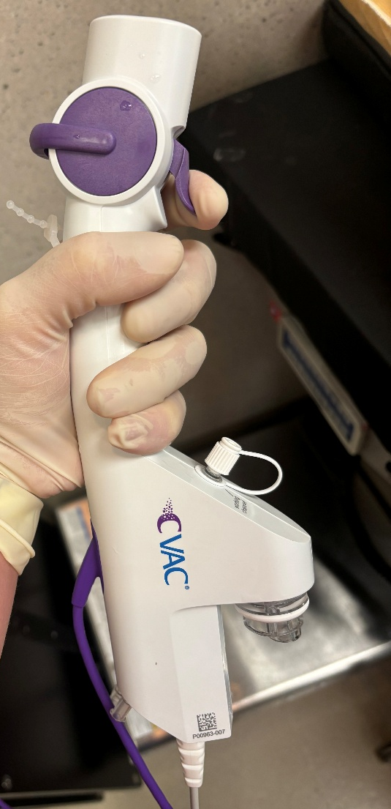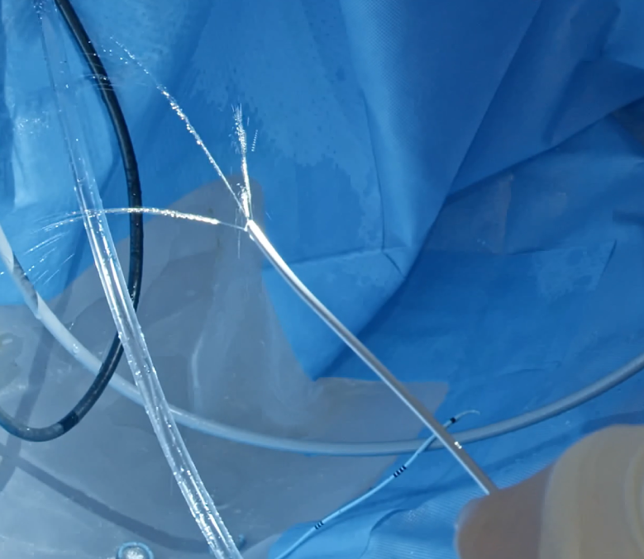 | Compressing the trigger halfway will increase irrigation in 4 streams which can displace fragments and distended a calyx prior to attempting aspiration.
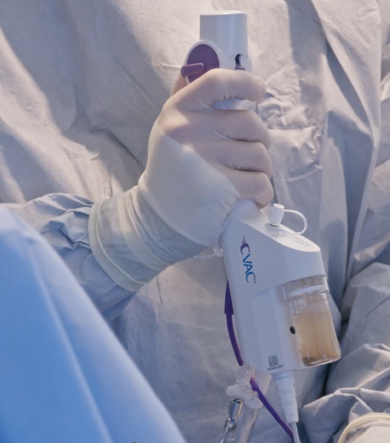 | Fully depressing the trigger allows for active suction and removal of fragments through the 7 Fr working channel and collection in the specimen container. Note the laser stabilization catheter is removed from the working channel for this functionality.
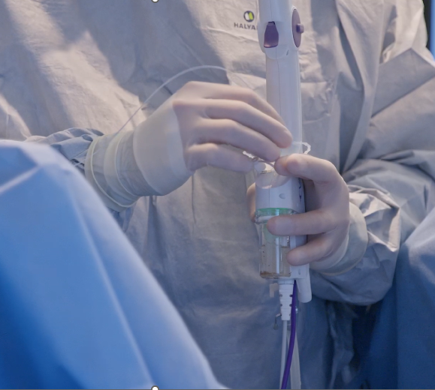 | Introducing the laser stabilization catheter into the working channel. Passive suction of small dust is still ongoing with this in place during lasering.

