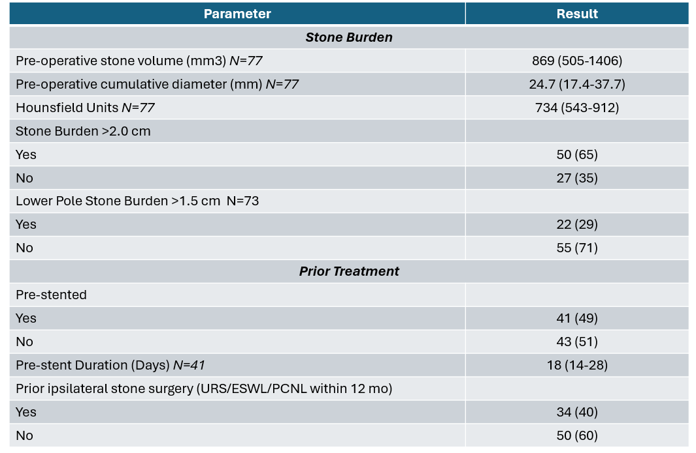
Supplemental Table 1: Pre-operative information who underwent CVAC 2.0 procedure. All continuous variables expressed as median (IQR), while categorical variables expressed as N (%).

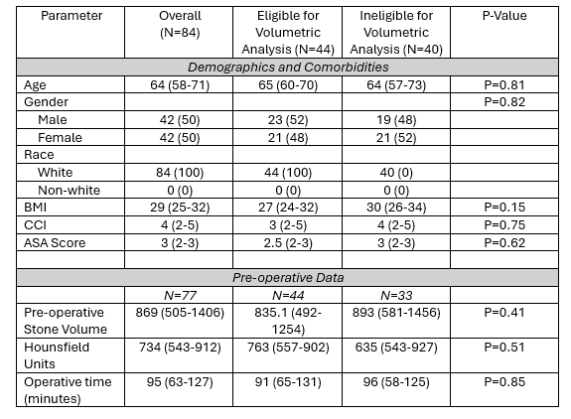
Supplemental Table 2. Comparison of demographic and clinical variables of patients eligible and ineligible for volumetric stone clearance analysis. Analysis includes individuals with eligible pre and post op CTs. All continuous variables expressed as median (IQR), while categorical variables expressed as N (%). Wilcoxon ranked sum test used for continuous variable comparisons and Fisher’s exact test for categorical variables.

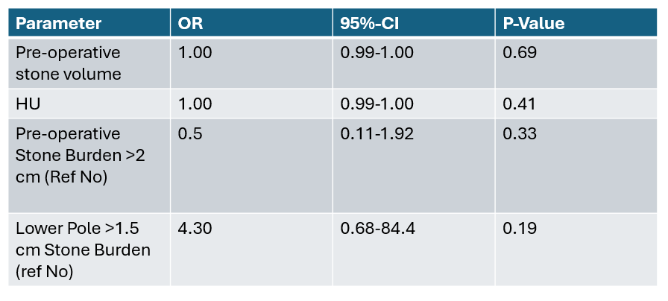
Supplemental Table 3: Univariable Logistic regression assessing for impact on SFR Grade A, B, C status (<4mm residual)

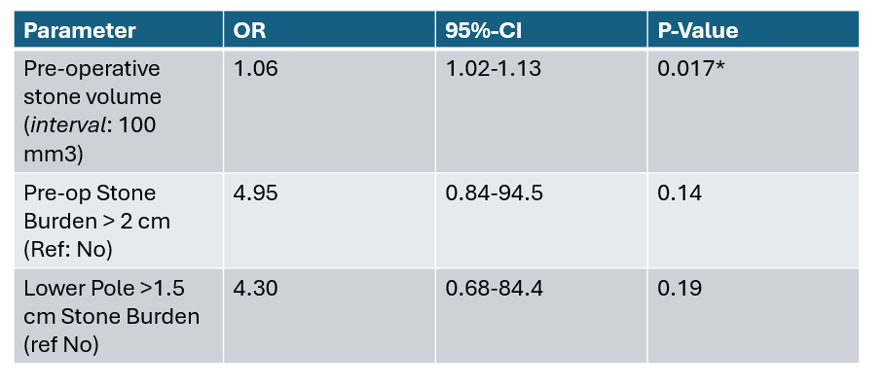
Supplemental Table 4: Logistic regression (univariable) association with staged procedures

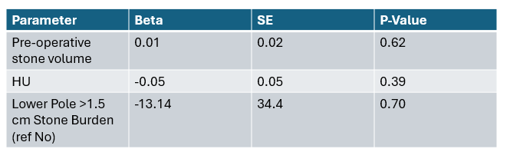
Supplemental Table 5: Univariate Linear regression on correlation with residual stone volume

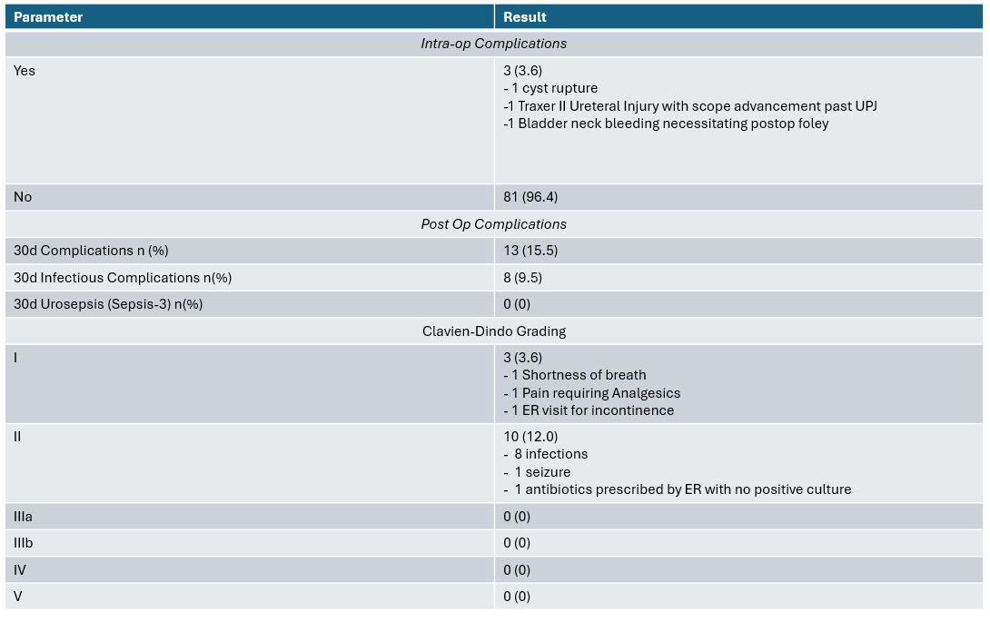
Supplemental Table 6: Safety data and postoperative complications. Categorical variables expressed as N (%).

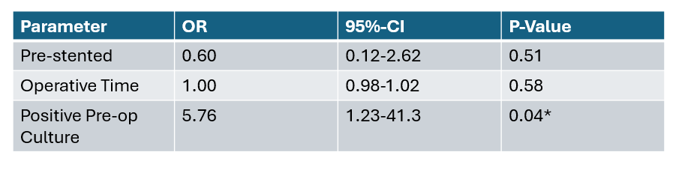
Supplemental Table 7: Logistic regression (univariable) association with 30-day infectious complication

