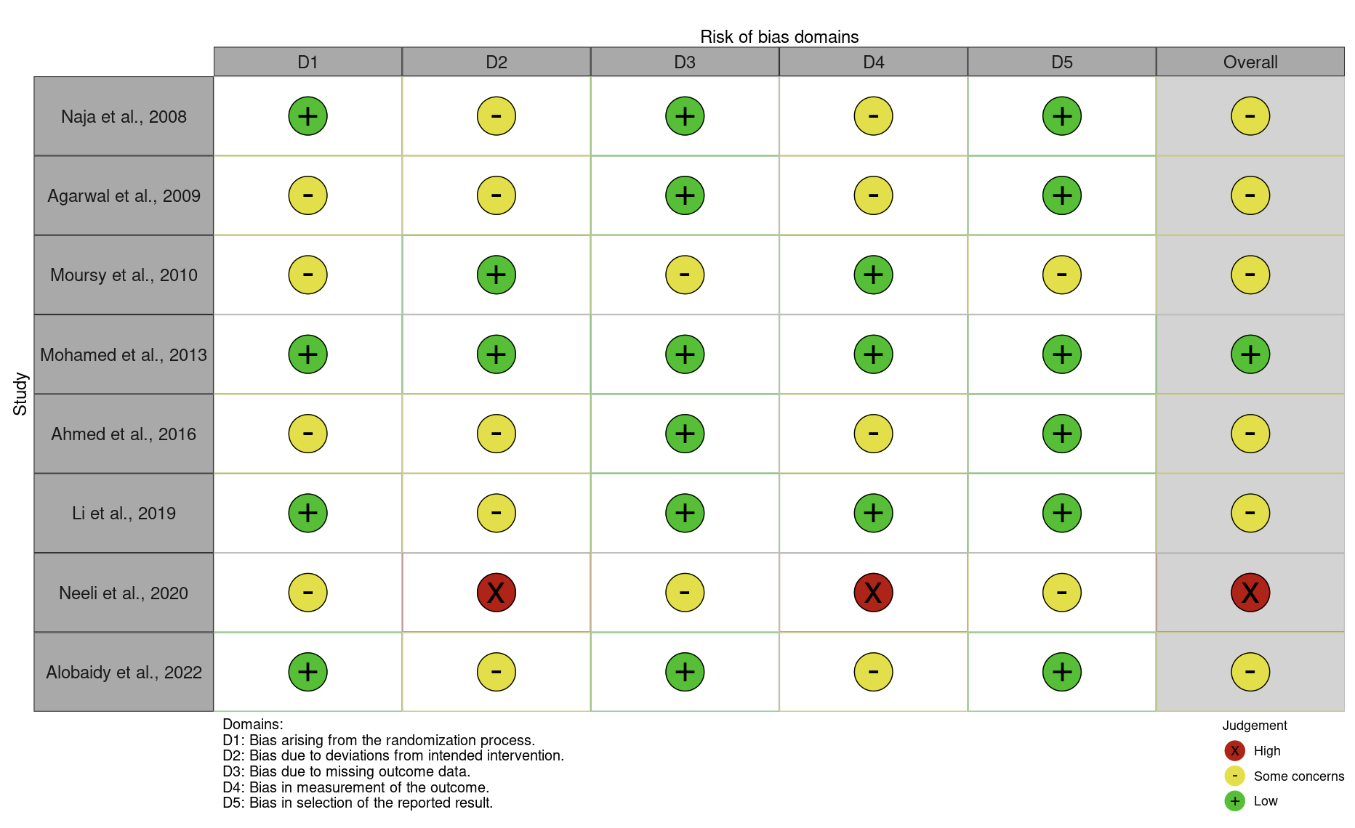
Supplementary Table 1. Risk of Bias assessment of randomized studies of interventions

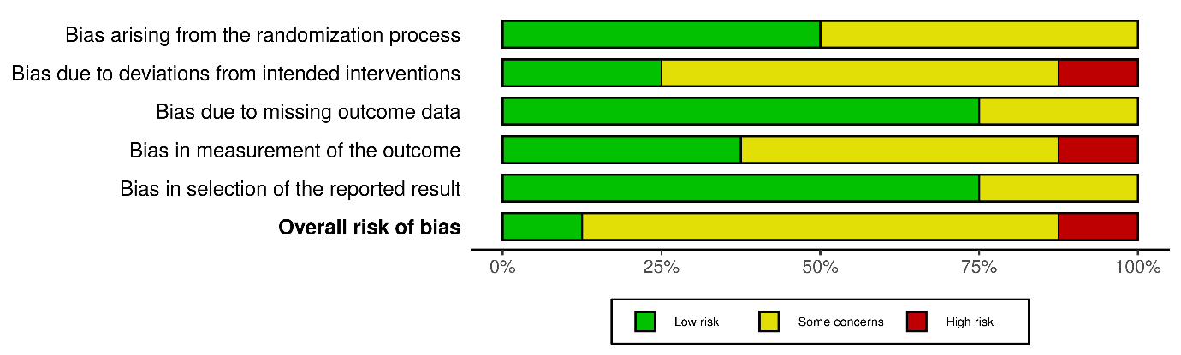

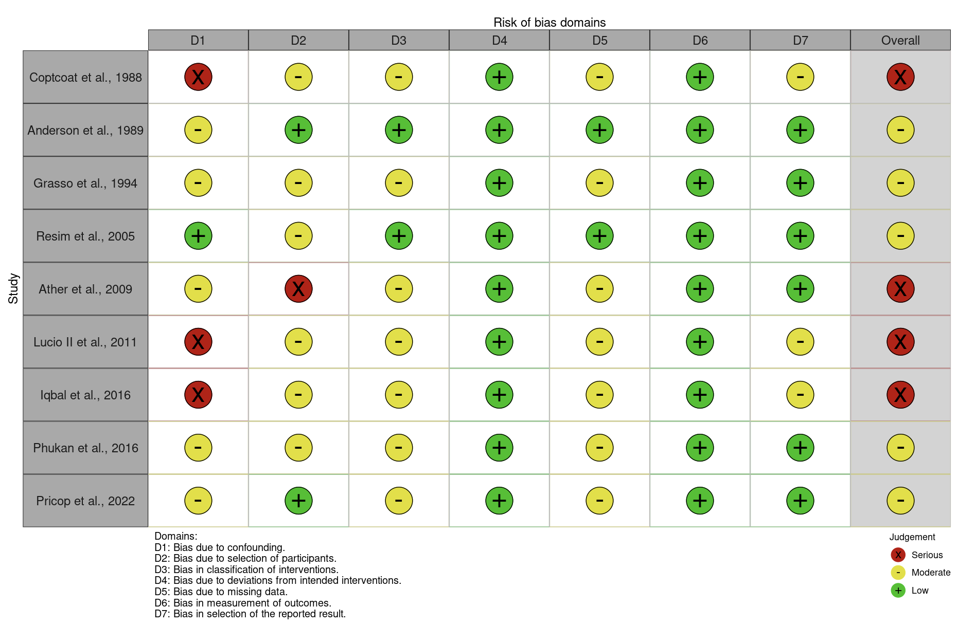
Supplementary Table 2. Risk of Bias assessment of non-randomized studies of interventions

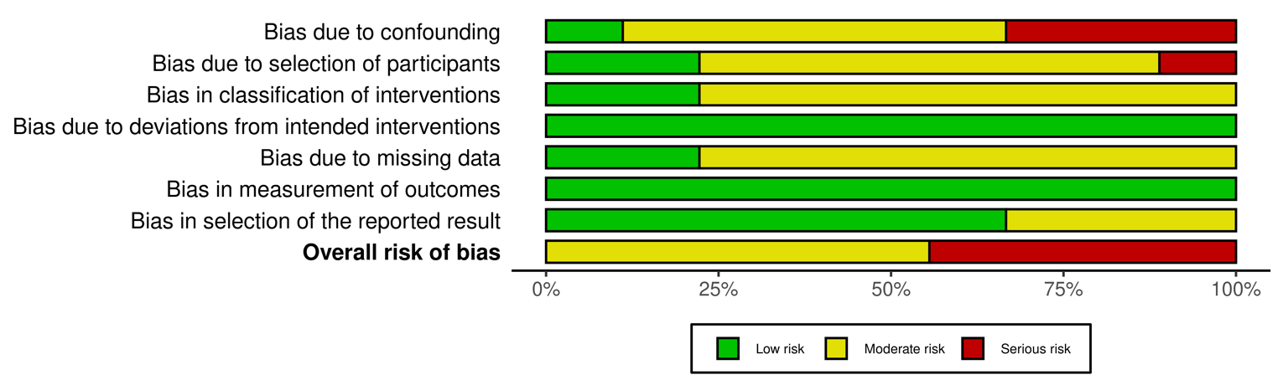

Supplementary Table 3. Risk of Bias assessment of single-arm studies
Author, Year | Was there an a priori protocol? | Was the total population included or were study participants selected consecutively? | Was outcome data complete for all participants and any missing data adequately explained/unlikely to be related to the outcome? | Were all prespecified outcomes of interest and expected outcomes reported? | Were primary benefit and harm outcomes appropriately measured? | RoB low/high
Coptcoat et al., 1986 | No | Yes | No | Yes | Yes | High
Chaussy et al., 1987 | No | No | No | Yes | Yes | High
Böhle et al., 1989 | No | No | No | Yes | Yes | High
Fine et al., 1989 | No | No | No | No | No | High
Weinerth et al., 1989 | No | No | Yes | Yes | Yes | High
Kim et al., 1991 | No | No | No | Yes | Yes | High
Küpeli et al., 1998 | No | No | No | Yes | Yes | High
Sulaiman et al., 1999 | No | No | No | Yes | Yes | High
Sayed et al., 2001 | No | Yes | Yes | Yes | Yes | Low
Madbouly et al., 2002 | No | No | No | Yes | Yes | High
Soyupek et al., 2005 | No | No | No | Yes | Yes | High
Goyal et al., 2006 | No | No | No | Yes | Yes | High
Yoshida et al., 2007 | No | Yes | Yes | No | Yes | Low
Rabbani et al., 2008 | No | No | No | No | No | High
Shrestha et al., 2010 | No | Yes | Yes | Yes | Yes | Low
Al-Marhoon et al., 2013 | No | Yes | Yes | Yes | Yes | Low
Feng et al.,2013 | No | No | Yes | Yes | Yes | High
El-Assmy et al., 2015 | No | No | Yes | Yes | Yes | High
Kang et al., 2017 | No | Yes | Yes | Yes | Yes | Low
Dobrowiecka et al., 2018 | No | No | No | Yes | Yes | High
Parmar et al., 2021 | Yes | Yes | No | Yes | Yes | High
Ivanov et al., 2022 | Yes | Yes | Yes | Yes | Yes | High
Wang et al., 2023 | No | Yes | Yes | Yes | Yes | High
Elbaset et al., 2024 | No | Yes | Yes | Yes | Yes | High
Yuming et al., 2024 | No | Yes | Yes | Yes | Yes | High

Supplementary table 4. Classification of SS based on clinical management proposed by Coptcoat et al. (1988), categorized according to clinical presentation, imaging findings, and recommended therapeutic strategy.

 | Clinical presentation | Proposed treatment
Group 1 | Asymptomatic SS | Managed conservatively with weekly radiological and ultrasound examinations until spontaneous passage of fragments
Group 2 | Symptomatic SS without proximal dilatation | Single-dose Intramuscular Gentamicin, followed by oral trimethoprim and analgesia until spontaneous passage of stone fragments
Group 3 | Symptomatic SS with proximal dilatation or fever | PNS under local anesthesia. If no spontaneous clearance occurs after 3 weeks, a combined endoscopic approach (PCNL and URS) is recommended. Failure of endoscopic management is an indication for open ureterolithotomy
Abbreviations: SS = Steinstrasse; URS = retrograde ureterorenoscopy; PCNL = percutaneous nephrolithotomy; PNS = percutaneous nephrostomy.

Supplementary Table 5: Studies analyzing predictive features, prevention strategies, and therapeutic interventions for SS following ESWL and endourological procedures
Authors  (year) | Study design | Number of patients | Study aim | Procedure/ lithotripsy settings | Stone location  and dimension | Steinstrasse Definition | Incidence and localization of Steinstrasse | Treatment purposed | Predictive features
Anderson et al (1989) | Retrospective,  Adults | 36 patients (46 renal units) | To evaluate the management of large renal calculi treated with PNS + ESWL, or Stent + ESWL, or ESWL alone | Electrohidraulic, lithotripsy (18-24 kV | Kidney stones ≥3 cm | Retained ureteral fragments causing ureteral obstruction | SS occurred in 1/12 (8%) after PNS + ESWL,  7/21 (33%) after DJ stent + ESWL,  5/8 (62%) after ESWL alone | Expectant management, URS with basket retrieval, DJ or PNS placement for symptomatic obstruction | ND
Fine et al.  (1989) | Retrospective, Adults | 1000 patients | To evaluate the function of ureteral stents during voiding cystography | ND | ND | Obstruction of the ureter by sand/fragment boluses following ESWL of large renal stones | ND | 170 prophylactic stents placed prior to ESWL for stones ≥ 2cm under fluoroscopic guidance | Stents prevent SS formation and facilitate faster fragment clearance
Kim et al.  (1991) | Retrospective,  Adults | 958 | To evaluate repeat ESWL for complicated SS | Piezoelectric lithotripter | Renal pelvis (56,4%),  Calyces (32.7%),  UPJ (10.9%) | Arrest of spontaneous fragment passage through ureter | 55/958 (5,7%):  distal ureter 60%,  proximal ureter 32.7%,  mid ureter 7.3% | Expectant management (n=35, 63.6%),  repeat ESWL (n=18, 32,8%),  URS (n= 1), open ureterolithotomy (n= 1) | Repeat ESWL effective for SS management
Sulaiman et al  (1999) | Retrospective,  Adults | 1087 | To compare outcomes between pre-stented and non-stented patients | Piezoelectric lithotripter; 75 shock waves/ minute | Stone 10 - 95 mm | Accumulation > 2 fragments in any ureteral segment | 69/ 1087 (6,3%):  distal ureter 72%, proximal 18%,  middle 10% | Expectancy management (46,4%),  Endoscopy (39.1%),  ESWL on SS (14,5%) | ND
Sayed M. A. B. et al (2001) | Retrospective,  Adults | 885 patients | To determine causes, methods of prevention, treatment strategies | Eltrohydraulic lithotripsy,17-26 kV | Upper tract stones <3 cm | Gravel-like fragments migrating together and obstructing the ureter post- ESWL | 52 / 885 (5.9%); Distal 64%, proximal 29%, mid 8% | Expectant (48%),  repeated ESWL (23%),  PNS (19%), URS (6%), open surgery (4%) | Active treatment required for obstruction/infection.  ESWL and PNS most effective; URS and open surgery reserved for complex cases
Kupeli B. et al  (2003) | Retrospective, Adults | 6300 | To evaluate outcomes of SS after ESWL | Electromagnetic lithotripter;  mean 17.8 kV, 2900 shock waves/treatment | Stone size varied 4-42 mm, ≥21 mm stented | Multiple ureteral fragments after ESWL | 360 / 6300 (5.7%) | Expectant, ESWL on SS, URS, ureterolithotomy | Endoscopic treatment preferred for stones > 3 cm²
Ather M. H. et al (2008) | Retrospective, Adult + children | 4644 | To assess factors affecting SS and impact of pre-ESWL stenting | Electrohydraulic lithotripter | Mean size 16.8mm | Dynamic SS = stones in transit; Static SS = as a persistent SS on ≥ 2 consecutive imaging studies ≥ 1 week apart. | 326 /4644 (7%),  SS localized in distal ureter in 89%, middle ureter in 9%, proximal 2% | Expectant (54%), intervention (46%): URS, ESWL on SS, PNS, open ureterolithotomy. | Pre-ESWL DJ stenting reduce acute SS, but not overall need for intervention
Iqbal N. et al  (2016) | Retrospective,  Adult | 200 | To compare outcomes of URS vs ESWL for proximal ureteral stones | ND | Proximal radiopaque single stone < 2cm | Impacted fragments causing ureteral obstruction | 4 / 200 (2%) after ESWL | ND | ND
Parmar K. et al  (2021) | Prospective Observational, Adult | 684 | To assess the aetiology and management issues of large spontaneous SS | ND | Renal/ureteral stones post-ESWL | Multiple ureteral stones, often asymptomatic, but potentially obstructive causing loss of renal function | 28 / 684 (4.1%): 19 (2.8%) post- ESWL, 9 (1.31%) spontaneous SS (1 bilateral) | Spontaneous SS: 5 ureterolithotomy, 2 PCNL, 1 URS, and 1 nephroureterectomy | Prompt treatment essential to prevent renal loss; metabolic evaluation mandatory
Ivanov A. S.  (2022) | Retrospective,  Adult | 76 | To assess efficacy of WiScope® single-use flexible ureterorenoscope | FURS + 12/14Fr UAS; 273micron Ho:YAG laser (1 J, 10 - 20 Hz) | mean size 1.34;  upper calyx 16 cases, middle calyx in 20, lower calyx in 18,  pelvis in 22 | Ureteral fragment aggregation causing obstruction | 1 / 76 (1.3%),  distal ureter | Success 72 / 76 (94.7%), SFR of 92.1%,  lower calyx 77.7%,  middle-upper 96.5% | ND
Abbreviations: SS = Steinstrasse; FURS= flexible ureteroscopy; ESWL = extracorporeal shock-wave lithotripsy; URS = retrograde ureterorenoscopy; PCNL = percutaneous nephrolithotomy; PNS = percutaneous nephrostomy; DJ = Double-J stent; FANS = Flexible Aspirating Navigable Ureteral Access Sheath ; Ho:YAG = Holmium:Yttrium–Aluminum–Garnet laser

Supplementary Table 6: Randomized controlled trials and retrospective studies evaluating the efficacy of medical expulsive therapy for the clearance of SS.
Authors (year) | Study design | Study aim | Population / treatment groups | Steinstrasse Definition | Incidence of SS | Localization & dimensions | Stone clearance
Resim et al.  (2005) | RCT,  Adults | To evaluate the efficacy of tamsulosin in lower-ureter SS clearance | 436 patients treated with ESWL, 67 developed SS and were randomized:  Group 1(n= 35) NSAID + expectant management,  Group 2 (n =32) NSAID + Tamsulosin daily | Column of stone fragments developing within the ureter after SWL | 67 patients with SS in the lower ureter | Distal third of the ureter | SS resolved in 23/35 (65.7%) of Group 1 and 24/32 (75%) of Group 2 at 6-week follow-up
Naja et al.  (2005) | RCT,  Adults | To evaluate alpha-blocker efficacy on SS resolution in the lower ureter | 139 patients with single renal lithiasis underwent weekly ESWL ≤ 3 months;  Group 1 (n= 51) tamsulosin, Group 2 (n= 65) analgesic only | Column of retained fragments in the ureter associated with pain | 11 patients developed SS (2 in group1, 9 in group 2) | ND | ND
Agarwal et al.  (2009) | RCT,  Adults | To assess efficacy of MET for upper-tract ureteral calculi | 40 patients with single upper-ureteral stone  treated with ESWL;  Group 1 (n= 20) tamsulosin; Group 2 (n = 20) no MET | Column of retained fragments associated with pain | 9 patients (22.5%) developed SS | ND | SFR 95% in group 1 vs 90% in group 2
Moursy et al.  (2010) | RCT,  Adults | To evaluate efficacy of tamsulosin for SS clearance | 1564 patients scheduled for ESWL;  88 with unilateral SS randomized: Group 1 (tamsulosin) vs group 2 (expectant). | Column of retained fragments obstructing the pelvicalyceal system | 88 patients with SS | Mean SS length: 6 cm (group 1), 6.25 cm ( group 2) | Stone expulsion: 32/44 (72.7%) in Group 1, 25/44 (56.8%) in group 2
Mohamed et al.(2013) | RCT,  Adults | To compare stone passage rate and pain after ESWL ± tamsulosin | 130 patients with solitary ureteric stone treated by ESWL; group 1 (n= 65) tamsulosin; group 2 (n= 65) analgesics only | Column of fragments in the ureter following ESWL | 6/130 (4,.6%) developed SS (4 in group 1, 2 in group 2) | Distal ureter | SFR 85% in group 1; 89% in group 2
Ahmed et al.  (2016) | RCT,  Adults | To evaluate adjunctive tamsulosin therapy after ESWL on renal stones | 249 patients with solitary renal stones; Group 1 (n = 123) tamsulosin + analgesia; Group 2 (n = 126) analgesia only (≤ 12 weeks) | SS = simultaneous mobilization of multiple fragments lodging in ureter causing obstruction and colic | 14/249 (5.6%): 5 group 1 (4.1%), 9 group 2 (7.1%) | ND | 6/9 SS in group 2 required urgent intervention (PNS or DJ). SFR 78% group 1 vs 69% group 2
Li et al.  (2020) | RCT,  Adults | To assess whether sexual intercourse aids stone clearance after ESWL for distal-ureteral calculi (7-15 mm) | 209 patients randomized:  Group 1 (n= 70) sexual intercourse ≥ 3 x/week;  Group 2 (n= 71) tamsulosin daily;  Group 3 (n= 68) control therapy | Presence of > 1 ipsilateral ureteral stone after SWL | SS developed in 2/70 (2.9%) group 1; 2/71 group 2 (2.8%); 8/68 group 3 (11.8%). | Distal ureter | SFR after 2 weeks: 80% group 1; 81.7% group 2; 63.2% group 3.
Neeli et al.  (2021) | RCT,  Adults | to compare tamsulosin alone vs tamsulosin + tadalafil for post-ESWL clearance | 140 patients with solitary renal calculi < 20 mm (non-lower calyx); Group 1 (n= 74) tamsulosin; group 2 (n =74) tamsulosin + Tadalafil | Column of fragments retained in the ureter with pain | SS in 20 (13,5%);  13 (17,6%) group 1, 7 (9,6%) group 2 | SS length ≤12mm in 4 cases; > 12 mm in 16 cases) | SFR 72.5% in group 1; 90% in group 2
Goyal et al.  (2023) | Retrospective,  Adults & Children | 1000 patients with urinary stones treated by ESWL | To assess outcome of expectant management according to SS type | Recognized ESWL complication influenced by stone size, location, composition, energy settings. | SS occurred 60/1000 patients (6%) after ESWL (<1 cm = 0.6%; 1–2 cm = 6.1%; 2–3 cm = 11.1%; 3–4 cm = 18.5%) | Distal ureter 53%, upper 33%, mid 14%;  SS length 1-9cm | Expectant management sucess 50%; re-ESWL 45%; URS required in 5%
Elbaset et al.  (2024) | Retrospective,  Adults | 145 patients with SS after ESWL; all received tamsulosin daily ± re-ESWL if needed | To define predictors of MET success after ESWL for uncomplicated SS | Aggregation of fragments in ureter post- ESWL | 145 with SS | ND | SFR 40/145 (27.6%) with only tamsulosin; with tamsulosin + re-ESWL 48%; 26/ 145 (17.9%) required urgent surgery dor complications
Abbreviations: URS = Ureterorenoscopy, PNS = Percutaneous Nephrostomy, NSAIDs = Non-Steroidal Anti-Inflammatory Drugs, ESWL= Extracorporeal Shock Wave Lithotripsy, re-ESWL= repeat session(s) of ESWL, RCT = Randomized Controlled Trial, SS = Steinstrasse; US = Ultrasound, SFR = Stone Free Rate

Appendix 1: Detailed search strategy across database.
Common Core across database
("steinstrasse" OR "sandstrasse" OR "stein street" OR "stone street")
AND
("urolithiasis" OR "kidney stones" OR "renal calculi" OR "ureteral calculi" OR "urinary calculi" OR "stones" OR "calculi").

PubMed
("steinstrasse"[All Fields] OR "sandstrasse"[All Fields] OR "stein street"[All Fields] OR "stone street"[All Fields])
AND
("urolithiasis"[MeSH Terms] OR "urolithiasis"[All Fields] OR "kidney stones"[All Fields] OR "renal calculi"[All Fields] OR "ureteral calculi"[All Fields] OR "urinary calculi"[All Fields] OR "stones"[All Fields] OR "calculi"[All Fields]).

Embase
('steinstrasse' OR 'sandstrasse' OR 'stein street' OR 'stone street')
AND ('urolithiasis'/exp OR 'kidney stone' OR 'renal calculi' OR 'ureteral calculi' OR 'urinary calculi' OR 'stones' OR 'calculi').

Scopus
("steinstrasse" OR "sandstrasse" OR "stein street" OR "stone street")
AND
("urolithiasis" OR "kidney stones" OR "renal calculi" OR "ureteral calculi" OR "urinary calculi" OR "stones" OR "calculi").

