Supplementary Figure 1: Proportion of men in the final AS cohort who underwent deferred radical prostatectomy
*We retrieved data on follow-up until 31.12.2023. Complete 10-year follow-up through 2013, 5-year follow-up through 2018, 2-year follow-up through 2021 and 1-year follow-up through 2022.
RP = Radical prostatectomy; yr = Year

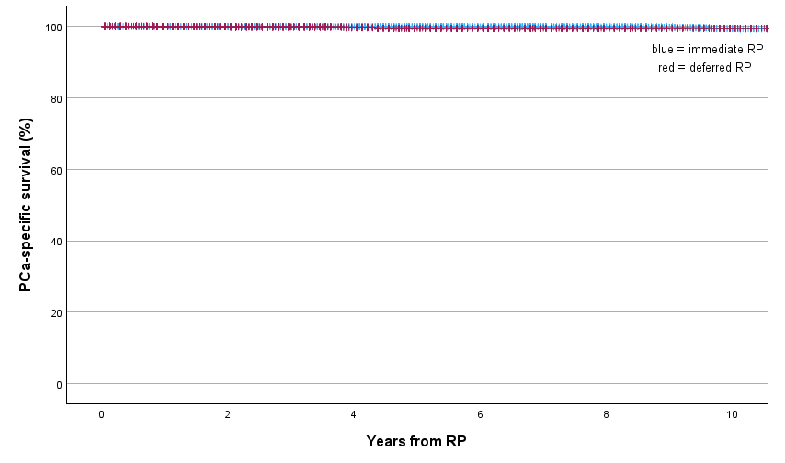
Numbers at risk | 0 | 2 | 4 | 6 | 8 | 10
Immediate RP | 5767 | 5197 | 4351 | 3586 | 2756 | 1732
Deferred RP | 1839 | 1308 | 860 | 507 | 285 | 108

Supplementary Figure 2: Kaplan-Meier estimates of prostate cancer-specific survival in men treated with immediate vs deferred RP
PCa = Prostate cancer; RP = Radical prostatectomy

Supplementary Table 1. Multivariable logistic regression analyses of adverse pathological findings and prostate cancer treatment after deferred radical prostatectomy*
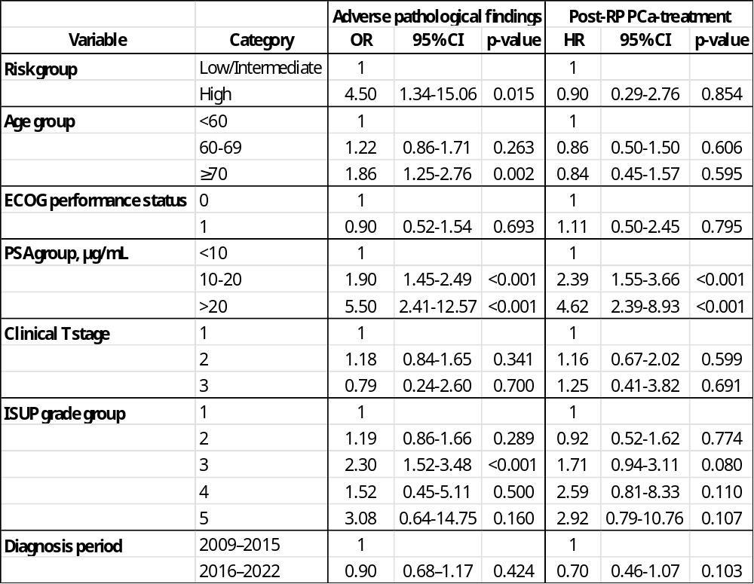
*Adjusted for characteristics at the time of RP
RP = Radical prostatectomy; PCa = Prostate cancer; ECOG = Eastern Cooperative Oncology Group; PSA = Prostate-specific antigen; T = tumor¸ ISUP = International Society of Urological Pathology; OR = Odds ratio; CI = Confidence interval

Supplementary Table 2. Multivariable logistic regression analysis of the association between time from diagnosis to radical prostatectomy and adverse pathological findings among men undergoing deferred radical prostatectomy*
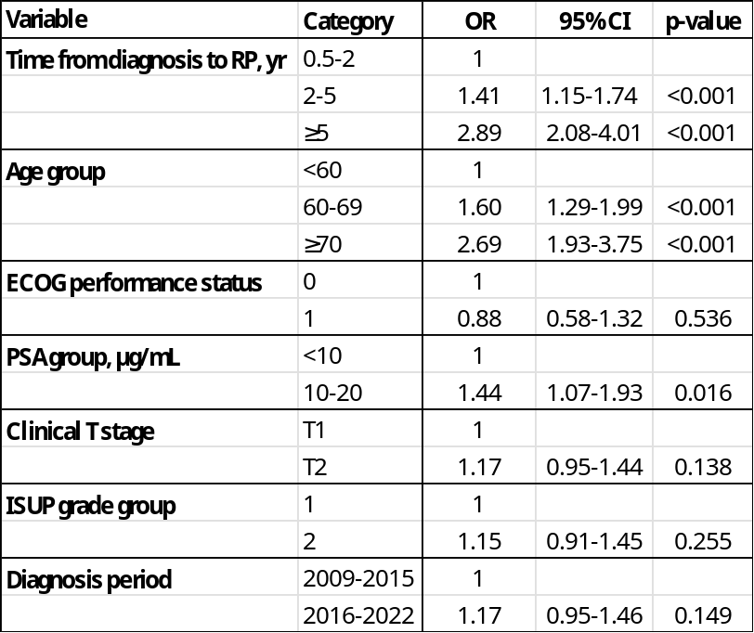
*Adjusted for characteristics at the time of diagnosis
RP = Radical prostatectomy; yr = year; ECOG = Eastern Cooperative Oncology Group; PSA = Prostate-specific antigen; T = tumor¸ ISUP = International Society of Urological Pathology; OR = Odds ratio; CI = Confidence interval

Supplementary Table 3. Norwegian national guidelines for active surveillance during the study period
Domain | Guideline period | Recommendation
Eligibility for AS | 2009–2019 | PSA <10 ng/mL, cT ≤T2b, ISUP grade group 1, ≤2 positive biopsy cores (of minimum 8), <50% cancer involvement per core
 | 2020–2022 | PSA <20 ng/mL, cT ≤T2b, ISUP grade group ≤2 (limited pattern 4 permitted), with concordance between MRI and pathology findings
PSA monitoring | 2009–2019 | Every 3 months for 2 years, then every 6 months
 | 2020–2022 | Every 3-6 months
Repeat biopsy | 2009–2019 | Scheduled biopsies at years 1, 4, and 7
 | 2020–2022 | Biopsy at year 1 and subsequently at least every 3-5 years
MRI use | 2012–2019 | Prostate MRI recommended as part of AS assessment (introduced in guidelines from 2012)
 | 2020–2022 | MRI incorporated into AS follow-up; MRI before repeat biopsy considered optional
Triggers for intervention | 2009–2019 | Gleason score ≥7, >2 positive biopsy cores, PSA doubling time <3 years, or patient preference
 | 2020–2022 | Disease progression, life expectancy <10 years, or patient preference

AS = Active surveillance; PSA = Prostate-specific antigen; cT = Clinical tumor stage; ISUP = International Society of Urological Pathology; MRI = Magnetic resonance imaging

Supplementary Table 4. Multivariable regression analyses of adverse pathological findings and post-RP prostate cancer-treatment stratified by risk group*
- Multivariable logistic regression for adverse pathological findings
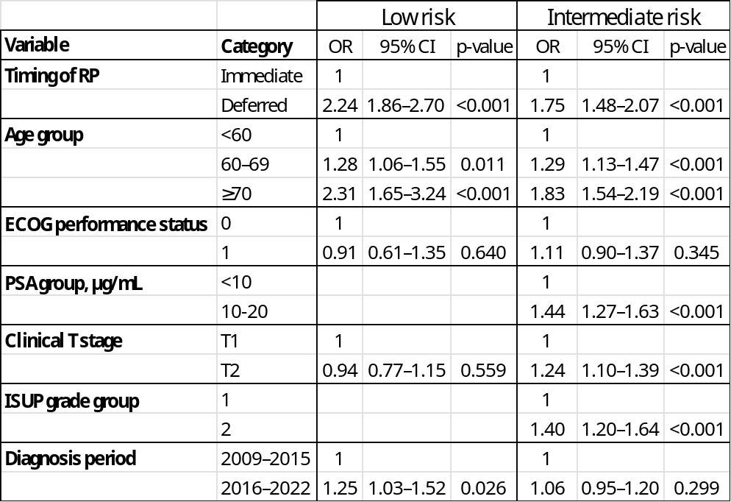
- Multivariable Cox regression for post-RP prostate cancer-treatment
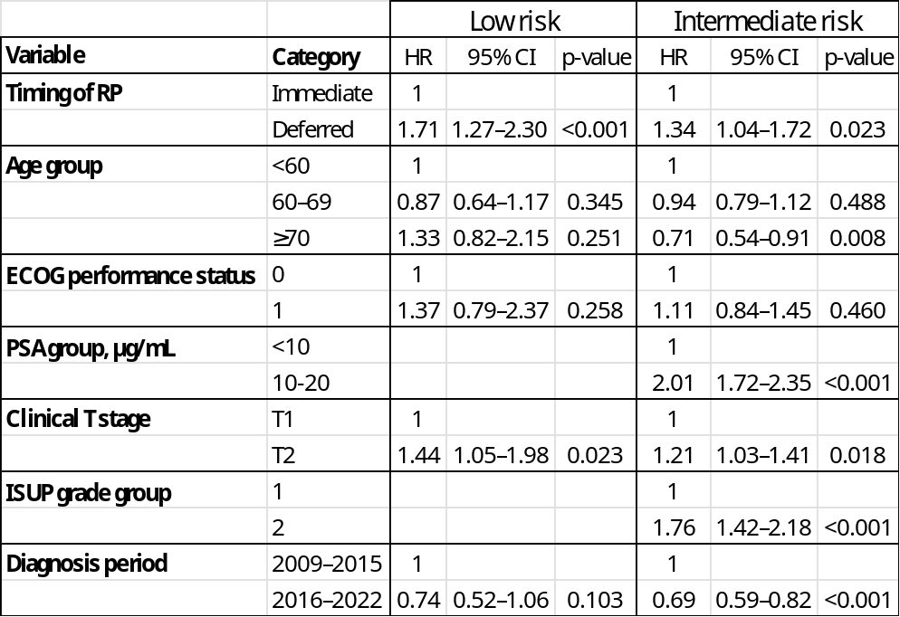
*Adjusted for clinical characteristics at diagnosis
RP = Radical prostatectomy; ECOG = Eastern Cooperative Oncology Group; PSA = Prostate-specific antigen; T = tumor¸ ISUP = International Society of Urological Pathology; OR = Odds ratio; CI = Confidence interval; HR = Hazard ratio
Supplementary Table 5. Multivariable analyses of adverse pathological findings and post-RP prostate cancer-treatment stratified by diagnosis period*
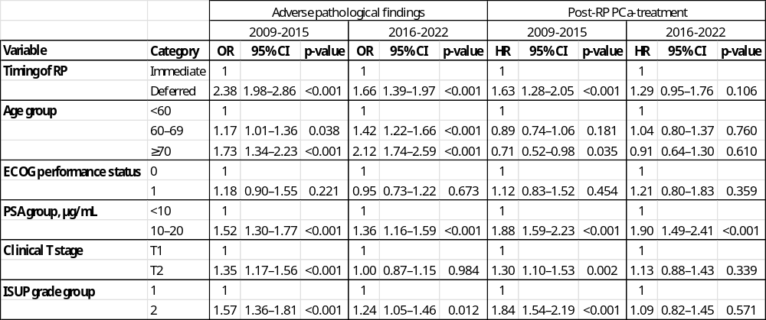
*Adjusted for clinical characteristics at diagnosis
RP = Radical prostatectomy; PCa = Prostate cancer; ECOG = Eastern Cooperative Oncology Group; PSA = Prostate-specific antigen; T = tumor¸ ISUP = International Society of Urological Pathology; OR = Odds ratio; CI = Confidence interval; HR = Hazard ratio

