Supplementary Figure 1. PFS and OS according to risk stratification in patients with only bladder cancer
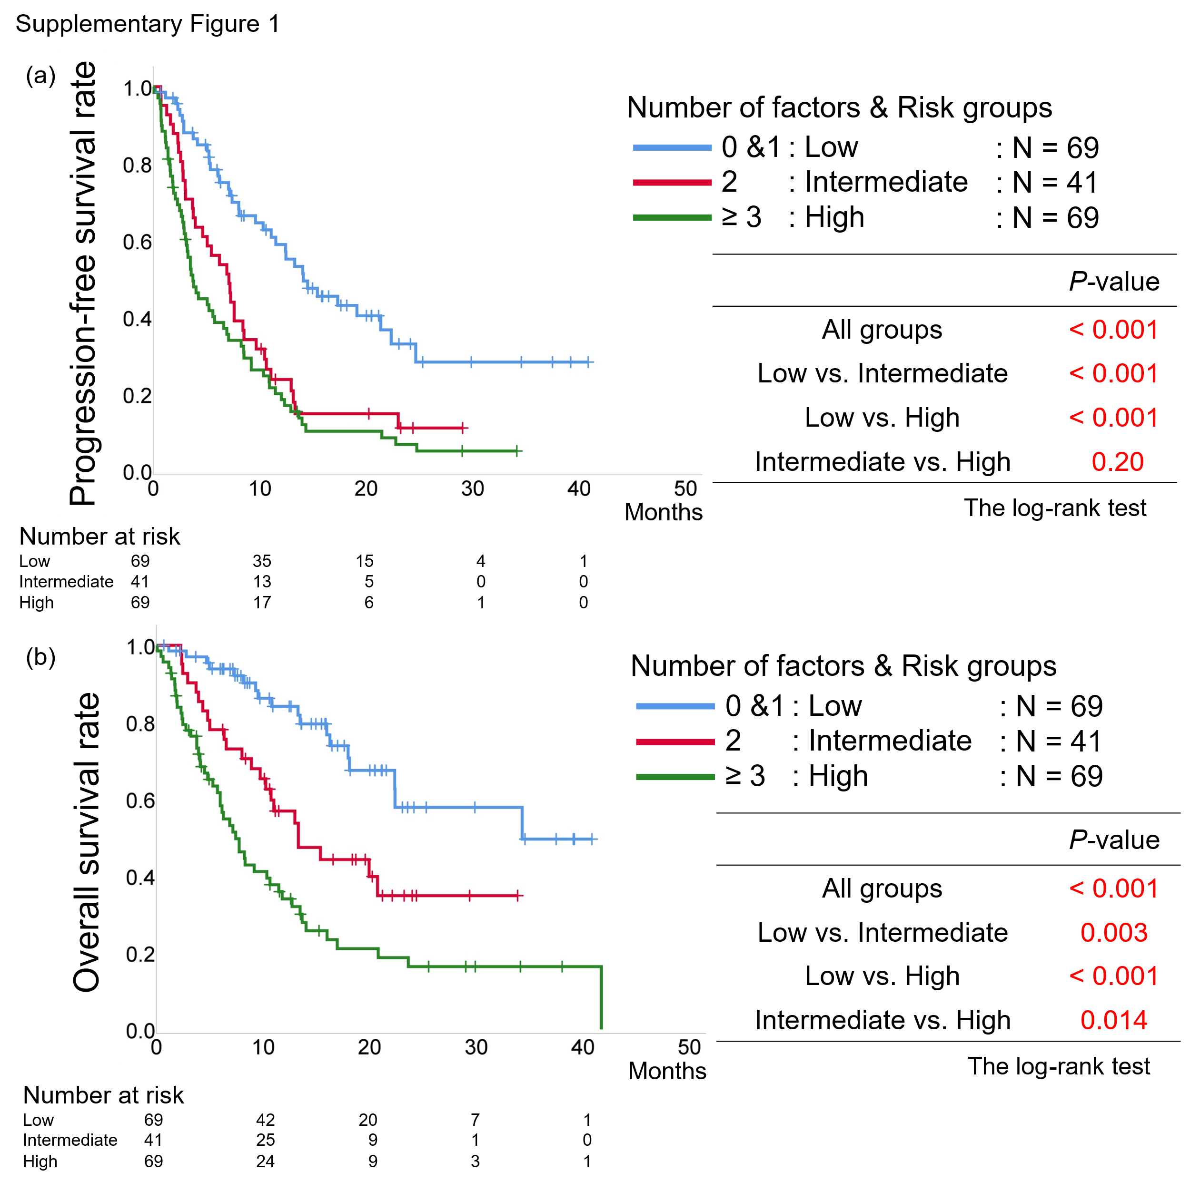
(a) Kaplan–Meier curves of progression-free survival, and the P-values calculated among the three risk groups using the log-rank test. (b) Kaplan–Meier curves of overall survival, and the P-values calculated among the three risk groups using the log-rank test.
Supplementary Figure 2. PFS and OS according to risk stratification in patients with UTUC.
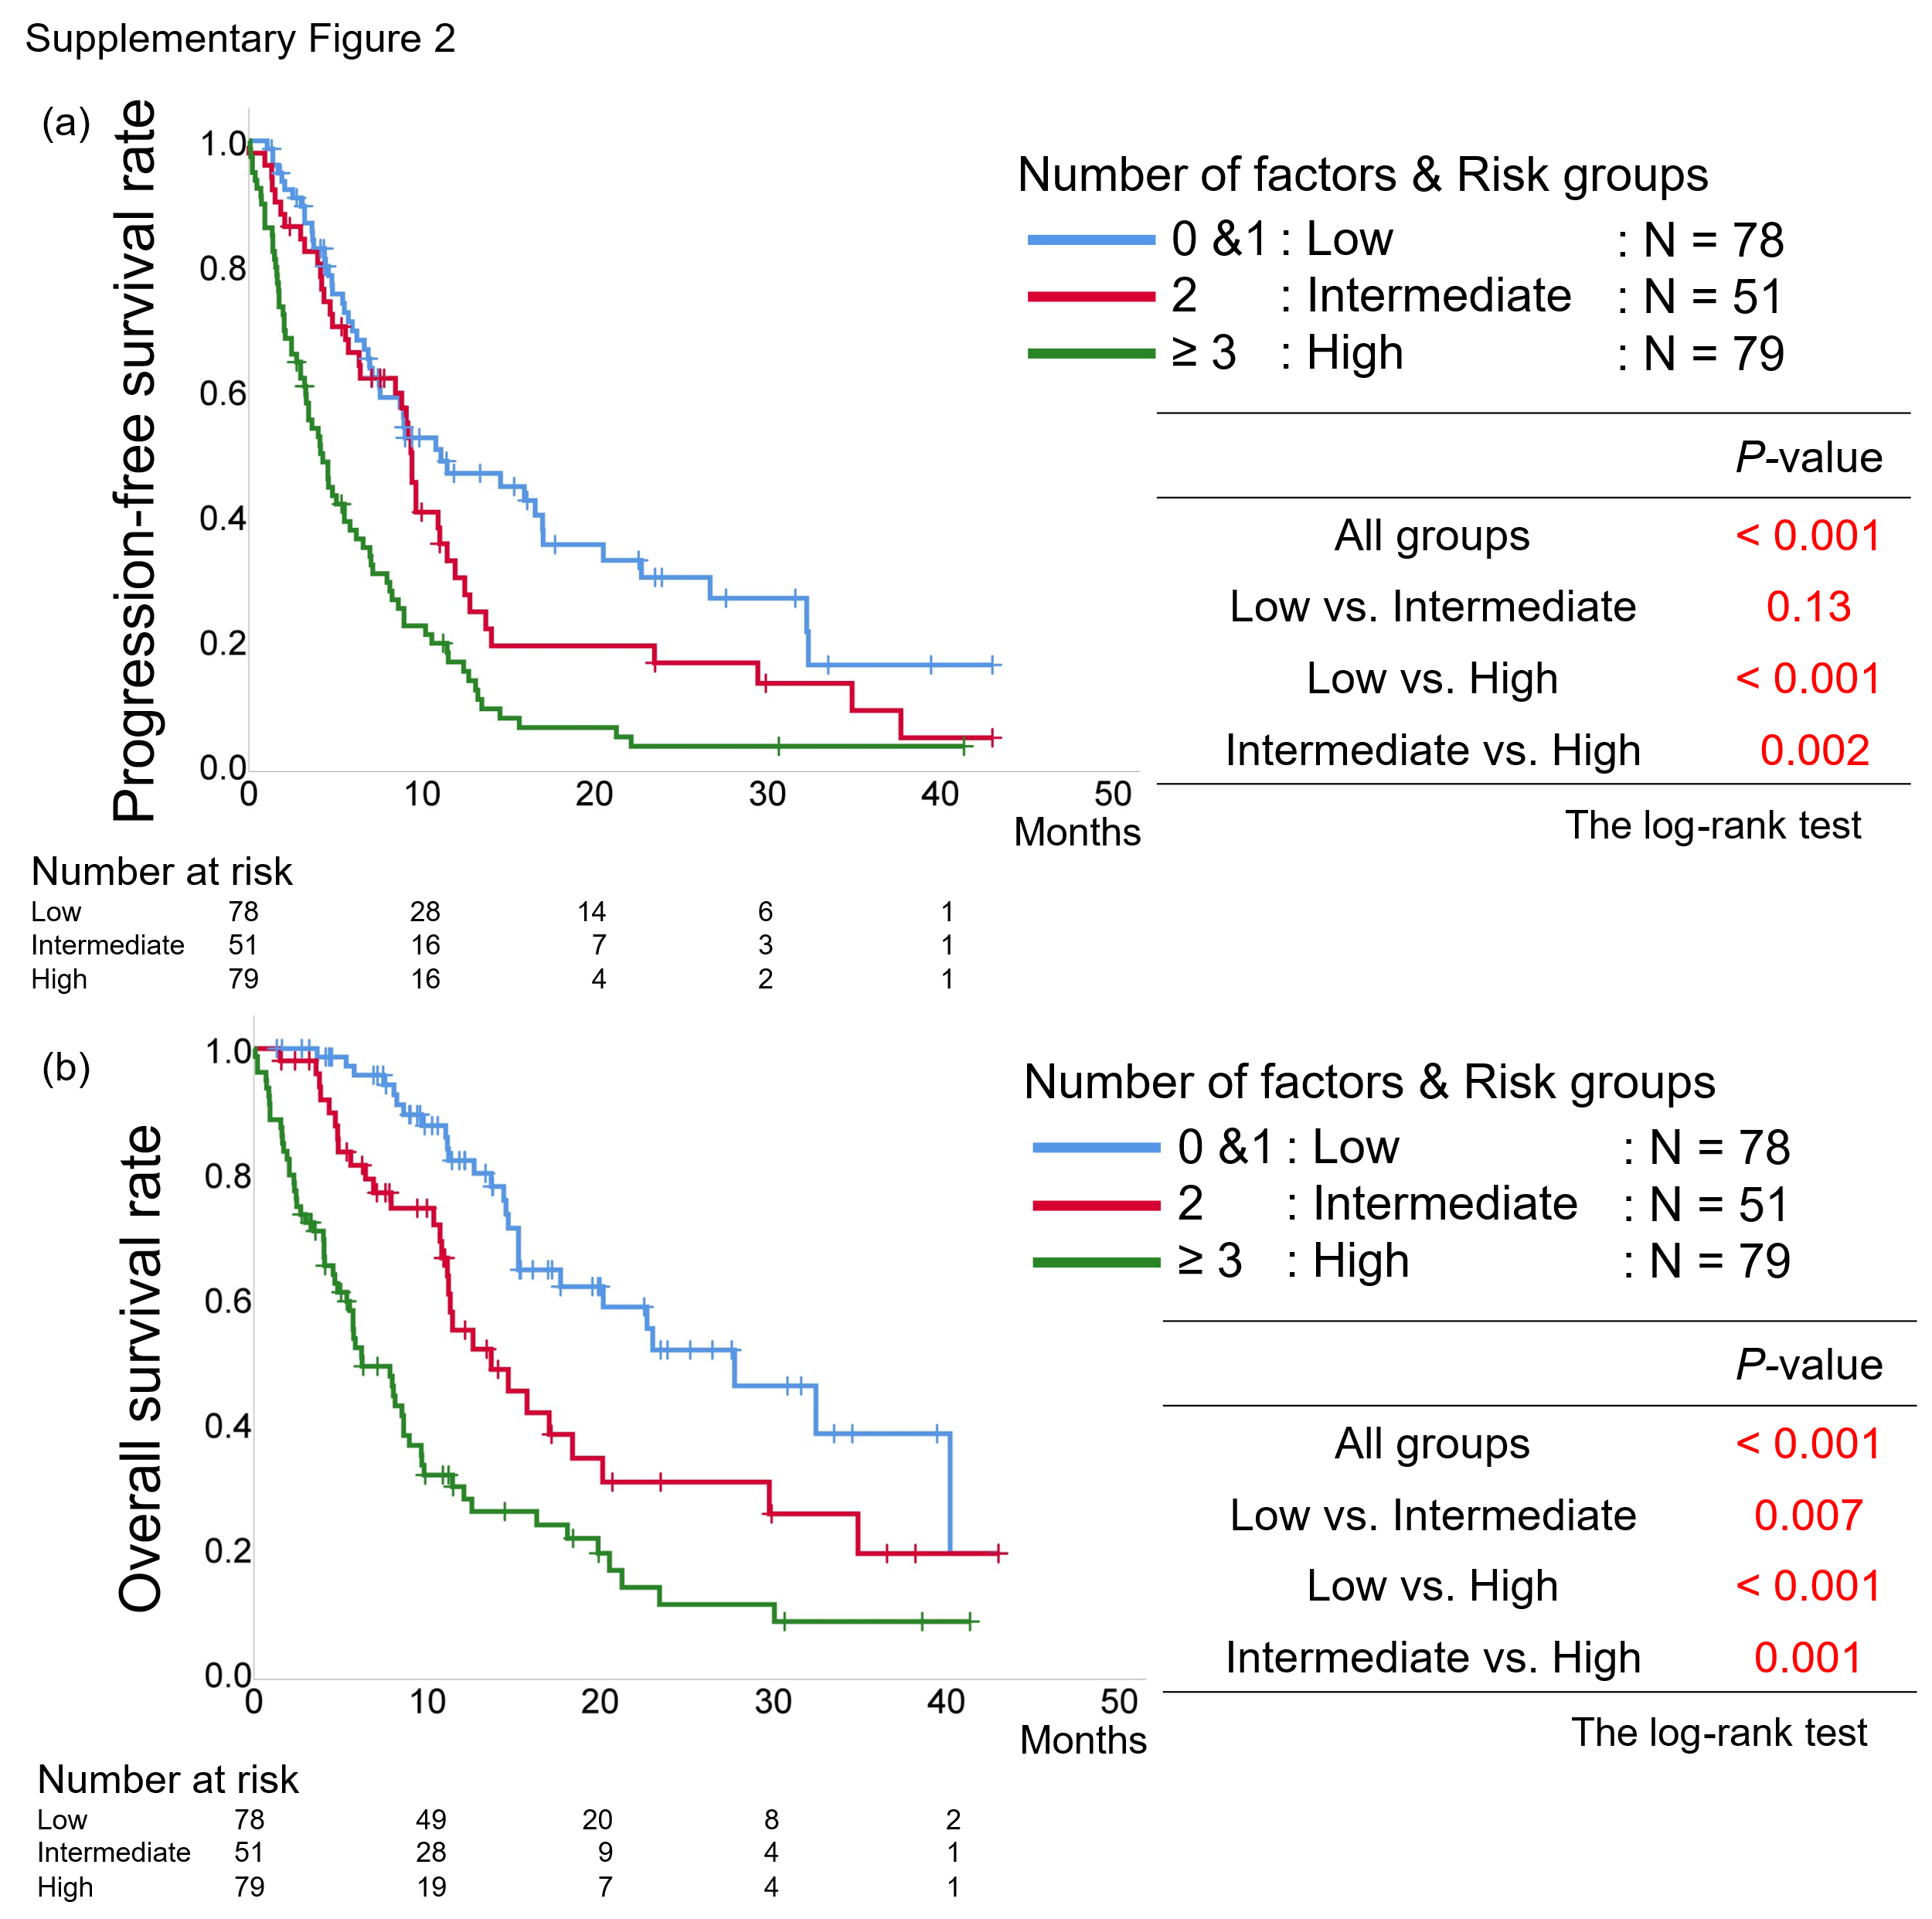
(a) Kaplan–Meier curves of progression-free survival, and the P-values calculated among the three risk groups using the log-rank test. (b) Kaplan–Meier curves of overall survival, and the P-values calculated among the three risk groups using the log-rank test.

