Online Appendix

Appendix A: Experimental materials

This appendix contains the experimental instructions that were provided as paper handouts and the on-screen instructions, as well as the fairness questionnaires. We also provide screenshots of the different phases of the experiment.
All materials are English translations from the German originals. The original versions in German are available from the authors upon request.

Instructions (Paper handout 1)
  - Welcome to this experiment. Please do not talk to any of the other participants from now on and please use the only computer for the experiment.
  - The purpose of this experiment is to study decision-making. You can earn real money in this experiment. . The amount of money you earn is determined by your own decisions and the decisions of other participants. You will learn in the course of this experiment, how your earnings will be determined,
  - The data from the experiment are entirely anonymous and cannot be traced back to participants. At no point in the experiment (during or after) will the other participants or the experimenters learn the choices you have made, and how much you have earned.

Structure of the Experiment
The experiment consists of several parts: a questionnaire at the beginning, the first phase of the experiment, the second phase, and a further questionnaire at the end.
Answering the questionnaires gives you a certain payment of € 4, you can earn additional money in the other two phases of the experiment. We ask you to answer the questions of the questionnaires truthfully, because this is very important for the scientific evaluation of the data.

Sequence of tasks
First, you complete an on-screen questionnaire. The detailed instructions will be shown on the screen.
After completing the questionnaire you will receive further instructions on paper. These instructions will clarify, what your tasks are and how your payment is determined.
After the second phase of the experiment, you will fill in another questionnaire on screen. You will then be called individually to receive your earnings in cash. Please bring the ID card and the completed and signed payment form. You will receive your earnings in private and anonymously.
So your name cannot be associated with the experimental data available from the database, we add an additional amount between 0 and 1 Euro to your earnings. This is determined at random and added to your experimental earnings.

The questionnaire will now follow. Please read the instructions on the screen now.

On-screen instructions (questionnaire)

Phase 1: open-choice questions
Imagine the following situation:
Two persons A and B have produced an output together. Each of these persons contributed individually (towards this joint output), and each contribution can be measured in terms of money earnings.
Example:
A has contributed 13 EUR, and B 16 EUR.
The total value of the joint output is therefore 29 EUR.
Imagine that it is possible that the sources of the individual contribution can be measured in money. Possible causes are: Talent, Effort, and Luck.
Example:
A’s contribution can be decomposed into: 8 EUR for Talent, 5 EUR for Effort and 0 EUR for Luck.
Your first task is to specify how you would divide fairly the joint output between A and B.
Example:
Two persons A and B have produced an output in the following way:
Person | Talent | Effort | Luck | Total
A | 8 | 5 | 0 | €13
B | 5 | 8 | 3 | €16

The total value to divide is 29 EUR. How would you divide this fairly between A and B?
On the following screens you will see a succession of such tables. Below the table are two fields, in which you must enter your division. When you have confirmed your choice with OK, you will access the next screen. Please express your honest opinion. There is no right or wrong answer.
Question 1
A and B have produced the following joint output as follows:
 | Talent | Effort | Luck | Total
A | 5 | 8 | 0 | €13
B | 12 | 5 | 3 | €20

The total value of the joint output to be divided is therefore €33.
How you would divide the joint output between A and B in a way fair way?
Please give your honest opinion. There is no right or wrong answer.

Amount for A
Amount for B

Question 2

A and B have produced the following joint output as follows:
 | Talent | Effort | Luck | Total
A | 8 | 5 | 3 | €16
B | 12 | 12 | 0 | €24

The total value of the joint output to be divided is therefore €40.
How you would divide the joint output between A and B in a way fair way?
Please give your honest opinion. There is no right or wrong answer.

Amount for A
Amount for B

Question 3
A and B have produced the following joint output as follows:
 | Talent | Effort | Luck | Total
A | 8 | 12 | 3 | €23
B | 5 | 8 | 0 | €13

The total value of the joint output to be divided is therefore €36.
How you would divide the joint output between A and B in a way fair way?
Please give your honest opinion. There is no right or wrong answer.

Amount for A
Amount for B

Question 4

A and B have produced the following joint output as follows:
 | Talent | Effort | Luck | Total
A | 12 | 12 | 3 | €16
B | 5 | 5 | 0 | €24

The total value of the joint output to be divided is therefore €37.
How you would divide the joint output between A and B in a way fair way.
Please give your honest opinion. There is no right or wrong answer.

Amount for A
Amount for B

Phase 2: multiple-choice questions
Your task is now slightly different. Once more, there is a table that displays a given output. The lines in the table display five different divisions for this output.
A has produced a contribution of 17 EUR, B has produced 19 EUR. The total value of the combined output is therefore 36 EUR.
Please choose now the division which you regard as being the fairest. Click with your mouse in the corresponding field. When you have confirmed your choice with OK, you will access the next screen.

Question 5

A and B have produced the following joint output as follows:
 | Talent | Effort | Luck | Total
A | 5 | 12 | 0 | €17
B | 8 | 8 | 3 | €19

The total value of the joint output to be divided is therefore €36.
How you would divide the joint output between A and B in a way fair way?
Please give your honest opinion. There is no right or wrong answer.

Proposed Division | 1 | 2 | 3 | 4 | 5
A | 18 | 20 | 21.6 | 18.5 | 17
B | 18 | 16 | 14.4 | 17.5 | 19

Question 6

A and B have produced the following joint output as follows:
 | Talent | Effort | Luck | Total
A | 8 | 5 | 3 | €16
B | 5 | 12 | 0 | €17

The total value of the joint output to be divided is therefore €33.
How you would divide the joint output between A and B in a way fair way?
Please give your honest opinion. There is no right or wrong answer.

Proposed Division | 1 | 2 | 3 | 4 | 5 | 6
A | 16 | 14.5 | 14.3 | 13 | 9.7 | 16.5
B | 17 | 18.5 | 18.7 | 20 | 23.3 | 16.5

Question 7

A and B have produced the following joint output as follows:
 | Talent | Effort | Luck | Total
A | 12 | 12 | 3 | €27
B | 5 | 5 | 0 | €10

The total value of the joint output to be divided is therefore €37.
How you would divide the joint output between A and B in a way fair way?

Please give your honest opinion. There is no right or wrong answer.

Proposed Division | 1 | 2 | 3 | 4 | 5
A | 22 | 26.1 | 27 | 18.5 | 25.5
B | 15 | 10.9 | 10 | 18.5 | 11.5

Instructions (Paper handout 2)

Experiment
The experiment consists of a production phase and a distribution phase.
In the production phase, you will generate an amount of money, which will be credited to an account.
In the distribution phase, you will be matched randomly with one another participant who generated a sum of money during the production phase in the same manner as you.

With this other experiment participant (counterpart) you will divide the total amount of money among yourselves. More information about the distribution phase will be given after the production phase.

Production phase
The production phase has three parts, in which you can earn money that is credited to your account. During this phase, you belong either to group H or group T. Both groups are of the same size. The allocation to these two groups is decided at random by the computer. Which group you have been allocated to will be displayed on the screen. In Parts 1 and 2 of the production phase, the group affiliation does not matter.
In Part 1 and Part 2, you will perform tasks for which you will receive points. At the end of each part, a ranking of all participants will be created according to the points earned in this part of the experiment. Participants will be ranked in three groups. The participants in the highest third will earn 12 EUR that will be credited to the account. Participants in the middle third of the ranking will earn 8 EUR, and participants in the lowest third will earn EUR 5.
Example:
Suppose you performed in a way such that you are in the middle third of the distribution in the first phase, and in the top third in the second phase. Then you have earned 8 EUR + 12 EUR = 20 EUR that will be credited to the account.
The production phase will now begin. Please read the instructions on the screen now.

On-screen instructions (production phase, talent)
You are now in the first part of the production phase of the experiment. You are in group T (H).
You must now solve a brainteaser. You will see several tasks, and you have 15 minutes in total. Then this part of the experiment will be over.
Under each task, you see an entry field in which you are prompted to enter your solution. You must click on OK to confirm the entry and advance to the next screen. When you have clicked on OK, you can no longer change your answer, nor return to this screen.
For each correct answer you will earn a point. For each wrong answer, a point will be deducted from your earnings. If you do not want to give an answer, leave the field blank and press OK. You will then earn nothing for this task.
Screenshot 3
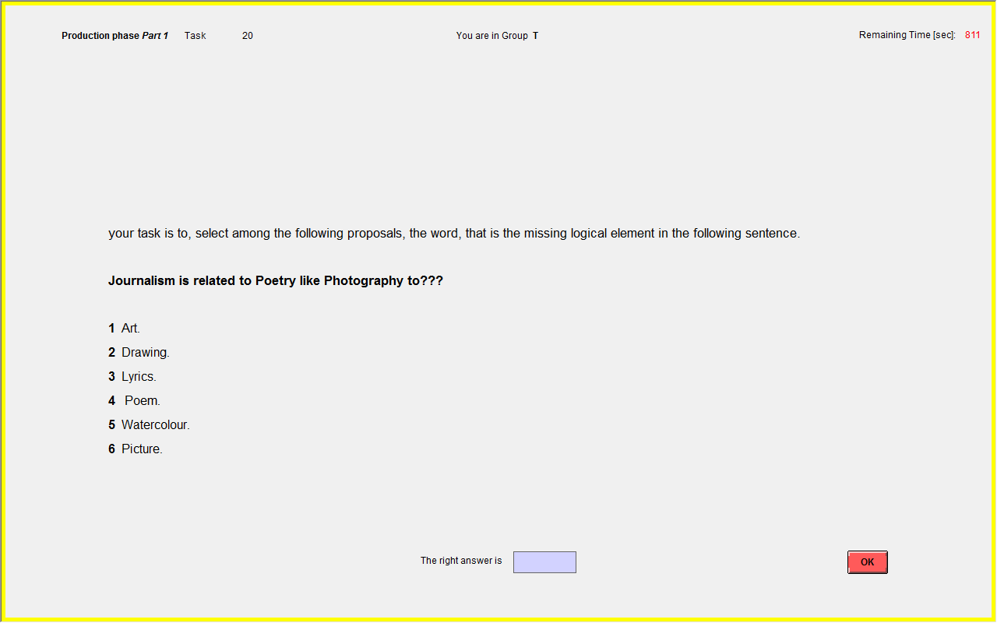

On-screen instructions (production phase, effort)
You are now in the second part of the production Phase. You still are in group T (H).
You must now solve a numerical exercise. You will see on your screen rows of zeros and ones. Please count the number of ones and enter your answer into the input box. By clicking OK, you will confirm your answer and move on to the next screen. When you have clicked OK you can no longer change your answer, nor access this screen again.
You have for this task a total of fifteen minutes. If you like, you can finish this task before the end of the 15 minutes. To do this, press the STOP button. Once you have pressed this button, you can no longer take part in this task. While you wait for others to finish the task, you may deal with personal matters, as long as you do not disturb the other participants.
For each correct answer you will earn a point. For each wrong answer, a point will be deducted from your earnings. If you do not want to give an answer, leave the field blank and press OK. You will then earn nothing for this task.
Screenshot 4
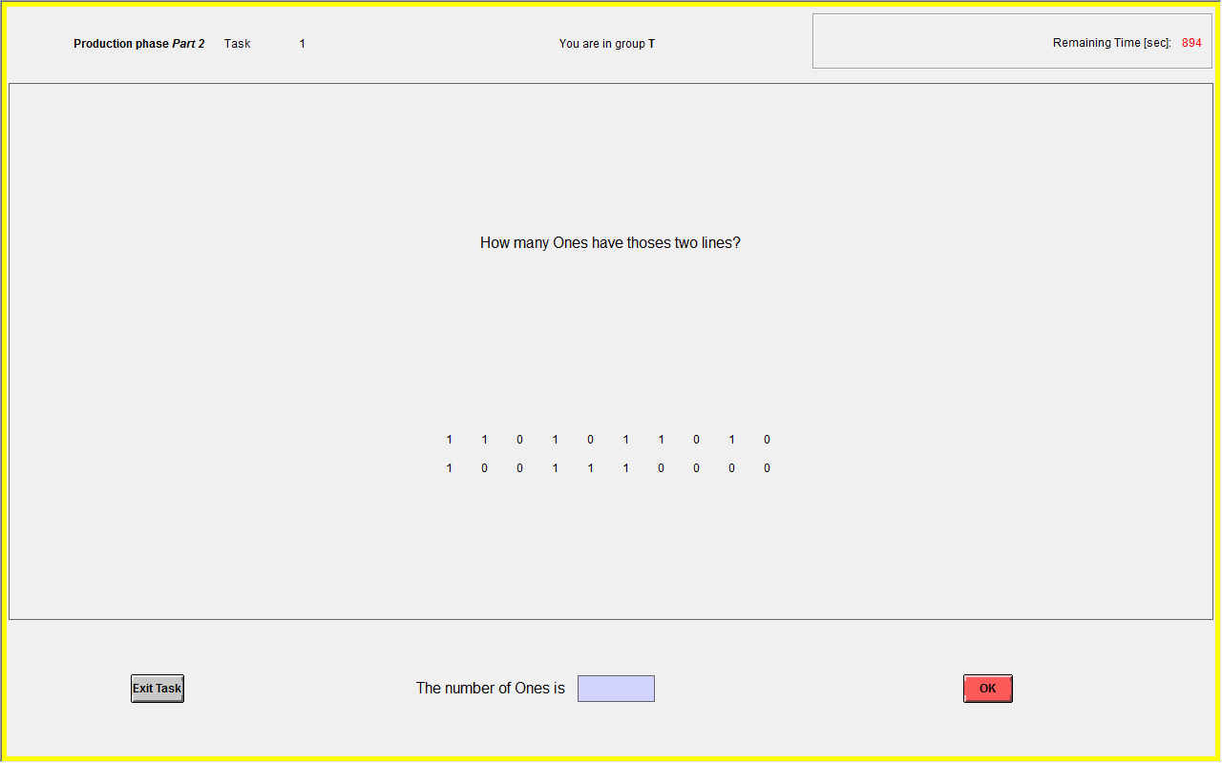

On-screen instructions (production phase, luck)
You are now in the third part of the Production phase. You are still in group T (H).
A participant will be chosen at random to throw a coin. When the coin falls on Tail, all members of group T earn 3 EUR more, that will be credited to their Production account. The other group earns nothing.
When the coin falls on Head, all members of group H earn 3 EUR more, that will be credited to their Production account. The other group earns nothing.
Screenshot 5
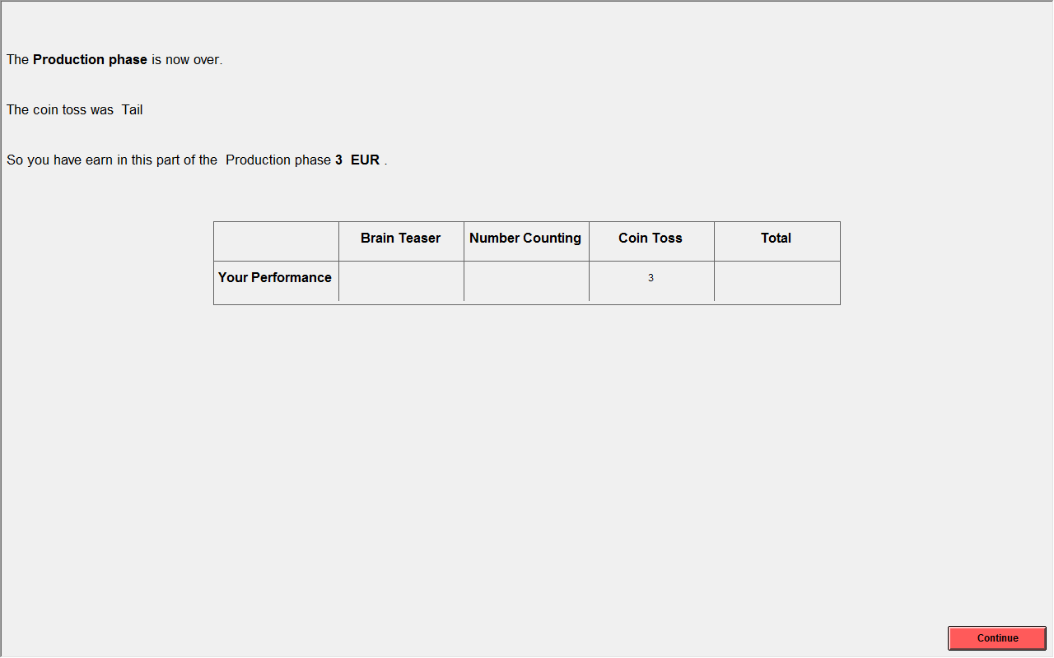

Instructions (Paper handout 3)

Distribution Phase
This phase consists of 5 identical rounds. You will in each round be matched with another randomly chosen participant. You will not meet any participant more than once and will not know the identity of any of the participants you are matched with.
The amounts of money that you and your counterpart have earned in the production phase are credited in each round to a joint account. Your task is to divide the total amount in the joint account between yourselves (i.e. you and your counterpart).
The computer will randomly select one of these five rounds and implement this distribution at the end. You and your counterpart will earn those amounts of money that you have divided among yourselves in this randomly chosen round. In addition, you will receive the payment for the questionnaires of EUR 4. If the random round that was selected is one in which you and your partner could not agree on a distribution of the money in the joint account, you will both just get the show-up fee.
In each round, you and your respective counterpart have five minutes to agree on a distribution. During this time anyone can propose an amount of money they would like to receive. The remainder of the money in the joint account (if any) will go to the other person. During the distribution phase, you and your partner see the following screen.
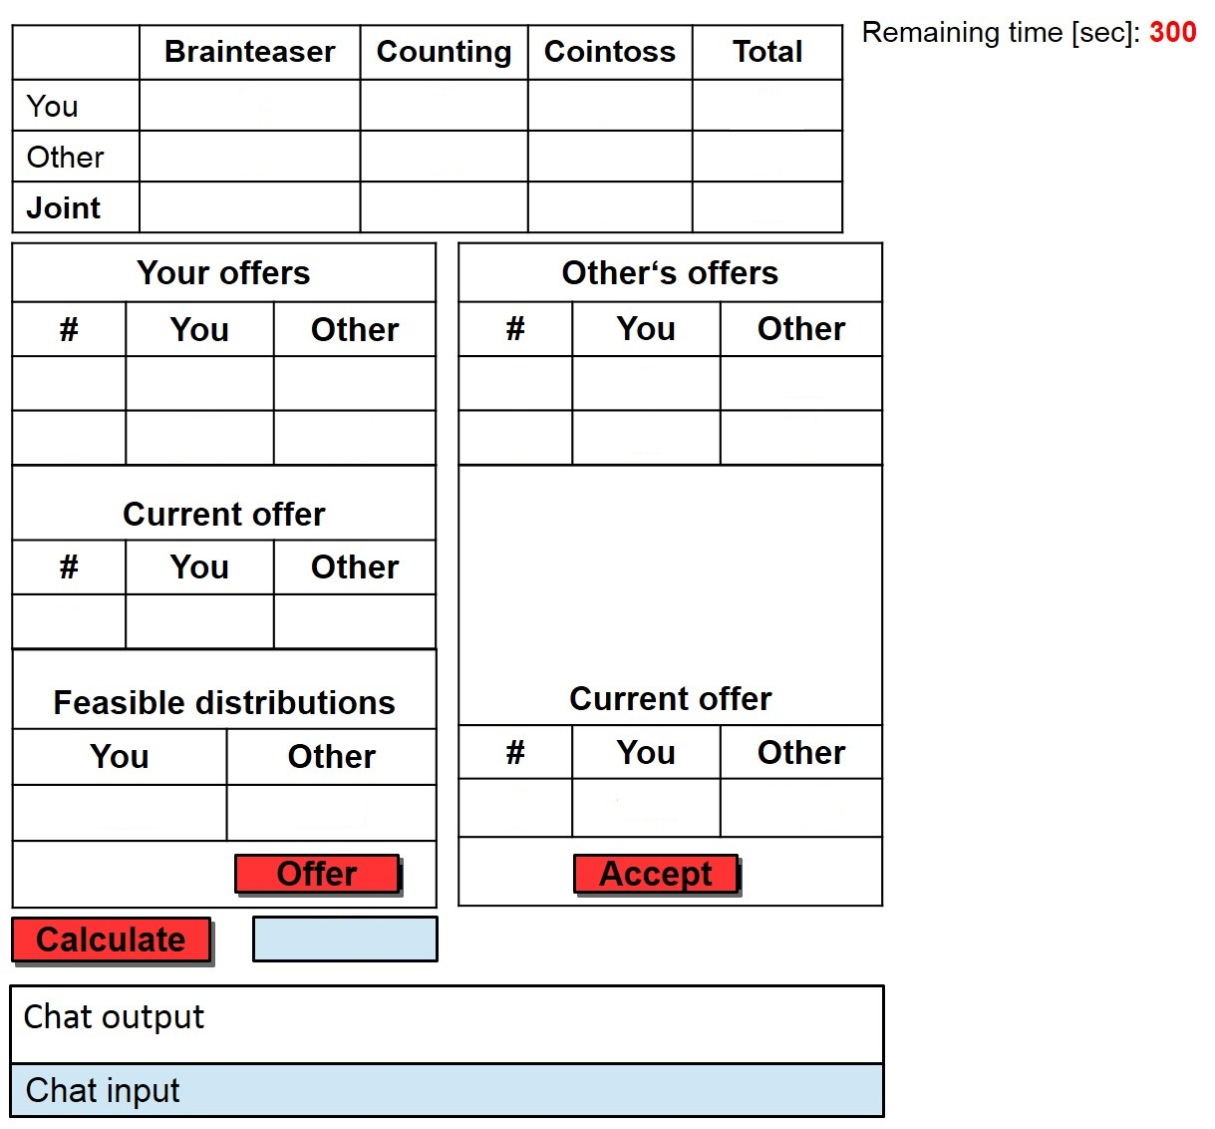
7
6
5
4
3
2
1

The numbers on the above picture refer to the steps below.
1. The table in the upper left corner of the screen contains the total amount in the joint account and the respective contributions by you and your partner to this amount (excluding the payment for the response to the questionnaire).
2. If you want to suggest a distribution to your counterpart, you must enter the amount you want to get in the "you" field on the left side. This amount cannot exceed the total amount in the joint account. You can specify values with one decimal. Please enter a comma (,) as a period (.).
3. When you press the button "Calculate", the field "Possible distributions" then shows the amount that would go to you and your counterpart. You can calculate several possible distributions by following this procedure.
4. In the table "Feasible distributions" you can then select one of these distributions with the mouse. If you click on the button "Offer", your allocation proposal is then sent to your counterpart. Your proposal will be on the right side of the table for the other participant and on the left in your table under the field "your offers".
5. Your counterpart has the same opportunities as you and may at any time propose divisions. His proposals are shown on your screen on the right side of the table in the middle of the screen displayed under the field "Your counterpart’s offers”. There is no set order for the allocation proposals. You and your partner can make suggestions any time
6. You or your partner can accept the last proposal made by one of you by selecting the offer of the other person under "Current offer" with the mouse and then clicking the "Accept" button. Doing so terminates the distribution round, and the accepted division becomes binding.
If an offer is accepted before the end of the allocated five minutes, you and your counterpart must wait until all participants have completed this round. Only then will you be matched with a new participant.
If none of the proposed allocations are accepted, the recorded payoff in this round for both participants is EUR 0. If at the end of the distribution phase this round happens to be selected by the computer, you and your counterpart will only receive the show-up fee.
You can always change your last proposed allocation, as long as the other participant did not accept your proposal already. To do so, just choose a new potential distribution and press "Offer". Your new proposal appears just under the old proposal in the table and is now the active proposal. Old proposals remain in the table, but can no longer be accepted. New proposals can be smaller, larger or equal to the old proposal.
7. During the distribution phase, you can send your counterpart messages. Your counterpart can also send you messages. Your messages must not reveal your identity, and must not contain threats or other inappropriate content. These messages will be monitored by the experimenter. If you violate these instructions, you will receive no money at all and will be excluded from future experiments. You can type your message in the blue chat box at the bottom of the screen and then submit it by pressing the Enter or Return key .
The division phase starts now. Please read the instructions on the screen.

Appendix B: Further Analysis

Table B 1: Classification of subjects based on questionnaire responses (2 questions in the pre-experimental questionnaire)
Shares |  | Post-experimental questionnaire
 |  | Egalitarian | Choice Egalitarian | Meritocratic | Libertarian | Total pre
Pre-experimental questionnaire | Egalitarian | 0.0% (0) | 1.4% (1) | 0.0% (0) | 01.4% (1) | 2.8% (2)
Pre-experimental questionnaire | Choice Egalitarian | 2.8% (2) | 8.3% (6) | 16.7% (12) | 4.2% (3) | 31.9% (23)
Pre-experimental questionnaire | Meritocratic | 4.2% (3) | 1.4% (1) | 15.3% (11) | 13.9% (10) | 34.7% (25)
Pre-experimental questionnaire | Libertarian | 2.8% (2) | 0.0% (0) | 2.8% (2) | 25.0% (18) | 30.6% (22)
Pre-experimental questionnaire | Total post | 9.7% (7) | 11.1% (8) | 34.7% (25) | 44.4% (32) | 100.0% (72)
This table contains the results of a similar analysis as presented in table 2 in the main text, using only questions Q1 and Q6 for the classification, as these are used in both, the pre- and the post-experimental questionnaires.

Table B 2 Estimation of weights on contributions, by relative contribution
 |  |  | (1) | (2) |  | (3) | (4) |  | (5) | (6) | (7) | (8)
 |  | Choice Egalitarian |  |  | Meritocratic |  |  | Libertarian |  |  | All
 |  |  | Low | high |  | low | high |  | low | High | Low | High
Proposer | Y_{i}^{effort} | 1 | 0.85+  (0.06) | 1.04  (0.08) | 1 | 0.80++  (0.06) | 0.96  (0.05) | 1 | 0.64++  (0.09) | 0.90++  (0.04) | 0.73  (0.05) | 0.96  (0.04)
Proposer | Y_{i}^{talent} | 0.5 | 0.87++  (0.06) | 0.81+  (0.13) | 1 | 0.79++  (0.07) | 0.96  (0.03) | 1 | 0.66++  (0.06) | 0.96  (0.03) | 0.75  (0.05) | 0.93  (0.05)
Proposer | Y_{i}^{luck} | 0.5 | 0.75++  (0.08) | 0.67  (0.16) | 0.5 | 0.68+  (0.09) | 0.66+  (0.07) | 1 | 0.67+  (0.15) | 0.96  (0.08) | 0.76  (0.05) | 0.86  (0.06)
Partner | Y_{k}^{effort} | 0 | 0.15+  (0.06) | -0.04  (0.08) | 0 | 0.20++  (0.06) | 0.04  (0.05) | 0 | 0.36++  (0.09) | 0.10++  (0.04) | 0.27  (0.05) | 0.04  (0.04)
Partner | Y_{k}^{talent} | 0.5 | 0.13++  (0.06) | 0.19+  (0.13) | 0 | 0.21++  (0.07) | 0.04  (0.03) | 0 | 0.34++  (0.06) | 0.03  (0.03) | 0.25  (0.05) | 0.07  (0.05)
Partner | Y_{k}^{luck} | 0.5 | 0.25++  (0.08) | 0.33  (0.16) | 0.5 | 0.32+  (0.09) | 0.34+  (0.07) | 0 | 0.33+  (0.15) | 0.04  (0.08) | 0.24  (0.05) | 0.14  (0.06)
 | Const | 0 | 0.59+  (0.25) | 0.99  (0.62) | 0 | -0.02  (0.29) | -0.07  (0.15) |  | -0.43  (0.26) | 0.26  (0.21) | -0.09  (0.21) | 0.34  (0.25)
 | Adj. R² |  | 0.960 | 0.705 |  | 0.790 | 0.954 |  | 0.683 | 0.966 | 0.807 | 0.878
Type | P |  | <0.001 | 0.148 |  | <0.001 | 0.006 |  | <0.001 | 0.036
Libertarian | P |  | 0.012 | 0.195 |  | <0.001 | <0.001 |  | <0.001 | 0.036 | <0.001 | 0.102
Egalitarian |  |  | <0.001 | <0.001 |  | <0.001 | <0.001 |  | 0.012 | <0.001 | <0.001 | <0.001
equal | P |  | 0.165 |  |  | 0.08 |  |  | <0.001 |  | <0.001
 | # |  | 46 | 73 |  | 77 | 81 |  | 51 | 71 | 174 | 225
Notes: constrained OLS regressions, all offers, adj. R² refers to the estimation with unconstrained coefficients, Type refers to F-test on difference from theoretically predicted weights of the type determined by the questionnaire, Libertarian refers to F-test on difference from theoretically predicted weights of libertarians, equal refers to F-test on equality of coefficients for subjects with low and high contributions, ++,,+ indicate significant difference from theoretical value at 1%, 5% level. The standard errors in parenthesis are clustered at the bargain-group level.

Analysis of the Bargaining process
The fairness-augmented Nash model does not provide any hints on how the bargaining outcome is reached. In order to get some insights on the bargaining process, we present some additional results on the offers and their evolution during the bargaining.
In total, there were 180 bargaining groups in all sessions. The total number of offers was 444 resulting in about 2.47 offers per bargaining group. In only 5 groups (2.8%) the two partners did not reach an agreement and hence received payoffs of zero. In 53.1% of all groups that achieved an agreement, the first offer was accepted. In 18.9% the accepted offer was the second offer made, in 9.7% the third offer was accepted. 18.3% of the groups exchanged 4 offers or more, before they agreed on a distribution of the surplus.
It is also interesting to see how much the initial offer and the accepted offers differ (see Table B3). In the majority of the cases (60%) the accepted offer is equal to the initial offers. A deviation of €1 or less occurred in 21.7% of the cases, and the deviation was between €1 and €2 in 10.3% of the cases. Only 6 accepted offers (3.4%) differed by more than €3 from the initial offer in that bargaining group.
Table B 3: Absolute deviation of accepted offer from initial offer (for person1)
 | 0 | ]0,1] | ]1,2] | ]2,3] | >3
Number | 105 | 38 | 18 | 8 | 6
Share | 60.0% | 21.7% | 10.3% | 4.6% | 3.4%

The total earnings of a subject are a natural benchmark for a description of the claims in the bargaining process. Recall that claiming one’s own total earnings would be fair according to the libertarian fairness ideal. Many offers are close to the total earnings from the production phase suggesting that subjects indeed derive claims or entitlements from the production achievements. Of all offers 44.8% were equal to the total earnings of the person who made the offer and only 5.6% differed by more than €3 from the total earnings.
There is clear evidence that subjects with low total earnings tend to demand more than their own contribution to the total surplus than subjects with high earnings (see Figure B1)

Figure B 1: Average offers relative to own total earning by own total earnings
On average, subjects with a production of 20 or higher demand their own contributions. The average claims for subjects with lower total earnings, however, are significantly larger than their production (p<0.001 for total earnings <19, t-test).
While the own total earnings from the production phase are a natural benchmark in the bargaining, an offer claiming more than this benchmark for oneself might be a reasonable bargaining strategy if the subjects expect that they will have to subsequently offer more in order to reach an agreement. In table B4 we report the results of OLS regression of the excess claims (difference between own claim and own earnings from production) on some personal characteristics and the level of own and the partner’s earnings.
We find a clear gender difference in subjects’ claims relative to their own contributions. Men make more aggressive claims and demand on average € 0.65 more than women. In line with Dohmen et al. (2011), we find that men are more risk tolerant than women. On an eleven point scale referring to their general risk attitude, men’s average willingness to take risks is 5.64 while women score at 4.18 (p=0.001, one-sided t-test). The risk variable itself, however, has no significant effect on the size of the excess claims. Men’s final payoffs after the bargaining are on average about € 1.41 higher than those of women (€18.56 vs. €17.15) but this difference simply reflects the unequal earnings of men and women in the production phase (€18.46 vs. €17.21).
Table B 4: Determinants of excess claims, OLS regression
 | (1) | (2) | (3) | (4) | (5)
 | all | all | Less than partner | equal | more than partner
Constant | -0.06  (0.28) | -0.29  (0.50) | -0.29  (0.85) | 0.79  (2.57) | -0.59  (0.67)
Risk tolerance | 0.00  (0.05) | -0.01  (0.04) | -0.00  (0.06) | 0.02  (0.24) | -0.00  (0.05)
Male | 0.65***  (0.21) | 0.83***  (0.19) | 0.60**  (0.27) | 1.21  (0.96) | 0.68***  (0.26)
Econ | 0.59***  (0.18) | 0.48***  (0.16) | 0.60**  (0.26) | -0.53  (0.85) | 0.32  (0.21)
Offer # | 0.01  (0.05) | -0.06  (0.04) | -0.07  (0.06) | -0.23  (0.39) | -0.10*  (0.06)
Own total earnings |  | -0.12***  (0.02) | -0.26***  (0.04) | -0.01  (0.11) | -0.05  (0.03)
Partner’s total earnings |  | 0.15***  (0.02) | 0.25***  (0.04) |  | 0.09**  (0.04)
Adj R² | 0.034 | 0.274 | 0.333 | -0.020 | 0.067
# | 444 | 444 | 174 | 45 | 225
Notes: OLS regressions. The dependent variable are the excess claims (the difference between the subject’s own claim and their own earnings from the production phase). The variable Risk tolerance was measured by the answers to the question: “Are you generally a person who is fully prepared to take risks or do you try to avoid taking risks?” The possible answer range from 0 (completely unwilling to take risks) to 10 (completely willing). P-values of t-tests on the respective hypothesis.
When considering all observations we observe that the level of total earnings in the production phase, both of the subject who makes the offer and the respective partner, matter for the size of the excess claims. For each euro the partner earned more, the subject making the offer claims on average €0.15 more than the own total earnings. This suggests that especially the subjects with the lower contribution to the total surplus in a bargaining group claim more than their own contribution. Splitting the sample according to the relative position of the offer or compared to the partner confirms that especially the low performers are dissatisfied with their own contribution and would like to receive a higher payoff. Subjects who produced less than the partner on average claim about €0.25 more than their own contribution for every euro difference in earnings. Subjects with higher production tend to demand slightly less than their own contribution, especially in later offers. Notice, however, that for high-performers there is still a positive male effect, but no economist effect.

Classification of the tasks
A core part of our analysis is the comparison of the fairness ideals as elicited from a questionnaire to the observed behaviour in the bargaining stages. A crucial assumption in this analysis, however, is that the three tasks used for the production in our experiment (an IQ-test labelled “brainteaser” a number counting task and a coin toss) indeed reflect the three factors talent, effort and luck respectively, more precisely that our subjects view the tasks as reflecting these factors. As an anonymous referee pointed out correctly, it might be a problem if the brain teaser and the number counting task were perceived to be indistinguishable, both only driven by effort. We therefore repeated the pre-experimental questionnaire with new 114 participants at the University of East Anglia. This was a “questionnaire only” implementation, subjects did not participate in any incentivised experiments, they only came to the lab to fill in the on-screen questionnaire. We described the three tasks with the same wording that we used to describe the production phase in the experiment – only changed to a third-person view. The respondents were explained in detail how the task was implemented and what it entailed
In this questionnaire respondents were asked four questions about each task (brain teaser, number counting, coin toss): the first three were “How important is effort (talent/luck) for the performance and earning in the brain teaser (number counting/coin toss) - on a scale of 0 to 10?” with the answer in a 11 point Likert-scale ranging from 0 “no impact on the performance” to 10 “very high impact on the performance”. The fourth question was "Which factor do you think is the most important one for the earnings of an individual in the coin toss?
Analysing the answers to the fourth question we find that there is no significant difference between the responses from the group with and without having done the fairness questionnaire first (Mann-Whitney U test p > 0.4). Figure B2 provides an overview of the answers. The coin toss is clearly perceived to be only depending on luck and the number counting task was stated to be most importantly depending on effort by 90% of the respondents. Two thirds of our respondents stated that the brain teaser is most importantly depending on talent, with a minority seeing talent as more important.
This result is mirrored by the ratings from the Likert-scale questions, as depicted in table B5. On average respondents rate the effect of Luck in the coin toss on 9.7 and the other factors around 0.5. For the number counting task effort is rated 8.6, talent 4.7 and luck on 1.7. For the brain teaser respondents see luck as of limited importance (2.7) and effort only slightly less important than talent (7.1 and 7.7).

Figure B 2: Shares of responses to the questions: "Which factor do you think is the most important one for the earnings of an individual in the respective tasks?

Table B 5 Mean rating of the impact on each task
 | effort | talent | luck
brain teaser | 7.061 | 7.736 | 2.701
number counting | 8.587 | 4.711 | 1.728
coin toss | 0.482 | 0.57 | 9.745

Summing up, we found what we had expected: While the coin toss is perceived to be purely driven by luck and the number counting task to be depending almost exclusively by effort, the brain teaser is seen as a combination of talent and effort, with the emphasis on talent. This is quite intuitive since without any effort talent lies idle. For our fairness classification it is important that there is a clear, significant distinction firstly between effort and talent in the brain teaser (Wilcoxon signed-rank test p = 0.014) and between the effort and talent ratings for the brain teaser and the number counting task (p < 0.01).

Subjects did not see this heading. This is introduced here to make it easy for the reader to see where each different question starts. Each question was displayed on an individual screen.
Here the proportionality rule and the Talmud rules both give the same allocation for subjects who have meritocratic ideals (namely 18.5 to A and 17.5 to B) so there are only five allocations to choose from for six fairness ideals..
Here again the Talmud rule and the proportionality rule give the same allocations using the proportional or the Talmud rules to split the surplus between A and B.
Interestingly, men made almost twice as many offers than women (282 vs. 162). They also more often made the first offer (103 vs. 77).
Note that the bargaining was anonymous so that nobody knew the gender of the respective bargaining partner.
We measured risk attitude by the answers to the question: “Are you generally a person who is fully prepared to take risks or do you try to avoid taking risks? The possible answer range from 0 (completely unwilling to take risks) to 10 (completely willing).

