Supplementary Information

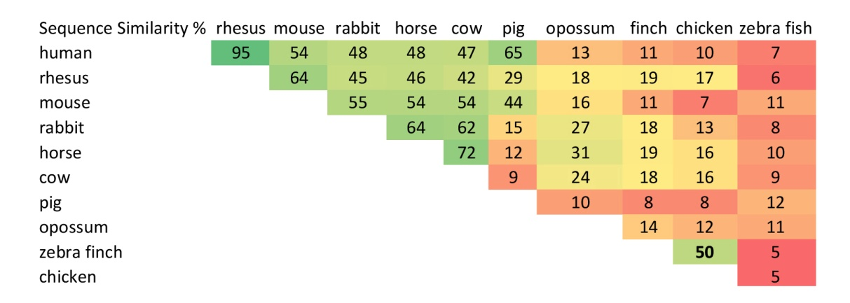

Supplementary table 1.
Similarity of the androgen receptor exon 1 promoter sequences of birds, mammals and the zebra fish. Pairwise similarity scores are shown in percentage based on the number of identical nucleotides of AR promoter sequences for full length RNAs among vertebrates. The zebra finch is most similar to the chicken, and eutherian mammals are most similar to other eutherian species but different from the opossum. Sequences were extracted from the available genome annotations of ElDorado (Genomatix GmbH). Abbreviations: rhesus = rhesus monkey; finch = zebra finch.

