Supplementary material

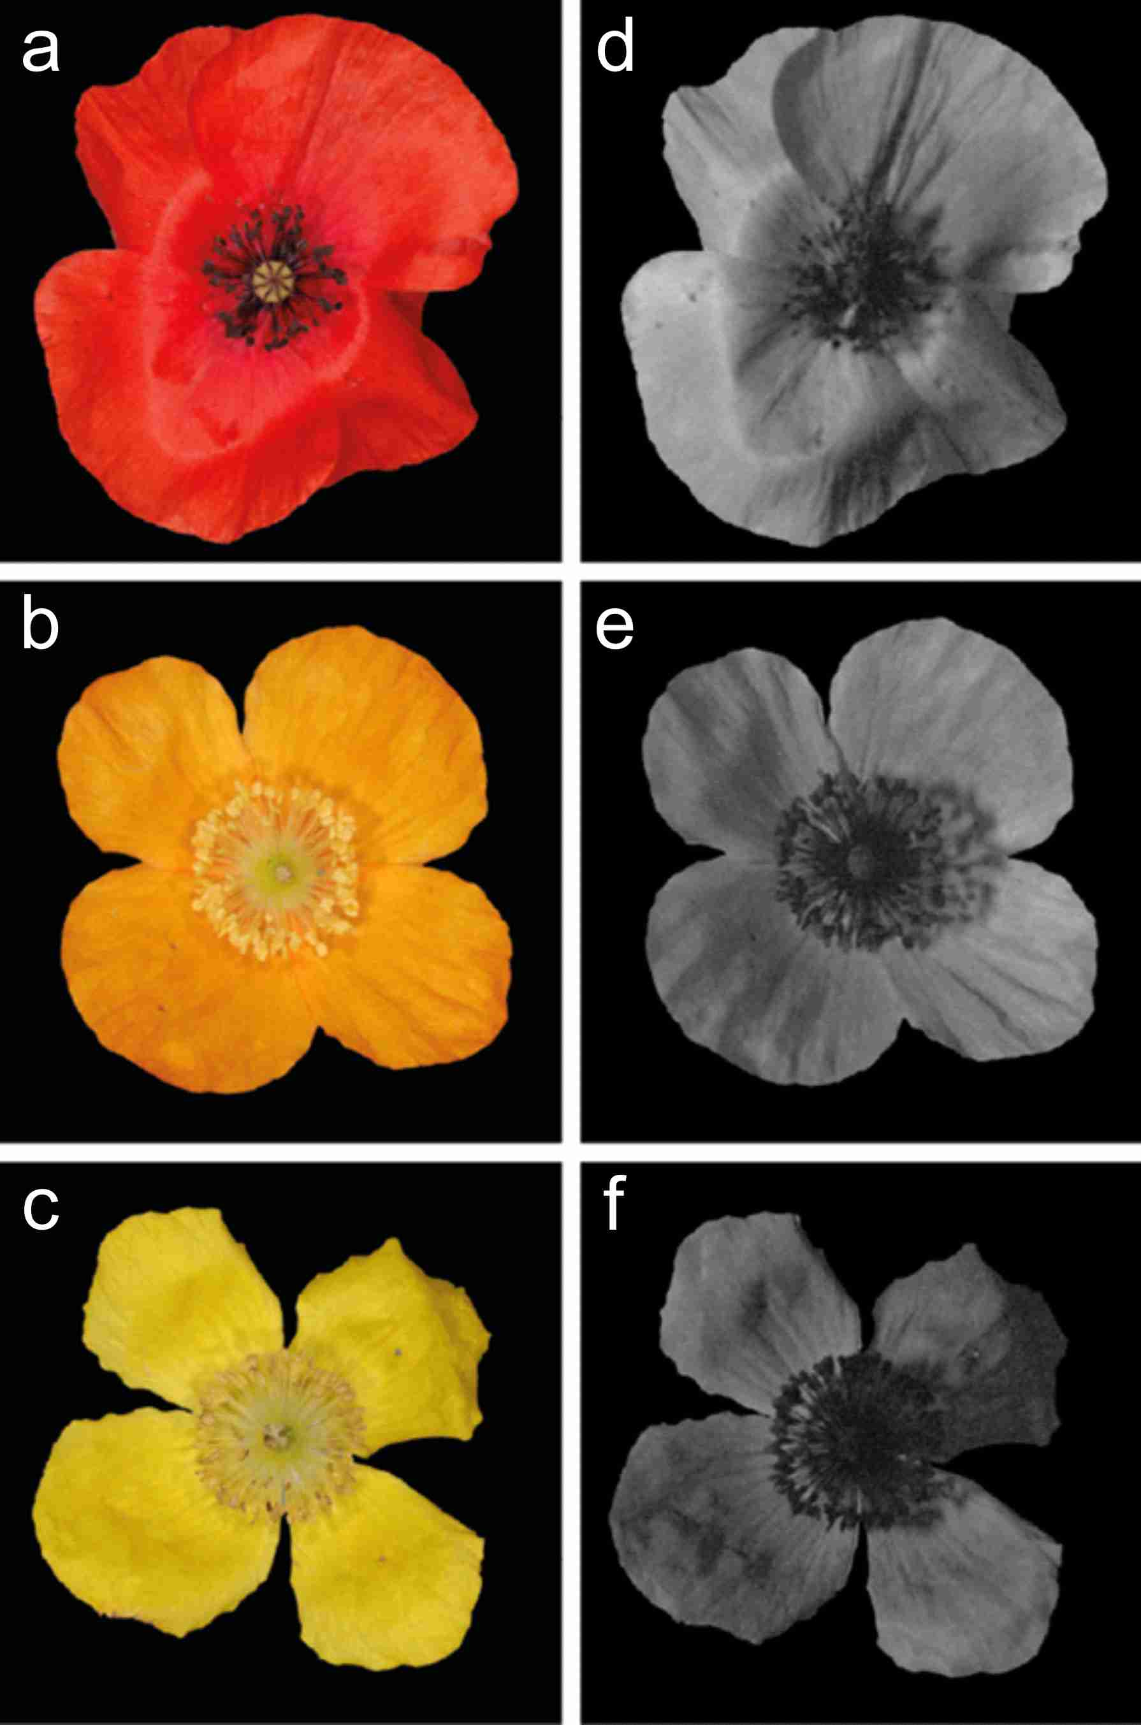

Figure S1. RGB (a-c) and ultraviolet (d-f) photographs of a P. dubium (a, d) flower and of orange (b, e) and yellow (c, f) M. cambrica flowers.
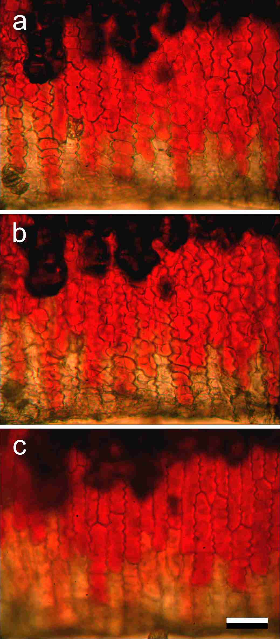

Figure S2. A cut P. rhoeas petal immersed in water, observed at different levels of focus (all in transmission). a Focus at upper epidermal layer. b Focus at intermediate level. c Focus at lower epidermal layer. The black area in the top of the images are air cavities that have not yet been filled with water and thus appear dark in the transmitted light. Scale bar: (a-c) 50 µm.

