Supplementary figures for
Seeing the world through the eyes of a butterfly:
Visual ecology of the territorial males of Pararge aegeria (Lepidoptera: Nymphalidae)
Martin Bergman, Jochen Smolka, Dan-Eric Nilsson & Almut Kelber

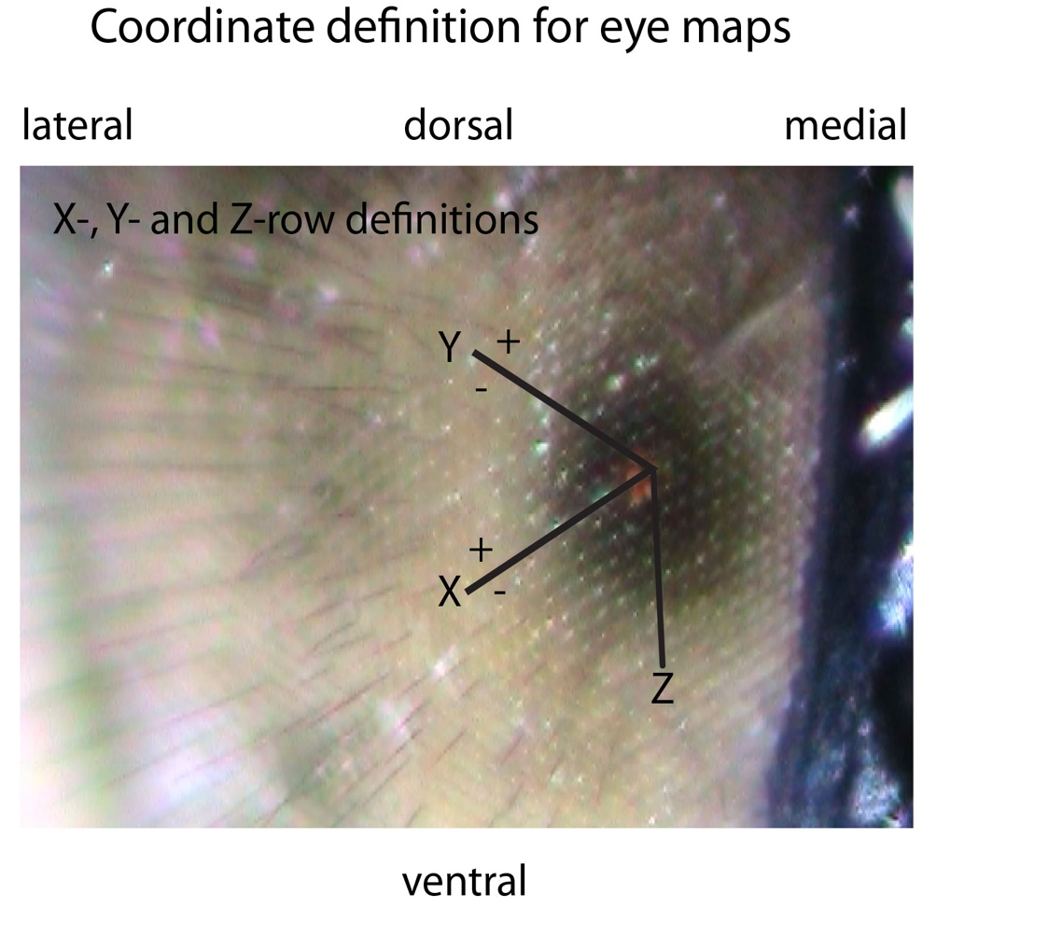

Figure S1. Coordinate definition for the eye maps. The x-, y- and z axes follow the hexagonal ommatidial mosaic. The position of the pseudopupil (facets with red eye glow elicited by the illuminating light) in each photo are given in x- and y-coordinates on the eye.

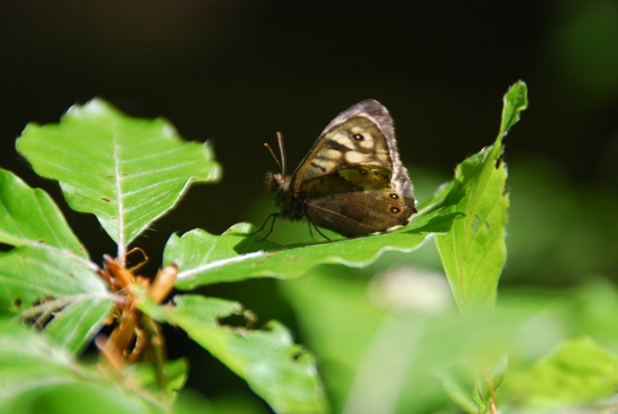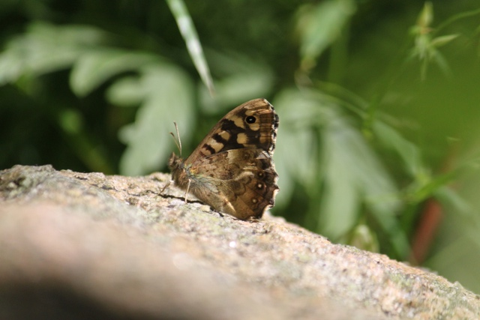
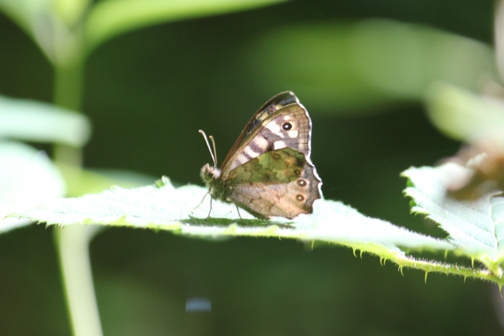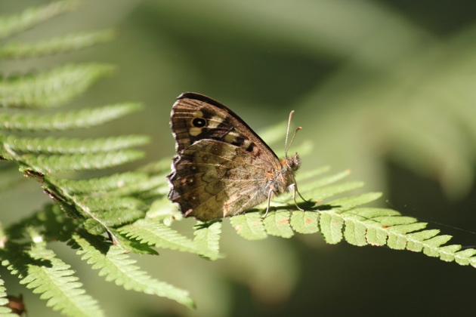

Figure S2. Examples of the photos of perching P. aegeria males that were used to determine body and head pitch.

