Journal of Comparative Physiology A (2026)

Iridescence, polarisation and directionality of Morpho butterfly displays
Juliana Sosa Espinosa^{1,2}, Marco A. Giraldo², Doekele G. Stavenga¹, Casper J. van der Kooi¹
¹Groningen Institute for Evolutionary Life Sciences, University of Groningen, The Netherlands
²Biophysics Group, Institute of Physics, University of Antioquia, Medellin, Colombia

Correspondence: patricia.sosa@udea.edu.co

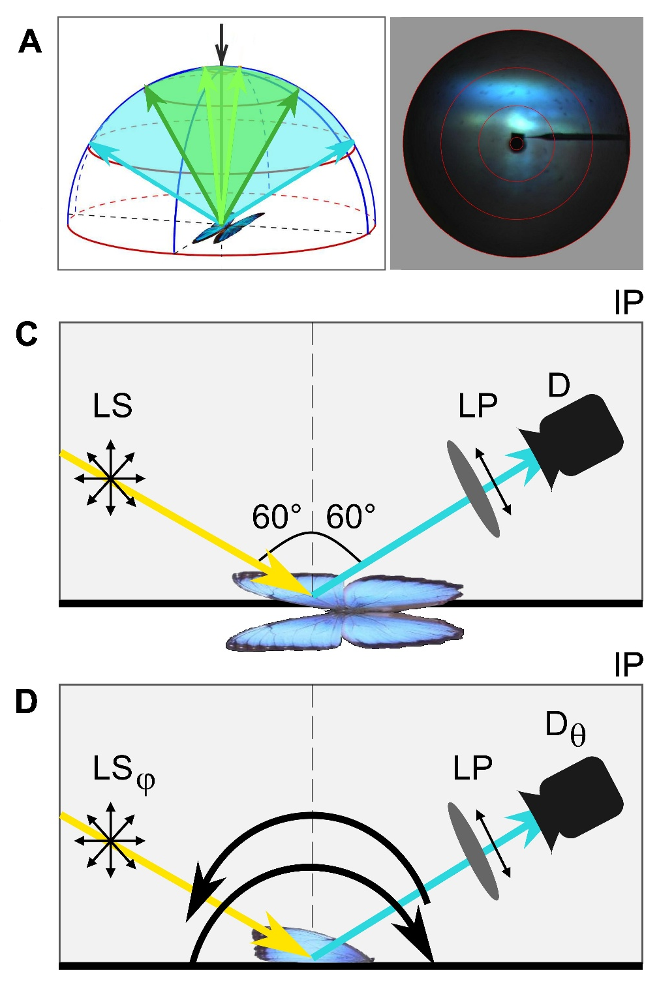
Fig. S0 Illumination-recapture geometries used in the experiments. A Angular spread of reflected light (blue and green arrows) after incident light (black arrow) reaches the sample. B Scatterogram of a M. helenor wing patch, showing the angular spread of the reflected light as illustrated in A. C Illumination geometry of the photography set-up. Both the lightsource (LS) and the detector (D) were fixed at 60°. A linear polariser (LP) was placed before the detector. D Illumination geometry of the goniometric set-up. Both the light source and the detection probes scan the illumination plane (IP), with all possible illumination (ϕ) and recapture (θ) angles combinations ranging from -70 to 70 in steps of 10°. A linear polariser (LP) was also placed before the detector.

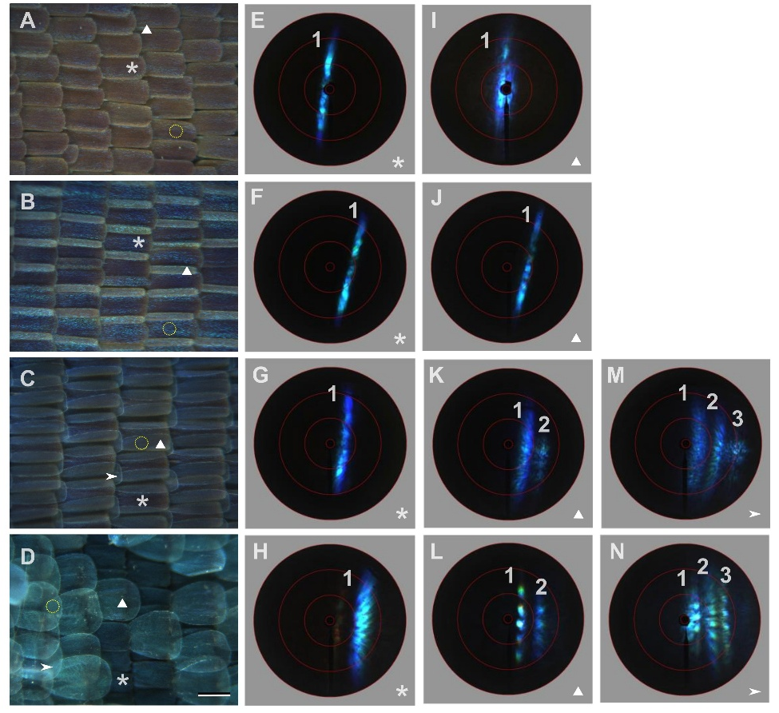
Fig. S1 Full superposition experiment for the model species. A-D Dark field micrographs showing the scale degrees of overlap for A M. aega, B M. zephyritis, C M. godartii and D M. helenor. Scalebar: 100 µm. Asterisk: ground scale, triangle: cover-ground scale overlap; and arrowhead: cover-cover-ground scale overlap (if applicable). E-N Narrow aperture scatterograms from alternative scale superposition degrees for E,I M. aega; F,J M. zephyritis; G,K,N M. godartii and H,L,N M. helenor. The red circles indicate spatial angles of 5°, 30°, 60°, and 90°. Numbers 1, 2 and 3 specify the band numbers for better clarity.

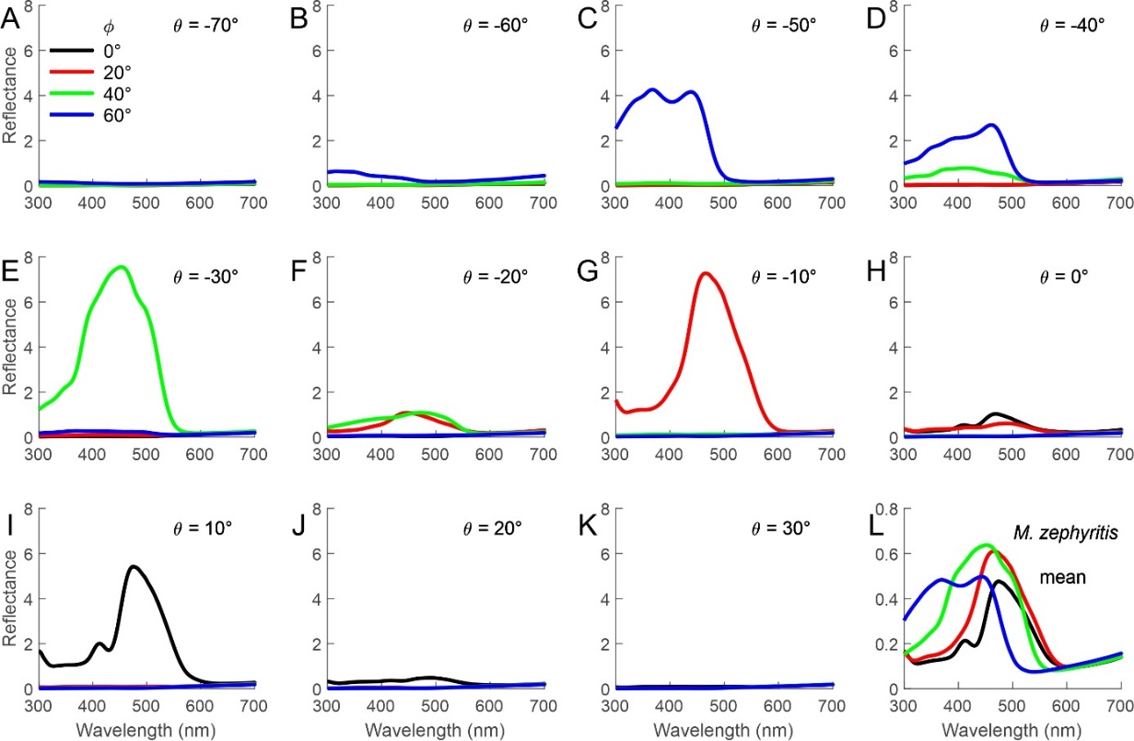

Fig. S2 Measurements of the angle-dependence of the reflectance spectra of Morpho zephyritis wings. Illumination from angular directions 0, 20, 40 and 60° show strongly directional reflections with peak reflection into angles differing 20° from the mirror angle and hypsochromic-shifted spectra with increasing angle of light incidence.

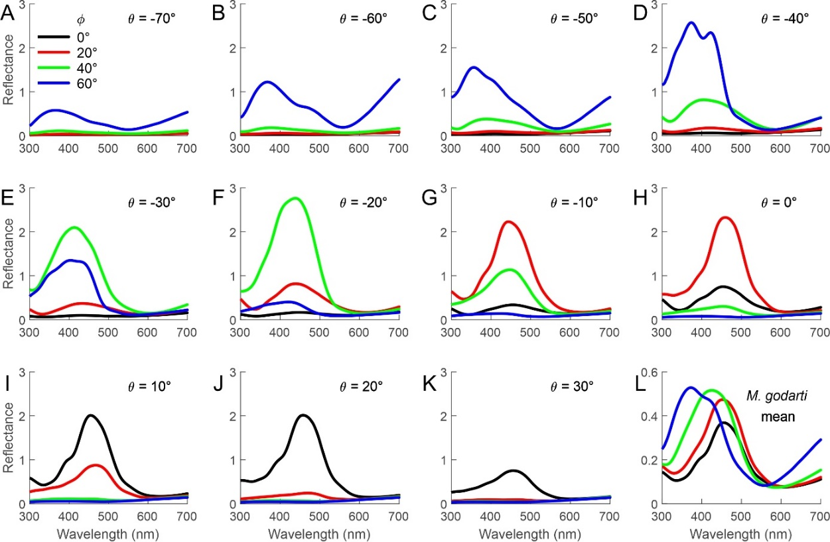
Fig. S3 As Fig. S2, for M. godartii.
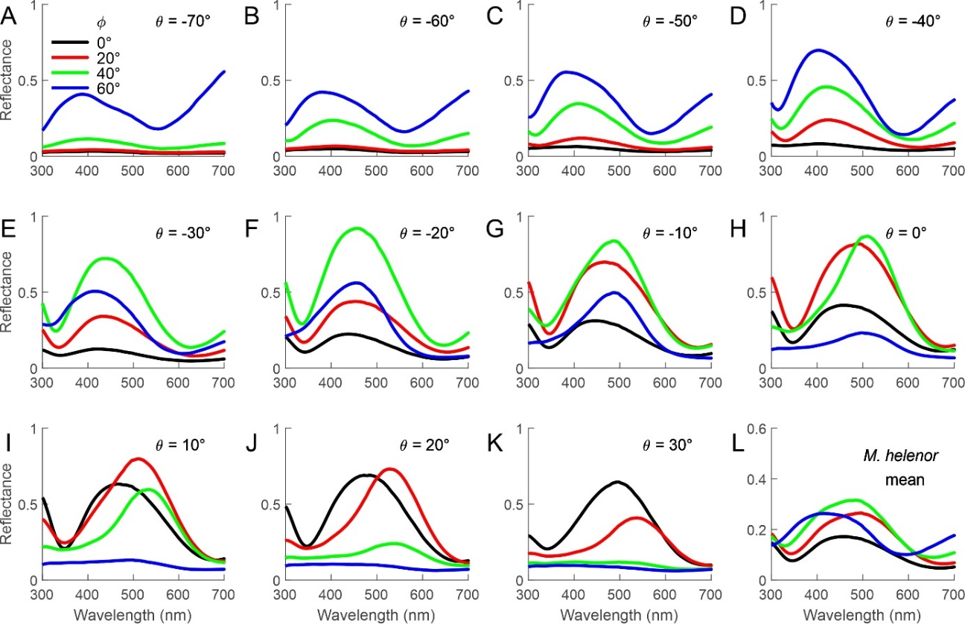
Fig. S4 As Fig. S2, for M. helenor.

